

**The Book of Secrets**

**Version 5.5.22**

TABLE OF CONTENTS

MINIMUM SYSTEM REQUIREMENTS 15

SendPlus 15

Support 16

More Documentation 16

*ADBANK 5* OVERVIEW 17

Accessing Adbank 19

Logging in 21

Signing up 22

Refreshing expired password 24

Resetting own password 24

Impersonating 26

Dashboard 28

*Approvals* widget 29

*My Projects* widget 30

*Files in your projects* widget 31

*Recent Activity* widget 32

*Presentations* widget 33

*Latest Library Uploads* widget 34

Projects area 35

*Projects* tab 38

*Work Requests* tab 41

*Project Templates* tab 42

*Work Request Templates* tab 44

*Approvals* tab 45

Project/Work Request details page 48

*Overview* tab 48

*Files* tab 53

*Team* tab 58

*Approvals* tab 59

*Shares* tab 60

Project Template/Work Request Template details page 61

*Overview* tab 62

*Files* tab 62

*Team* tab 63

File details page 64

Library area 65

*Library* tab 66

Asset details page 73

*Presentations* tab 74

Presentation details page 76

*Assets* tab 76

*Activity* tab 77

*Branding* tab 78

*Layout* tab 79

*Presentation Settings* tab 82

*Shared Collections* tab 83

Administration area 85

*Users* tab 85

*Projects* sub-tab 87

*Library* sub-tab 88

*Delivery* sub-tab 89

*Applications* sub-tab 89

*Roles* tab 90

*Metadata* tab 92

Metadata properties 93

Types of metadata 95

*String* metadata 95

*Date* metadata 96

*Dropdown* metadata 97

*Catalogue Structure* metadata 98

*Section Break* metadata 100

*Multiline* metadata 100

*Phone* metadata 101

*Address* metadata 102

*Radiobutton*s metadata 103

*Hyperlink* metadata 104

*Custom Code* metadata 105

*Views* tab 106

*Branding* tab 107

*System Branding* sub-tab 107

*Login Page* sub-tab 109

*Presentations* sub-tab 111

*Collections* tab 112

*Approvals* tab 116

*T&C* tab 116

*Related Files* tab 118

*User Settings* page 119

*Profile Setting* tab 119

*Account Setting* tab 123

*Notification Setting* tab 124

*Delivery Setting* tab 131

*Address Book* tab 131

*Notifications* page 132

Main menu 133

Global Search tool 135

Search Results pages 139

Examples of using Global search 142

Customizing data views 145

Scrolling data in lists 145

Filtering data 148

Filtering Projects, Work Requests and their Templates by views 148

Filtering Projects, Work Requests and their Templates by Business Units 150

Filtering Projects and Work Requests by *Published/Unpublished* status 151

Filtering Projects, Work Requests and their Templates by Media Type 151

Filtering Projects and Work Requests by Project metadata 152

Filtering activity records by activity types and users 154

Filtering list of Projects/Work Requests/Templates/files/Assets by columns 158

Filtering files and Assets by Media types and Media sub-types 159

Switching data views 159

Switching between views for Projects and Library 159

Switching between previews of Files/Assets 162

Customizing metadata visibility in List and Tile views 163

Hiding/displaying metadata for list of Projects, Work Requests and Templates 163

Hiding/displaying media-specific metadata for files/Assets in List view 163

Sorting folders/files/Assets 165

PROJECTS AREA 167

Projects/Work Requests 167

Creating Projects/Work Requests 167

Creating Projects/Work Requests from scratch 167

Creating Projects/Work Requests from Templates 171

Creating Work Requests based on Assets retrieved from Library 172

Publishing and Unpublishing Projects/Work Requests 177

Editing metadata of Projects/Work Requests 180

Deleting Projects/Work Requests 182

Adding Assets to Projects/Work Requests from the Library 182

Downloading Projects by *SendPlus* 185

Subscribing/unsubscribing to email notifications from Projects 186

Team members and their permissions 189

Adding users, Team Templates to Projects/Work Requests 189

Adding separate users to Projects/Work Requests 194

Using Team Templates to Add Users to Projects/Work Requests 196

Using Public Project Team Templates to Add Users to Projects/Work Requests 199

Removing users from Projects/Work Requests 200

Amending users’ access to Projects/Work Requests and their folders 201

Folders 202

Creating folders 202

Editing folders 203

Sharing folders 204

Removing folders 206

Restoring folders 206

Copying/moving folders 208

Expanding/collapsing Project folders tree 211

Downloading folders by *SendPlus* 212

Files 213

Uploading files to Projects/Work Requests 213

Uploading files via the *Uploader* 213

Uploading files via the *SendPlus* 216

Uploading file revisions 219

Downloading files from Projects/Work Requests 220

Downloading single files 220

Downloading multiple files as single ZIP archive 223

Downloading multiple files by *SendPlus* 225

Managing file details 225

*Info* tab 225

*Activity* tab 227

*Comments* tab 227

Adding comments to files 228

Replying to files’ comments 228

Removing comments from files 228

*Approvals* tab 229

*Version History* tab 229

*Usage Rights* tab 230

Adding Usage Rights 231

Editing Usage Rights 233

Removing Usage Rights 233

Adding multiple *Countries* Usage Rights at once to files 234

*Related Files* tab 235

Linking Project files 237

Unlinking Project files 240

*Attachments* tab 241

Uploading Attachments to files 242

Downloading Attachments from files 242

Editing Attachments of files 243

Deleting Attachments of files 243

Changing file versions 244

Annotating files 245

Editing metadata of files 254

Editing metadata of single files 254

Editing metadata of multiple files in batch 255

Editing metadata of multiple files one-by-one 257

Adding/editing Usage Rights of multiple files in batch 259

Copying/moving files to Projects 262

Copying files to the Library 265

Deleting files 267

Restoring files 267

Adjusting file previews 268

Sending files for approval 269

Creating new Approvals when sending files for approval 271

Applying Approval templates when sending files for approval 272

Sharing files with users 273

Sharing files securely 273

Sharing files publicly 276

Unsharing files with users 280

Unsharing securely shared files 280

Unsharing publicly shared files 280

Viewing users with whom files were shared 281

Viewing/commenting securely shared files 281

Redefining Media Types for uploaded files 284

Managing captured frames of video files 285

Capturing frames 285

Downloading captured frames 287

Editing captured frames 288

Deleting captured frames 289

Sending files to the Delivery area 289

Templates of Projects/Work Requests 290

Creating Project/Work Request Templates from scratch 290

Publishing Project/Work Request Templates 291

Creating Templates from Projects/Work Requests 292

Deleting Project/Work Request Templates 294

Approvals 294

Adding Approval Stages 298

Editing Approval Stages 307

Adding or deleting Approvers to Approval Stages 308

Sending reminders to Approvers 309

Editing/deleting comments on Approval Stages 310

Removing Approval Stages 312

Starting Approvals 312

Approving or rejecting files 314

Approving or rejecting single files 314

Approving or rejecting group of files 328

Closing or cancelling Approvals 330

Saving Approvals as Approval templates 333

Applying Approval templates to files 335

Navigating between Approval details and list of Approvals 336

LIBRARY AREA 339

Collections 340

Creating Collections 343

Creating Collections based on metadata filters 343

Creating Collections based on manually added Assets 349

Editing Collections 350

Opening Collections 351

Renaming Collections 351

Removing Collections 352

Searching for Collections locally in the Library 353

Marking Collections as default in the Library 353

Subscribing/unsubscribing to Collections 354

Assets 355

Managing Asset details 356

*Info* tab 356

*Activities* tab 359

*Usage Rights* tab 361

*Destinations* tab 362

*Related Assets* tab 362

Linking Assets 363

Unlinking Assets 367

*Related Projects* tab 368

*Attachments* tab 369

Uploading Attachments to Assets 370

Downloading Attachments from Assets 370

Editing Attachments of Assets 370

Deleting Attachments of Assets 371

Viewing slates and storyboards on QC-ed Assets 371

Uploading Assets to the Library 374

Adding Assets to Presentations 375

Adding Assets to new Presentations 378

Adding Assets to existing Presentations 380

Editing metadata of Assets 381

Editing metadata of single Assets 381

Editing metadata of multiple Assets in batch 384

Editing metadata of multiple Assets one-by-one 386

Adding/editing Usage Rights on multiple Assets in batch 389

Removing Assets from the Library 392

Deleting manually added Assets from Collections 393

Restoring Assets to the Library 394

Downloading Assets from the Library 395

Downloading Assets from the *Library* tab and related Search Results page 395

Downloading Assets from the Asset details page 397

Downloading QC-ed Assets’ storyboards as ZIP archives 400

Sharing Assets with users 401

Sharing Assets securely 402

Sharing Assets publicly 402

Unsharing Assets with users 402

Unsharing publicly shared Assets 403

Unsharing securely shared Assets 403

Viewing users to whom Assets were publically shared 403

Copying Assets to Projects/Work Requests 403

Copying Assets to Projects 403

Copying Assets to Work Requests 405

Redefining Media Types for uploaded Assets 405

Managing captured frames of video Assets 407

Sending Assets to the Delivery area 408

Presentations 409

Creating Presentations 409

Deleting Presentations 410

Sharing Presentations 410

Sharing Presentations securely with users 410

Sharing Presentations publicly with users 411

Sharing Presentations with Library Teams 412

Unsharing Presentations 414

Unsharing securely shared Presentations 414

Unsharing publicly shared Presentations 415

Viewing users with whom Presentations were shared 416

Previewing Presentations 418

Downloading Presentations 419

Downloading Presentations with Assets from the same storage 419

Downloading Presentations with Assets from different storages 420

Searching for Presentations locally in the Library 422

Shared Collections 422

Accepting shared Assets 422

Rejecting shared Assets 423

Viewing shared Assets 424

Searching for shared Assets 425

Editing and accepting shared Assets 426

Downloading shared Assets 428

DELIVERY AREA 429

Viewing Order Reports and emails 433

Order Summary 433

Delivery Reports 437

Destination Details 439

Order Confirmation Reports for *Beam*-tagged Business Units 440

Order Summary Reports for *Beam*-tagged Business Units 441

Order Confirmation emails for Beam-tagged Business Units 443

Media Upload Request emails 443

Subtitling emails 449

Uploading requests for Orders without media 449

Advanced searching for Orders 451

Creating Orders 455

Selecting Markets 459

Filling Order details 460

*Add Media* section 460

Creating New Masters 461

Retrieving media from the Library 463

Retrieving media from Projects 465

Reviewing Assets’ details before retrieving them to Orders 467

*Add information* section 469

Features of Market-related metadata 473

Managing Custom Code Generator for Orders’ Clock Numbers 479

Integrating with Pub ID system 482

*Library Information* section 485

*Usage Rights* section 485

*Select Broadcast Destinations* section 487

Navigating among broadcast destinations 491

Bookmarking broadcast destinations 492

Applying bookmarked broadcast destinations 493

*QC and Ingest Only* option 494

*Additional Services* section 494

Adding Dubbing Services 495

Adding Production Services 500

Adding Commercials 501

Holding Ads for approval 502

Approving Orders’ ads held for approval 504

Validating Orders 506

Placing Orders 508

Saving Orders as drafts 511

Deleting Orders 512

Transferring Orders 513

Ordering on behalf 515

Billing on behalf 517

Reassigning *SendPlus* upload requests 519

Managing Delivery Settings 520

Assigning Default Market to Orders 522

Assigning Default Transfer User to Orders 522

Assigning Default Additional Recipients to Orders 523

Assigning expanded by default Metamarketsto Orders 524

Assigning Default Media Delivery Deadline to Orders 524

Marking Ads in Orders as held for approval by default 525

Predefining default state for email notifications on Order Summary page 526

Enabling *Hold for approval* option for QC Assets retrieved from Library 526

Predefining default subtitles for Orders 527

ADMINISTRATIVE AREA 529

Users 529

Managing user profiles 529

Adding user profiles 529

Editing user profiles 532

Enabling/disabling users in Business Units 533

Managing users’ access to applications 533

Enabling/disabling Projects area for users 533

Enabling/disabling Work Requests and their Templates for users 534

Enabling/disabling Library area for users 534

Enabling/disabling Delivery area for users 535

Enabling/disabling Traffic module for users 535

Enabling/disabling Approvals for users 536

Enabling/disabling Annotations for users 536

Enabling/disabling Presentations for users 537

Enabling/disabling Dashboard for users 537

Enabling/disabling Frame Grabber tool for users 537

Managing Library Teams 538

Adding users to new Library Teams 538

Adding users to existing Library Teams 538

Deleting Library Teams 539

Deleting users from Library Teams 539

Managing Public Project Team Templates 540

Adding users to new Public Project Team Templates 540

Adding users to existing Public Project Team Templates 540

Deleting Public Project Team Templates 541

Deleting users from Public Project Team Templates 541

Managing Project access rules 542

Adding Project access rules 543

Editing Project access rules 544

Deleting Project access rules 545

Managing Delivery access rules 545

Adding Delivery access rules 547

Editing Delivery access rules 548

Deleting Delivery access rules 548

Roles 548

Viewingroles permissions 549

Renaming editable roles 549

Hiding/displaying unused user roles 550

Metadata 551

Adding/editing metadata 552

Adding/deleting metadata Choices 554

Arranging metadata order on system forms 555

Assigning default values for metadata 555

Hiding/displaying metadata 558

Deleting metadata 558

Adding Custom Codes for generating metadata of *Custom Code* type 559

Defining the behaviour of metadata of *Custom Code* type 566

Marking metadata as common for Orders and available for Billing 569

Managing custom Media Types and Media Sub-types 571

Adding custom Media Types 571

Deleting custom Media Types 573

Adding custom Media Sub-types 573

Deleting custom Media Sub-types 575

Views 575

Customizing metadata settings on thumbnails for files/Assets 575

Resetting metadata settings on thumbnails for files/Assets 578

Branding 579

Customizing Web header 579

Background colour 579

Logo 580

Help URL for Business Unit 580

*From* email address for notifications 580

Browser title 580

Favicon 580

Customizing Login page 580

Background colour 581

Footer colour 581

Footer text 582

Footer text colour 582

Background image 582

Welcome message’s text 582

Logo 582

*Login* button’s colour 582

*Forgot password* link’s colour 582

Invitation message text’s colour 583

Customizing default branding and settings for new Presentations 583

Collections 583

Creating Collections 583

Editing Collections 585

Deleting Collections 585

Sharing Collections 586

Sharing single Collections with users 586

Sharing single Collections with Business Units 588

Sharing single Collections with Library Teams 588

Sharing multiple Collections with users and Library Teams 589

Unsharing Collections 590

Unsharing Collections with users 590

Unsharing Collections with Business Units 590

Unsharing Collections with Library Teams 591

Changing user roles for shared Collection 591

Managing Section Breaks for Collections 593

Adding Section Breaks 593

Editing Section Breaks 594

Deleting Section Breaks 595

Separating Collections via Section Breaks 596

Approvals 596

Creating Approval templates 597

Viewing Approval templates 600

Editing Approval templates 601

Deleting Approval templates 602

Terms and Conditions 602

Managing T&C for Business Units 602

Adding/editing T&C to Business Units 602

Deleting T&C for Business Units 603

Managing T&C for Projects 603

Enabling T&C for Projects 603

Adding T&C to Projects 604

Viewing T&C for Projects 606

Editing T&C for Projects 608

Deleting T&C for Projects 608

Printing T&C for Projects 608

Relation Types 610

Adding Relation Types 610

Deleting Relation Types 611

Watermarking video files/Assets 611

ADDRESS BOOK & USER PROFILE 614

Inviting users to the *Adbank 5* 614

Managing Address Book’s contacts 615

Adding contacts to the Address Book 615

Removing contacts from the Address Book 616

Editing contacts within the Address Book 617

Managing Groups 617

Adding contacts to Groups 617

Removing contacts from Groups 618

Subscribing/unsubscribing to email notifications 618

APPENDIX A – Types of Usage Rights 621

APPENDIX B – Default Media Sub-types 627

APPENDIX C – Permissions 631

# MINIMUM SYSTEM REQUIREMENTS

Officially, Adbank web application should always work with the 2 latest versions of the following major browsers: Chrome, FireFox, Safari, Edge, Internet Explorer. At the time of of this update, Microsoft has long since ended official support of IE <http://venturebeat.com/2016/01/12/microsoft-ends-support-for-ie8-ie9-ie10-and-windows-8/>, but some major clients of Adstream are still using this dinosaur.

If you are unsure how to check these details on your machine please visit <http://a5.adstream.com/browsercheck>. This page is supposed to work, but hasn’t been update for ages – too low a priority (<https://jira.adstream.com/browse/NGN-17256>, <https://jira.adstream.com/browse/NGN-15199>, https://jira.adstream.com/browse/NGN-18357)

*Adbank 5* can additionally be used on Android 4.4+ and iOS 6.1+ devices, however access to certain features might be limited. (it’s just indecent to say in the world of mobile that our enterprise application officially is not supported on mobile, right? Sad truth is, testing on mobile is not a part of our QA cycle. So it kind of works, but only by gods’ mercy).

## SendPlus

SendPlus is a desktop client of *Adbank 5*, design to transfer huge files at high speed (in early releases it would kill your office network by devouring all the bandwidth). SendPlus works on Mac OSX: 10.7 or higher; MS Windows: 7 & 8, 8.1. Windows 10 should work, but hasn’t been tested yet.

You can learn more about this amazing application, and download it, from <http://www.sendplus.com>.

The following ports should be open on your firewall for optimal Sendplus operation:

TCP port 80

TCP port 443

UDP port 12345

UDP port 49921

XMPP port 5222

## Support

If you have any further questions concerning system requirements, please email competent people of support at [helpcentre@adstream.com](mailto:helpcentre@adstream.com).

## More Documentation

<https://connect.adstream.com/display/ArC/A5+Architecture+Overview> and around

https://connect.adstream.com/display/GDAM/Documentation

# *ADBANK 5* OVERVIEW

*Adbank 5* main applications include:

* Dashboard
* Projects
* Library
* Delivery
* Business Unit (BU) Admin
* User Settings
* Address Book
* Notifications
* Approvals (available in Projects)
* Annotations (available in Projects)
* Framegrabber (available in both Projects and Library)

Dashboard, Projects, Library, Delivery, Approvals, Annotations, Presentations and Framegrabber all can be switched on and off per Business Unit (this is done by Adstream Support in a separate Global Admin application; see the original spec in <https://jira.adstream.com/browse/NGN-88>). Applications available to current BU, can additionally be switched on/off for each user of this BU. So, for example, if BU has Projects, Library and Delivery enabled, BU Admin user can turn on Projects and Library for one user, then Library and Delivery to another, and then all 3 modules to themselves, and feel Mighty!

In Projects, you will find the following tabs:

* *Projects*.
* *Work Requests.*
* *Project* *Templates*.
* *Work Requests* *Templates*.
* *Approvals*.

Work Requests (and Work Request Templates) are a subtypes of projects. While technically they are not a separate application, they also can be enabled per BU and per user.

In Library, there are the following tabs:

* *Library*.
* *Presentations*.
* *Shared Collections.*

BU Admin area allows you to configure BU settings on the following tabs:

* *Users*.
* *Roles*.
* *Metadata.*
* *Views*.
* *Branding*.
* *Collections**.*
* *Approvals**.*
* *T&C.*
* *Related Files.*
* *Watermarking.*

The diagram below shows direction of data flow between the main applications (Figure 1).

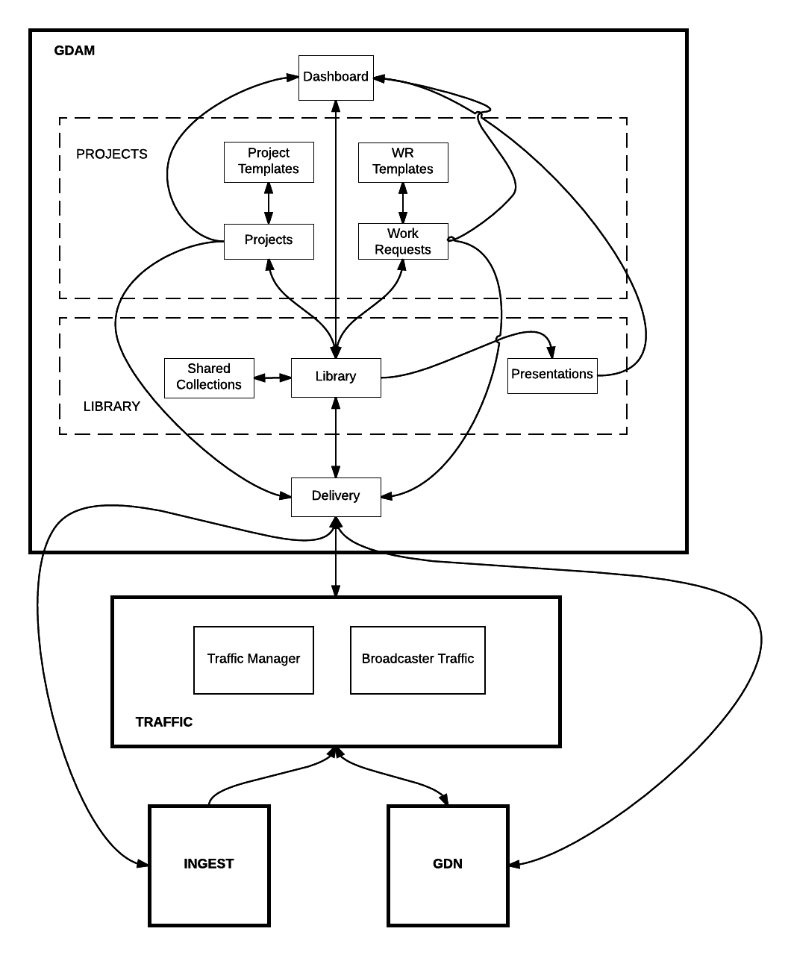

Figure 1 Main Adbank Applications

## Accessing Adbank

Default URL for Adbank live environment is a5.adstream.com

However, many clients access Adbank by custom URLs, like breville.adstream.com or application.beam.tv

This allows them to apply custom branding to login page and look really cool.

For more information about how to set up custom URL, please refer to <https://connect.adstream.com/display/SupportGlobal/adding+a5+custom+URL>.

The diagram below explains the logic which defines branding applied to the login page (see Figure 2).

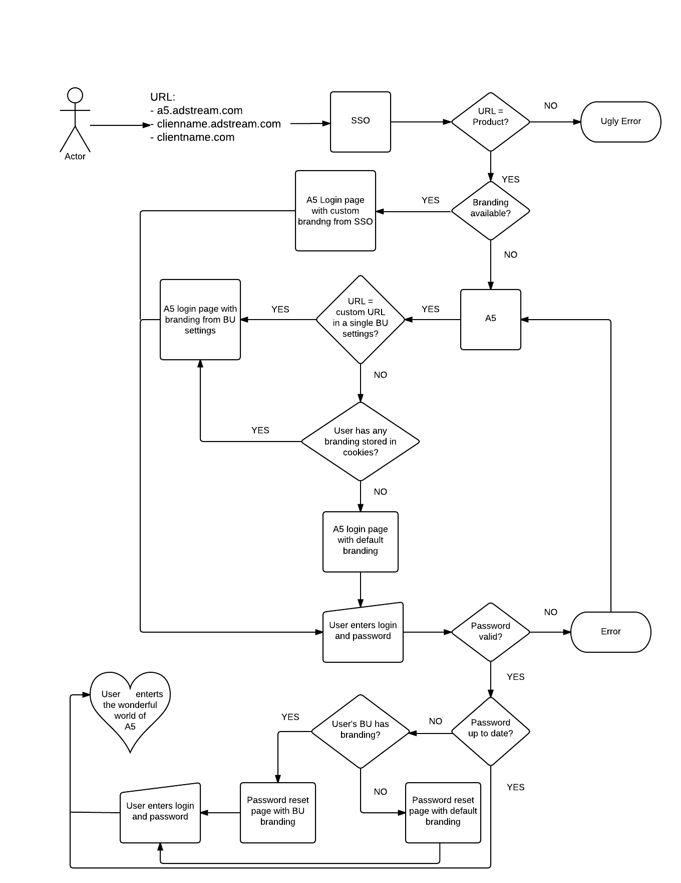

Figure 2 The arcane knowledge of login page branding logic

### Logging in

To log in the *Adbank 5* a user should enter own account credentials on the Login page, i.e. fill in the *User* and *Password* fields, and then click the *Login* button. If they are filled correctly, the user will be redirected to their landing page; by default, it is Dashboard (see Figure 3).

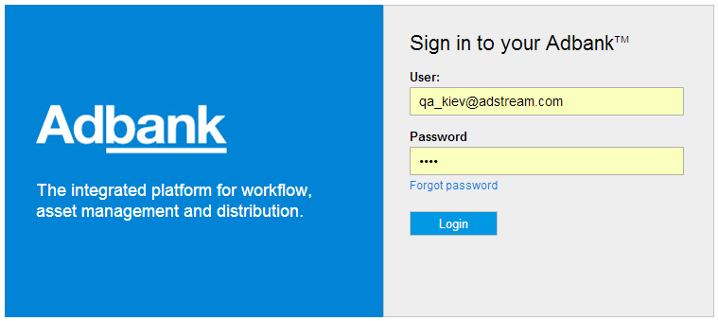

Figure 3 Login page

If user clicks the *Login* button with one or both fields left blank, or with the login or password entered incorrectly login fails and the warning pop-ups:

*‘The username and password do not match*’.

### Signing up

An unregistered user to whom a system item (e.g. folder/Project/etc.) was shared receives invitation email with the link to this shared item. Note that such invitation email will not be sent to an unregistered user added to a Template’s folder until this Template was used for creating and publishing a Project.

Following by the invitation link, an unregistered user lands to the Sign-up page. There, they should fill in at least mandatory (highlighted in red) metadata fields and click the *Sign Up* button to create own account in the *Adbank 5* (see Figure 4).

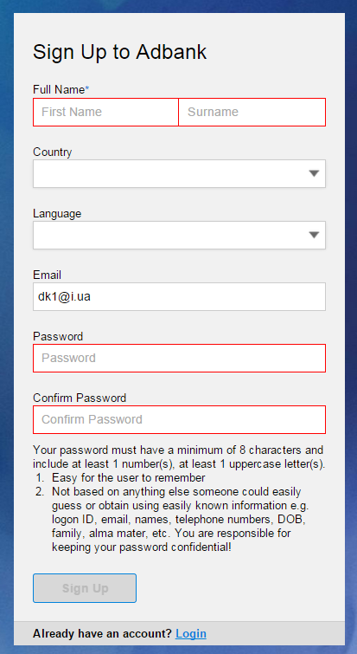

Figure 4 Sign-up page

Once the button is clicked, this user goes directly to the folder/Project that has been shared to them. When the unregistered user is on the Sign-up page, they can see branding of a Business Unit under which this user was invited.

Password of an unregistered user should meet the requirements listed under the *Confirm Password* field.

**Note**: If an unregistered user was invited to a shared folder/Project as Project Owner, after logon they is taken directly to the *Overview* tab of the shared Project.

### Refreshing expired password

Each user password has expiration period which is set for all users of a Business Unit by the Global Admin. By default, expiration period is 30 days from the date a user was registered in the *Adbank 5*.

If a user’s password is expired, the user will be redirected to the Password Refresh page after filling own account credentials and clicking the *Login* button on the Login page (see Figure 3).

On the Password Refresh page the user should fill in expired password, then new one with confirmation and click the *Refresh* button to refresh (see Figure 5).

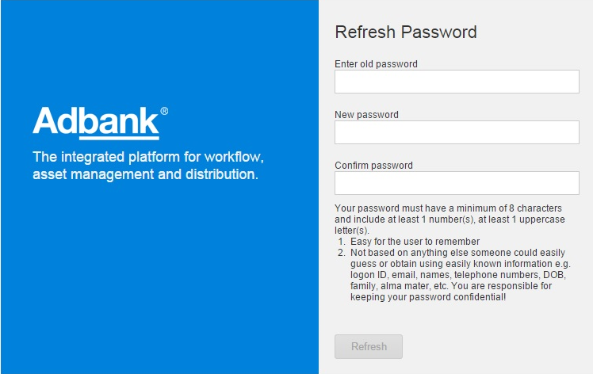

Figure 5 Password Refresh page

After refreshing password the user will be redirected to their landing page.

**Note**: For each Business Unit custom logo and footer on the Password Refresh page are displayed according to user’s primary Business Unit branding. Also, Password Refresh page has the same styling as Password Reset page.

### Resetting own password

User has possibility to reset own password by clicking the *Forgot password* link on the Login page. The *Reset Password* pop-upwindow will be displayed afterwards. There, the user should specify the email on which encrypted link to reset own password will be sent, and click the *Reset Password* button(see Figure 6)*.*

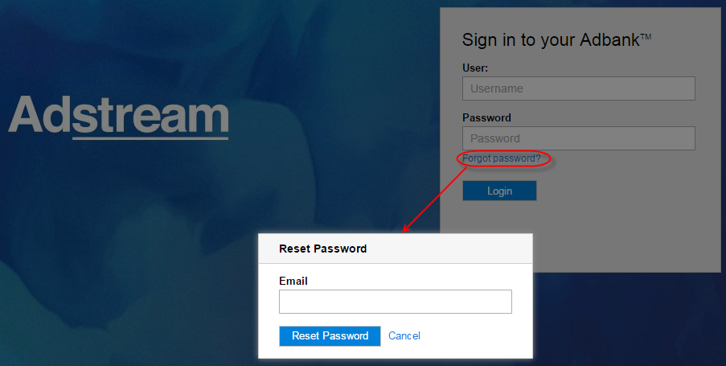

Figure 6 *Reset Password* pop-up window

After the link is clicked in the received email, the user will be redirected to the Password Reset page where they should enter and confirm new password, and click the *Reset* button (see Figure 7).

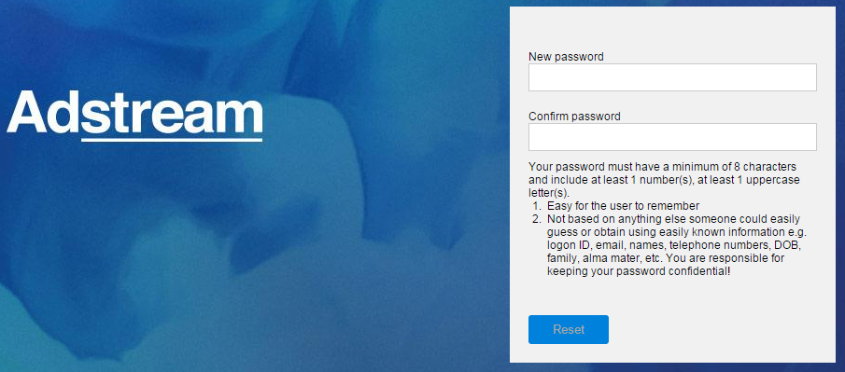

Figure 7 Password Reset page

After clicking *Reset* button, user’s password is reset, user receives confirmation email, and is redirected to the login page, where they can login with their new password.

Link to reset user’s password is valid only once for 24 hours since it was sent to the user. If user clicks on the link that has already expired, they will be taken to the Login page.

If the user clicked password reset link in the email, and have finished resetting their password, the link is no longer valid. If user tries to click it again after successfully resetting their password – they will be redirected to the *Login* page.

**Note**: After the new password is generated for the user, expiration period for this password becomes automatically prolonged according to the password expiry.

**Note:** If the user clicked the *Reset Password* link, and triggered password reset email, their account is not locked in any way. User can still log in with the old password, until they have followed the link and successfully created a new one.

### Impersonating

Users with the *user.impersonate* permission can impersonate as any other user in own Business Unit.

**Note:** user cannot impersonate as a “secondary” BU user, only as a user whose Primary BU is the same as their own.

**Note:** A part of the requirement regarding *user.impersonate* permission was never properly implemented. As of 5.5.22, it works like this:

* On front end, visibility of the Impersonate link is hardcoded to Global Admin role and agency.admin role.
* On back end, actual check for *user.impersonate* permission is performed
* In clean environment, *user.impersonate* permission is not switched on by default for agency.admin role, so needs to be added (manually or as a part of environment setup script).
* On Live/UAT, if you remove *user.impersonate* permission from the agency.admin role, user will still see the Impersonate link in the UI, will be able to click it, but will not be able to proceed with impersonation.

To impersonate:

1. Log in as Global Admin or BU Admin (user with agency.admin role)
2. Click the User menu and select the *Impersonate* menu-item (see Figure 8).

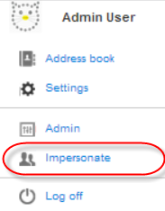

Figure 8 User menu > *Impersonate* menu-item

1. Start typing username or email in the *Impersonate me* pop-up window, leave comment (max to 250 symbols) to explain the reason of impersonation and click the *Impersonate* button (see Figure 9).

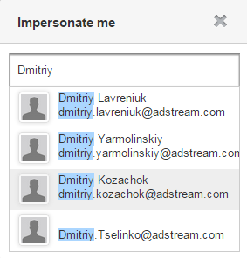 🡪 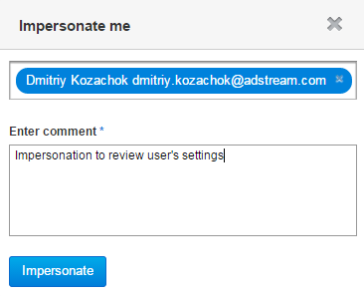

Figure 9 Impersonating

User of current Business Unit cannot impersonate as a user of other Business Unit or a non-existent user. Also, Business Unit Admin can impersonate users of only own Business Unit, impersonation users of partner Business Units is not possible (and shouldn’t be!)

Impersonation event creates an activity which is recorded in database and is visible in the UI. The comment that you leave when impersonating, will not be shown anywhere in the UI, but is recorded for audit purposes and available through reporting tools, so don’t write any obscenities there!

**Note**: Each user’s activity performed by impersonated user has appropriate system record, which contains additional ‘*(Impersonated by <user’s email>)’* text added to main text of activity record. Activity records with this text are visible on appropriate system widget/tab for the user who impersonated, as well as for the user under whom the impersonation was made.

## Dashboard

Dashboard is a special application for quick start working with main *Adbank 5* features. If user has permissions to manage both Projects and Library areas, they can see *Approvals*, *Files in your projects*, *Presentations*, *Latest Library Uploads*, *My Projects* and *Recent Activity* widgets on the Dashboard (see Figure 10).

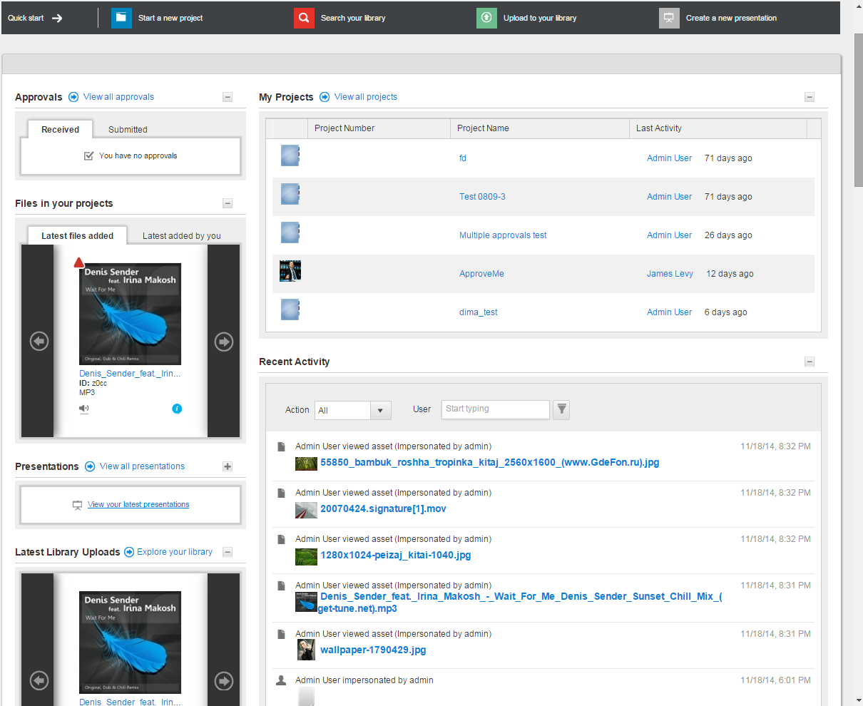

Figure 10 Dashboard

Visibility of widgets on the Dashboard depends on user’s applications access (User > Settings page):

* Presentations – requires access to Library AND Presentations modules
* Latest Library Uploads – requires access to Library AND permission asset.create in the global role of user’s primary BU
* Approvals – requires access to Folders AND Approvals modules
* Files in your Projects – requires access to Folders
* My Projects – requires access to Folders; additionally, user has to have a permission project.create to see something in this widget, otherwise it will always be empty

Dashboard allows a user to:

* Start a new Project via the  button (provided that user has access to Folders AND project.create permission)
* Explore the Library via the  button (provide that user has access to Library, and some collections already shared with them)
* Upload files to the Library via the  button (provided that user has access to Library AND asset.create permission)
* Create a new Presentation via the  button (provided that user has access to Library AND Presentations AND presentation.create permission; this is the most useless shortcut of all, as clicking it only allows you to create empty presentation; you will then need to navigate to Library to select assets to populate your presentation)
* Access Approvals via the *Approvals* widget.
* Access Project files via the *Files in you projects* widget.
* Access latest Presentations via the *Presentations* widget.
* Access latest Library files via the *Latest Library Uploads* widget.
* Access latest Projects created by this user via the *My Projects* widget.
* Access recent Activities across all available applications via the *Recent Activity* widget.

Each widget can be minimized by clicking the  icon and maximized by clicking the  icon next to its caption. While widget is minimized its content is hidden. To view widget content it is necessary to click the respective link which is placed on widget’s area. For details see the widgets overview below.

The best thing about the Dashboard is that it can be switched off per BU and per user. This area hasn’t been updated for ages, and could use some product management loving.

### *Approvals* widget

*Approvals* widget has the *Received* and *Submitted* tabs which display list of Approvals, which current user receives and submits for approval (see Figure 11).

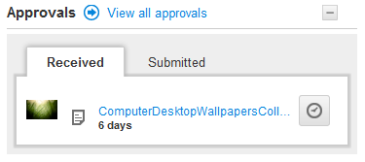 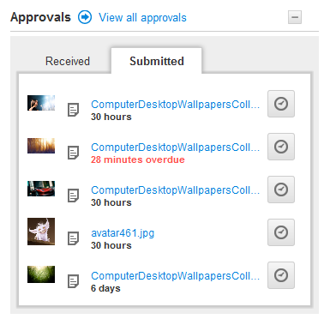

Figure 11 Dashboard > *Approvals* widget > *Received* and *Submitted* tabs

All Approvals placed on the tabs are clickable, so a user goes directly to respective Approval after clicking a file name. For details about Approval management see page 294.

If the widget is minimized, the *View files for Approval* link is shown on both widget tabs. The widget’s content will be shown by clicking this link (see Figure 12).

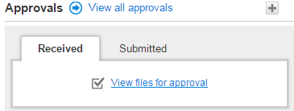 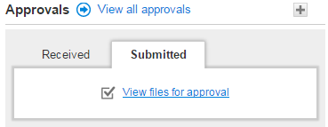

Figure 12 Dashboard > Minimized *Approvals* widget

If any tab has no content, the following notification is shown:

*‘You have no Approvals*.’

### *My Projects* widget

*My Projects* widget displays list of Projects where current user is a creator – in no particular order as it seems. Sorting does not work, and unnecessary column Job Number is hardcoded into the table (many BU’s have this field hidden so it really shouldn’t be hardcoded in the table). If you have created a project, and then was removed from this project, you will still see it in the widget, and after clicking on it, will get full access to a project – because you are a creator. By clicking the *View all projects* link a user goes to the list of Projects. Each Project entry has clickable *Job Number*, *Title* and *Last Activity* metadata. By clicking the *Job Number* or *Title* field user goes to the Project details page > *Overview* tab. By clicking the *Last Activity* field user goes to the Project details page > *Team* tab (see Figure 13).

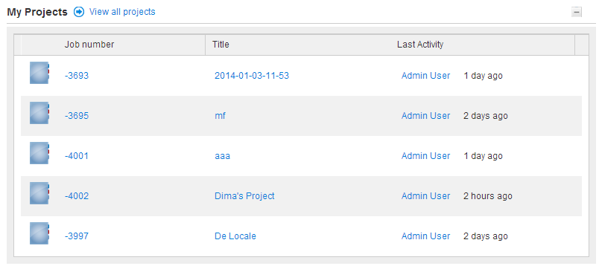

Figure 13 Dashboard *> My Projects* widget

If the widget is minimized, the *View your latest Projects* link is shown. By clicking it, the widget content will be shown if it is available (see Figure 14).

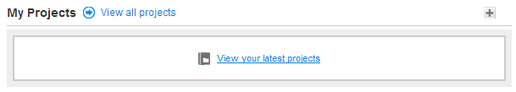

Figure 14 Dashboard > *My Projects* widget is minimized

**Note:** By default, the widget displays 5 projects (randomly selected, from the looks of it); sometimes when you click into the project from this widget, and then go back to Dashboard – it will show you the list of all projects that you have created. There was no clear requirement how this should behave, so the developer (who was working on it in isolation) used the best of his judgement to put something together.

### *Files in your projects* widget

*Files in you projects* widget has the *Latest files added* and *Latest added by you* tabs. Each tab has left-side and right-side arrow buttons to scroll through file previews.

The *Latest files added* tab displays files added to Projects which user has access to.

The *Latest added by you* tab displays files which were uploaded to Projects by the current user.

Users can open File details page by hover over the centre of file preview and click the *Open file* pop-up link. By hover over the  icon they can view additional file info.

**Note:** Unlike Projects and Library, where metadata fields displayed in thumbnails are defined in BU settings (Admin > Views), fields shown on the Dashboard are hardcoded.

If the widget is minimized, the *View latest files in your Projects* link is shown on both widget tabs. By clicking this link widget’s content will be shown (see Figure 15).

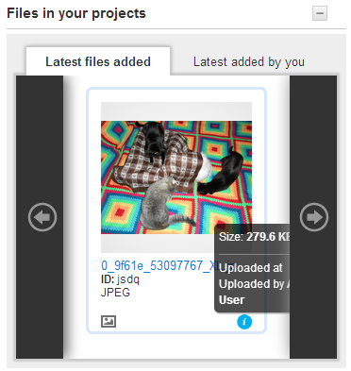 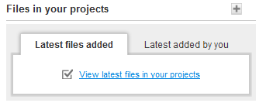

Figure 15 Dashboard > *Files in you projects* widget (maximized and minimized)

If the widget is empty, the notification is shown:

*‘You have no Project files*.’

### *Recent Activity* widget

*Recent Activity* widget displays list users’ activities across Projects and Library, e.g. activities about creating Projects, uploading files,linking/unlinking files/Assets, adding/deleting attachments to/from files/Assets, etc. By clicking the activity title a user goes directly to the activity details on the Project/Template/File/Asset/Presentation details page (see Figure 16).

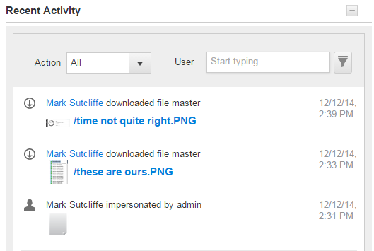

Figure 16 Dashboard > *Recent Activity* widget is maximized

If the widget is minimized, the *View your latest activity* link is shown. By clicking this link the widget content will be displayed (see Figure 17).

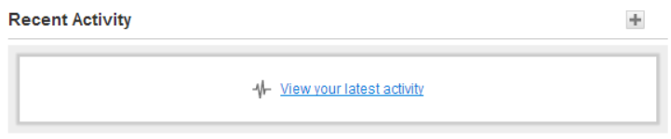

Figure 17 Dashboard > *Recent Activity* widget is minimized

User can use filters to show only activities of a certain type/action and/or certain user. See original spec for this functionality: <https://jira.adstream.com/browse/NGN-12480>; it hadn’t change since.

### *Presentations* widget

*Presentations* widget displays the list of 5 newest Presentations created by the current user, OR created by other users, IF current user has permissions presentations.read + presentations.write included in their global role. The widget will not show any presentations shared to the current user.

By clicking the Presentation title a user goes to appropriate Presentation details page.

Also, the widget has the *View all Presentations* link. By clicking it a user goes to the *Presentations* tab *> All Presentations* view*.*

If the widget is minimized, the *View your latest Presentations* link is shown. By clicking it the widget content will be displayed (see Figure 18).

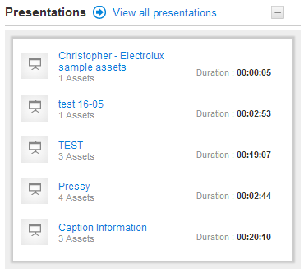 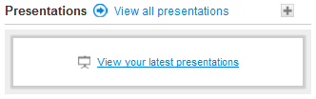

Figure 18 Dashboard > *Presentations* widget is maximized

### *Latest Library Uploads* widget

*Latest Library Uploads* widget displays list of latest files uploaded to Library by the current user. Widget has left-side and right-side arrow buttons to scroll through Assets’ previews.

This widget is NOT displayed if user does not have permission asset.create in their global role in Primary BU (=cannot upload anything to Library, so this makes sense). The part that does not make sense, is this: user can have access to multiple BU’s with various permissions, so while not being able to upload in their Primary BU, they still could have this permission in their Secondary BU, so the widget should be there in this case – but it isn’t. This is because the Dashboard was built way before Multi-BU functionality.

User can hover over the centre of Asset’s preview and click the *Open file* pop-up link to open the Asset details page. By hover over the  icon they can view some Asset Info. By clicking the *Explore your library* link the user goes to the *Library* tab *> My Assets* Collection.

If the widget is minimized, the *View latest files in your library* link is shown. By clicking it the widget content will be displayed (see Figure 19).

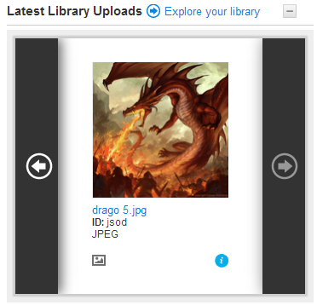 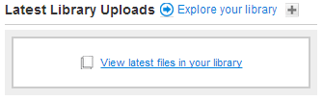

Figure 19 Dashboard > *Latest Library Uploads* widget is maximized

## Projects area

Projects area is used to manage Projects, Work Requests, Project Templates and Work Request Templates, files, folders and Approvals on files.

Technically, Project is a collection of folders, that is used to store various types of files. Users can have access to Projects and to folders with different permissions. Project permissions is one of the most important features of the system.

Work Request is a special type of a project. 99% of functionality is the same, but Work Requests have their own schema, so that you can set up different metadata for Project and for Work Requests. The idea was to separate out Work Requests as localization/adaptation projects, whilst using Projects for creative/production projects.

Templates are just that – a template structure of folders, with permissions already set up around this structure, which can be used to create projects, to eliminate the repeating job of building folder structure and permissions from scratch.

Different clients use Projects very differently. Major full cycle agencies like BBDO use Projects most closely to their intended purpose – store and approve files during various stages of campaign management, both for new jobs and adaptations. Here is a sample folder structure from BBDO, where each folder represents a typical stage in TV campaign development (creative+production):

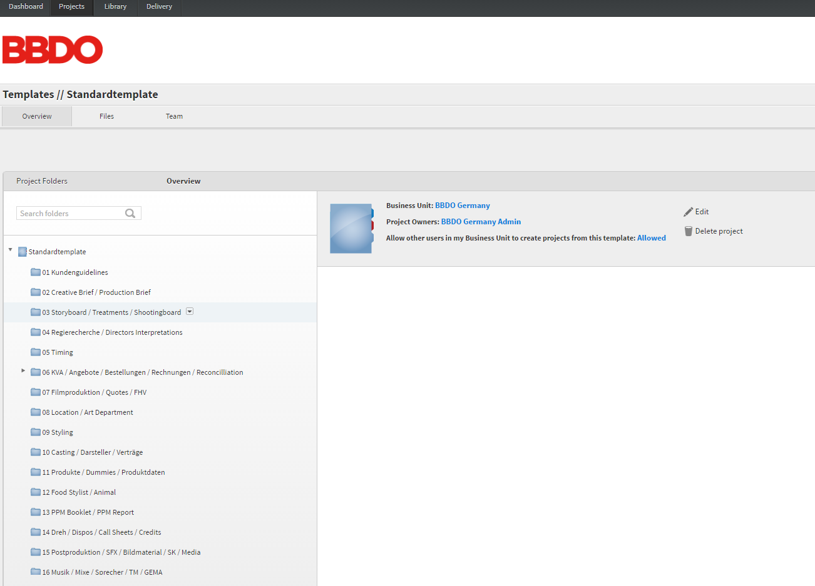

Figure 20 Typical BBDO project structure – “agency job bag”

In BBDO world, a typical project would have up to 50 folders. Users would have access always the whole project structure with the same level of permissions on all folders. There would be up to 100 users on each project.

Another example of project usage is Warner Bros. They use projects to share cinema trailers for adaptation around the world. Here is their typical template:

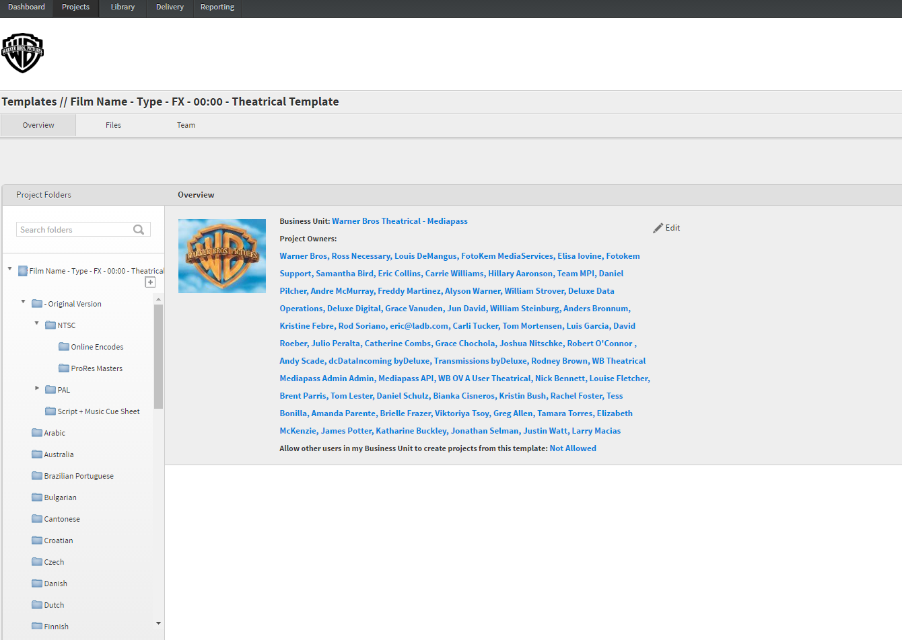

Figure 21 Typical Warner Bros Project Structure

While their folder structure is relatively simple, Warners projects can have 1000+ users accessing different folders within each project, with different permissions. In Warners world, it’s a common usage of the project to give user Read Only access on one folder, and then Download Only access to another folder in the same project (“Original Version” folder in the example above), and then Upload Only in yet another folder all within the same project (regional-specific folders in the example above).

There are many other clients using Projects area in different ways. It’s a very flexible functionality. Key thing to remember is: Projects allow you to create a folder structure reflecting your workflow, upload any content that you need, and then share it with different users, with different permission levels.

The Projects area is accessible by clicking the *Projects* menu-item in the Main menu (see Figure 88).

### *Projects* tab

*Projects* tab is used to:

* Search for Projects according to your permissions, and view their metadata.
* Filter Projects by their metadata, Media types, Business Units, *All Projects/My Projects* group, *Published/Unpublished* status.
* Open Project details.
* Create and delete Projects, provided you have relevant permissions

The tab is accessible by clicking the *Projects* menu-item in the Main menu (see Figure 22).

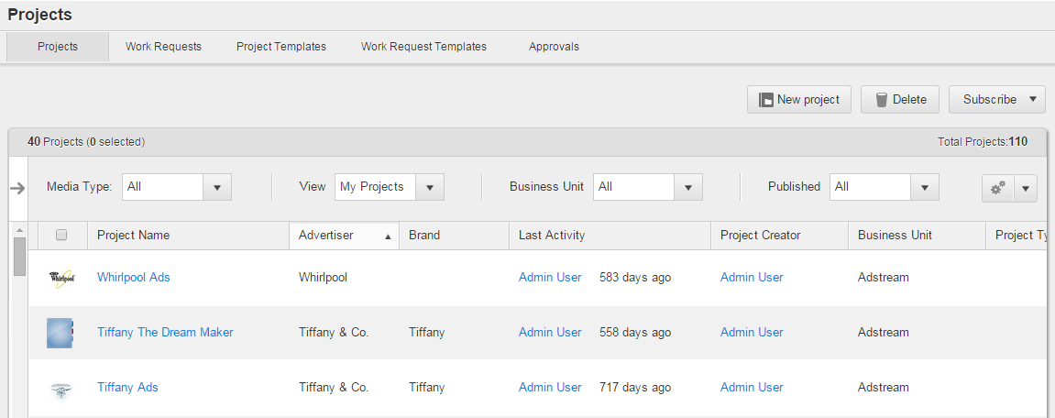

Figure 22 *Projects* tab with additional metadata filters collapsed

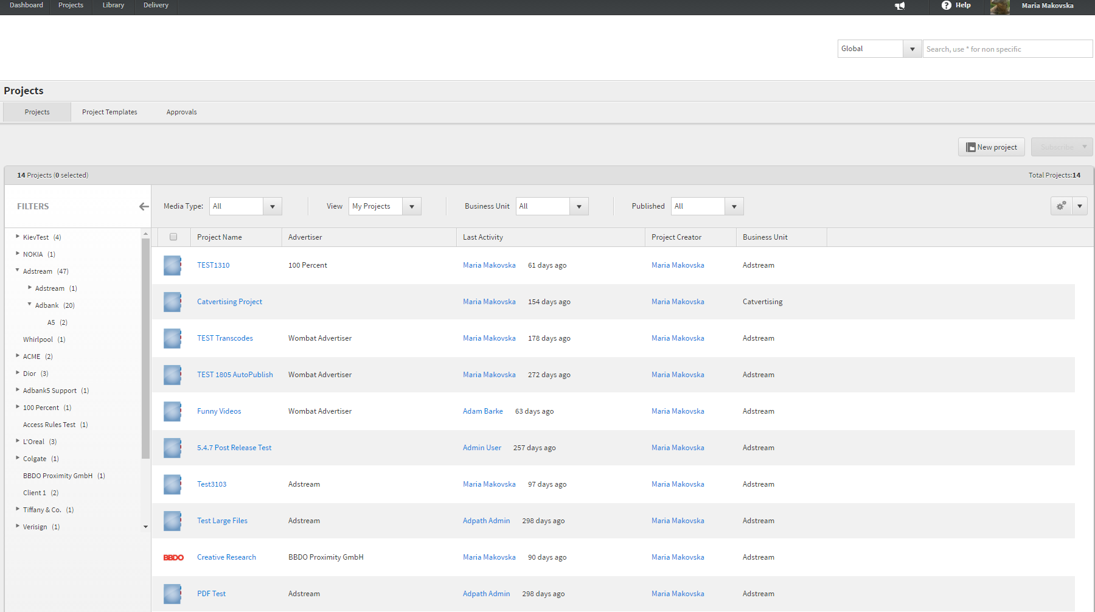

Figure 23 Projects tab with additional metadata filters enabled

*Projects* tab details are described in Table 1.

Table 1 *Projects* tab details

| Field | Description |
| --- | --- |
| List of Projects | Is used to display Projects metadata and get quick access to Project details page (by clicking theProject title). The metadata can be sorted by ascending and descending. |
| Additional metadata filters | Can be enabled per BU and are off by default. See more in Jira: <https://jira.adstream.com/browse/NGN-11494>, <https://jira.adstream.com/browse/NGN-11488>  Additional metadata filters only work properly on the Projects list. On the Work Requests list, this control is displayed, but does not work (known issue, low priority to fix). On the Project Templates / Work Request Templates list, this control is not displayed (this is by design). |
| *New Project* button | Is used to initiate creating a new Project from scratch. For details see page 167. Visibility of this button depends on the project.create permission in user’s global role, in at least one BU. |
| *Delete* button | Is used to initiate Project deletion from the Projects list. For details see page 182.  In the project list, this button will only be rendered for BU Admin users, as only agency.admin role has project.delete permission enabled (this permission is not even available to include in any other roles, as it’s a bit dangerous). See original spec in https://jira.adstream.com/browse/NGN-1877  Note: User can have access to projects from multiple business units. And, user can have different roles in these business units. If user is agency.admin in one BU, and select a project created in another BU where they are not admin, and click Delete button – they will get permissions error, which is correct. |
| Projects counter | Is used to display number of Projects per page and number of Projects selected among them, e.g. |
| Total number of Projects | Is used to display total number of Projects on the *Projects* tab, e.g. |
| *Media Type* dropdown list filter | Is used to filter Projects list by the Media Type selected from the dropdown list.  Media Types can be default or custom. Default Media Types are: *Broadcast, Cross Media*, *Digital, Print* and *Other*.Custom Media Types can be added or deleted by Business Unit Admin on the Admin area > *Metadata* tab > *Project* metadata schema.  If the *All* filter is enabled, Projects of all Media Types are displayed in the list. |
| *View* dropdown list filter | Is used to filter Projects list by *All Projects* or *My Projects* groups.  If the *All Projects* filter is enabled, all Projects are displayed on the tab. If the *My Projects* filter is enabled, only the Projects where current user is Project Owner and Project Creator are displayed. |
|  | Is used to select all Projects in the list. |
| (Metadata dropdown list filter) | Is used to select what metadata fields should be displayed or hidden in the Projects list. Metadata can be displayed by clicking respective checkboxes next to them.  To restore the default metadata set in the Projects list a user should click the *Restore to Default* link under the Metadata dropdown list filter.  Default set of metadata fields to be displayed in a new BU is hardcoded and not configurable. |
| *Business Unit* dropdown list filter | Is used to filter Projects list by Business Unit. User can have access to projects created in different business units. This filter will list all business units where user has any level of access (not necessairly with some projects available). |
| *Published* dropdown list filter | Is used to filter Projects list by current project status (*Published*, *Unpublished*, or both of them). |
| *Subscribe* dropdown list | Is used to subscribe to single or multiple Projects to receive email notifications about different activities related to Projects, folders and files. |

### *Work Requests* tab

*Work Requests* tab is used to:

* Search for Work Requests according to permissions, and view their metadata.
* Filter Work Requests by their metadata, Media types, Business Units, *All Work Requests/My Work Requests* group, *Published/Unpublished* status.
* Open Work Requests details.
* Initiate creating and deleting Work Requests (permissions: adkit.create and adkit.delete; Adkits was initial name for Work Requests, that was changed to Work Requests just before release, so developers didn’t have time to update all the corresponding functionality naming in the back end).

The tab is accessible by clicking the *Projects* menu-item in the Main menu and then clicking the *Work Requests* menu item in the Projects area (see Figure 24).

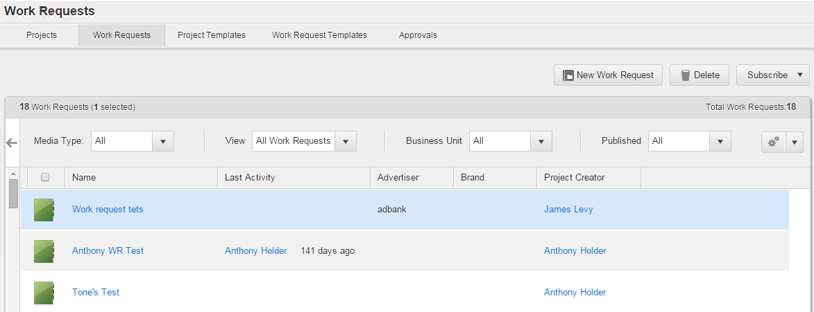

Figure 24 *Work Requests* tab

**Note**: *Work Requests* tab details are similar to the *Projects* tab details. For the details please refer to the Table 1.

**Note:** Additional metadata filters are rendered on the Work Request page, but don’t work there. This is because additional metadata filters were built for one specific client that does not use Work Requests. Eventually other clients started to use metadata filters on projects, but obviously none of these clients use Work Requests, too. In the new UI, this control should be consolidated with hardcoded filters (above the project list), and column filters, into one advanced search control for Projects, Work Requests and Templates.

### *Project Templates* tab

*Project Templates* tab is used to:

* Search for Project Templates and view their metadata. User can see a Template in 3 cases: 1) they are Template creator, or 2) they have permission project_template.read included in their global role, or 3) they have a flag View Public Templates in their profile, AND the template is set to Public.
* Filter Project Templates by their metadata, Media types, Business Units, *All Project Templates/My Project* *Templates* group.
* Open Project Template details page. User can edit a Template in 2 cases: 1) they are Template creator, or 2) they have permission project_template.write included in their global role
* Initiate creating and deleting Project Templates (permissions: project_template.create and project_template.delete, correspondingly)
* Initiate creating Projects from Project Templates (at least Read access to the template AND project.create permission)

The tab is accessible by clicking the *Projects* menu-item in the Main menu and then clicking the *Project* *Templates* menu item in the Projects area (see Figure 25).

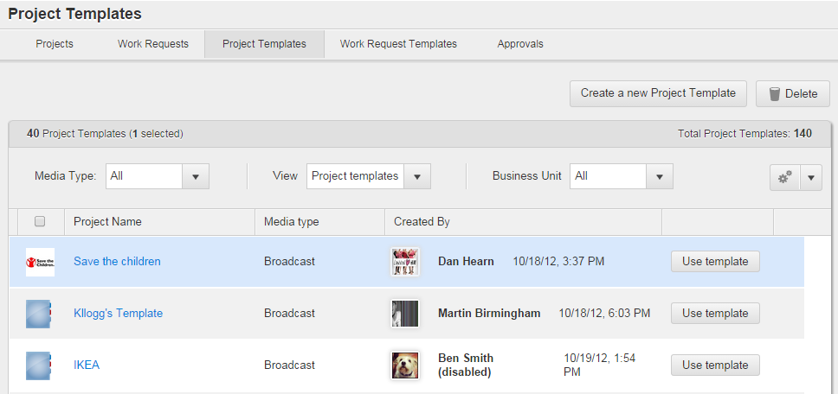

Figure 25 *Project Templates* tab

*Project Templates* tab details are described in Table 2.

Table 2 *Project* *Templates* tab details

| Field | Description |
| --- | --- |
| List of Project Templates | Is used to display Project Templates metadata and get quick access to Project Template’s details page (by clicking theProject Template title). The metadata can be sorted by ascending and descending. |
| *Create a new Project Template* button | Is used to initiate creating a new Project Template. |
| *Delete* button | Is used to delete an existing Template selected in the Templates list. In the Project Templates list, this button will only be rendered for BU Admin users, as only agency.admin role has project_template.delete permission enabled (this permission is not even available to include in any other roles). |
| *Use template* button | Is used to initiate creating a new Project from Project Template. For details see page 171. |
| Project Templates counter | Is used to display number of Project Templates per page and number of Project Templates selected among them. |
| Total number of Project Templates | Is used to display total number of Project Templates on the *Project Templates* tab. |

**Note**: All othertab details are similar to the details described at the Table 1.

### *Work Request Templates* tab

*Work Requests* *Templates* tab is used to:

* Search for Work Request Templates and view their metadata. User can see a Template in 3 cases: 1) they are Template creator, or 2) they have permission project_template.read included in their global role, or 3) they have a flag View Public Templates in their profile, AND the template is set to Public.
* Filter Work Request Templates by their metadata, Media types, Business Units, *All Work Request Templates/My Work Request Templates* group.
* Open Work Request templates details.
* Initiate creating and deleting Work Requests.

The tab is accessible by clicking the *Projects* menu-item in the Main menu and then clicking the *Work Requests* *Templates* menu-item in the Projects area (see Figure 24).

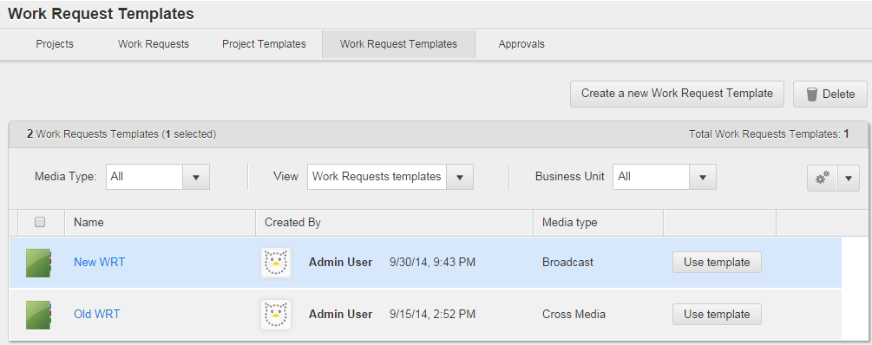

Figure 26 *Work Request* *Templates* tab

**Note**: *Work Request Templates* tab details are similar to the *Project Templates* tab details. For the details please refer to the Table 2.

### *Approvals* tab

*Approvals* tab is used to:

* Approve/reject files received and submitted for approval (also, files where approval process is not started).
* Open File details page > *Approval* tab for file.
* Filter and sort files.

*Approvals* tab contains received, submitted and not started Approvals within all Projects which a user has access to. The tab is accessible by clicking the *Projects* menu-item and then clicking the *Approvals* caption.

When a user is on the *Approvals* tab > *Received* sub-tab, they can view, filter, approve, reject and open the details of files received for approval. Also, the user can view their own responses on files (under the *My Response* column) and details of current Approval Stage (under the *Approval Stage* column). All completed Approvals can be shown or hidden via the *Include completed approvals* checkbox (see Figure 27).

**Note:** Column My Response can be blank if user has not been added to the latest stage of the approval. Request to improve this: <https://jira.adstream.com/browse/FAB-54>

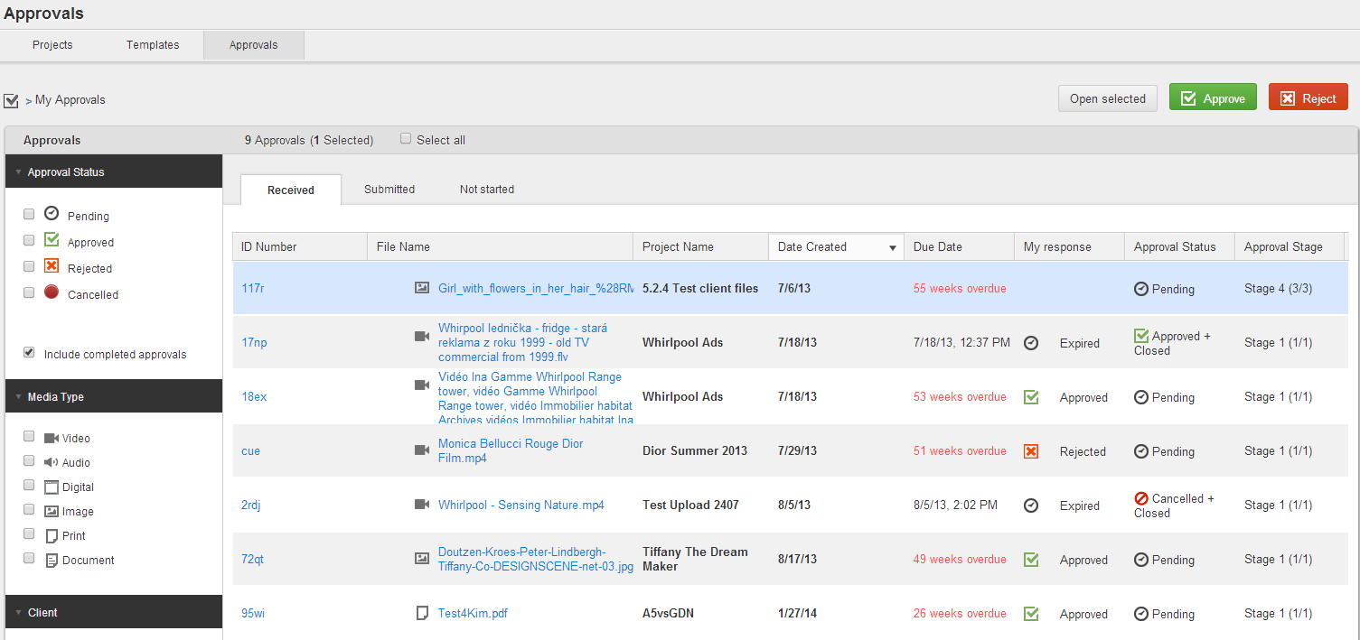

Figure 27 *Approvals* tab > *Received* sub-tab

When a user is on the *Approvals* tab > *Submitted* sub-tab, they can manage files submitted for approval (see Figure 28).

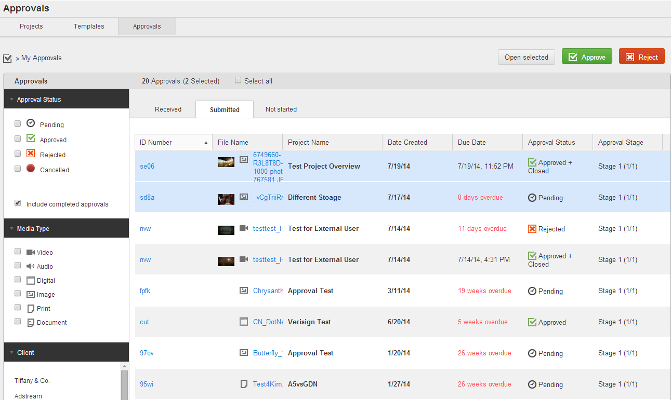

Figure 28 *Approvals* tab > *Submitted* sub-tab

When a user is on the *Approvals* tab > *Not started* sub-tab, they can manage Approvals on files which were created but not started (see Figure 29).

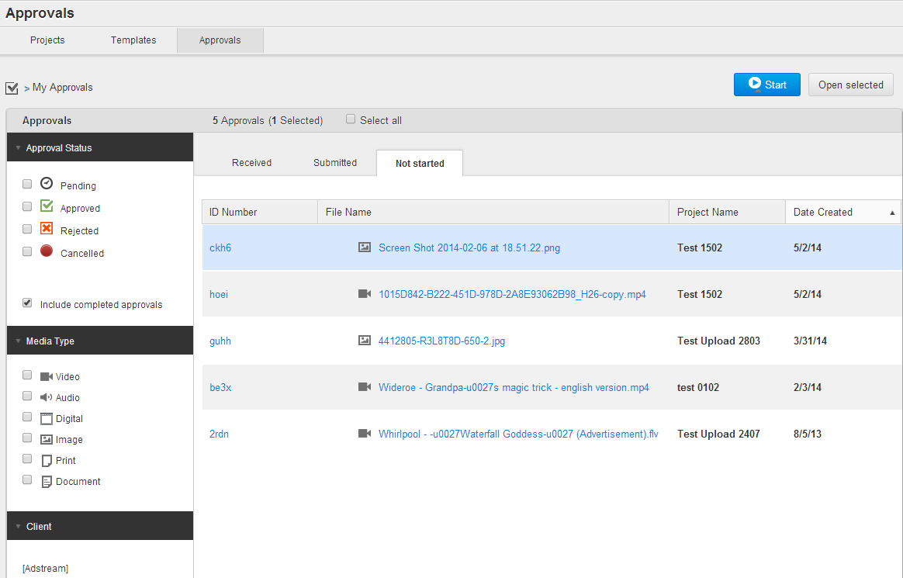

Figure 29 *Approvals* tab > *Not started* sub-tab

It is possible to filter list of Approvals on each sub-tab via special filters on the left side of the tab. These filters are:

* *Approval Status.*
* *Media Type.*
* *Client.*
* *Data Range*.

*Approvals* tab details are described in Table 3.

Table 3 *Approvals* tab details

| Field | Description |
| --- | --- |
| *Approval Stage* column | Is used to indicate:   * Title of current Approval Stage. * Ordinal number of current Stage (first number in brackets). * Total number of Stages within an Approval (second number in brackets). |
| *Approval Status* filters | Is used to filter list of Approvals by possible Approval statuses via the *Pending, Approved, Rejected* and *Cancelled* checkboxes*.* It is possible to select more than one filter at once. |
| *Media Type* filters | Is used to filter list of Approvals by file’s Media Type via the *Video, Radio, Digital, Image, Document* and *Print* checkboxes*.* It is possible to select more than one filter at once. |
| *Client* filter | Is used to filter list of Approvals by Advertisers (Clients) as per Projects where Approvals came from. It is possible to select more than one filter at once.  For example, if several files from different Projects were sent for approval to a particular Business Unit user, and these Projects have *Adstream*, *Nokia* and *Acer* Advertisers, this user can view *Client* filter pane populated by the *Adstream*, *Nokia* and *Acer* Clients on the *Approvals* tab > *Received* sub-tab. The list does not show any values that do not have Approvals associated with them. |
| *Data Range* filter | Is used to filter list of Approvals by date range:   * *Sent Date* *From.* * *Sent Date* *To.* * *Due Date* *From.* * *Due Date* *To*.   For example, if a user ticks the *Sent Date* radio button and then selects *26/06/2013* value from the *To* Calendar field, they can see all Approvals which have been created before 26.06.2013. |
| *Select all* checkbox | Is used to single-click all Approvals in the Approvals list. |
| *Approve* button | Is used to approve a file selected in the Approval list. It is possible to approve more than one file at once. |
| *Reject* button | Is used to reject a file selected in the Approval list. It is possible to reject more than one file at once. |
| *Open selected* button | Is used to open an Approval details on the File details page > *Approvals* tab. It is possible to open more than one Approval details at once. |

List of Approvals on files can be sorted per metadata on each sub-tab. Sorting order of Approvals on the *Approvals* tab > *Received/Submitted/Not started* sub-tabs is kept in the position selected by a user while they navigate through the *Adbank 5*. It remains even after the user made re-authorization.

For details about Approvals management please refer to the page 294.

### Project/Work Request details page

Project/Work Request details page consists of the *Overview, Files, Team* and *Approvals* tabs. To open the Project details page it is necessary to click a Project title on the *Projects* tab. To open the Work Request details page it is necessary to click a Work Request title on the *Work Requests* tab. Also, corresponding page opens automatically just after Project/Work Request is created.

Project/Work Request Name is displayed in the top left of the Project/Work Request details page. The name of the business unit where project belongs is displayed next to the project name in brackets:

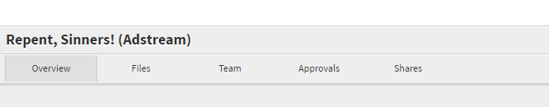

Figure 30 Project Header Area

BU defines project metadata schema and roles available when sharing folders from this project.

#### *Overview* tab

Project/Work Request details page > *Overview* tab is used to:

* Manage Project metadata and folders.
* View list of files and activity records within Project.
* View and print Term & Conditions on Project.
* Initiate Project Template creation on Project.
* Delete a Project and its folders.
* Publish/unpublish a Project, or set a future publication date.

Project/Work Request details page > *Overview* tab is displayed to users who have permission project_settings.read in their current Project role, or their Global role.

To open the tab a user should click the Project/Work Request title on the *Projects*/*Work Requests* tab (see Figure 31).

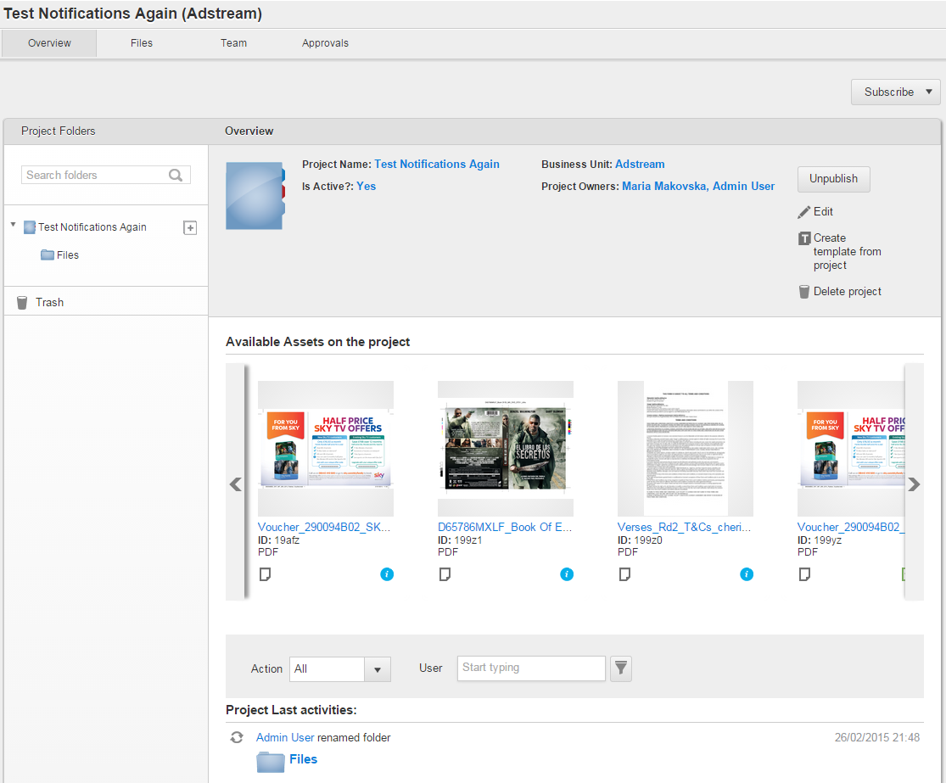

Figure 31 Project/Work Request details page > *Overview* tab – Published project

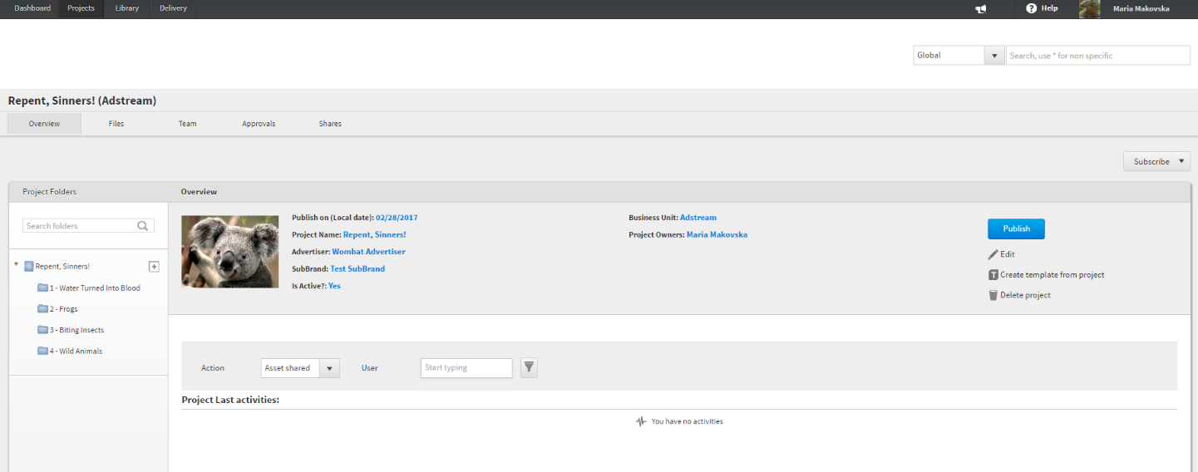

Figure 32 Project/Work Request details page > *Overview* tab – Unpublished project with automatic publication date set in the future

Project/Work Request details page > *Overview* tab details are described in Table 4.

Table 4 Project/Work Request details page > *Overview* tab details

| Field | Description |
| --- | --- |
| Project's folder tree | Is used to navigate on Project folders. |
| Search box | Is used to search folders in Project's folder tree. This search works only in “starts with” mode, and treats the whole folder name as a single word (does not observe spaces between words). A bit awkward and ideally should be improved. |
| *Trash* | Is used to display deleted Project files. Is only visible to agency.admin users |
| *Overview* section | Is used to view Project metadata. Note that project metadata is custom per BU, so different fields will be displayed for projects created in different BU’s. Fields that are not populated, are not displayed in read view.  Additionally, the *Overview* section contains such controls:   * *Edit* – edit Project metadata, add/remove project owners. Visible to a user with permission project.write in either current Project role, or a Global role. This includes system role Project Creator. If user created a project, and then was removed from it – they could still see the project (oops) and can see this Edit link, which allows them to add themselves back as project.admin * *Create template from Project* – is used to initiate Project Template creation on Project. Is displayed only for user with the project.admin role, as per original spec <https://jira.adstream.com/browse/NGN-37>. There is a defect: if user has permission to create project in a secondary BU, the *Create Template from Project* button is not displayed for them, even though they are project creators and have role project.admin. Also, the original spec does not take into account a case when user with project.admin role does not have permission project_template.create, and as such will see an error when trying to create a template. But this is a rare case, never reported from production so probably not worth fixing. * *Delete Project* – is used to delete a Project. Available to user with a project.admin role in the current role, and user with agency.admin Global role. Original spec: https://jira.adstream.com/browse/NGN-1877 * *Term & Conditions –* is used to view and print Project’s Term & Conditions (if enabled for Projects in BU settings) * *Publish/Unpublish* – is used to publish unpublished Project (if *Publish* control is enabled) or unpublish published Project (if *Unpublish* control is enabled). |
| *Available Assets on the project* section | Is used to preview file thumbnails in all Project folders. Thumbnailscan be scrolled to the left or to the right via special arrow-buttons. Main file metadata are displayed on each thumbnail (in this control, metadata is hardcoded and not configurable) User can go directly to the File detail page by mouseover and clicking the *Open file* pop-up control on the centre of thumbnail.  In the *Available Assets* section, user will only see files from folders where they have element.read access. See implementation details in <https://jira.adstream.com/browse/NGN-4761>  When file is moved from the project or deleted, a thumbnail will disappear from the carousel. If you navigate to the Overview tab immediately after deleting or moving file, you might still see it in the carousel, but it will disappear after page refresh. Same for copying file into the project – it will appear in the carousel eventually, but you might need page refresh to see it. |
| *Project last Activities* section | Is used to view activity records on Projects. Each activity has such details: file/folder title and icon, username, timestamp.  User will only see activities from folders where they have access. See implementation details in <https://jira.adstream.com/browse/NGN-4761>  User can filter activities by Type and by User. See details in https://jira.adstream.com/browse/NGN-12943 |
| *Subscribe* dropdown list | Is used to subscribe to current Project to receive email notifications about different activities related to it, its folders and files. For details, see https://jira.adstream.com/browse/NGN-13215 |

On the Project/Work request details page > *Overview* tab, Project users can view only activities related to the folders where they have access. Also, they can view recently added files which have been uploaded to the folders to which they have access. Once folder has been shared to the user, they can see all history of activity in that folder. Once folder has been unshared to the user, they lose visibility of any activity from that folder.

User with global role agency.admin in a BU, can view all Project activities on the Projects created in the same BU

#### *Files* tab

Project/Work Request details page *> Files* tab is used to manage files and folders of a Project/Work Request.

Project/Work Request details page *> Files* tab is visible to a user with folder.read permission in the current project’s role, or in the Global role. If project contains multiple foldes, user will only see those folders where they have folder.read permission.

To open the *Files* tab:

1. Click the Project/Work Request title on the *Projects/Work Requests* tab.
2. Click the *Files* caption on the Project/Work Request details page (see Figure 33).

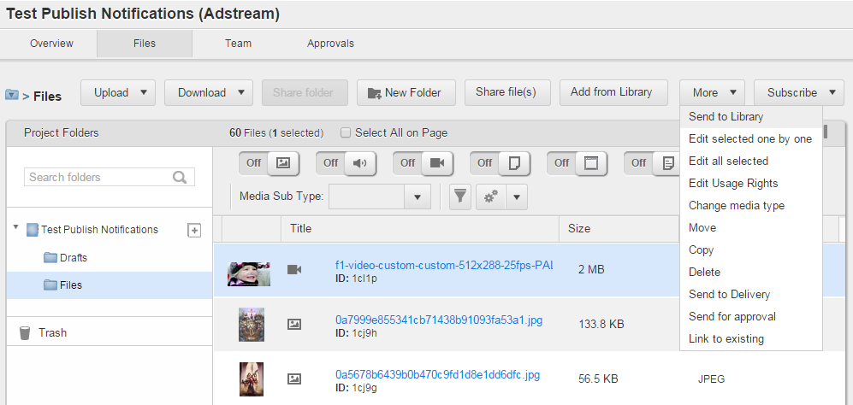

Figure 33 Project/Work Request details page > *Files* tab

Project folders tree is hierarchically organized. Parent folder can include sub-folders and files. In the Folder Tree panel, only folders are displayed (not files).

In the Folder Tree panel, folders are always displayed in alphabetical order, and there is no way to sort them otherwise in this view.

Folder names can contain special symbols.

Folder name is unique on the same level of folder hierarchy. When you create a folder with a name which already exists on this level, you will see an error. However, if you move, copy, or restore folder from trash – this validation does not happen, so you may end up with 2 or more folders of the same name on the same level. This is not right and ideally should be fixed by appending duplicating folder name with an (increment) (same as OS Windows does).

In the right-hand area, sub-folders as well as files within parent folders can be sorted by title (*A* to *Z* or *Z* to *A*), size (ascending or descending) or newest first. Filtering by Media Type (and sub-type) is available only for files. All sub-folders become invisible while files are filtered.

Project/Work Request details page > *Files* tab fields are described in Table 5.

Table 5 Project/Work Request details page > *Files* tab details

| Field | Description |
| --- | --- |
| Folder tree | Is used to navigate on Project folders and files. |
| Search box | Is used to search folders in Project's folder tree. This search works only in “starts with” mode, and treats the whole folder name as a single word (does not observe spaces between words). A bit awkward and ideally should be improved. |
| Media Type filters | Is used to filter Project files by such default Media Types: *Video, Audio, Documents, Images, Print*, *Digital* and *Other*.  Each filter can be either enabled (set in *On* mode) or disabled (set in *Off* mode). If filter is enabled, its label is highlighted blue and the *On* mark is displayed next to it. If filter is disabled, its label is shaded and the *Off* mark is displayed next to it. By default, all filters are disabled, so all files uploaded to a Project folder are visible. It is possible to set *On* or *Off* mode for several filters at the same time.  **Note:** media type is defined on file upload based on MIME type which is returned for this file by exiftool. Mapping between A5 types and MIME types is stored in mongo, collection “mediatypes”, and can be updated on the fly, if needed. |
| filter mode | Is used to enable *Image* Media Type filter. |
| filter mode | Is used to disable *Image* Media Type filter. |
| filter mode | Is used to enable *Audio* Media Type filter. |
| filter mode | Is used to disable *Audio* Media Type filter. |
| filter mode | Is used to enable *Video* Media Type filter. |
| filter mode | Is used to disable *Video* Media Type filter. |
| filter mode | Is used to enable *Print* Media Type filter. |
| filter mode | Is used to disable *Print* Media Type filter. |
| filter mode | Is used to enable *Digital* Media Type filter. |
| filter mode | Is used to disable *Digital* Media Type filter. |
| filter mode | Is used to enable *Document* Media Type filter. |
| filter mode | Is used to disable *Document* Media Type filter. |
| filter mode | Is used to enable *Other* Media Type filter. |
| filter mode | Is used to disable *Other* Media Type filter. |
| *Media Sub Type* dropdown list | Is used to filter files by Media Sub-Type according to selected Media Type. When more than one Media Type filter is enabled or all of them are set in *Off* mode, the dropdown list is unavailable.  **Note:** list of media sub-types is configurable per BU, in BU Admin > Metadata tab. |
| *Sort by* dropdown list | Is used to sort Project files and folders by such options:   * Title (*A* to *Z* / *Z* to *A*). * Size (Ascending / Descending). * *Most Recently Uploaded First /Most Recently Modified First*. * *Most Recently Uploaded Last / Most Recently Modified Last*. |
| *Upload* button | Is used to upload Project file(s) to folders via *Web Uploader* or *SendPlus*. Is visible only to users with permission element.create in the current folder, or in Global role.  For details see page 213. |
| *Download* button | Is used to download Project file(s) from folders. The button is active if at least one file is highlighted. Is visible only to users with permission proxy.download and/or file.download in the current folder, or in a Global role.  For details see page 220. |
| *Share file(s)* button | Is used to share Project file(s) with users. This control becomes active only if at least one file is highlighted. Is visible only to users with element.share permission in the current folder, or in a Global role.  For details see page 204. |
| *Share folder* button | Is used to share Project folder(s) with users. This control becomes active only if at least one folder is selected in the right hand area (not in the folder tree!). Is visible only to users with element.share permission in the current folder, or in a Global role.  For details see page 204. |
| *New Folder* button | Is used to create a new Project folder within current one. Is visible to users with folder.create permission in the currently selected parent folder, or in the Global role.  For details see page 202. |
| *More > Send to Library* button | Is used to copy selected files to the *Library*. Is visible to users with permission element.send_to_library in the current folder, or in the Global role. For details see page 265 |
| *More > Move* button | Is used to move selected files OR folders to another folder or Project.  Is visible to users with permission element.move / folder.move in the current folder, or in the Global role.  For details see page 208 and 262. |
| *More > Copy* button | Is used to copy selected files OR folders to another folder or Project.  Is visible to users with permission element.copy / folder.copy in the current folder, or in the Global role.  For details see page 208 and 262. |
| *More > Delete* button | Is used to delete selected files or folders.  Is visible to users with permission element.delete / folder.delete in the current folder, or in the Global role.  For details see page 267. |
| *More > Send for approval* button | Is used to create a new single or tiered Approval for selected files or use one of pre-defined Approval templates.  Is visible to users with approval.create permission in the selected folder.  For details see page 294. |
| *More > Send to Delivery* button | Is used to send Project files to the Delivery.  Is active only for Video files AND only for users with tv_order.create permission in the Global role of the business unit where this Project belongs.  After a file was sent to the Delivery and the Order based on this file was placed, link to the original Project for the QC-ed Asset master is displayed on the Asset details page > *Related Projects* tab.  For more information about the wonderful world of TV Delivery (aka Ordering), see DELIVERY AREA.  Eventually should become available for Audio files as well https://jira.adstream.com/browse/NGN-16897 |
| *More > Edit selected one by one* button | Is used to edit metadata of multiple files one-by-one.  Is visible for users with permission element.write in the current folder, or in the Global role.  For details see page 257. |
| *More > Edit all selected* button | Is used to edit metadata of multiple files in batch. The files can be of different media types.  For details see page 255. |
| *More > Edit Usage Rights* button | Is used to edit Usage Rights on single or multiple files. The files can be of different media types.  For details see page 259. |
| *More > Change media type* button | Is used to redefine Media Types for single or multiple files. The files can be of different media types. Media Type’s redefining updates metadata of selected file(s) according to new Media Type’s schema. So, any media-specific metadata are lost, while any common metadata are kept.  For details see page 284. |
| *More > Link to existing* button | Is used to link single or multiple files between each other and set relation type for the linking.  For details see page 237. |
| *Subscribe* dropdown list | Is used to subscribe to current Project to receive email notifications about different activities related to it, its folders and files.  For details see page 186. |
| *Select All on Page* checkbox | Is used to highlight all files and subfolders in current folder. |
|  | Is used to display number of files highlighted in selected folder. |

#### *Team* tab

Project/Work Request details page > *Team* tab is used to manage users’ access to folders and files, and to view users’ activities on the Project/Work Request.

To open the tab a user should: click the Project/Work Request title on the *Projects/Work Requests* tab and then click the *Team* caption on the Project/Work Request details page (see Figure 34).

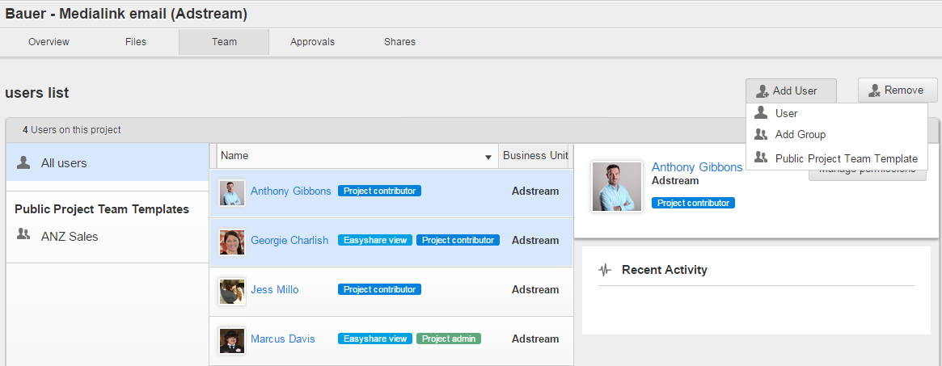

Figure 34 Project details page > *Team* tab > No user details are selected

Originally, the intention was to make this tab available to users with project_team.read permission (who might not be full project admin). This still works, adding this permission to user’s project role gives them visibility of the Team tab – but in the same time it automatically gives them visibility of all folders in the Project (which is logical, as they’ll see them on Team tab anyway) – and all files, as well (which is less logical). Not sure there is a valid business case for such role, too. For simplicity, lets agree that this tab is only available to users with project.admin role.

Project/Work Request details page > *Team* tab fields are described in the Table 6.

Table 6 Project details page > *Team* tab details

| Field | Description |
| --- | --- |
| Users’ filters | Is used to filter Project users by Public Project Team Templates where they were added. Username, Project role and Business Unit is displayed for each filtered user. |
| Users’ list | Is used to view list of filtered users and to display main user details and activities. |
| *Manage permissions* button | Is used to manage user permissions per Project folders. By clicking the button the Window for managing permissions is opened. |
| *Recent Activity* section | Is used to view last user activities for a Project. Each activity record has such details: filename, username, committed action and timestamp. |
| *Add user* > *User* button | Is used to add user to a Project. By clicking this button, the Window for adding users to Project is opened. There it is possible to type in username (registered/unregistered), select necessary folders, assign appropriate role and select expiry date. |
| *Add user* > *Add* *Group* button | Is used to add users from your private Address Book Group to a Project. By clicking this button, the *Add Group* pop-up window is opened where it is possible to assign separate roles to Project folders, including expiration dates per each assigned role. |
| *Add user* > *Public Project Team Template* button | Is used to add users from the BU Public Project Team Template to a Project. By clicking this button, the *Add* *Public Project Team Template* pop-upwindow is opened where it is possible to assign appropriate Public Template to selected Project folders. |
| *Remove* button | Is used to remove selected user from a Project Team. Removing stops users' access to all Project folders. Users who were removed do not have any access to the Project any more.  Project Owner can delete several Project Team members at once by highlighting them on the Project details page > *Team* tab and clicking the *Remove* button |

For more information about managing user’s access to Project, see page 189.

#### *Approvals* tab

Project/Work Request details page *> Approvals* tab is used to manage Approvals on files within current Project/Work Request. To open the tab a user should:

1. Click the Project/Work Request title on the *Projects/Work Requests* tab.
2. Click the *Approvals* caption on the Project/Work Request details page.

On this tab Project//Work Request Owner can view and manage own Approvals across the Project/Work Request, as well as Approvals created by any users on that Project/Work Request. To display all Approvals on the Project/Work Request, they should tick the *All users Approvals* checkbox. By default, it is unticked (see Figure 35).

User who is not project.admin, can still see this tab, but will not be able to see approvals created by/sent to other users (will not see the *All users Approvals* checkbox). This is regardless of their Global role – so even agency.admin will not see the *All users Approvals* checkbox on the Project > Approvals tab, if they are not added to this project as project.admin.

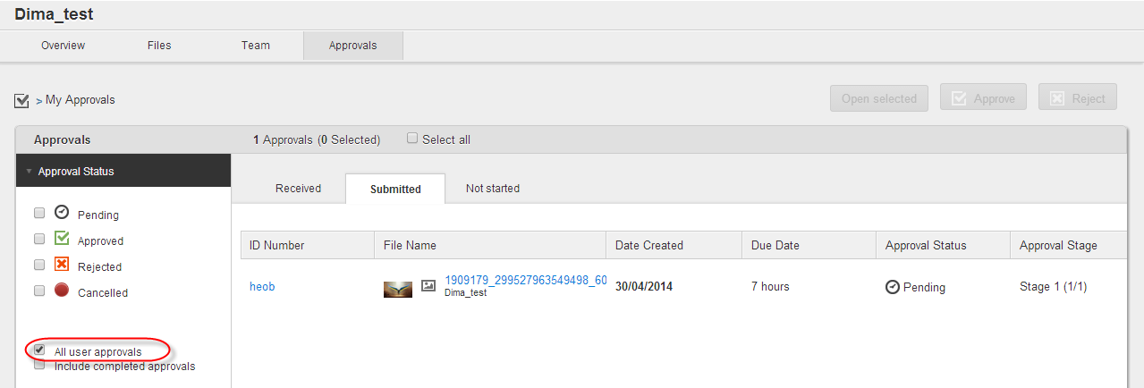

Figure 35 Project/Work Request details page > *Approvals* tab > *All user Approvals* checkbox

#### *Shares* tab

Project/Work Request details page *> Shares* tab is used to:

* View list of files shared from current Project/Work Request.
* Edit expiry dates for files publicly shared from current Project/Work Request.
* Activate/deactivate share for files publicly and securely shared from current Project/Work Request.

Project Owners can manage all shared files from their Project, while other Project users can manage only those files which were individually shared by them.

To open the tab, a user should click the *Shares* caption on the Project/Work Request details page (see Figure 36).

To edit expiry date for a publicly shared file it is necessary to click the  control next to appropriate filename on the *Expire date* column and select the date from the pop-up calendar on the *Shares* tab.

To deactivate Public share for a shared file it is necessary to click the *Deactivate* button next to appropriate filename on the *Action* column of the *Shares* tab. Also, this file can be quickly shared publicly again by clicking the *Activate* button which appears instead of the *Deactivate* one.

To deactivate Secure share for a shared file it is necessary to click the *Delete* button next to appropriate filename on the *Action* column of the *Shares* tab.

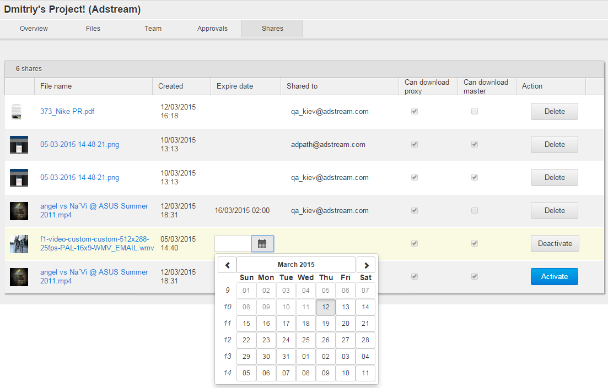

Figure 36 Project details page > *Shares* tab

### Project Template/Work Request Template details page

Project Template and Work Request Template details page consists of such tabs:

* *Overview.*
* *Files.*
* *Team.*

To open the Project Template details page, click a Project Template title on the *Project Templates* tab.

To open the Work Request Template details page, click a Work Request Template title on the *Work Request Templates* tab.

Also, corresponding page opens automatically just after a Project/Work Request Template was created.

#### *Overview* tab

Project Template/Work Request Template details page *> Overview* tab is used to:

* Manage Template metadata and folders.
* View list of files within all Template folders.
* Delete a Template or its folders.

To open the tab a user should click the Project Template/Work Request Template title on the *Project Templates*/*Work Request* Templates tab (see Figure 37).

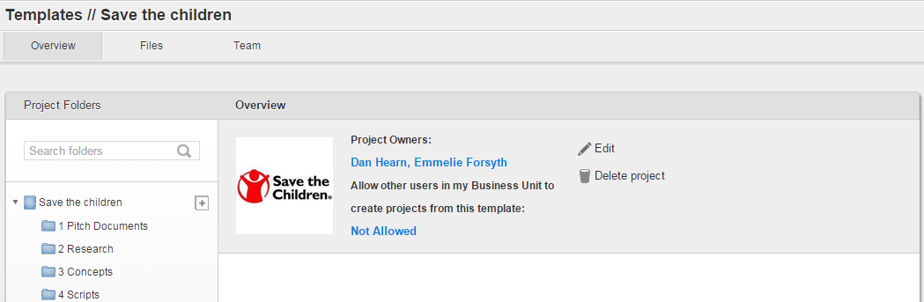

Figure 37 Project Template/Work Request Template details page > *Overview* tab

Project Template/Work Request Template details page *> Overview* tab is similar to the Project/Work Request details page *> Overview* tab. For details please refer to the Table 4.

Main difference is the Publish/Unpublish option. Templates do not need to be published or unpublished, as they do not contain any sensitive material, and are just used to save reusable folder structure and team.

#### *Files* tab

Project Template/Work Request Template details page *> Files* tab is used to manage files and folders of a Project Template/Work Request Template.

To open the tab a user should:

1. Click the Project Template/Work Request Template title on the *Project Templates/Work Request Templates* tab.
2. Click the *Files* caption on the Project Template/Work Request Template details page (see Figure 38).

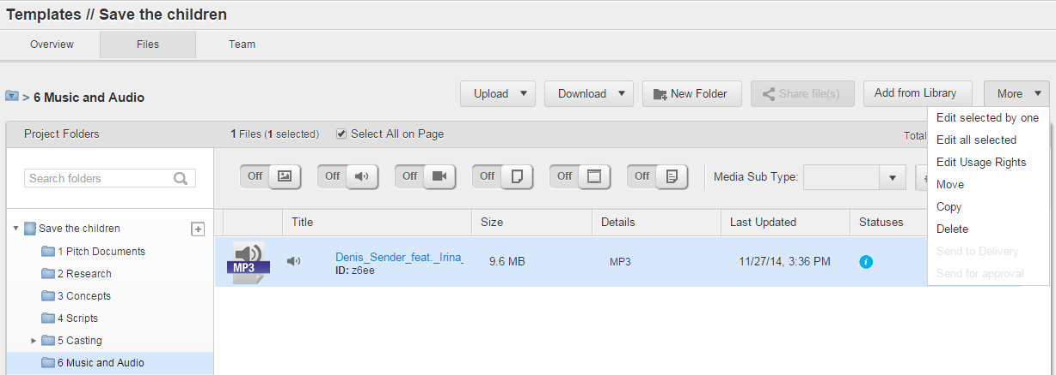

Figure 38 Project Template/Work Request Template details page > *Files* tab

The details of the Template details page *> Files* tab are similar to the details of the Project details page *> Files* tab (see Table 5).

**Note:** The *Share file(s)* and *Send for Approval* tabs are not available for Templates, as they are not used to store production files. Users don’t need to share anything for approval from the Template.

#### *Team* tab

Project Template/Work Request Template details page > *Team* tab is used to store information about user’s access to folders in a future project/work request, which will be created from the template. **Adding user to a template does not give this user access to the template as such.** User added to the template, will get access to the project that will be created from this template – but not to the template itself.

To open the *Templates > Team* tab:

1. Click the Project Template/Work Request Template title on the *Project Templates/Work Request Template*s tab.
2. Click the *Team* caption on the Project Template/Work Request Template details page (see Figure 39).

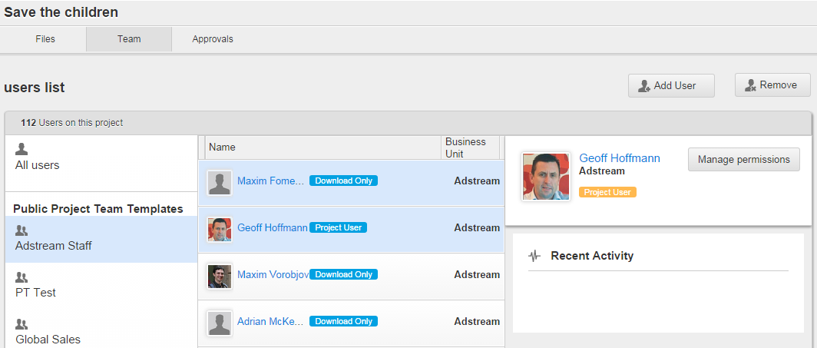

Figure 39 Project Template/Work Request Template details page > *Team* tab

The details of the Project Template/Work Request Template details page *> Team* tab are similar to the details of the Project/Work Request details page *> Team* tab (see Table 6).

### File details page

File details page consists of such tabs:

* *Info.*
* *Activity.*
* *Comments.*
* *Approvals.*
* *Version History.*
* *Usage Rights.*
* *Related Files.*
* *Attachments.*
* *Frames.*

To open the File details page, click the *Open file* pop-up control which appears by hover over the file thumbnail on the Projects/Work request details page > *Overview/Files* tab or on the Dashboard > *Files in your projects* widget (see Figure 40).

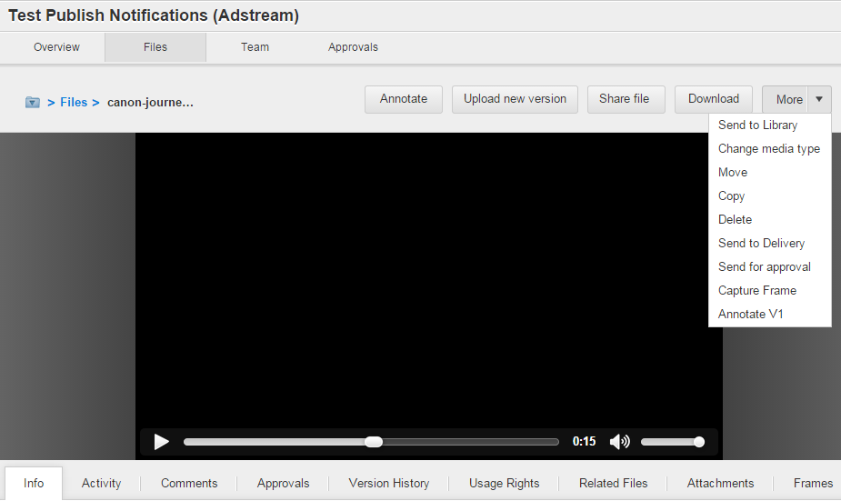

Figure 40 File details page

Actions which users can do via the File details page are described on the page 225.

## Library area

Library area is used to manage Assets, Presentations and Shared Collections. It is accessible by clicking the *Library* menu-item on the Main menu (see Figure 88). By default, the area opens on the *Library* tab.

Library is a collection of finished commercials, that have already been approved and are ready to go to market / have already been broadcast or published. As such, Library provides access to a ready material for local market representatives, who might want to request localization or adaptation job via Work Request; or place a Delivery order for TV or Radio commercials.

Main difference between Projects and Library materials is that what sits in the Library, has already been approved. That’s why Approvals module is not available in Library.

Access to Library materials is organised by collections. Collection, in essence, is a search result based on metadata filters. Collections are populated as soon as asset with matching metadata is added to the library (uploaded, copied from project, or created as a part of a delivery order). To add asset to collection(s), you simply tag it with metadata, and then this asset starts automatically appearing in all collection with matching filters.

So, one asset can sit in multiple collections.

Collections can be shared to users with various permissions.

The same user can have access to the same asset through more than one collection, with different permissions. In this case all user’s permissions for this asset will be summarized.

Example:

Collection 1: media type = Video

Collection 2: Advertiser = Adstream

User A has access to collection Video with permission: Read

User A has access to collection Adstream with permission Download Proxy

Asset TEST is Video, tagged with Advertiser: Adstream.

User will be able to both Read and Download this asset, because it sits in 2 cllections, and their permissions will be summarized.

### *Library* tab

*Library* tab is used to:

* Upload, download, share, edit remove and link Assets within Collections.
* Open Asset details pages.
* Initiate creating Work Requests and Presentations.
* Add Assets to projects
* Send Assets to the Delivery area.

The tab is accessible by clicking the *Library* menu-item in the Main menu (see Figure 41).

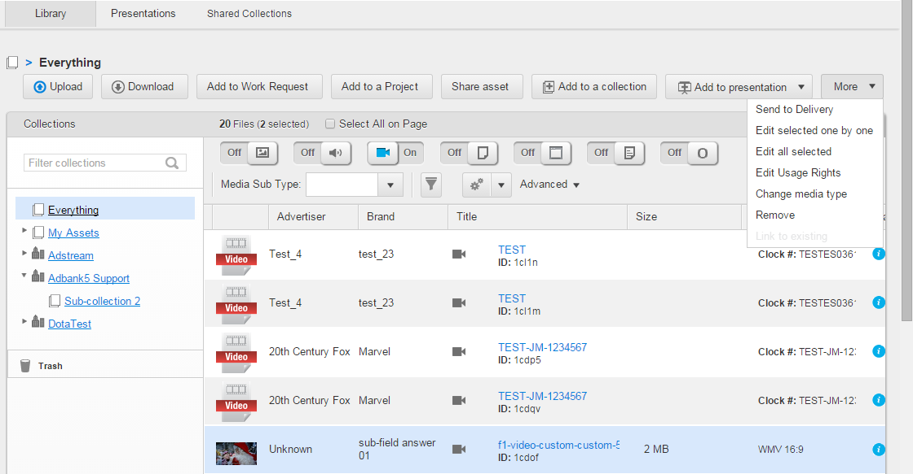

Figure 41 *Library* tab – List view

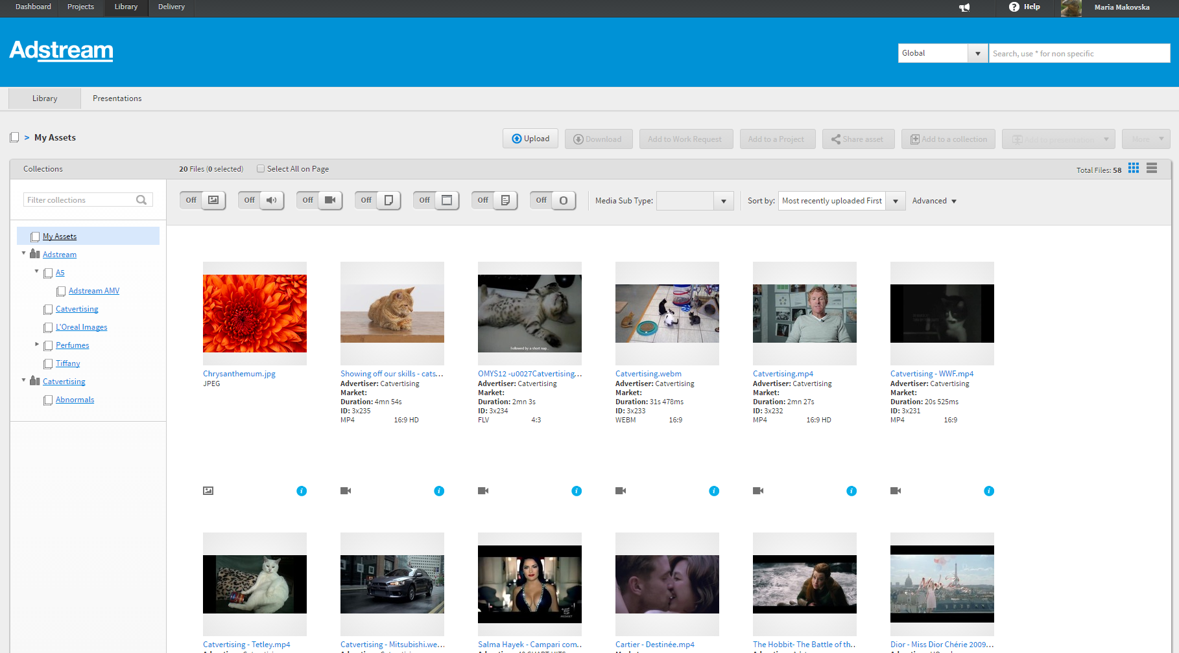

Figure 42 Library tab – Thumbnail view

*Library* tab fields are described in Table 7.

Table 7 Library tab details

| Field | Description |
| --- | --- |
| List of Collections | Is used to filter Assets by the Collections in the list. Collections can be private (=user’s saved search results) and shared (= shared to a user by BU admin).  Context menu can be opened for a Collection. It contains the controls:   * *Remove –* delete collection. This option is only available for user’s private collections, i.e. collections created by this user. Collections shared to a user by BU admin, cannot be deleted by the user. * *Rename* – is used to rename a Collection in the list. This option is only available for user’s private collections, i.e. collections created by this user. Collections shared to a user by BU admin, cannot be renamed by the user. * *Open* – is used to display Assets within a Collection. * *Make default –* mark this collection as default landing page for Library. See <https://jira.adstream.com/browse/NGN-13792> for details * *Subscribe to updates* – receive email notification every time when new asset with matching metadata appears in the Library. For details, see https://jira.adstream.com/browse/NGN-13508 |
| Media Type and Media Subtype filters | Is used to filter Assets by Media Types and Media Subtypes.  These controls are only visible to users with permission asset.filter_collection.create in the Global Role.  For details see Table 5. |
| *Sort by* dropdown list | Is used to sort Assets in the Library by such options:   * *Title (A to Z / Z to A).* * *Size (Ascending / Descending).* * *Most Recently Uploaded First / Most Recently Modified First.* * *Most Recently Uploaded Last / Most Recently Modified Last.* |
| *Upload* button | Is used to upload Assets to Collections. This button is available to users with the asset.create permission in their Global role. Note: the button should be displayed if user has asset.create pemission in at least one global role, in any of their business units. Now this check is only done for user’s Primary BU, so user with asset.create in secondary BU role will not be able to upload. This is already fixed in the new Library UI.  For details see page 374. |
| *Add to presentation > Add to new presentation* control | Is used to add Assets within selected Collection to a new Presentation. This button becomes active once the user has selected one or more assets. This button is only visible for users with permission asset.create in their Global role of Primary BU. This is not exactly correct, as user might have this permission in their secondary BU – and in this case they should be able to create Presentations in that BU, so should be able to see this button in their secondary BU’s collections.  Presentation can contain assets from various business units.  For more information, see:  https://jira.adstream.com/browse/NGN-1709  https://jira.adstream.com/browse/NGN-9761 |
| *Add to presentation > Add to existing Presentation* control | Is used to add Assets within selected Collection to an existing Presentation.  For more information, see:  https://jira.adstream.com/browse/NGN-1715  https://jira.adstream.com/browse/NGN-9761 |
| *Share asset* button | Is used to share Assets in a Secure mode or Public mode. Becomes active after user selects one or more assets.  Is visible to users with asset.share permission in the Library role for the selected Collection, or in the Global role; and on the Library > Search results page. See:  <https://jira.adstream.com/browse/NGN-8411>  <https://jira.adstream.com/browse/NGN-8325>  <https://jira.adstream.com/browse/NGN-8541> (never done)  For more information, see page 401. |
| *Add to a collection* button | Is used to add manually selected Assets to user’s private Collection. One of the very few buttons in Adbank that does not have any permissions behind it!  For details, see:  <https://jira.adstream.com/browse/NGN-1051> |
| *More > Remove* button | Is used to delete Assets from Library into the Trash Bin. Visible to users with permission asset.delete in the Library role of the selected Collection, or in the Global role. See:  <https://jira.adstream.com/browse/NGN-1052>  For more information, see page 392. |
| *More > Remove from Collection* button | Is used to delete manually added Assets from a private Collection. One of the very few buttons in Adbank that does not have any permissions behind it. |
| *More > Send to Delivery* button | Is used to send selected Assets to the Delivery. Becomes active when user selects one or more assets in the Library. Selected assets should be of Video or Audio type. User should have permission tv_order.create (for Video) or radio_order.create (for Audio). |
| *More > Edit selected one by one* button | Is used to edit metadata of multiple Assets one-by-one. Becomes active after user selects one or more assets.  Is visible to users with asset.write permission in the Library role for the selected Collection, or in the Global role; and on the Library > Search results page. See:  <https://jira.adstream.com/browse/NGN-11330>  For more information, see page 386. |
| *More > Edit all selected* button | Is used to edit metadata of multiple Assets in batch. The Assets can be of different media types. Becomes active after user selects one or more assets.  Is visible to users with asset.write permission in the Library role for the selected Collection, or in the Global role; and on the Library > Search results page. See:  <https://jira.adstream.com/browse/NGN-5208>  For more information, see page 384. |
| *More > Edit Usage Rights* button | Is used to edit Usage Rights on single or multiple Assets. The Assets can be of different media types.  Becomes active after user selects one or more assets.  Is visible to users with asset. File Usage Rights Expire Soon.write permission in the Library role for the selected Collection, or in the Global role; and on the Library > Search results page. See:  <https://jira.adstream.com/browse/NGN-10334>  For more information, see page 389. |
| *More > Change media type* button | Is used to redefine metadata schema for single or multiple Assets. Selected Assets can be of different media types. So, any media-specific metadata are lost, while any common metadata are kept.  Is visible to users with asset.write permission in the Library role for the selected Collection, or in the Global role; and on the Library > Search results page. See:  https://jira.adstream.com/browse/NGN-13899  For more information, see page 405. |
| *More > Link to existing* button | Is used to link single or multiple Assets between each other and set relation type for the linking.  Is visible to users with asset.related_files.create permission in the Library role for the selected Collection, or in the Global role; and on the Library > Search results page. Not going to add link to a corresponding Jira as that was very badly written. The whole epic on Related Files was this: <https://jira.adstream.com/browse/NGN-9164>  For more information, see page 362. |
| *Select All on Page* checkbox | Is used to select all Assets displayed on the current page. No way to select All assets in selected collection or search, unless you scroll down to the very bottom! |
|  | Is used to display how many Assets are selected on a page. |
| *Advanced Search* panel | One f the most abominable controls you’ll ever see. Is used to filter Assets by metadata filters. User could use these filters across all Collections they have access to. *Advanced Search* panel is minimized by default. User can click the *Advanced* down arrow to maximize pane and to show list of metadata filters. User can apply metadata filters by clicking  button or delete it by clicking  button. It is possible to combine metadata filters. It contains the controls:   * *Save as a collection* – is used to create a new private Collection after editing metadata filters of existing private Collection and/or adding new ones. * *Save* – is used to edit current private collection after editing existing metadata filters and/or adding new ones. * *Close* – is used to cancel adding or editing metadata filters and close the *Advanced* pane.   For more information, see page 343. |
| *Add to Work Request* button | Is used to create a Work Request based on selected Assets.  This button is visible when user has access to Work Request module, AND has permission adkit.create.  For more information, see page 405. |

### Asset details page

Asset details page consists of such tabs:

* *Info.*
* *Activities.*
* *Usage Rights.*
* *Related Assets.*
* *Related Projects.*
* *Attachments.*
* *Frames.*

To open the Asset details page, click the *Open file* pop-up control which appears by hover over on the Asset’s thumbnail on the *Library* tab or the Dashboard > *Latest Library Uploads* widget (see Figure 43).

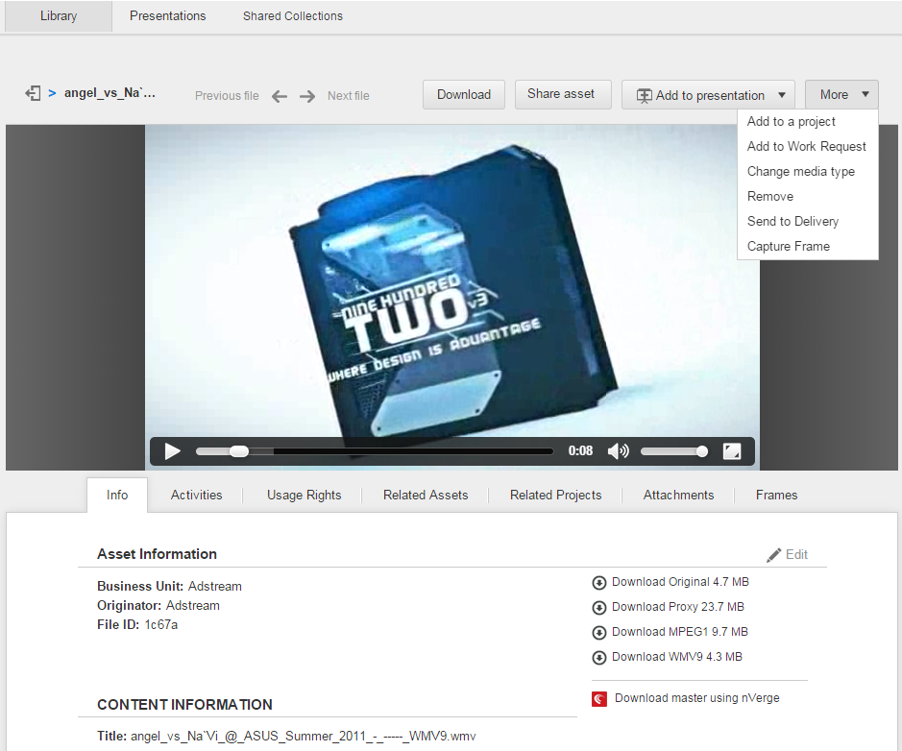

Figure 43 Asset details page

Actions which users can do on the *Asset Details* page, are described on page 356.

### *Presentations* tab

*Presentations* tab is used to manage Presentations. Each Presentations is based on the Assets placed on the *Library* tab. When asset is added to a presentation, a copy of asset is created – so changes to original asset will not be reflected in the presentation where it was added.

Presentation, or reel, is a sequence of ads that agency wants to show off – for example, ads filmed by certain director, or best ads for some brand, or all their ads that won gold at Cannes, etc. Autoplay is an important feature of presentations. In Adbank, *Presentations* tool is supposed to be cross-media, but in reality, flowplayer component that we use for playout, is not very good for print media, so if you add images and videos to the same presentation, it might not play correctly. Multi-page PDFs are especially painful, as we are only able to render the first page of multipage PDF in a player. This has been looming somewhere on the roadmap for a while, <https://jira.adstream.com/browse/NGN-10635> - watch out when it will surface next.

*Presentations* tab is accessible by clicking the *Library* menu-item on the Main menu and then clicking the *Presentations* caption (see Figure 44).

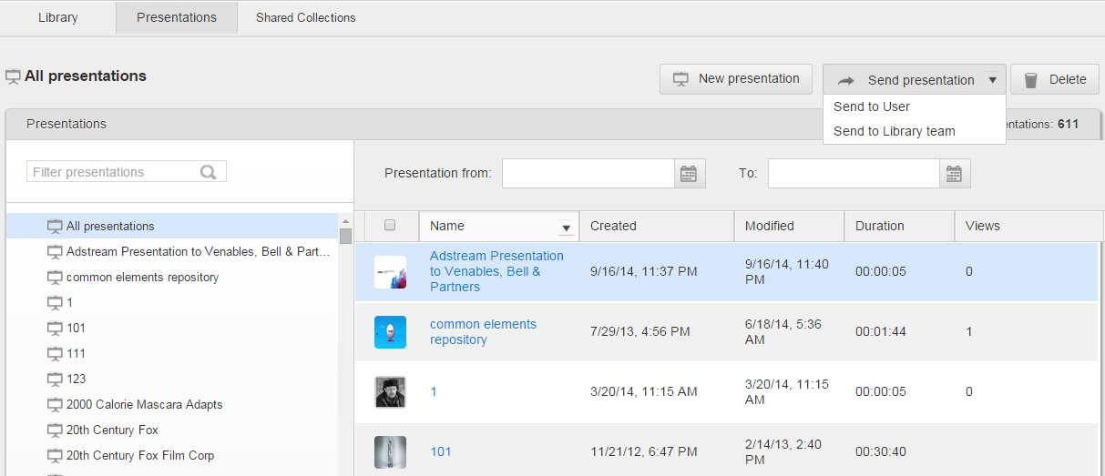

Figure 44 *Presentations* tab

*Presentation* tab is described in Table 8.

Table 8 *Presentation* tab details

| Field | Description |
| --- | --- |
| List of Presentations | Is used to:   * Open the Presentation details page by clicking a Presentation title. * View list of Presentations with main metadata by clicking the *All presentations* control.   By default, this list will display only Presentations that current user has created. If user has permission presentation.read/write/delete in their Global role – they will see all presentations created by other uses in the same BU.  This list will never show presentations shared to the current user. Separate tab should be added to show shared presentations – see https://jira.adstream.com/browse/FAB-40 |
| Search box | Is used to search Presentations by the title in the list. This search works in “contains” mode, so will look up a match anywhere in the Presentation Title (and this is not consistent with other areas of the system where similar search box is present, for example Project > Overview tab). |
| *New Presentation* button | Is used to create a new Presentation. For details see page 409. |
| *Send presentation* > *Sent to user* button | Is used to share selected Presentation securely with users.  This button seems to be broken in 5.5.22.  **Note:** Public Share mode is currently not available for multiple selected presentations. |
| *Send presentation* > *Sent to Library team* button | Is used to share selected Presentation securely with Library Teams.  This button seems to be broken in 5.5.22.  **Note:** Public Share mode is currently not available for multiple selected presentations. |
| *Delete* button | Is used to delete Presentations when the *All presentations* mode is active. The button is inactive until a user selects Presentation(s) in the list.  Should not be visible if user does not have presentation.delete permission in their Global role. |
| *Presentation from… to…* Calendar filters | Is used to filter list of Presentations by date range. |

### Presentation details page

Presentation details page consists of such tabs:

* *Assets.*
* *Activity.*
* *Branding.*
* *Layout.*
* *Presentation Setting.*

Also, Presentation details page contains the *Preview Presentation* link to open a Presentation preview in a new browser tab

#### *Assets* tab

Presentation details page *> Assets* tab is used to:

* View thumbnails and metadata of the assets in presentation. Note that metadata displayed in thumbnails on this page is hardcoded, and cannot be configured.
* Open Asset details page by mouseover to centre of Asset thumbnail and click the *Open file* pop-up link.
* Delete highlighted Asset(s) from a Presentation via the Delete button. It is inactive until at least one Asset is highlighted.
* Reorder Assets by drag and drop them in a Presentation. Reordering updates Asset’s sequence number.

The tab opens by clicking the Presentation title on the *Presentations* tab (see Figure 45).

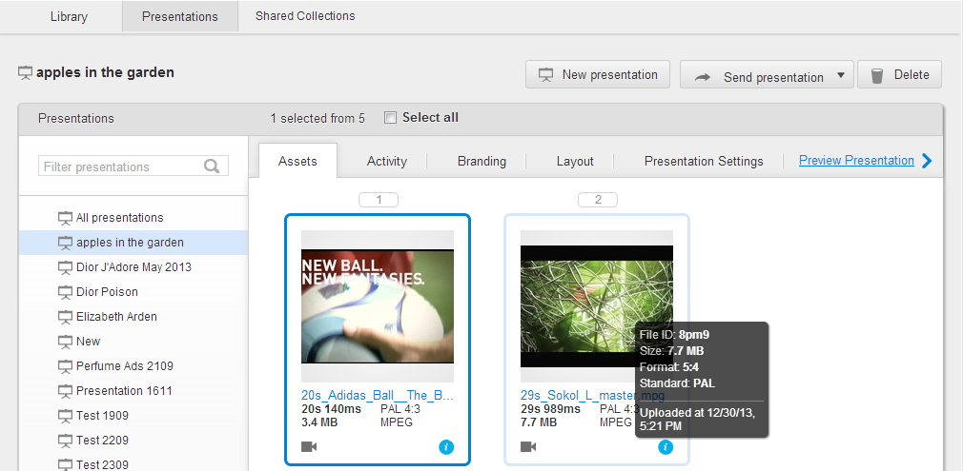

Figure 45 Presentation details page > *Assets* tab

#### *Activity* tab

Presentation details page > *Activity* tab is used to view Presentation metadata and statistics about Presentations lookups. The tab opens by clicking the Presentation title on the *Presentations* tab and then clicking the *Activity* caption (see Figure 46).

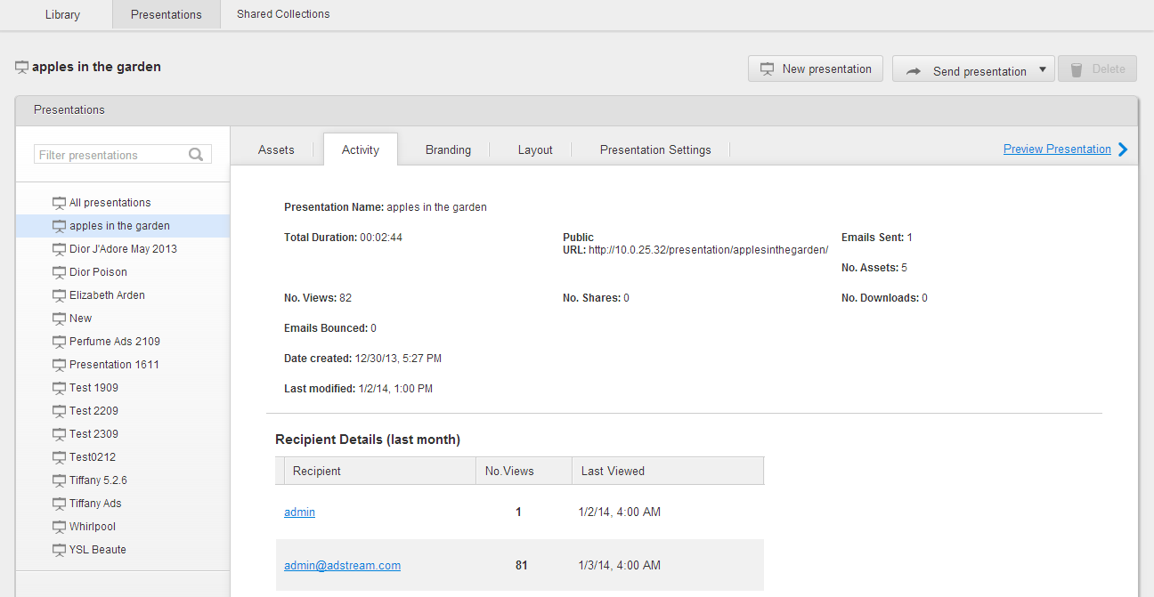

Figure 46 Presentation details page > *Activity* tab

Original story / implementation details: <https://jira.adstream.com/browse/NGN-8828>

At the times of 5.5.22, this area is in a desperate need of rework.

#### *Branding* tab

Presentation details page *> Branding* tab is used to:

* Upload, delete and preview Presentation logo and background image (Logo and Background Image sections).
* Set white & light grey or black & dark grey colour theme for a Presentation (Colour Theme section).
* Scale to fit screen or tile background image for a Presentation (Background Image section).

The tab opens by clicking the Presentation title on the *Presentations* tab and then clicking the *Branding* caption.By default, all new Presentations are created with the logo taken from current Business Unit branding. If necessary, a user has possibility to change it on the Presentation details page > *Branding* tab (see Figure 47).

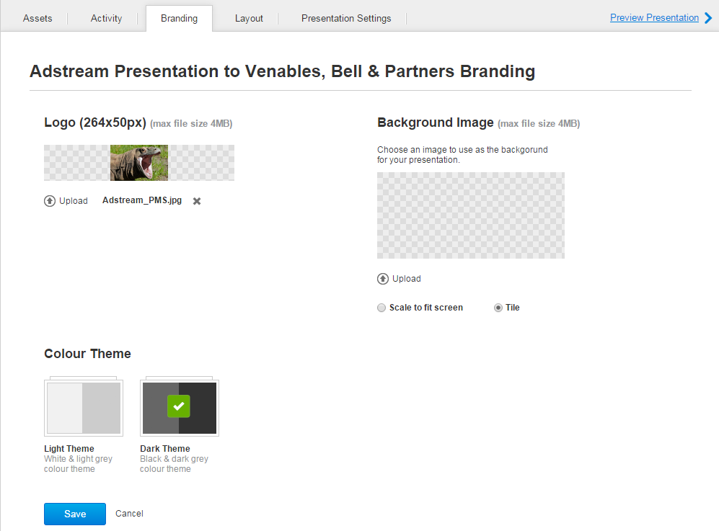

Figure 47 Presentation details page > *Branding* tab

#### *Layout* tab

Presentation details page *> Layout* tab is used to set:

* Layout setting, i.e. *Reel*, *Slider, Grid with Metadata* or *Audio*, and Advanced setting, i.e. *Horizontal Thumbnails* or *Grid Thumbnails* (if the *Reel* mode is enabled) to display Assets within a Presentation.
* Metadata visibility for Assets of all Media Types via the checkboxes next to respective metadata (see Figure 48).

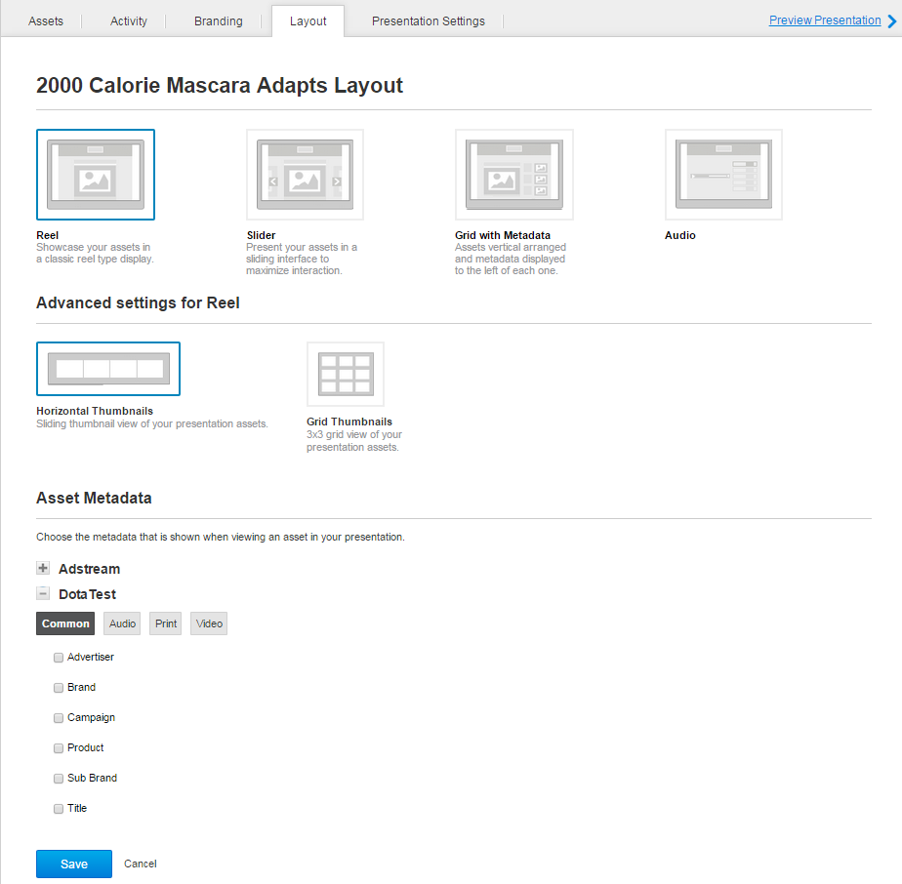

Figure 48 Presentation details page > *Layout* tab

*Grid with Metadata* layout contains vertical arranged Assets’ thumbnails and metadata displayed to the left of each one on the Presentation preview page. These metadata areTitles and Products of the Assets. Instead of *Product* field can be displayed any metadata field tagged as Product via the *Mark as Product* checkbox in the field’s settings (see Figure 49).

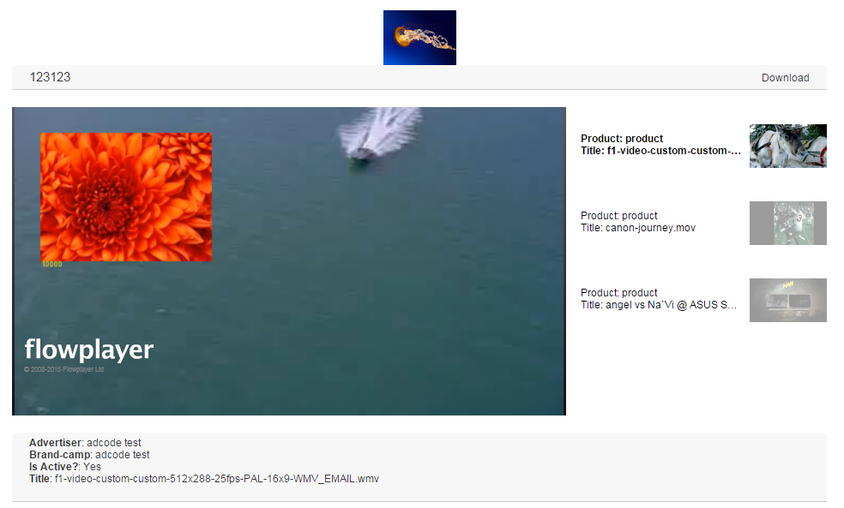

Figure 49 Presentation preview page with enabled Grid with Metadata layout

*Audio* layout is appropriate for Presentations with included audio Assets. Presentation preview page with enabled *Audio* layout looks like as shown on the Figure 50.



Figure 50 Presentation preview page with enabled *Audio* layout

#### *Presentation Settings* tab

Presentation details page *> Presentation Settings* tab is used to specify unique settings for each Presentation (see Figure 51).

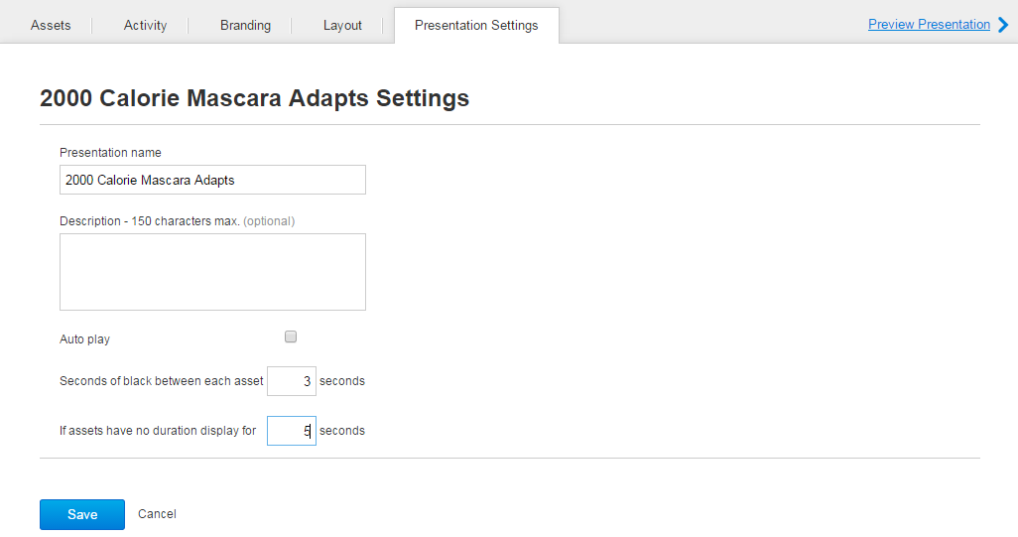

Figure 51 Presentation details page > *Presentation Settings* tab

*Presentation Settings* tab is described in Table 9.

Table 9 *Presentation Settings* tab details

| Field | Description |
| --- | --- |
| *Seconds of black between each Asset __ seconds field* | Is used to set time delay (in seconds) between displaying of Assets in a Presentation. |
| *If Assets have no duration display for __ seconds field* | Is used to set time delay (in seconds) during which static Asset is displayed in a Presentation. |
| *Auto play* checkbox | Is used to enable autoplay mode for a Presentation. If this mode is enabled for a Presentation, first included video/audio Asset begins to play as soon as a user opens the Presentation preview page for this Presentation. By default, this checkbox is ticked for newly created Presentations. |

### *Shared Collections* tab

*Shared Collections* tab is used to approve or reject Assets shared with current Business Unit by partner ones. This tab is only visible to user with permission inbox.read in their Global role.

History behind this tab and implementation details: <https://jira.adstream.com/browse/NGN-5978>

The *Shared Collections* tab is accessible by clicking the *Library* menu-item on the Main menu and then clicking the *Shared Collections* caption (see Figure 52).

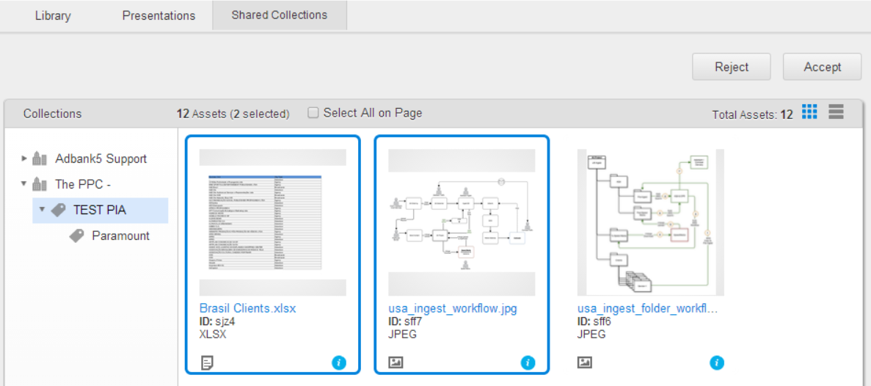

Figure 52 *Shared Collections* tab

*Shared Collections* tab details are described in Table 10.

Table 10 *Shared Collections* tab details

| Field | Description |
| --- | --- |
| List of Shared Collections | Is used to display list of partner Business Units who shared some collections to the current BU. |
| *Reject* button | Is used to reject highlighted shared Assets. |
| *Accept* button | Is used to accept highlighted shared Assets. |
| *Select All*checkbox | Select all assets visible on the page. |
| Item counter | Is used to display number of assets selected on the page. |

When a partner Business Unit shares a new Collection to a current Business Unit, users with granted *inbox.read* permission from this Business Unit are notified about this by email, provided they have email notifications Asset Filter Shared: Immediately set in their Notifications.

These users can view, accept, reject, edit (before accepting) and download Assets shared for them.

**Note**: By default, on opening the tab, there is no Assets from any shared Collection are displayed, so the notification is shown:

*‘Please select shared collection on the left to see assets’*.

## Administration area

Administration area is used to manage Users, Roles, Metadata, Views, Branding, Collections, Approval Templates, Terms & Conditions (for a Business Unit and its Projects), Relations Types (for Related files and Assets), and Watermarking. The area is accessible by clicking the Admin link into the User menu (see Figure 90). By default, the area opens on the *Users* tab.

### *Users* tab

*Users* tab is used to (see Figure 53):

* Add new users to current Business Unit.
* Add and remove existing users to/from the Library Teams and Project Team Templates of current Business Unit.
* Delete existing Library Teams and Project Team Templates from current Business Unit.
* Grant/deny user’s access to various applications, like Projects / Library / Delivery etc.
* Manage Project access rules and Delivery access rules for a user.

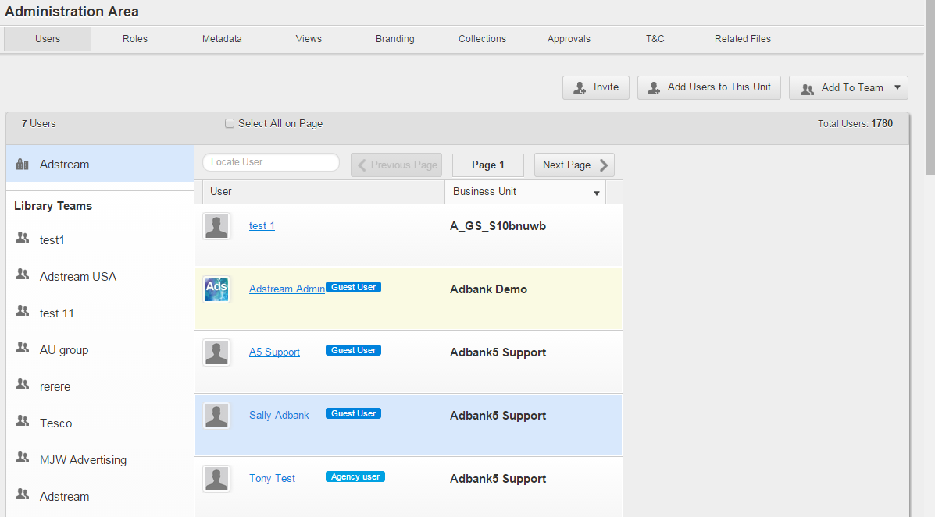

Figure 53 *Users* tab > All users within Business Unit

*Users* tab details are described in Table 11.

Table 11 *Users* tab details

|  |  |
| --- | --- |
| Public Project Team Template and Library Team filters | Is used to filter users of current Business Unit by Public Project Team Templates/Library Teams (by clicking appropriate filter). To display all users again, click the Business Unit title above the filters. |
| Users list | Will display all users who have some level of access to the current BU (Primary or Secondary).  For every user, the list will display an icon, first name, last name, Global role in the current BU, and Primary BU name.  Default sorting on this page is a mess and needs to be fixed.  Sorting by user name / BU name ditto, needs fixing.  Search control could also use some loving. For example, it searches not only current user’s details, but also details of user’s creator (because they are stored in the same document).  When a user is selected, it is possible to add them to a new or existing Library Team or Public Project Team Template.  If username is clicked, it is possible to manage their permissions on Project, Library and Applications via respective tabs. |
| *Edit Profile* link | Is used to open user profile. |
| *Projects* sub-tab | Is used to view list of Projects to which selected user has access and manage Project access rules (if they are enabled and available for the user). By clicking a Project title Project details page will be opened in a separate browser tab.  For details, see page 87. |
| *Library* sub-tab | Is used to view and manage list of Collections to which selected user has access and user roles assigned to these Collections.  For details, see page 88. |
| *Applications* sub-tab | Is used to grant/deny user’s access to applications. For details, see page 89. |
| [*Add*](https://jira.adstream.com/browse/NGN-49) *Users to this Unit* button | Is used to create a new user within current Business Unit. On clicking the button new user profile page will be opened. |
| *Add to Team* > *Add to Library Team* button | Is used to add selected user to a new or existing Library Team (see Figure 57). |
| *Add to Team* > *Add to Public Project Team Template* button | Is used to add selected user to a new or existing Public Project Team Template (see Figure 57). |
| *Locate User* search box | Is used to search user within the current Business Unit. |
| *Delete Team* button | Is used to delete selected Public Project Team Template or Library Team. |
|  | Is used to remove a user from the selected Public Project Team Template or Library Team. |

**Note**: After a Collection or a Project of current Business Unit was shared to a user of a partner Business Unit, this user automatically appears in the list of current Business Unit’s users.On the *Users* tab > User details view > *Projects*/*Library* sub-tabsAdmin of this Business Unit can view only the Projects and Collections of the current Business Unit where this user has been added.

To see additional configuration options for a user, click on the user’s name link in the list.

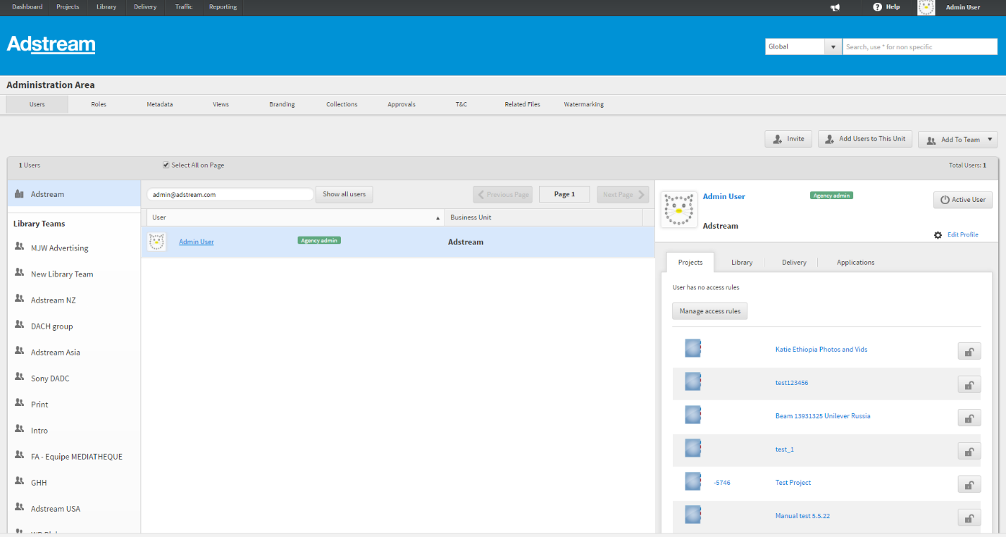

Figure 54 Users tab > Selected user

The *Active User* button is used to set Is Disabled flag on a user to True / False. The flag is False by default, meaning that user is active and can access the system. Setting this flag to True prevents user from logging in, but does not delete user’s record in the system. User can be enabled back at any time. The same flag can be set on the *Edit Profile* page.

The *Edit Profile* link allows BU admin to edit user’s details, like First Name, Last Name, Timezone, Language etc. For more information, see page 532. Note that some details would only be editable for Primary BU users.

#### *Projects* sub-tab

*Projects* sub-tab (see Figure 55) displays list of Projects to which selected user has access and Project access rules (if they are enabled and available for the user). User can go directly to a particular Project listed on the sub-tab by clicking the Project job number or title. The  icon next to a Project opens Permissions tab, where BU admin can check user’s access to the project. However BU admin will not be able to modify user’s access to Project in this control – there are no options to add new roles, and a control to remove existing project roles is broken in 5.5.22. So to modify user’s access to project, click into the Project name and go to the Project > Team tab.

**Note:** The *Manage Access Rules* button is visible only if BU has Access Rules feature enabled in BU settings.

**Note:** For users with agency.admin role, Projects tab should only display projects where these users were specifically added on the project team, not all BU projects. This seems to be broken in 5.5.22 – for selected BU admin, the list show all BU projects, because agency.admin has project.read on a Global role level. This is wrong, this control should only show projects where user has been added to the team.

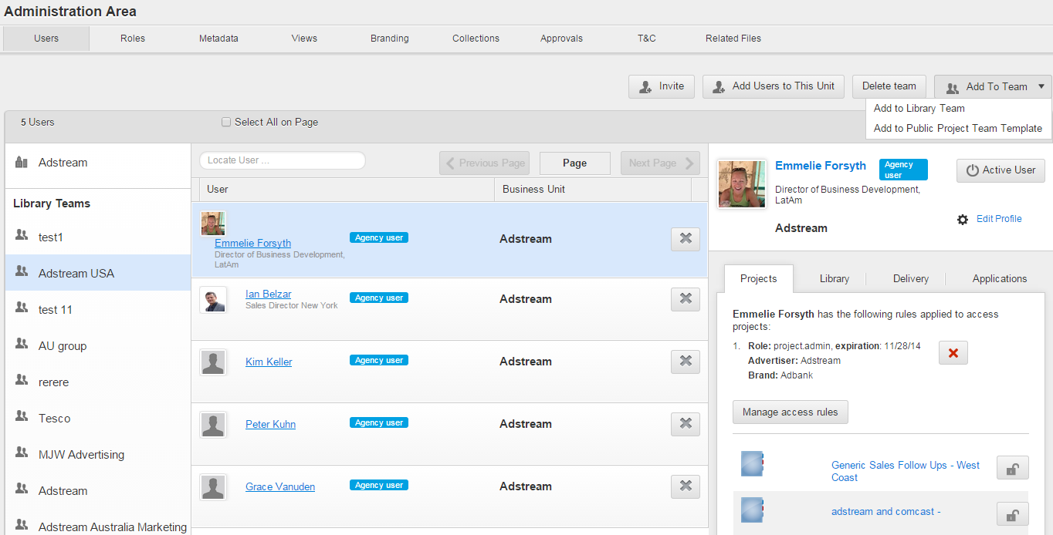

Figure 55 *Users* tab > User’s access details > *Projects* sub-tab

#### *Library* sub-tab

*Library* sub-tab displays list of public Collections that were shared to this user by BU Admin.

User could have been added to a collection in 2 ways:

* Individual access. User has been added to a collection on their own. This access is editable, can be modified/removed/added per user. Also, user role can be changed. To share Collection to the user from this control, select Collection title and user role from respective dropdown lists and click the  icon next to it; once it is added, the  mark appears next to the Collection. To delete such Collection from the list a user should click the  icon next. To change user role for such Collection, select appropriate role from the *Role* dropdown list and click the *Save* button.
* Access through Library Teams. User has been added to the Library team, and collection was shared to this Library Team. Such access cannot be modified on the individual user level. Collections where user is a part of Library Team, are not editable (are marked with  icon), so it is not possible to delete such Collection or change user role for it (see Figure 56).

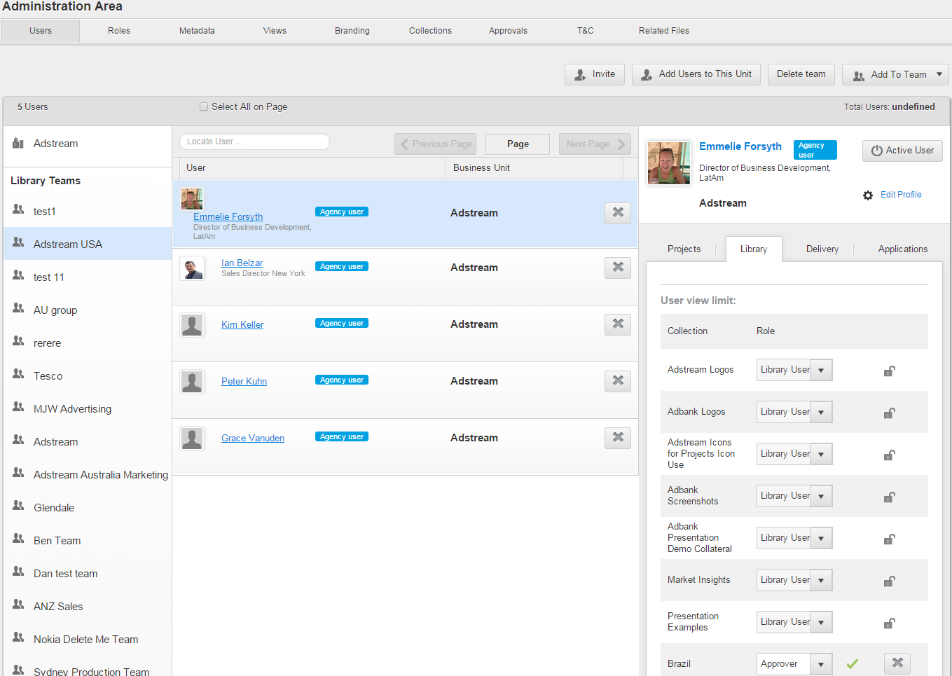

Figure 56 *Users* tab > User’s access details > *Library* sub-tab

#### *Delivery* sub-tab

*Delivery* sub-tab displays Delivery access rules available for selected user. For the details how to manage the Delivery access rules please refer to the page 545.

#### *Applications* sub-tab

*Applications* sub-tab allows Business Unit Admin to grant or to deny user access to the Projects, Library and Delivery areas by ticking corresponding checkboxes (see Figure 57).

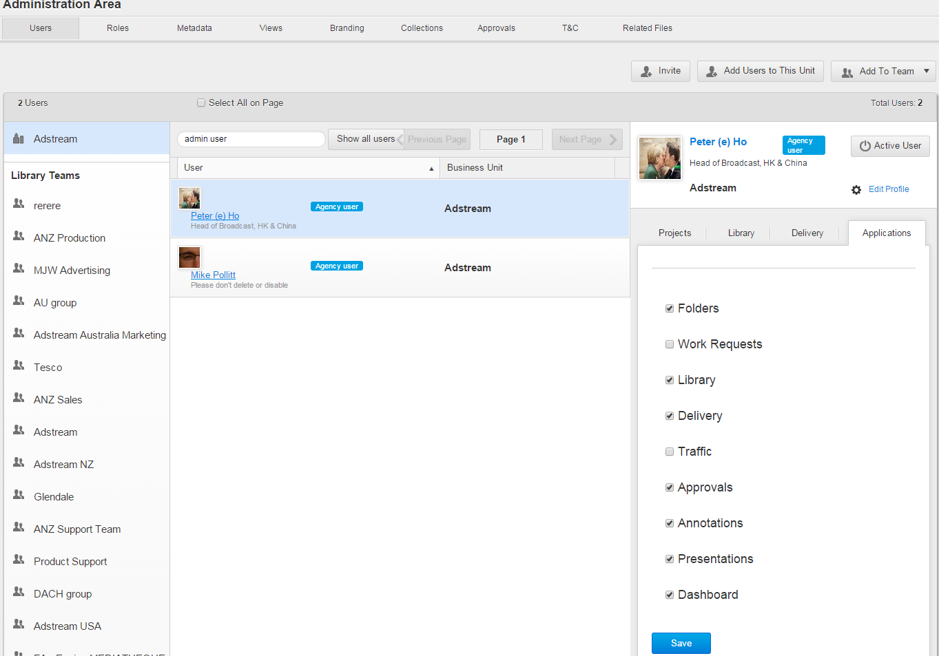

Figure 57 *Users* tab > User’s access details > *Applications* sub-tab

**Note:** the list of applications available on the BU Admin > Users > Applications tab is defined by the list of applications enabled for this BU in Global Admin. The list of applications available to a user within BU, can be same or less than available to a BU.

**Note:** the list of users shows both Primary and Secondary users that have been invited to a BU. Projects, Library and Delivery tabs are available and editable for both Primary and Secondary users, and are used by respective BU admin to regulated user’s access within their BU. Applications tab is only available in user’s Primary BU.

About managing user’s access in multiple business units, see more in https://jira.adstream.com/browse/NGN-7152

### *Roles* tab

Role is a combination of permissions, which can be assigned to a user within a context of specific Project Folder(s), or the whole Project, or Library Collection, or the whole Business Unit. By modifying the list of permissions in a role, unsuspecting user can cause a lot of grief, that’s why we don’t allow BU Admin to edit roles – apart from renaming them, or hiding them on a BU level.

*Roles* tab is used to:

* View permissions of user role.
* Rename editable roles.
* Hide/unhide unused roles.

The tab is accessible by clicking the *Admin* link into the User menu and then clicking the *Roles* caption (see Figure 58).

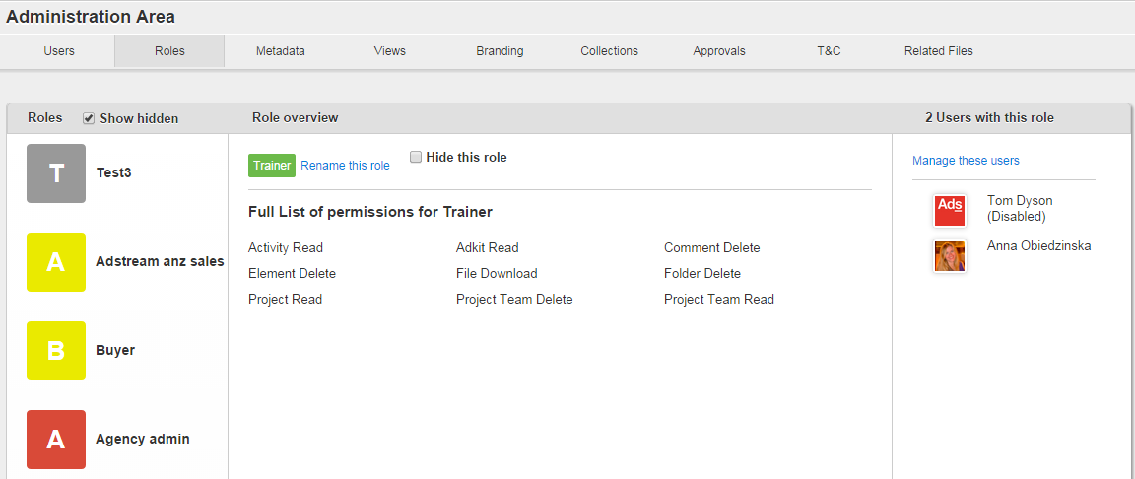

Figure 58 *Roles* tab

*Roles* tab details are described in Table 12.

Table 12 *Roles* tab details

|  |  |
| --- | --- |
| Field | Description |
| *Roles* pane | Is used to select a user role from the roles list. |
| *Role overview* pane | Is used to view permissions for selected user role. |
| *Users with this role* pane | Is used to display list of users related to role which is selected on the *Roles* pane. On clicking the user’s logo, user profile will be opened.  There is a serious bug in this area: it shows users unfiltered by business unit! By design, this area should only show list of users with this role ONLY in the current BU. |
| *Rename this role* | Allows BU admin to rename role in the current BU. Renaming is only allowed for custom BU roles – i.e. roles created and available for the current BU only. Renaming system roles is forbidden – which is not good really, this is because we still have a few places in the code that rely on role name (sic!) |
| *Hide this role* checkbox | Is used to hide/display a user role selected from the roles list. Hiding a role does not delete it and does not disable role permissions for the users that were already assigned to this role, but stops this role from being used in the new shares.  Hiding system roles like project.admin causes a lot of fun – basically you cannot create project anymore, as you cannot add yourself with the hidden role project.admin (example of hardcoded logic around specific role). There is an improvement somewhere in the backlog to stop users from hiding this role. |
| *Show hidden* checkbox | Is used to hide/display all roles on the tab, including those hidden. |

### *Metadata* tab

Custom Metadata is one of the biggest features of Adbank, which makes it so easy to sell – and so difficult to manage! Custom metadata is about allowing BU Admin to customize the set of fields that users of this BU will see on different forms. Every BU has its own “metadata schema” – a set of metadata fields grouped by the area of their usage.

*BU Admin > Metadata* tab is used to:

* Manage metadata for Projects, Work Requests and their Templates.
* Manage metadata for files and Assets of different media types.
* Create and edit Collections on the *Library* tab and Admin area > *Collections* tab.

All metadata are organized into groups (see Figure 59):

* *Common Editable Metadata* – metadata fields that are created by default for every business unit; this is a predefined list of fields that is available for every BU in the system. Fields are called “common” because they are available for all objects – Projects, Work Requests, Files/Assets of all media types. BU admin may decide to rename or hide Common Editable fields on a BU level (that’s why they are called “editable”).
* *Common Custom Metadata* – metadata fields that are created on a BU level, and are available only within this specific BU. These fields can also be created on a “common” level – so made available for all objects.
* *Project* – metadata fields available for Projects and Project Templates. Project/Template form for a BU will show Common Editable Fields, Common Custom Fields, and Project-level fields enabled for this BU.
* *Work Requests* – metadata fields available for Work Requests and Work Request Templates. Work Request/Template form for a BU will show Common Editable Fields, Common Custom Fields, and Work Request-level fields enabled for this BU.
* *Audio/Video/Print/Digital/Document/Image/Other Assets* – metadata fields available for Project Files and Library Assets, per specific media type. File/Asset form for a BU will show Common Editable Fields, Common Custom Fields, and Media Specific File/Asset-level fields enabled for this BU.

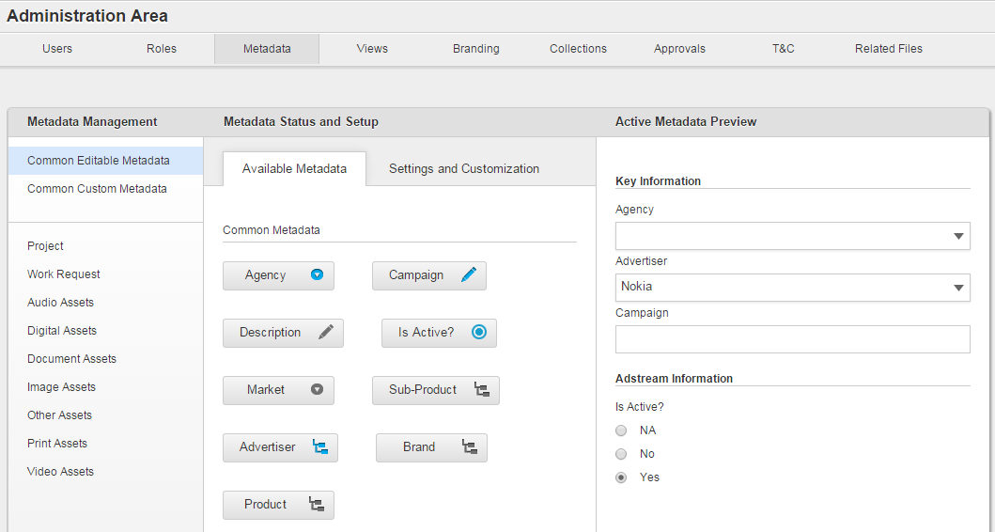

Figure 59 *Metadata* tab > *Common Editable Metadata* group

Original implementation, with all the gory details: https://jira.adstream.com/browse/NGN-4675, <https://jira.adstream.com/browse/NGN-242>, https://jira.adstream.com/browse/NGN-6356

#### Metadata properties

Metadata fields can have such properties:

* *Description* text box*.*
* *Field Size* dropdown list*.*
* *Make it compulsory* checkbox.
* *Hide* checkbox.
* *Add values on the fly* checkbox.
* *Make this field available for multiple choices for the user* checkbox.
* *Mark as Advertiser* checkbox*, Mark as Product, Mark as Campaign* checkboxes
* *Make this field available in Delivery* checkbox (see on Figure 60).
* *Make it Common for Order* checkbox (only available for fields present in the Ordering schema)
* *Make this field available for Billing* checkbox (only available for fields present in the Ordering schema)

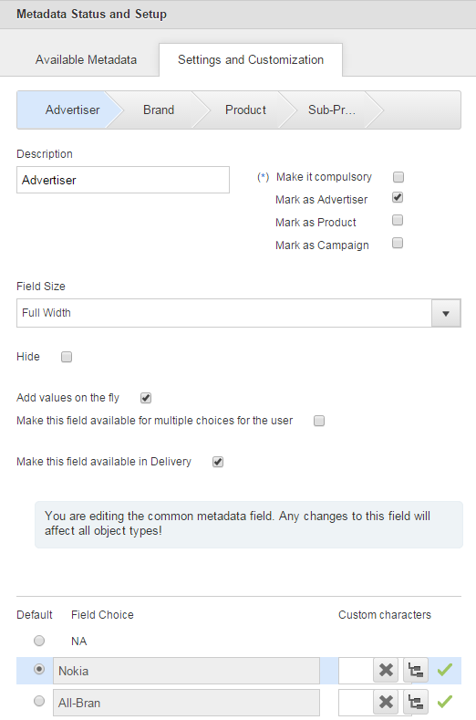

Figure 60 *Metadata* tab >Metadata properties

Table 13 Metadata properties

| Field | Description |
| --- | --- |
| *Description* text box | Is used to enter field’s title. This is mandatory field. |
| *Field Size* dropdown list | Is used to either narrow (if *Half Width* value is enabled) or enlarge (if *Full Width* value is enabled) a field on system forms and pop-up windows. |
| *Make it compulsory* checkbox | Is used to make a field compulsory (ifticked) or optional (ifunticked) for filling by users. |
| *Add values on the fly* checkbox | Is used to allow (ifticked) or deny (ifunticked) adding on the fly custom values for metadata of *Catalogue Structure* and *Dropdown* types. When this option is set for a predecessor *Catalogue Structure* field, it will be inherited for the successor field automatically.  Ability to add values on the fly for the metadata of *Catalogue Structure* and *Dropdown* types are regulated by the *dictionary.add_on_the_fly* permission. See <https://jira.adstream.com/browse/NGN-14399> for more info. |
| *Make this field available for multiple choices for the user* checkbox | Is used to allow (ifticked) or deny (ifunticked) selecting several predefined values at once for metadata of *Catalogue Structure* and *Dropdown* types*.* |
| *Mark as Advertiser* checkbox | Is used to mark (ifticked) or unmark (ifunticked) a field of *Catalogue Structure* type as *Advertiser* for the Assets in the Delivery area. |
| *Mark as Product* checkbox | Is used to mark (ifticked) or unmark (ifunticked) a field of *Catalogue Structure* type as *Product* for the Assets in the Delivery area. |
| *Mark as Campaign* checkbox | Is used to mark (ifticked) or unmark (ifunticked) a field of *Catalogue Structure* type as *Campaign* for the Assets in the Delivery area. |
| *Make this field available in Delivery* checkbox | Is used to allow (ifticked) or deny (ifunticked) usage a field in the *Delivery* area. |
| *Make it Common for Order* | See <https://jira.adstream.com/browse/ORD-4478>, https://jira.adstream.com/browse/ORD-4197 |
| *Make this field available for Billing* | See <https://jira.adstream.com/browse/ORD-4478>, https://jira.adstream.com/browse/ORD-4040 |
| *Hide* checkbox is used | Is used to enable (ifticked) or disable (ifunticked) a metadata field for usage. When the field is disabled, it is hidden for the users. Hidden fields are shaded while visible ones are highlighted in blue. |

Also, metadata of *Catalogue Structure* and *Dropdown* types have *Field Choice* area. It allows Business Unit Admin to add, edit, delete and drill down custom values (i.e. Choices) for metadata fields. These Choices can be selected by the users of this Business Unit (see on Figure 60).

#### Types of metadata

Some metadata are unique for files/Assets of each media type. These metadata can be of such types: *String, Date, Multiline, Section Break, Phone, Dropdown, Catalogue Structure*, *Address*, *Radiobutton* and *Hyperlink*.

##### *String* metadata

Metadata of *String* type have such properties (see Figure 61):

* *Description text box.*
* *Field Size dropdown list.*
* *Make it compulsory checkbox.*
* *Mark as Product checkbox.*
* *Mark as Campaign checkbox.*
* *Hide checkbox.*

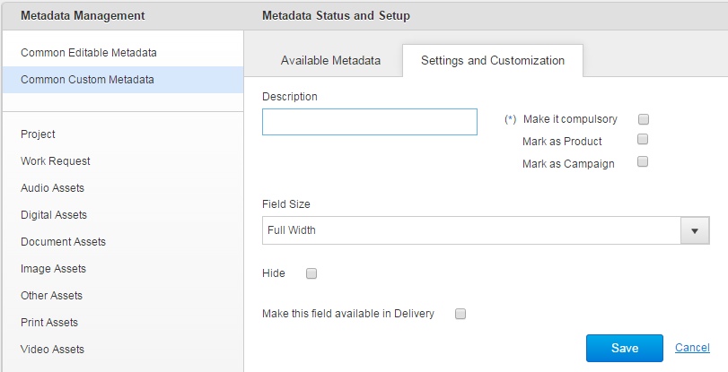

Figure 61 *Metadata* tab > *String* type of metadata

Any metadata field of *String* type can be marked as:

* *Product* – if the *Mark as Product* checkbox is ticked in their settings.
* *Campaign* – if the *Mark as Campaign* checkbox is ticked in their settings.

Description of the metadata properties see here*.*

##### *Date* metadata

Metadata of *Date* type have such properties (see Figure 62):

* *Description text box.*
* *Field Size dropdown list.*
* *Make it compulsory checkbox.*
* *Hide checkbox.*
* *Field Format dropdown list.*

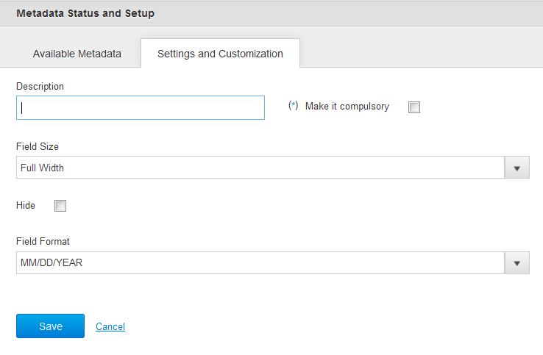

Figure 62 *Metadata tab > Date* type of metadata

Description of the metadata properties see here.

*Field Format* dropdown list allowing selecting appropriate date format from the list (see Figure 63).

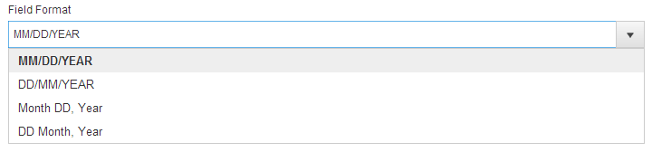

Figure 63 *Metadata* tab > *Field Format* dropdown list

##### *Dropdown* metadata

Metadata of *Dropdown* type have such properties (see Figure 64):

* *Description text box.*
* *Field Size dropdown list.*
* *Make it compulsory checkbox.*
* *Mark as Product checkbox.*
* *Mark as Campaign checkbox.*
* *Hide checkbox.*
* Add values on the fly *checkbox.*
* Make this field available for multiple choices for the user *checkbox.*
* *Field Choice area.*

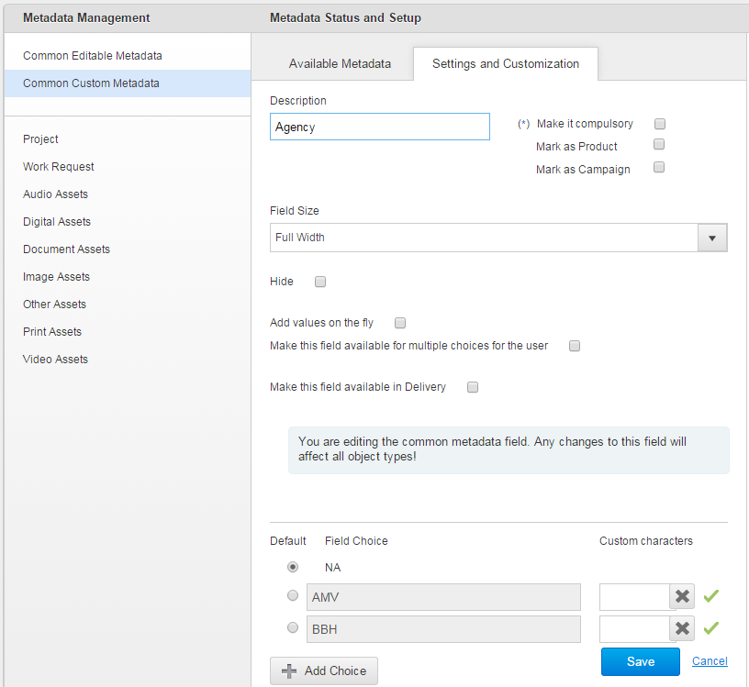

Figure 64 *Metadata* tab > *Dropdown* type of metadata

Any metadata field of *Dropdown* type can be marked as:

* *Product* – if the *Mark as Product* checkbox is ticked in their settings.
* *Campaign* – if the *Mark as Campaign* checkbox is ticked in their settings.

Descriptions of metadata properties see here.

##### *Catalogue Structure* metadata

Metadata of *Catalogue Structure* type are similar to metadata of *Dropdown* type but Catalogue fields are interdependent with each other by the ‘Predecessor 🡪 Successor’ dependence where each predecessor field defines properties of the following successor one. For example, in the *Advertiser > Brand* > … Catalogue value selected for the *Advertiser* field defines which corresponding values of the *Brand* field are available for selecting by a user (see Figure 65).

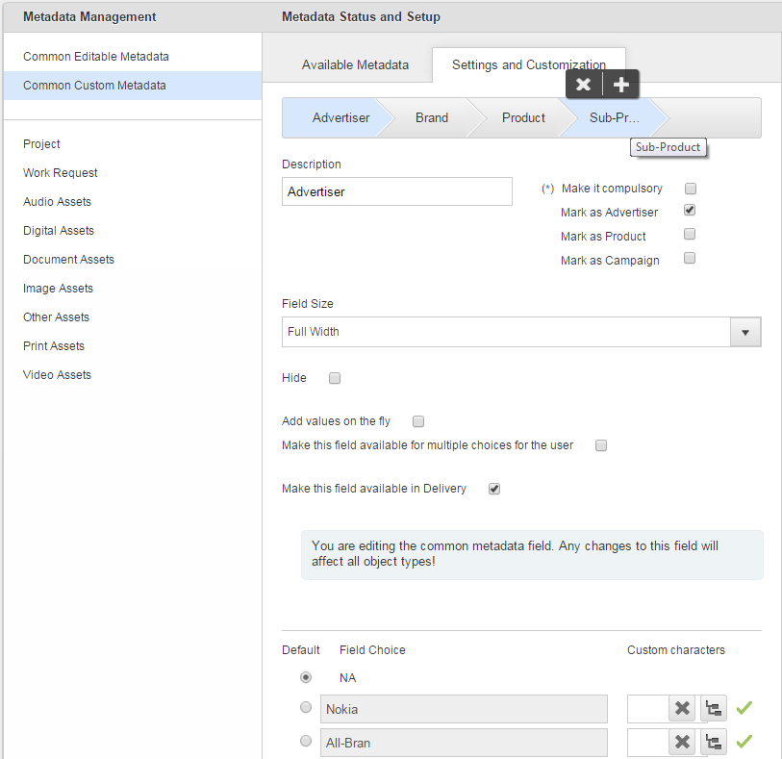

Figure 65 *Metadata tab > Catalogue Structure* type of metadata

Any metadata field of *Catalogue Structure* can be marked as:

* *Advertiser* – if the *Mark as Advertiser* checkbox is ticked in their settings.
* *Product* – if the *Mark as Product* checkbox is ticked in their settings.
* *Campaign* – if the *Mark as Campaign* checkbox is ticked in their settings.

To exclude a *Catalogue Structure* field which is marked as *Advertiser* from the *Advertiser* Catalogue, Business Unit Admin should tick the *Mark as Advertiser* checkbox in settings of any other field. In this case, this checkbox becomes automatically unticked in first field’s settings.

To exclude a *Catalogue Structure* field which is marked as *Product* from the *Advertiser* Catalogue, Business Unit Admin should tick the *Mark as Product* checkbox in settings of any other field. In this case, this checkbox becomes automatically unticked in first field’s settings.

To exclude a *Catalogue Structure* field which is marked as *Campaign* from the *Advertiser* Catalogue, Business Unit Admin should tick the *Mark as Campaign* checkbox in settings of any other field. In this case, this checkbox becomes automatically unticked in first field’s settings.

Properties description for metadata of *Catalogue Structure* type see here.

##### *Section Break* metadata

Metadataof *Section Break* type consist of the *Description* text box (see Figure 66). Their descriptions see here.

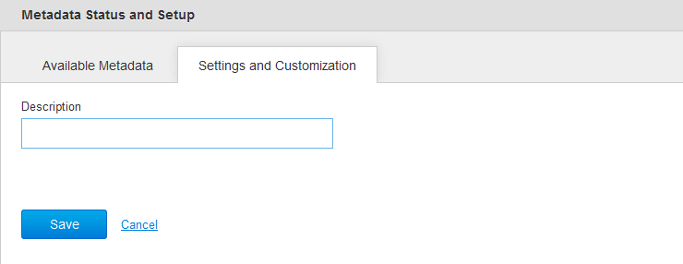

Figure 66 *Metadata tab > Section Break* type of metadata

##### *Multiline* metadata

Metadata of *Multiline* type have such properties (see Figure 67):

* *Description* text box*.*
* *Field Size* dropdown list*.*
* *Make it compulsory* checkbox.
* *Number of lines* text box (is used to set number of lines for data entering).
* *Hide* checkbox.

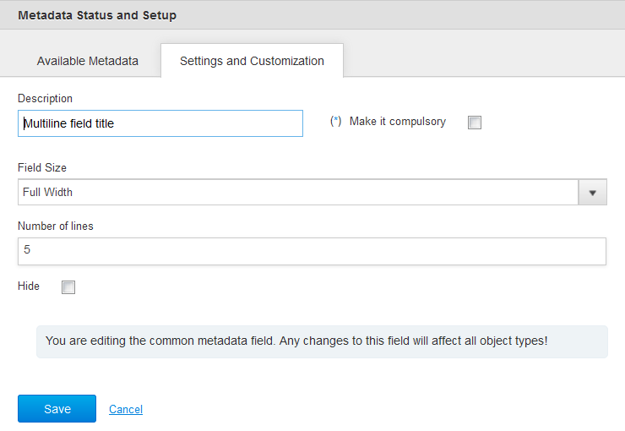

Figure 67 *Metadata* tab *> Multiline* type of metadata

Review for the *Description*, *Field Size, Make it compulsory* and *Hide* metadata properties see here*.*

##### *Phone* metadata

Metadata of *Phone* type have such properties:

* *Description* text box*.*
* *Field Size* dropdown list*.*
* *Make it compulsory* checkbox.
* *Hide* checkbox.
* *Field Format* section.

The *Field Format* section is used to specify USA, Europe or Universal format of the phone number via respectiveradiobuttons (see Figure 68).

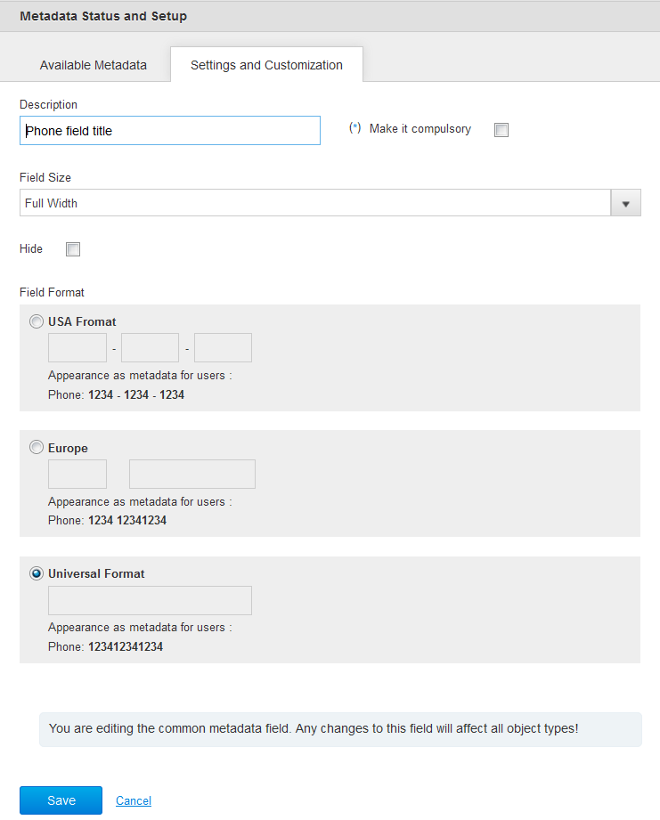

Figure 68 *Metadata* tab > *Phone* type of metadata

Review for the *Description*,the *Field Size,* the *Make it compulsory* and the *Hide* metadata properties see here*.*

##### *Address* metadata

Metadata of *Address* type have such properties (see Figure 69):

* *Description text box.*
* *Make it compulsory checkbox.*
* *Hide checkbox.*
* *Inner Fields Labels section.*

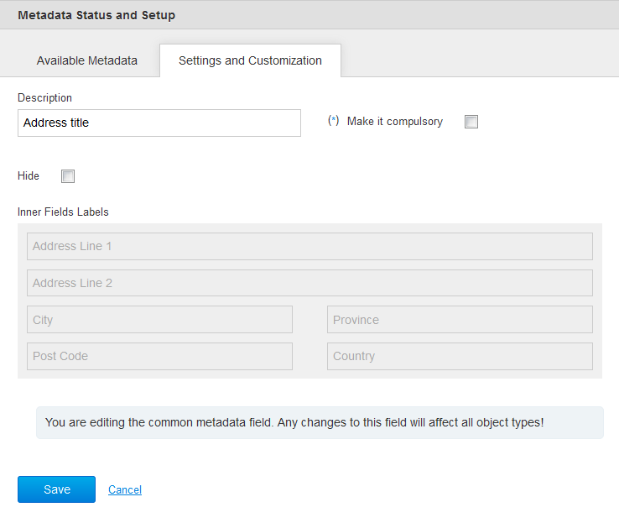

Figure 69 *Metadata* tab > *Address* type of metadata

The *Inner Fields Labels* section is used to specify such address properties:

* *Address Line 1.*
* *Address Line 1.*
* *City.*
* *Province.*
* *Post Code.*
* *Country.*

The *Inner Fields Labels* properties are not editable and have predefined location.

Review for the *Description*,the *Make it compulsory* and the *Hide* metadata properties see here*.*

##### *Radiobutton*s metadata

In effect, Radio Buttons control is just a different visualization of a dictionary.

Metadata of *Radiobutton* type have such properties (see Figure 70):

* *Description text box.*
* *Make it compulsory checkbox.*
* *Hide checkbox.*
* *Field Choice section.*

Review for the *Description*,the *Make it compulsory,* the *Hide* and the *Field Choice* metadata properties see here*.*

It is possible to add and delete Choices for *Radiobutton* metadata, as described at the page 554*.*

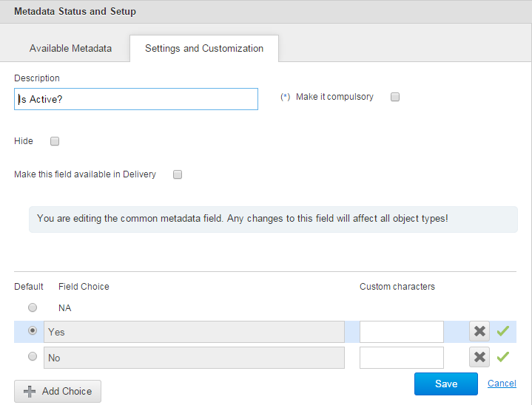

Figure 70 *Metadata* tab > *Radiobuttons* type of metadata

##### *Hyperlink* metadata

Metadata of *Hyperlink* type have such properties (see Figure 71):

* *Description text box.*
* *Make it compulsory checkbox.*
* *Field Size dropdown list.*
* *Hide checkbox.*
* *Field Format section.*

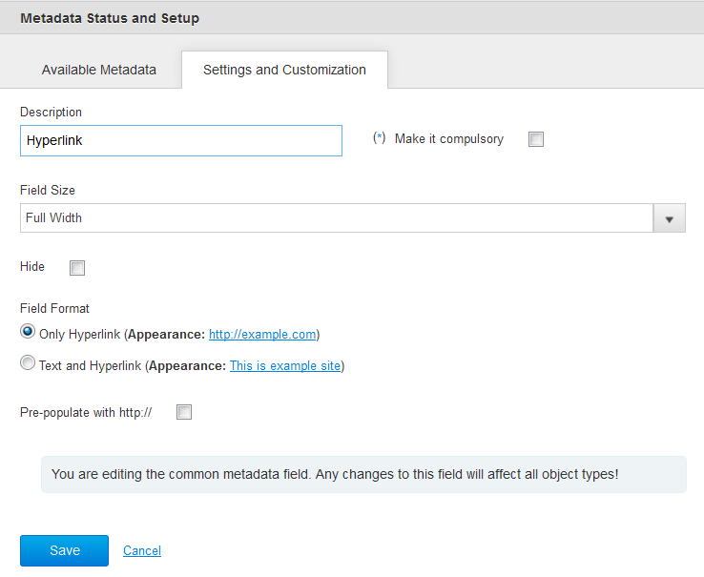

Figure 71 *Metadata tab > Hyperlink* type of metadata

Review for the *Description*,the *Make it compulsory,* the *Hide* and the *Field Size* metadata properties see here*.*

The *Field Format* section is used to specify such hyperlink properties:

* *Only Hyperlink* (the example of appearance in this case is: http://example.com)*.*
* *Text and Hyperlin*k (the example of appearance in this case is This is example site)

In addition, it is possible to pre-populate hyperlink using ***http://***via the *Pre-populate with http://* checkbox*.*

##### *Custom Code* metadata

*Custom Code* type of metadata can be used for creating metadata fields based on *Custom Code Generator*, e.g. *Clock Number* or *Job Number* fields. To create metadata field of *Custom Code* type Business Unit Admin should select appropriate metadata schema and click the *Custom Code* control under the *Custom Metadata* section on the Admin area > *Metadata* tab > *Available Metadata* sub*-*tab.

After this, Business Unit Admin will see standard properties available for *String* type of metadata, i.e. *Description* text box, *Field Size* dropdown list, *Make it compulsory* checkbox and *Hide* checkbox. Except them, each field of *Custom Code* type has *Custom Code Generator* and the *Pick up values on the fly*checkbox,but both they are enabled if Business Unit Admin opens this field details after all standard properties were previously set and saved (see Figure 72).

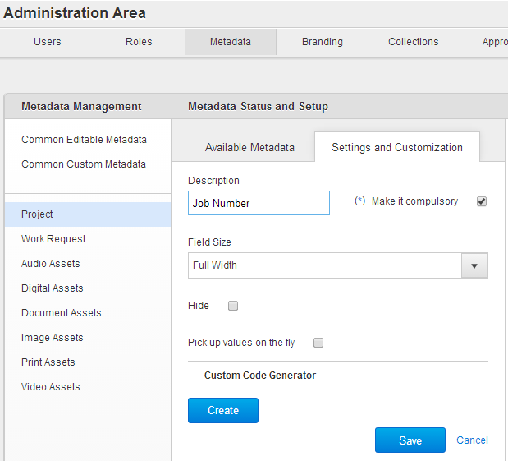

Figure 72 Admin area > *Metadata* tab > Creating field of *Custom Code* type

Original implementation: <https://jira.adstream.com/browse/NGN-7733>

Perverted implementation for Clock Number field for Ordering: <https://jira.adstream.com/browse/ORD-287>

**Note:** any changes to Custom Code Generator logic, especially in Delivery, should be handled with utmost care! It’s a very convoluted logic that is easily broken. Ideally it should be re-assessed and re-implemented from scratch.

### *Views* tab

*Views* tab is used to configure metadata details for Assets and files displayed in tile view within the Projects and Library areas. The tab is accessible by clicking the *Admin* link into the User menu and then clicking the *View* caption.

*View* tab is divided on the *View Management, Metadata Selection* and *Preview* panes. *View Management* pane allows Business Unit Admin to switch between the views: *General Settings, Audio, Digital, Document, Image, Print* or *Video.* For the details how to customize metadata settings for Assets and files in tile view please refer to the page 575.

### *Branding* tab

*Branding* tab is used to customize System Branding and Login Page for Business Unit.

#### *System Branding* sub-tab

*System Branding* sub-tab is used to manage Web header for Business Unit (see Figure 73).

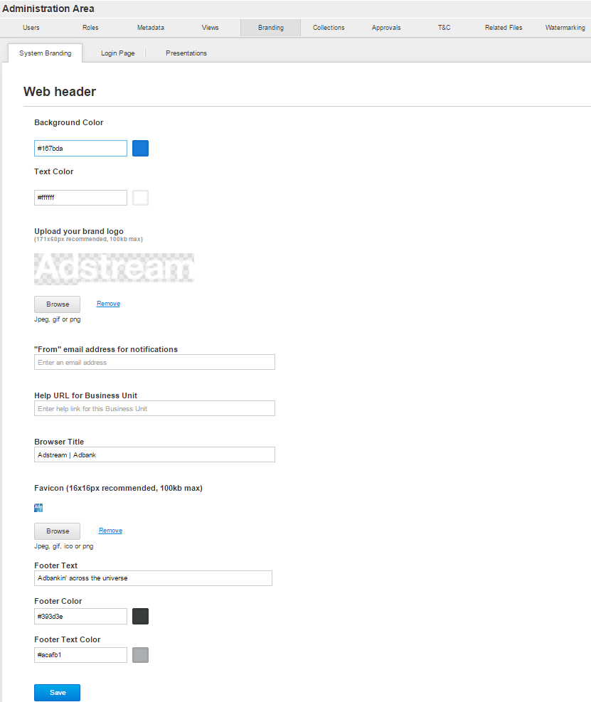

Figure 73 *Branding* tab > *System Branding* sub-tab

*System Branding* sub-tab details are described in Table 14.

Table 14 *System Branding* sub-tab details

| Field | Description |
| --- | --- |
| *Background Colour* picker | Is used to set background colour for the Web header of current Business Unit. |
| *Text Colour* picker | Is used to set text colour for Web header of current Business Unit. This text colour only affects visibility of options on the Delivery page: TV / Radio Music. By default, this colour is same as background, so those TV / Radio / Music options in delivery UI are completely invisible (and yes, this does confuse the hell out of people). |
| *Upload your brand logo* placeholder | Is used to upload (via the *Browse* button) and preview Web header’s logo of current Business Unit. |
| *Favicon* placeholder | Is used to upload (via the *Browse* button) and preview a favicon for web browser of current Business Unit. |
| *“From” email address for notifications* field | Is used to set email address for outcoming notifications for current Business Unit. Note: this setting is picked up from Sender’s BU settings. |
| *Help URL for Business Unit* field | Is used to set help link for current Business Unit. |
| *Browser Title* field | Is used to customize browser’s title for current Business Unit. |
| *Footer Color* picker | Is used to set colour for the footer of current Business Unit. |
| *Footer Text Color* picker | Is used to set text colour for the footer of current Business Unit. |

**Note:** for a user in multiple business units, all branding settings will be coming only from Primary BU settings.

#### *Login Page* sub-tab

*Login Page* sub-tab is used to manage Login Page details for current Business Unit (see Figure 74).

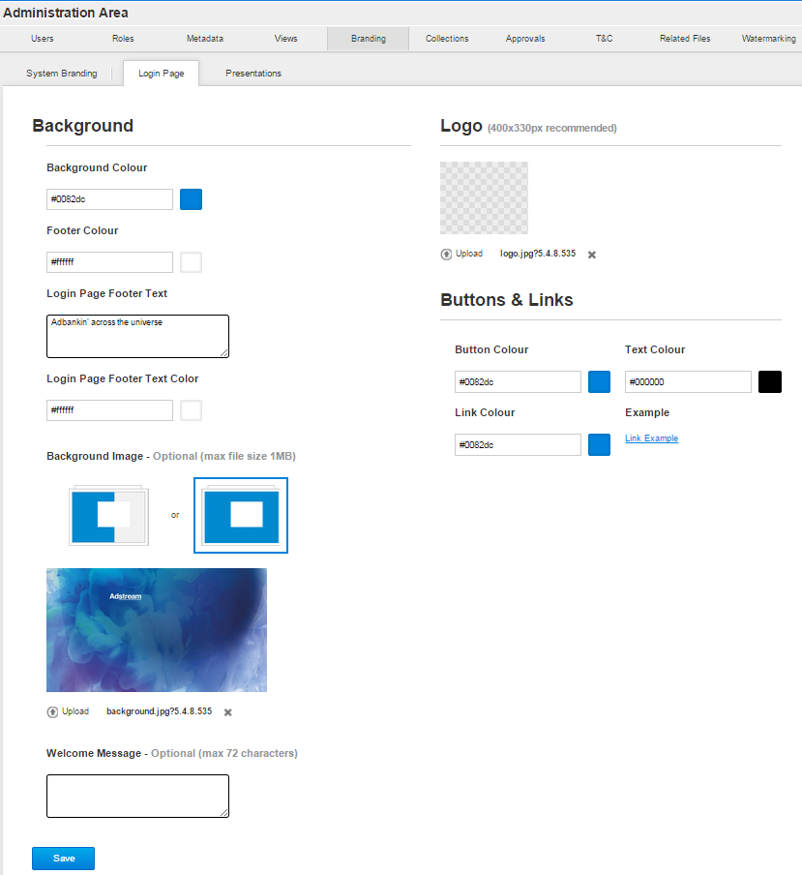

Figure 74 *Branding* tab > *Login Page* sub-tab

*Login Page* sub-tab details are described in Table 15.

Table 15 *Login Page* sub-tab details

| Field | Description |
| --- | --- |
| *Background Colour* picker | Is used for customizing background colour of the *Adbank 5* Login Page. |
| *Footer Colour* picker | Is used for customizing footer colour of the *Adbank 5* Login Page. |
| *Login Page Footer Text*field | Is used for customizing footer text of the *Adbank 5* Login Page. |
| *Login Page Footer Text Colour picker* | Is used for customizing footer text colour of the *Adbank 5* Login Page. |
| *Background Image* alignment control | Is used for customizing background image alignment of the *Adbank 5* Login Page. |
| *Welcome Message* field | Is used for customizing welcome message of the *Adbank 5* Login Page. |
| *Background Image* placeholder | Is used for preview background imagefor the Login Page of the *Adbank 5*. |
| *Logo* placeholder | Is used for preview logofor the Login Page of the *Adbank 5*. |
| *Upload* controls | Is used for uploading background imageandlogo for the Login Page into the respective placeholders. |
| *Button Colour* picker | Is used for customizing the *Login* button colour of the *Adbank 5* Login Page. |
| *Text Colour* picker | Is used for customizing text colour of the *Adbank 5* Login Page. |
| *Link Colour* picker | Is used for customizing the *Forgot password* link colour of the *Adbank 5* Login Page. |

**Note:** branding set up in BU Admin > Branding, is associated with user session via cookies. If you just set branding in BU Admin, without additional manipulations shown on Figure 2, user will only be able to see this branding after logging in and out of that BU.

#### *Presentations* sub-tab

*Presentations* sub-tab is used to manage default branding for Presentations within current Business Unit (see Figure 75). For the details about this please refer to the page 583.

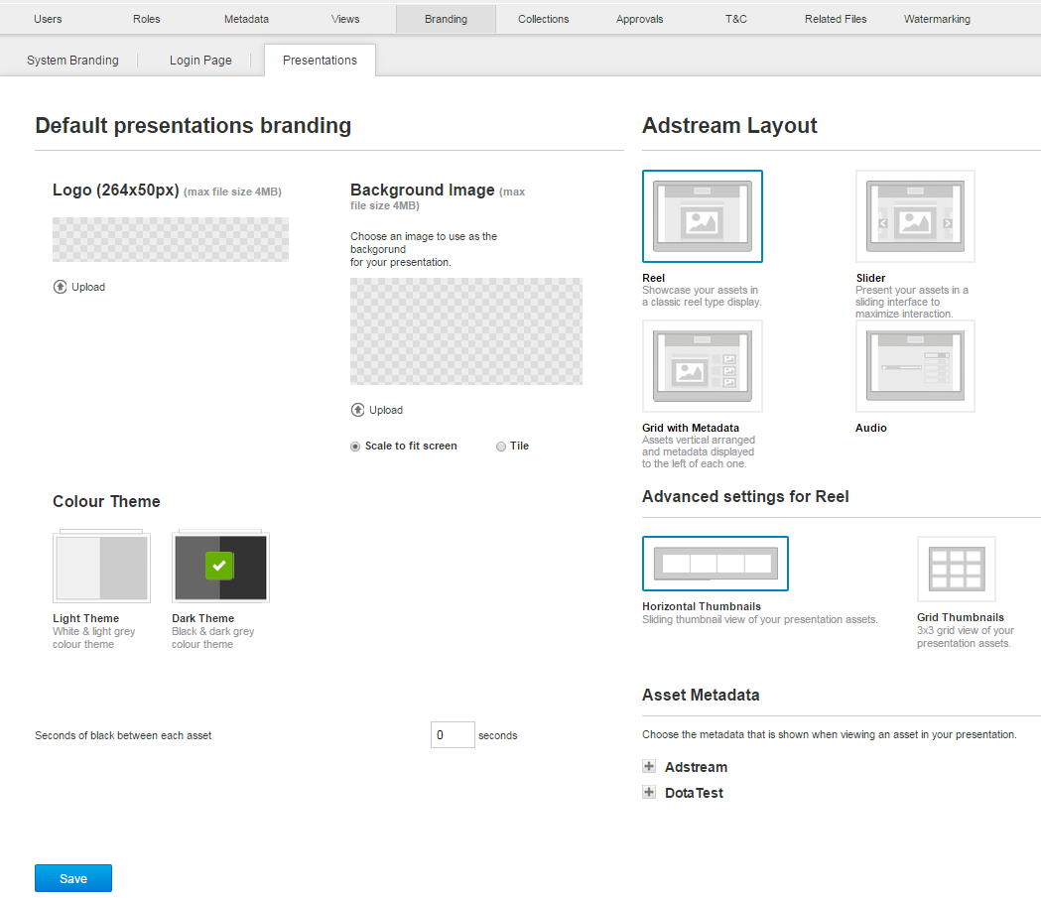

Figure 75 *Branding* tab > *Presentations* sub-tab

### *Collections* tab

The ability to organize content into collections, and share these collections to users with various permissions, is a key feature of the Library application.

Collection is a saved search filters. Collections can be private - created by user and only visible to this user, and public – created by BU admin in Admin > Collections area. Public collections can be shared to users (primary and secondary to this BU), Library Teams (dynamic user groups), and partner Business Units.

In the back-end, Public collections are creatively called “asset_filter_category”.

Private collections are called “asset_filter_collection”.

In Global Admin > Roles tab, you will see permissions asset_filter_category.read/write/delete, and asset_filter_collection.read/write/delete.

On a Global level, asset_filter_category.read permission grants user access to all Public collections of this BU. In the level of Library role, this permission gives access to specific Public Collection shared to a user.

On a Global level, asset_filter_collection.read will allow user to see all Private collections created by all users of this BU. This will probably kill Library UI for this user – it will die trying to load too many collections. This permission is not available on the level of Library role.

Removing asset_filter_collection.create permission from user’s Global role will hide Media Filter and Advanced Search controls in Library for this user.

Collections can be hierarchical. Child collections inherit filters from Parent collections, and use more filters to narrow down search results. https://jira.adstream.com/browse/NGN-4762

Sharing Parent collection to a user will automatically share all its Child collections, as well.

*BU Admin > Collections* tab is used to:

* Add, edit, rename and delete single or multiple administrative Collections.
* Share admin Collections with users, Business Units and Library Teams.
* Add, edit and delete Section Breaks for the Collections.

The tab is accessible by clicking the *Admin* link into the User menu and then clicking the *Collections* caption (see Figure 76).

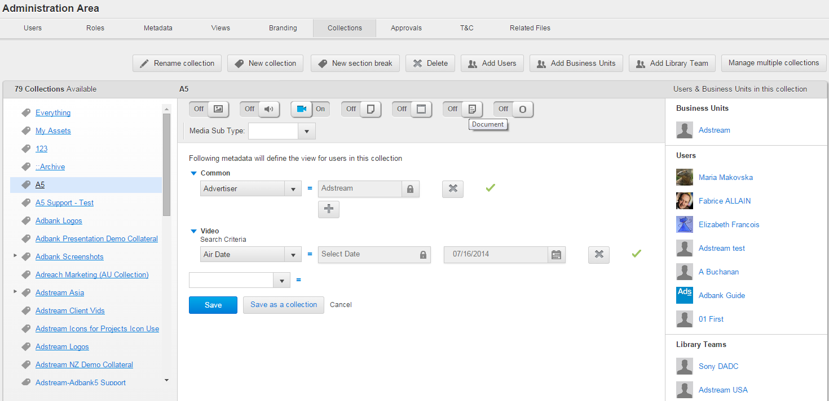

Figure 76 *Collections* tab

*Collections* tab details are described in Table 16.

Table 16 *Collections* tab details

| Field | Description |
| --- | --- |
| *Collections* *Available* section | This section contains list of Public Collections available for current Business Unit user. There are default Collections: *Everything* and *My Assets*. These collections are not editable and cannot be shared.  Everything collection is literally that – all assets of the current Business Unit. There are some serious architectural concerns around implementation of this collection, especially around the cases when user has access to Everything collection in more than one BU. Ideally it should be re-implemented to become All Assets Available to Current User, across all business units where this user has Library access.  My Assets is a collection of assets uploaded by the current user. When an asset it uploaded, it does not have any metadata, so by default will land in My Assets of the user who uploaded it, and in Everything (available by default to Agency Admin role). |
| Collection metadata section | This section contains set of Collection metadata which define what assets will be appearing in this Collection. |
| Media Types filters | Is used to define media types of Assets which should be included a Collection.  **Note:** Enabling media type filters unlocks more metadata options available for building collection filters! |
| *Media Sub-Type* filter | Is used to define media sub-type for single selected media type of Assets which should be included a Collection. |
| *New* Collection button | Is used to create new Collections. |
| *Delete* button | Is used to delete Collections and Section Breaks. |
| *Add Users* button | Is used to share Collections with single or multiple users. You can share a collection to primary user of the current BU, secondary user of the current BU, or user from Partner BU which hasn’t been added to your BU previously. Adding a user from Partner BU to a Collection automatically adds this user to the list of secondary users of the current BU. |
| *Add Business Units* button | Is used to share Collections with partner Business Units.  For more information, see *Shared Collections* tab. |
| *Add Library Team* button | Is used to share Collections with single or multiple Library Teams of the current BU.  Unlike Project Teams, Library Teams are dynamic user groups. Adding a user to Library Team automatically gives this user access to all public Collections already shared to this Library Team. Removing user from the Library Team removes this access. |
| *Users & Business Units in this collection* section | This section contains list of users, Business Units and Library Teams for a Collection which is selected from the *Collections* *Available* section.  Library Teams added to a Collection are grouped under the *Library Teams* section. Clicking separate Library Team name in this section brings up pop-up dialog box with list of users in this Team; there are no actions available for this list. Adding user to the Library Team automatically allows access for this user to all Collections where this Team has been assigned. Removing user from Library Team stops access to all Collections where this Team has been assigned. However, if user has been added to some Collection individually, their individual access remains. Deleting Library Team removes access from all users from all Collections where this Team has been assigned.  The *Users* section lists only users added individually to the Collection, not as part of Library Team. |
| *Rename collection* button | Is used to rename current Collection. |
| *New section break* | Is used to create new Section Break to demarcate Collections. Section breaks in the Library is a very dodgy functionality which was never completed properly. You are strongly advised not to partake of it. |
| *Manage multiple collections* button | Is used to switch to the *Multiple Collections* view for sharing multiple Collections at once with users and Library Teams. If the button is clicked, only the *Add Users* and *Add Library Team* buttons are enabled on the tab. |
| *Manage single collections* button | Is used to switch to the *Single Collections* view for managing single Collections and Section Breaks. |
| *Save* button | Is used to save all changes made under metadata of current Collection. |
| *Save as a collection* button | Is used to save all changes made under metadata of current Collection as a new Collection. |
| *Cancel* link | Is used to discard all made settings with set of Collection metadata. |

### *Approvals* tab

*Approvals* tab is used to manage Approval templates within current Business Unit. The tab is accessible by clicking the *Admin* link into the User menu and then clicking the *Approvals* caption. For more details about Approval templates management see description on the page 596.

**Note:** this is not to be confused with Traffic tab, which is used to manage Broadcaster Traffic Interface Approvals. Traffic tab is only available for BU of type: TV Broadcaster.

### *T&C* tab

*T&C* tab is used to add, edit and delete Terms and Conditions for current Business Unit; also to enable or disable them for the Projects within it (see Figure 77).

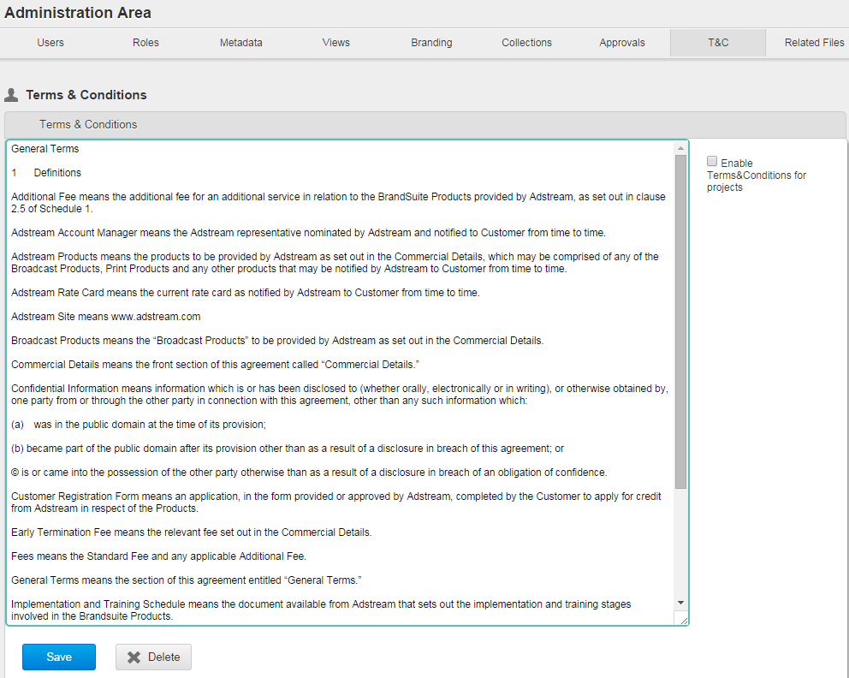

Figure 77 *T&C* tab

After the Terms and Conditions are added for a Business Unit, users of this Business Unit will be prompted to accept them during their first login to the *Adbank 5*. T&C acceptance is provided by clicking the *Accept* button in the *Terms and Conditions* pop-up window. After this, a user will be redirected to the Dashboard. T&C declining (by clicking the *Decline* link in the pop-up window) will result to automatic logout of the *Adbank 5*. Terms and Conditions text are limited to 200,000 symbols (see Figure 78).

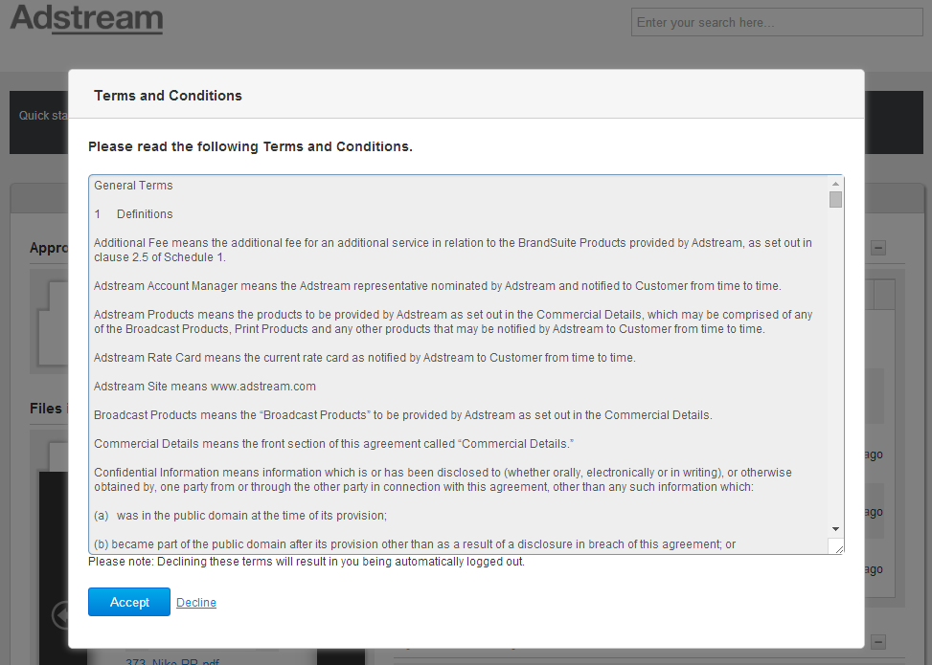

Figure 78 Log in the *Adbank 5* > Terms and Conditions to accept

### *Related Files* tab

*Related Files* tab is used to add and delete Relations Types. They can be used while linking Project files/Assets within current Business Unit (see Figure 79).

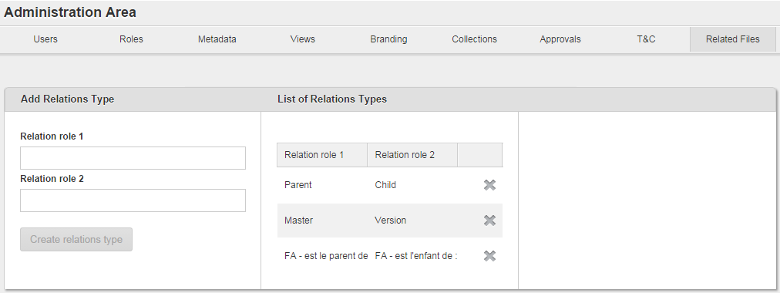

Figure 79 *Related Files* tab

For the details about managing Relations Types please refer to the page 610.

## *Address Book* tab

*Address Book* tab is used to manage current user contacts and Groups. The tab is accessible by clicking the *Address Book* link into the User submenu. If the *All contacts* is selected, full list of contacts within user’s Address Book is displayed (see Figure 86).

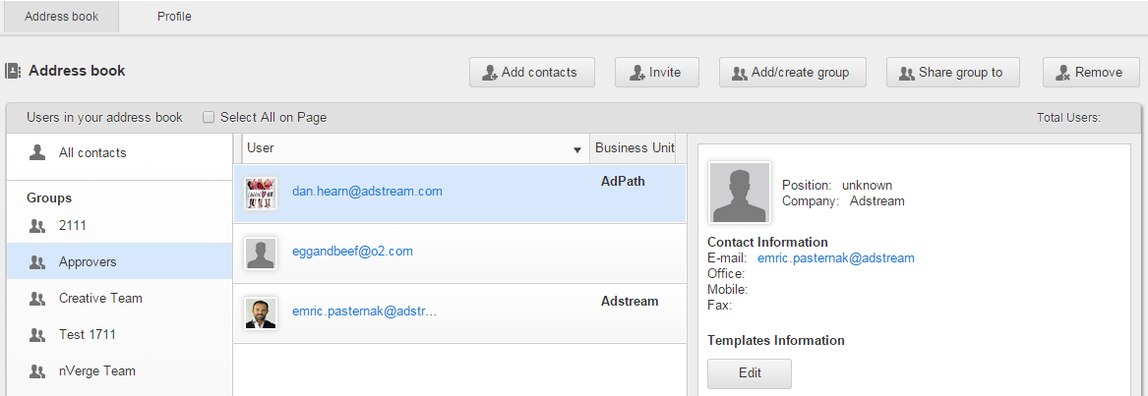

Figure 86 *Address Book* tab > All contacts view

If a Group is selected, only its contacts are displayed.

*Address Book* tab details are described in Table 19.

Table 19 *Address Book* tab details

| Field | Description |
| --- | --- |
| List of Groups | Is used to display all contacts and available notification Groups. For more information about Notification Groups, see https://jira.adstream.com/browse/NGN-14474 |
| List of contacts | Is used to display contacts within selected Group. |
| *Select All on Page* checkbox | Is used to select all contacts within selected Group. |
| Contact details | Is used to view and edit:   * General information: name, position and company. * Contact information: email, office, mobile and fax.   “Team Template” information section is some unknown artefact of someone’s early creativity. Never built, never used.  Contact Details are isolated to user’s address book and are not shared. This is one of the oldest areas of the system which begs for refactoring. The concept of a “contact”, in addition to “user”, already caused much grief and confusion. |
| *Edit* button | Is used to edit contact details. |
| *Add contacts* button | Is used to add existing users as contacts to the Address Book. |
| *Invite* button | Is used to invite unregistered users to register and start using the system, and add them as contacts t the current address book. |
| *Add to Group* button | Is used to add users to Notification Group(s). For more information about Notification Groups, see https://jira.adstream.com/browse/NGN-14474 |
| *Share Group* button | https://jira.adstream.com/browse/NGN-14559 |
| *Remove* button | Is used to remove selected contact from selected Group or the Address Book. |

**Note:** For the details about managing current user contacts and Groups please refer to the page 614.

## Global Search tool

The Global Search tool allows a user to search by any metadata field simultaneously across all system objects a user has access to. The tool is located at the top right corner, under the user menu (see Figure 91).

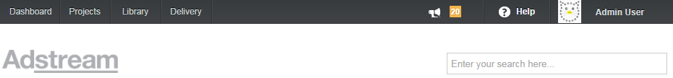

Figure 91 Global Search tool

**Search relevance**

I. Most relevant are considered full text matches in the below metadata fields:

1. *Clock.*
2. *Title.*
3. *Advertiser, Product, Brand, Sub-brand.*

II. After them, next relevant are considered partial matches in the same fields.

III. After them, next relevant are considered full text matches in any other fields, in no particular order.

IV. After them, least relevant are considered partial matches in any fields, in no particular order.

Also, Global Search tool works according to several basic rules described below.

**First rule**

Exact-match search has highest priority. The more exact search query entered in the Global Search tool, the more relevant search results displayed in the top three results of the search dropdown list.

Search query should contain at least one keyword of two characters minimum, both of which is not space.

‘*’ wildcard can replace any number of characters in the search query. So, it can consist even of one character and ‘*’.

Global Search returns search results with any character in the title (i.e. letter, number, stopword or special symbol), regardless from which character is in the title’s beginning.

**Second** **rule**

1. Search by the Clock Number (or a part of it) has higher priority than by the title (or this part in it).

For example, one Asset has *UK Ladies* title, and another one has *‘ABC/123/UK’* clock number, and there are no Assets with *‘UK’* full title in the Library. By entering *UK* keyword in the Global search tool a user will firstly see the Asset with *‘ABC/123/UK*’ clock number, and then the Asset with ‘*UK Ladies’* title, on the search dropdown list and on a Search Results page.

2. Search by full phrase (of two or more words) entered in a metadata field has higher priority than the search by any word of this phrase in the title.

For example, one Asset has ‘*Mononoke’* title, and another one has *Project Description* field which contains ‘*princess Mononoke’* phrase, and there are no Assets with *‘princess Mononoke*’ full title in the Library. By entering ‘*princess Mononoke*’ keywords in the Global search tool a user will firstly see the Asset with ‘*princess Mononoke’* phrase in the metadata field, and then the Asset with *‘Mononoke’* title, on the search dropdown list and on a Search Results page.

To perform global searching a user should enter a search query in the Global Search tool (see Figure 91) and click appropriate title displayed in the dropdown list with matched search results.

Search results in the search dropdown list are sorted by the groups:

* *Projects/Work Requests.*
* *Project Templates/Work Request Templates.*
* *Files & Folders.*
* *Assets.*
* *Presentations.*
* *Users.*
* *Shared Collections.*

It can be displayed up to three the most relevant search results per each group of results.

To go to appropriate search result a user should click its title. If Global Search did not return any matching results, the user is informed by respective UI notification*.*

If there are several equally relevant search results displayed in the search dropdown list below the Global Search tool, the last uploaded relevant result which matches to the search query is considered as the most relevant.

For example, search query is *Beam*, and there are three Assets where the *Advertiser* is *Beam*:

* Asset created on January 1, 2010.
* Asset created on January 1, 2013.
* Asset created on December 15, 2014.

In the search dropdown list and related Search Results page these Assets are displayed in this order:

1. Asset created on December 15, 2014.
2. Asset created on January 1, 2013.
3. Asset created on January 1, 2010.

After the user specified a search query in the Global Search tool, for all search results their metadata, which match to the search query, are displayed and highlighted in yellow in the search dropdown list. This highlighting is applied for the *Advertiser, Brand, Sub-brand, Product* and *Clock Number* metadata fields, even if the title of the search results does not match to the search query. To show all matching results for a group it is necessary to click the *Show all results* link below appropriate group legend (see Figure 92).

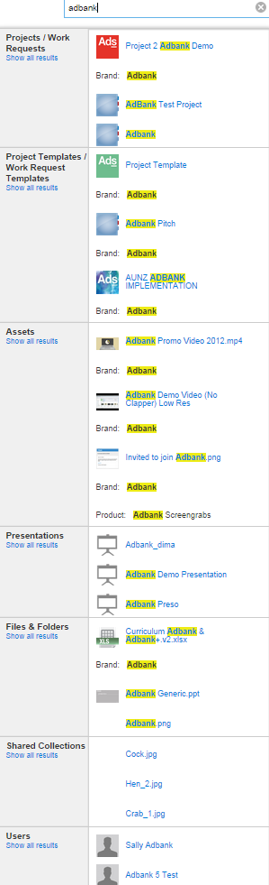

Figure 92 Global Search tool > Dropdown with matched search results

**Note**: If a user uses Global Search tool being within a Project (i.e. Project details page is opened at present), the *Search in Current Project* link appears below the search box. This link limits search results, so a user can view only the file(s) within current Project or users within the Project Team which contain matched metadata (see Figure 93).

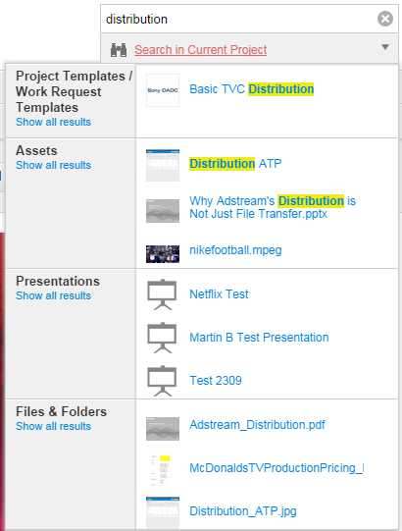

Figure 93 Global Search tool > *Search in Current Project* link

After the *Search in Current Project* link is clicked, the *Search everything* link appears instead of it, the Global Search dropdown list narrows to the *Files & Folders* search group where matched file is displayed. To come back to the previous search results it is necessary to click this link (see Figure 94).

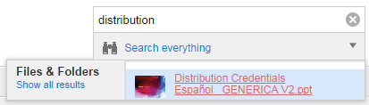

Figure 94 Global Search tool > *Search everything* link

### Search Results pages

If the *Show all results* link is clicked below the *Projects/Work Requests* legend in the Global Search dropdown list (see Figure 92), a user is redirected to the Search Results page for Projects/Work Requests (see Figure 95).

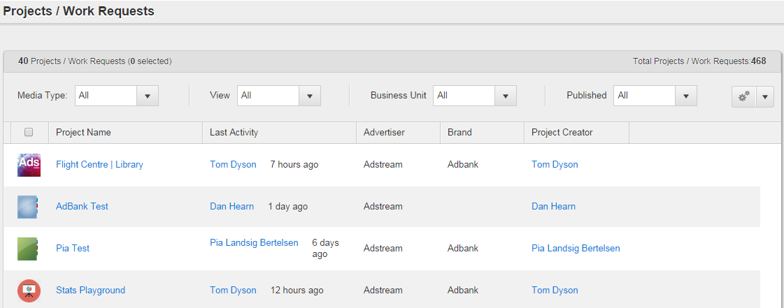

Figure 95 Search Results page for Projects/Work Requests

If the *Show all results* link is clicked below the *Project Templates/Work Request* *Templates* legend in the Global Search dropdown list (see Figure 92), a user is redirected to the Search Results page for Project Templates/Work Request Templates (see Figure 96).

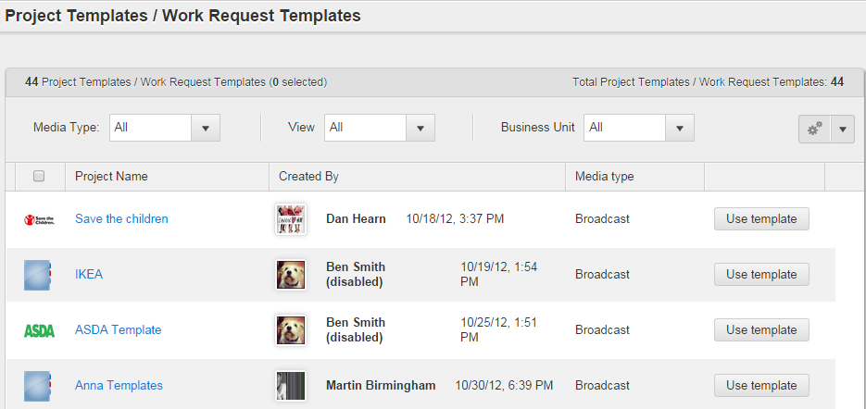

Figure 96 Search Results page for Projects Templates/Work Requests Templates

**Note:** There is a big problem with the columns that we need to display in search results for Projects and Work Requests. The original idea was that Projects and Work Requests should be represented in separate search result groups, but this was not possible to implement in the current architecture. On the other hand, Projects and Work Requests have completely separate metadata schema, so we could not properly combine the two in the search results columns configuration control. In the end we have hardcoded some options to display in search results for both Projects and Work Requests. Eventually this caused issues with Disney implementation, so we had to introduce the following changes: <https://jira.adstream.com/browse/NGN-19970>, <https://jira.adstream.com/browse/NGN-19971>

Normal expected behaviour here should be to show the same columns in search results as they are selected in the main Projects / Work Requests list view.

If the *Show all results* link is clicked below the *Assets* legend in the Global Search dropdown list (see Figure 92), a user is redirected to the Search Results page for Assets (see Figure 97).

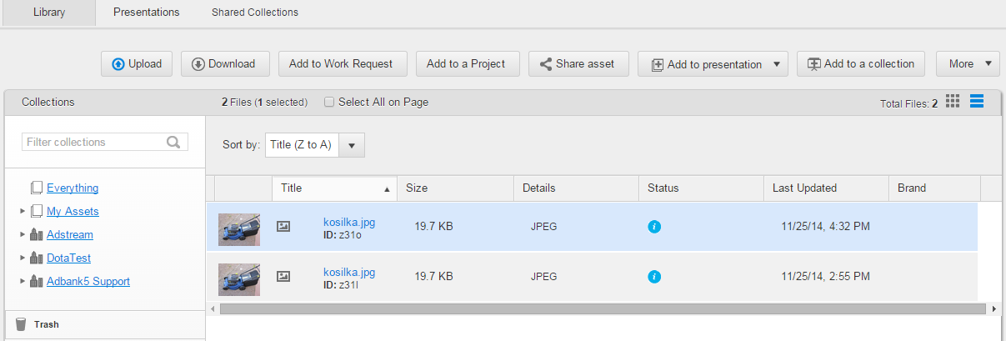

Figure 97 Search Results page for Assets

**Note:** there is a problem with this view configuration if the user has access to more than one BU Library. See https://jira.adstream.com/browse/FAB-18.

If the *Show all results* link is clicked below the *Files & Folders* legend in the Global Search dropdown list (see Figure 92), a user is redirected to the to the Search Results page for files and folders (see Figure 98).

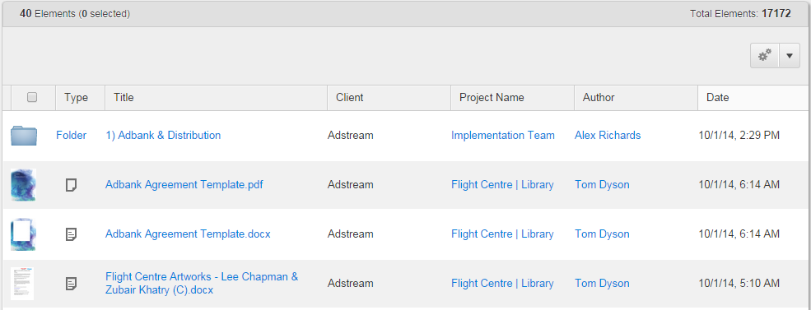

Figure 98 Search results page for files and folders

If the *Show all results* link is clicked below the *Shared Collections* legend in the Global Search dropdown list (see Figure 92), a user is redirected to the Search Results page for Shared Collections (see Figure 99).

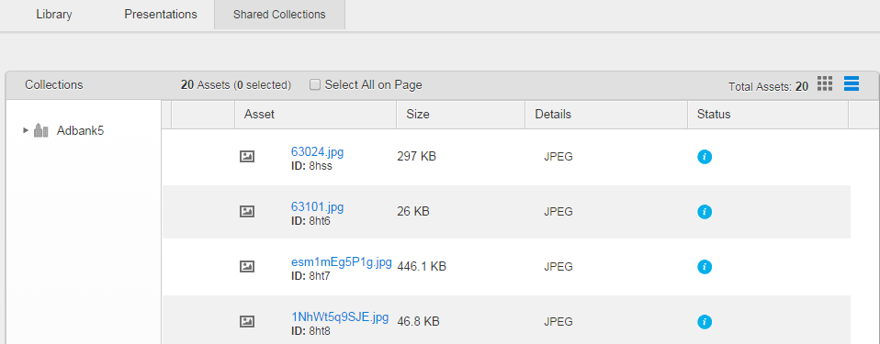

Figure 99 Search results page for Shared Collections

If the *Show all results* link is clicked below the *Presentations* legend in the Global Search dropdown list (see Figure 92), a user is redirected to the Search Results page for Presentations. This page is similar to the *Presentations* tab (see Figure 44).

If the *Show all results* link is clicked below the *Users* legend in the Global Search dropdown list (see Figure 92), a user is redirected to the Search Results page for users. This page is similar to the *Address Book* tab (see Figure 86).

### Examples of using Global search

**Example – Exact-match search**

* Asset #1 with the title: *‘By_the_book*’.
* Asset #2 with the title: ‘*Bookshelf.avi*’ and campaign: ‘*Book shop’*.
* Asset #3 with the title: *‘Home library/books’*.
* Asset #4 with the title: *‘Bookshelf.mpg*’.
* Asset #5 with the title: *‘5.56 mm round’*.

If the search query is ‘*book*’, relevant search results are displayed in such order:

1. Asset #1.
2. Asset #2

If the search query is ‘*book*s’, relevant search result is Asset #3.

If the search query is ‘*Bookshelf*’, relevant search results are displayed in such order:

1. Asset #2.
2. Asset #4.

If the search query is ‘*5.56 mm*’, relevant search result is Asset #5.

**Example** **– Search by polynomial title**s

If titles are *‘image test sample’, ‘image sample test’* and *‘image sample’* and the search query is *‘image test sample’,* search results are displayed in such order (see Figure 100).

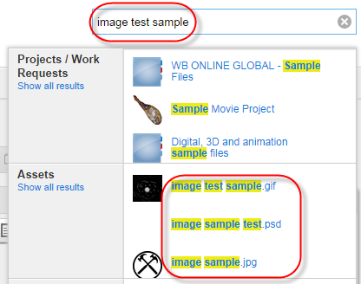

Figure 100 Search by polynomial titles

**Example – Search by monosyllabic titles with space**s

Monosyllabictitles with spaces can be found. If a title consists of two characters divided by the space, search results are displayed after the all characters were entered in the search box.

For example, if the title is *‘L B’* and the search query is *‘L ’*, the search results will not be displayed until the ‘*B*’ character is entered in the search box.

**Example – Search by titles with special symbols**

Titles with special symbols (e.g. dots, brackets, apostrophes, etc.) can be found. In this case, special symbols are not highlighted in the search dropdown list. (see Figure 101).

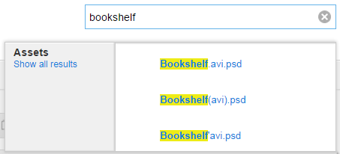

Figure 101 Search by titleswith special symbols

**Example – Search by the Clock Numbers**

Video and Audio Assets with Clock Numbers matching to the search query are always displayed in the top three search results of the search dropdown list. Also, it works for parts of Clock Numbers split by separator (see Figure 102).

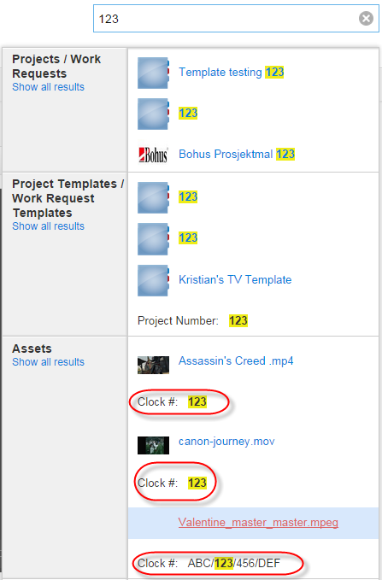

Figure 102 Search by the Clock Numbers

## Customizing data views

### Scrolling data in lists

Scrolling is applied for the lists of:

* Projects/Work Requests.
* Project/Work Request Templates.
* Notifications.
* Collections.
* Assets.
* Presentations.
* Project files and folders.
* Users.
* User activities (for files/Assets/*Recent Activity* widget).
* Search results.

While a user scrolls down the list on a page, all its content preloads, herewith the user can see special preloader (spinning wheel) and the list counter (e.g. ) which appear when general quantity of items does not fit on page.  button on the counter is used to go to the list begining. First number shows quantity of items which are not displayed on current page because of scrolling, second number indicates overall quantity of items presented on the page.

When user navigates away from the page and then returns, they can see just top results (previous number of loaded items does not keep).

When user has *X* items on page and total amount of items is *Y*, and user tries to sort the list, system sorts *Y* amount and show *X* results accordingly.

The preloader is used to show for a user the process of autoloading of next ten items per page (tab) during scrolling. For example, on Figure 103 is shown preloader which appears while scrolling list of Projects on the *Projects* tab.

Wonderful “preloader” contributes to approximately 3-5 support tickets every month. It’s a buggy, confusing piece of code, and whoever approved this abomination into development and release, should be condemned to work in support in their next life.

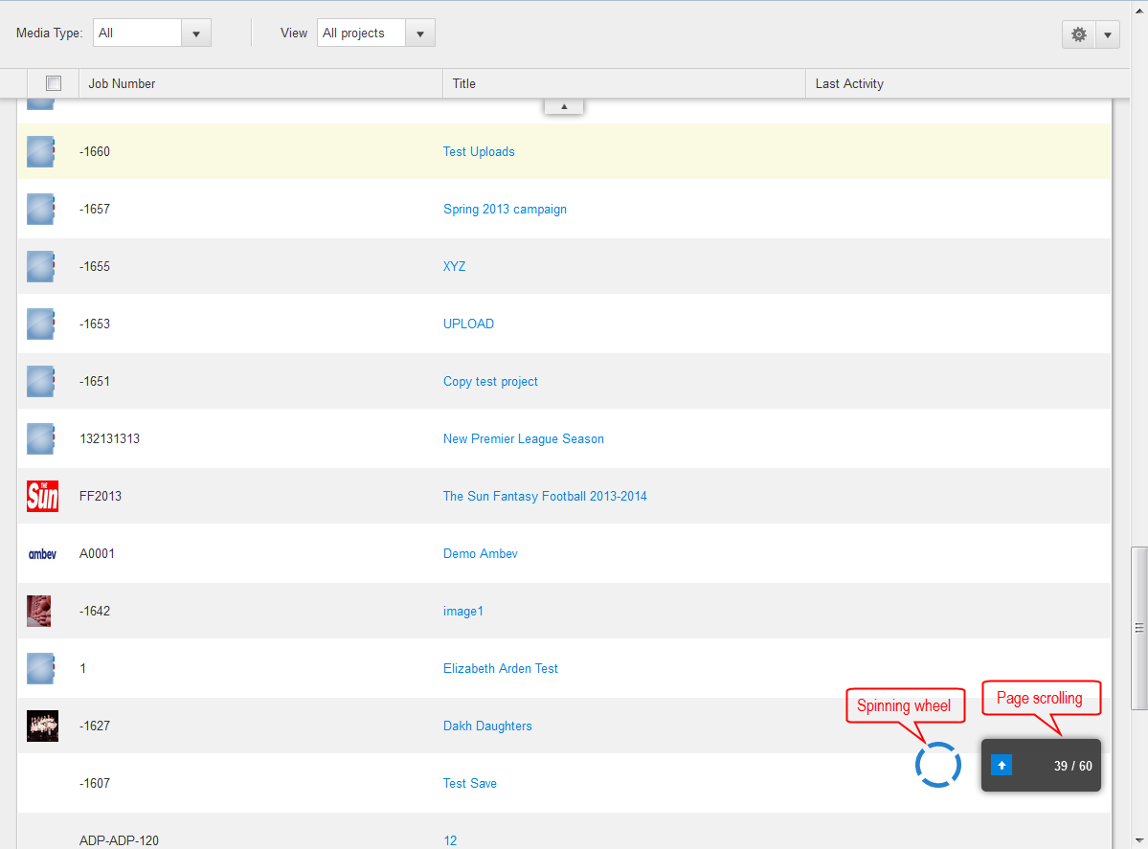

Figure 103 *Projects* tab > Scrolling list of Projects > Preloader

If a user clicks some Project, file or Asset to see its details during scrolling through the list, and after this they click the  browser button to return back, they automatically will be returned to the same position in the items list where they was before clicking the  browser button.

Standard scroll bar is used to scroll list of folders on the Project details page > *Overview/Files* tab, list of Collections on the *Library* tab and list of Presentations on the *Presentations* tab (see Figure 104 and Figure 105).

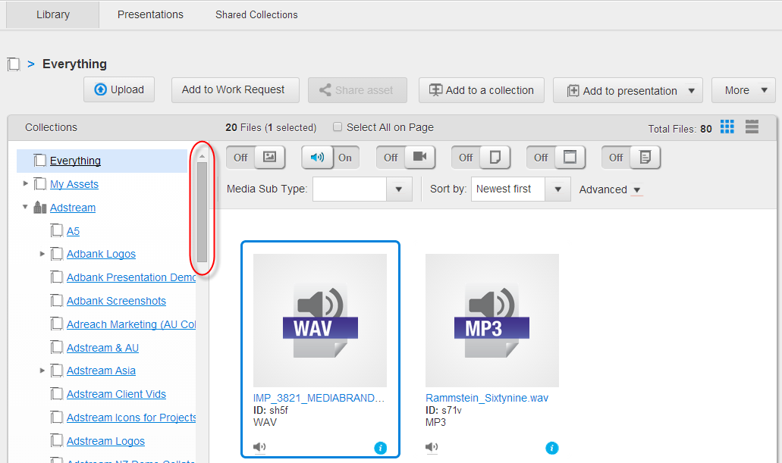

Figure 104 *Library* tab > Scroll bar for list of Collections

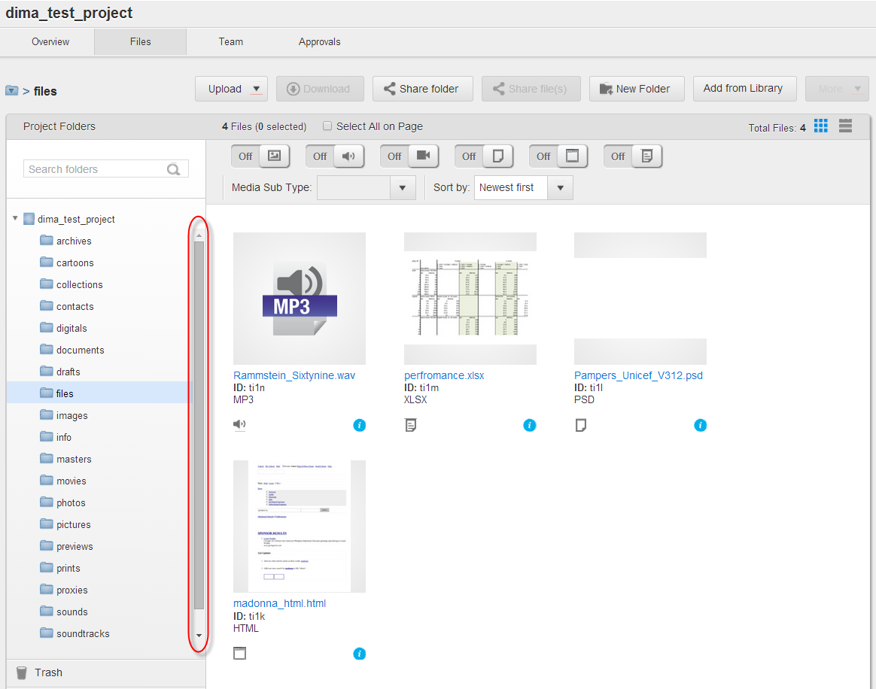

Figure 105 Project details page > Scroll bar for list of Project folders

While a user is scrolling through the list of Assets on the *Library* tab, or list of Presentations on the *Presentations* tab, pane with list of available Collections/Presentations (to the left side of appropriate tab) remains always visible for the user (see Figure 106). Also, paging (autoscroll) is applied to the list of Presentations while users scroll through the *Presentations* tab.

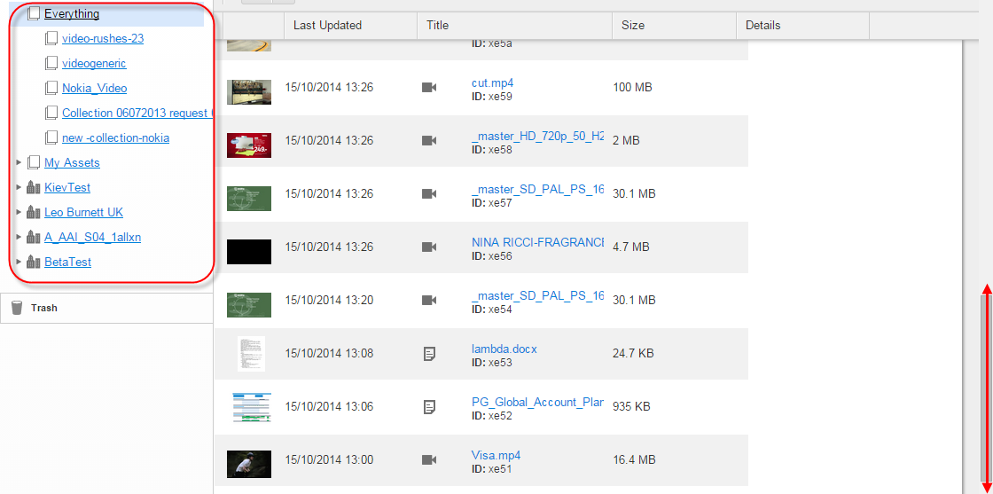

Figure 106 *Library* tab > Pane withlist of availableCollections is always visible for users

### Filtering data

Filtering lists of Projects, Projects Templates, Work Requests, Work Request Templates, files, users, Presentations and Assets is kept in the position selected by a user while they navigate through the *Adbank 5*. Selected filtering remains even after the user made re-authorization.

#### Filtering Projects, Work Requests and their Templates by views

On the *Projects* tab users can filter Projects per two groups: *All Project* (default) and *My Project* (see Figure 107)*.*

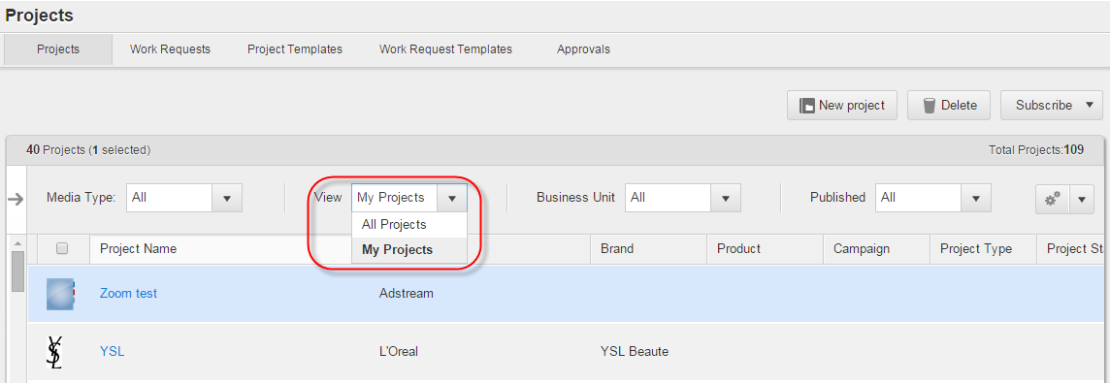

Figure 107 *Projects* tabs > Filtering by Views

On the *Project* *Templates* tab users can filter Project Templates per such groups:

* *All Project templates* (default).
* *My Project templates* (see Figure 108)*.*

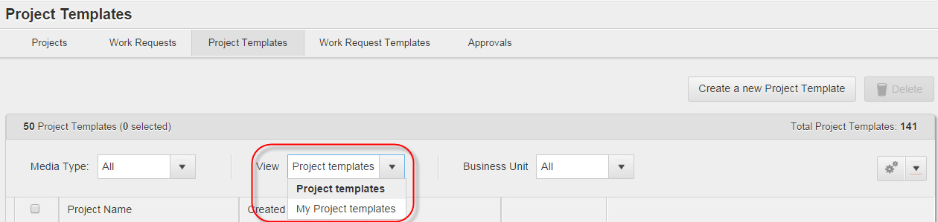

Figure 108 *Project Templates* tabs > Filtering by Views

On the *Work Requests* tab users can filter Work Requests per such groups:

* *All Work Requests* (default).
* *My Work Requests* (see Figure 109)*.*

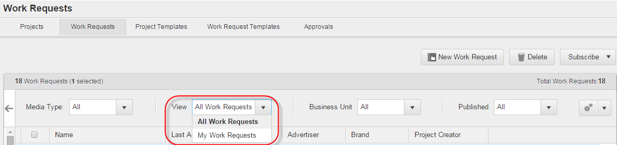

Figure 109 *Work Requests* tabs > Filtering by Views

On the *Work Request* *Templates* tab users can filter Work Request Templates per such groups:

* *All Work Request Templates* (default).
* *My Work Request Templates* (see Figure 110)*.*

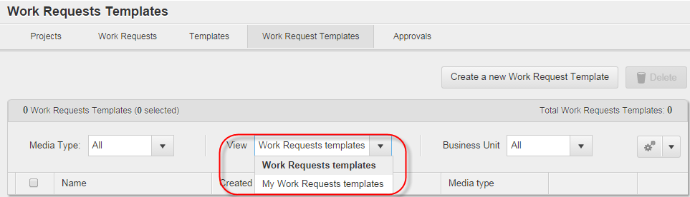

Figure 110 *Work Request Templates* tabs > Filtering by Views

**Note**: Default root folder for Projects and Project Templates is blue, while for Work Requests and Work Request Templates it is green.

#### Filtering Projects, Work Requests and their Templates by Business Units

If a user has access to the Projects, Work Requests, Project Templates or Work Request Templates of a partner Business Unit, they can filter them by this Business Unit.

To do this it is necessary to select appropriate Business Unit title from the *Business Unit* dropdown list on the appropriate tab. After this, list of Projects, Work Requests or their Templates will be filtered per selected Business Unit (see Figure 111, Figure 112, Figure 113, Figure 114).

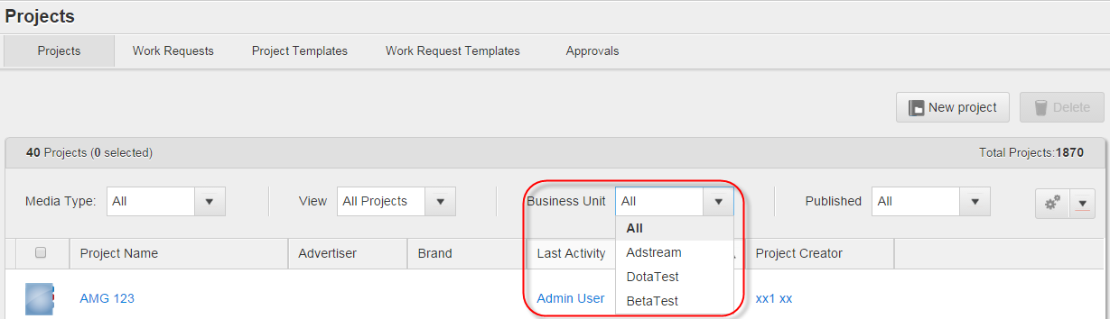

Figure 111 *Projects* tab > Filtering by Business Units

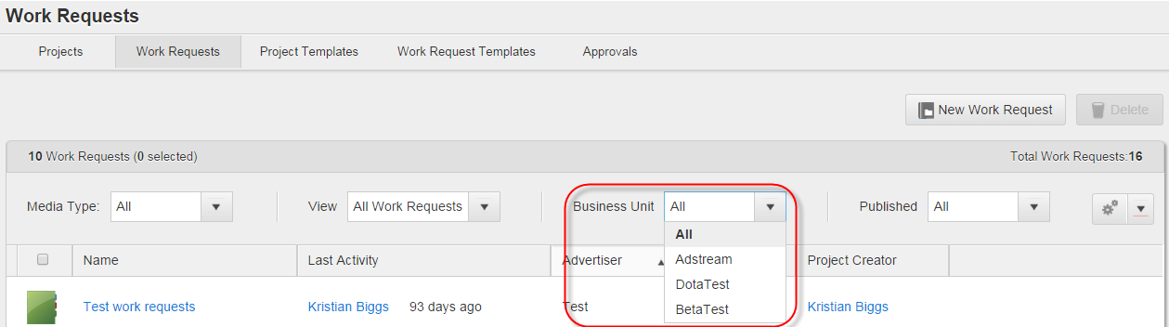

Figure 112 *Work Requests* tab > Filtering by Business Units

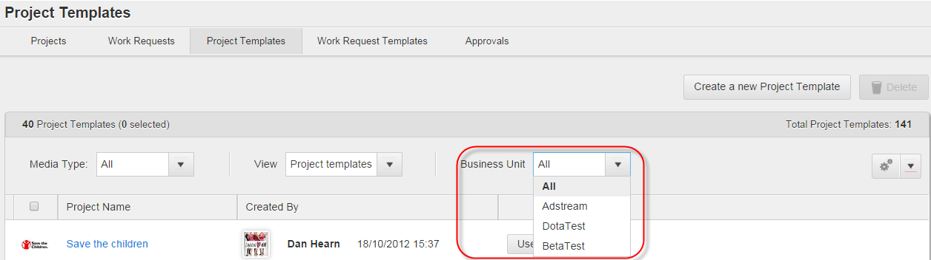

Figure 113 *Project Templates* tab > Filtering by Business Units

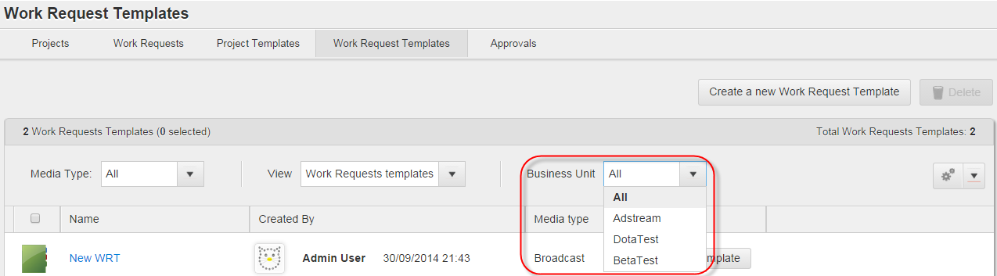

Figure 114 *Work Request Templates* tab > Filtering by Business Units

**Note**: If the *All* value is selected (default value), user will see Projects, Work Requests or their Templates of all Business Units where they have access.

#### Filtering Projects and Work Requests by *Published/Unpublished* status

Users have possibility to filter Projects and Work Requests by the *Published/Unpublished* status. To do this it is necessary to select appropriate status from the *Published* dropdown list on the *Projects* and *Work Requests* tabs (see Figure 115 and Figure 116).

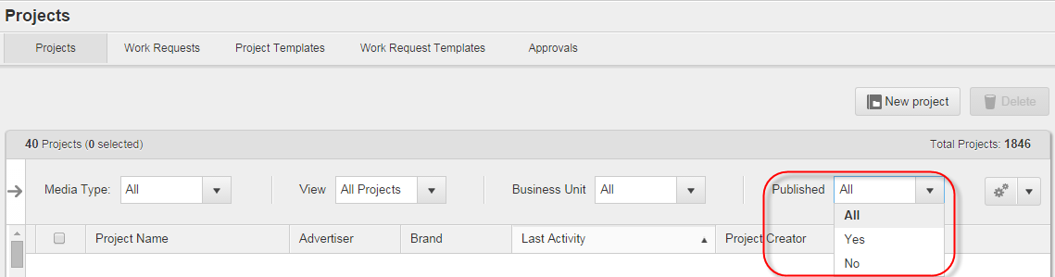

Figure 115 *Projects* tab > Filtering Projects by *Published/Unpublished* status

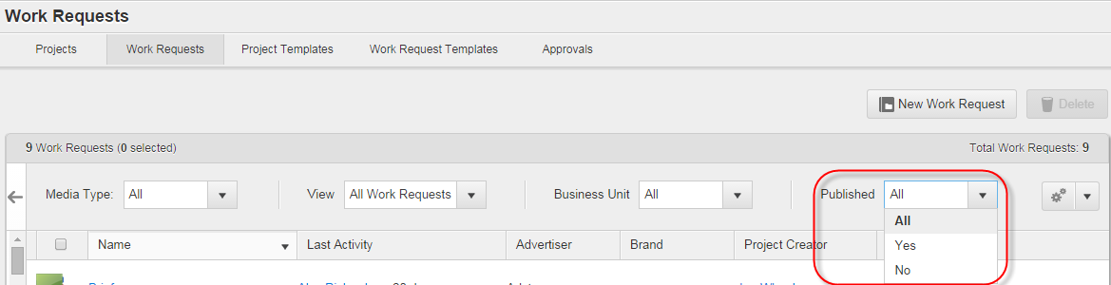

Figure 116 *Projects* tab > Filtering Work Requests by *Published/Unpublished* status

**Note**: Selecting the *All* value displays both published and unpublished Project/Work Requests on the active tab.

#### Filtering Projects, Work Requests and their Templates by Media Type

Projects, Project Templates, Work Requests and Work Request Templates can be filtered by Media Types (default and custom). To do this it is necessary to open appropriate tab and select necessary Media Type from the *Media Type* dropdown list. List of Media Types for sorting is the same on the *Projects, Project Templates, Work Requests* and *Work Request Templates* tabs (see Figure 117, Figure 118, Figure 119 and Figure 120).

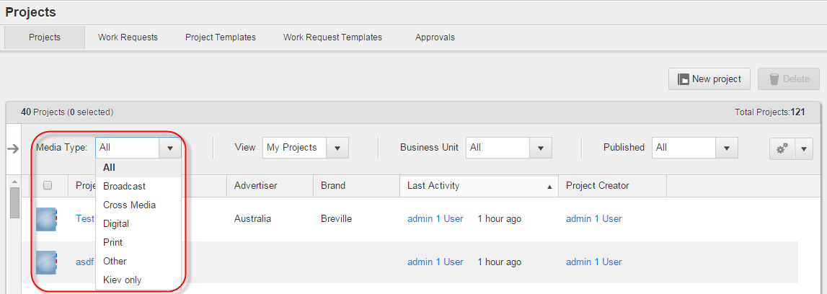

Figure 117 *Projects* tab > Filtering Projects by Media Type

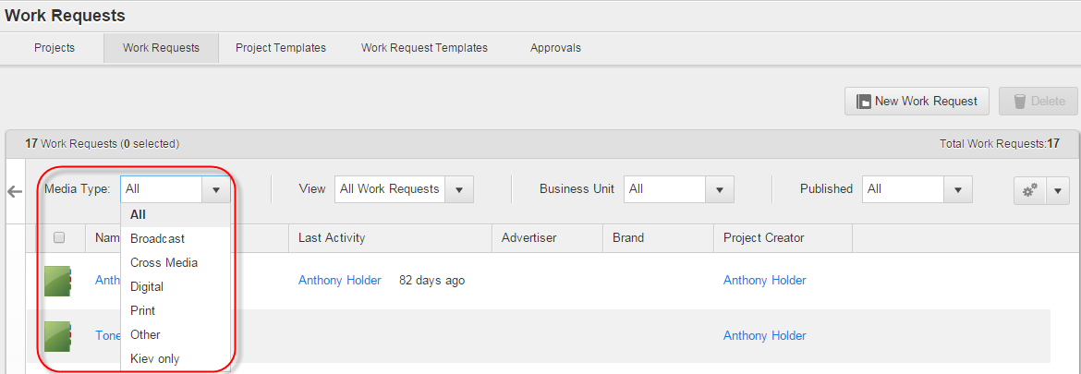

Figure 118 *Work Requests* tab > Filtering Work Requests by Media Type

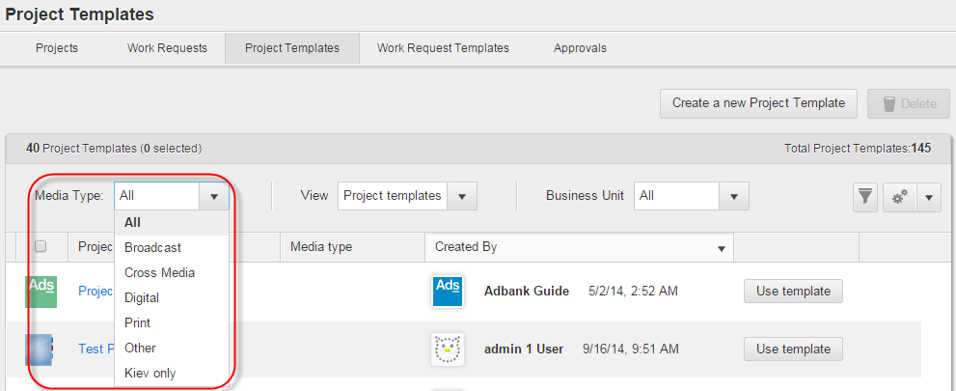

Figure 119 *Project Templates* tab > Filtering Project Templates by Media Type

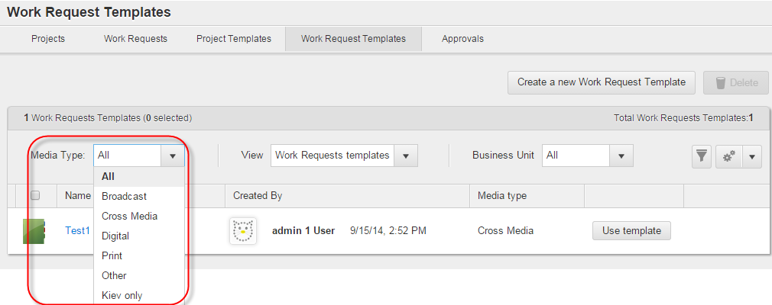

Figure 120 *Work Request Templates* tab > Filtering Work Request Templates by Media Type

#### Filtering Projects and Work Requests by Project metadata

Original implementation details: <https://jira.adstream.com/browse/NGN-11494>, <https://jira.adstream.com/browse/NGN-11488>

Later improvement to support metadata mapping, for users sitting in multiple business units: https://jira.adstream.com/browse/NGN-16874

Project metadata filters are based on the metadata of *Catalogue Structure* type, e.g. *Advertiser > Brand > Product*, etc. They can be used for filtering Projects and Work Requests on the *Projects* and *Work Requests* tabs.

If Global Admin enabled the use of Project metadata filters for a Business Unit, users of this Business Unit have possibility to apply them on these tabs by clicking appropriate metadata filter under the *Filters* panel. Clicking a filter will display only the Projects/Work Requests with matching metadata (see Figure 121).

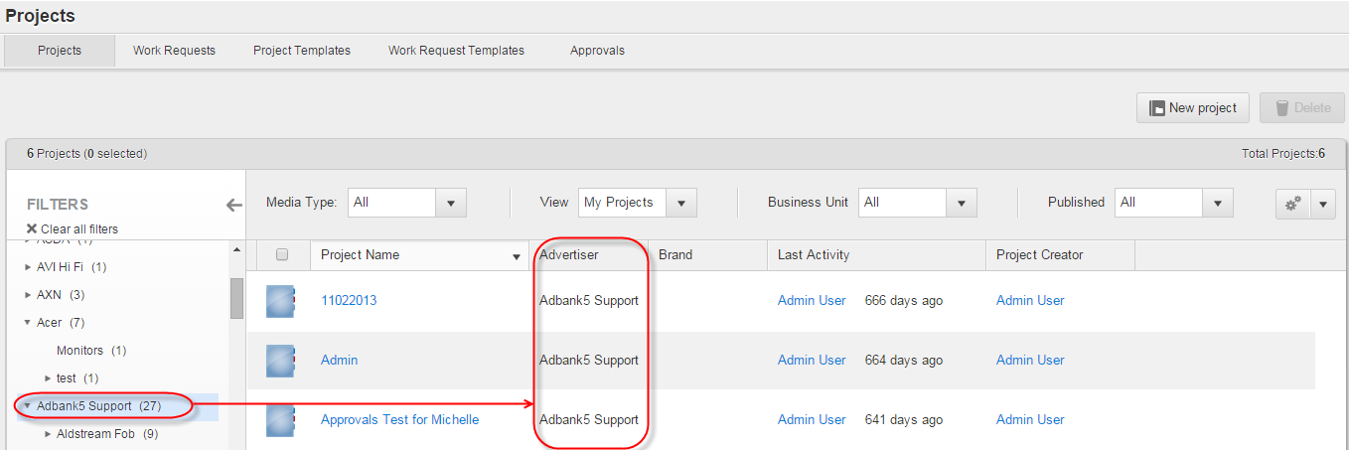

Figure 121 *Projects* tab > Filtering Projects by Project metadata

Filters can be hierarchically organized according to the structure of a *Catalogue Structure* field selected in the Business Unit settings. By default, all filter hierarchies on the *Filters* pane are collapsed. To expand a collapsed filter a user should click the  control next to it.

A user can apply only one Project filter at once to the Projects list. To reset applied filter and display list of Projects according to set regular filter(s) on the *Projects* tab (*Media Type, View* or *Business Unit* dropdown lists) it is necessary to click the  control above the filters. The control appears only if a Project filter is applied.

*Filters* panel can be expanded or collapsed by a user. To expand collapsed panel the user should click the  control, while to collapse it they should click the  control next on the right panel border. By default it is expanded.

Empty Project metadata filters are disabled in the *Filters* pane. So, if there are no Projects/Work Requests with matching metadata or accessible to a user, they does not see such filters in the list of Project metadata filters. Also, numbers of matching Projects/Work Requests are displayed in brackets next to each Project metadata filter.

**Note**: A user who has access to multiple Business Units can see all values from all common hierarchical metadata fields (which fall under the *Advertiser* hierarchy) from all Business Units where they have access.

**Note:** Project Metadata Filters are not very good friends with Column Filters on the Project List: https://jira.adstream.com/browse/NGN-13900. They are also not working properly for Work Requests https://jira.adstream.com/browse/NGN-13530. All this jazz should be wrapped in a brown paper, disposed in an environmentally-conscious way, and replaced with coherent advanced search control in the Projects / Work Requests list.

See also:

<https://jira.adstream.com/browse/NGN-18022>

<https://jira.adstream.com/browse/NGN-18807>

<https://jira.adstream.com/browse/NGN-19932>

<https://jira.adstream.com/browse/NGN-15617>

https://jira.adstream.com/browse/NGN-19682

#### Filtering activity records by activity types and users

Users have possibility to filter list of activity records by activity types and activity users. This filtering can be provided via the *Action* and *User* activity filters which are available on the:

* Dashboard > *Recent Activity* widget (see Figure 122).
* Project details page > *Overview* tab (see Figure 123).
* Asset details page > *Activities* tab (see Figure 124).
* File details page > *Activity* tab (see Figure 125).

Implementation details:

<https://jira.adstream.com/browse/NGN-12480>

<https://jira.adstream.com/browse/NGN-11155>

https://jira.adstream.com/browse/NGN-12943

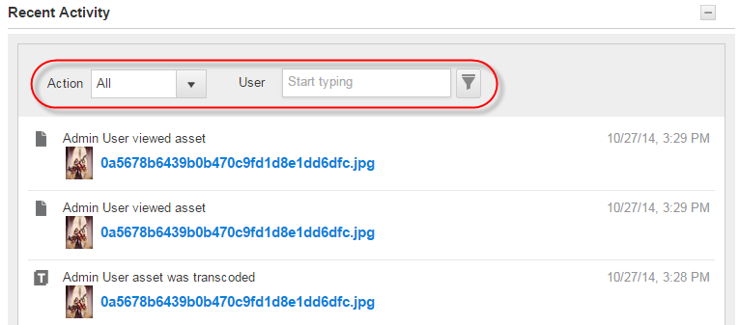

Figure 122 Dashboard > *Recent Activity* widget > *Action* and *User* activity filters

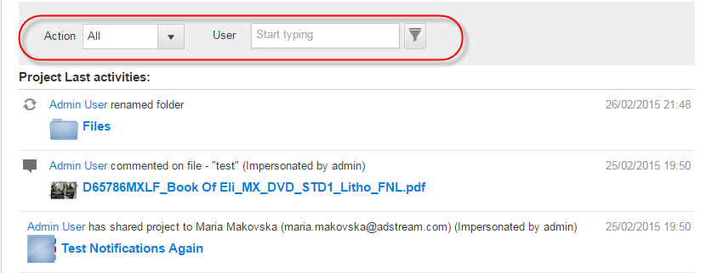

Figure 123 Project details page > *Overview* tab > *Action* and *User* activity filters

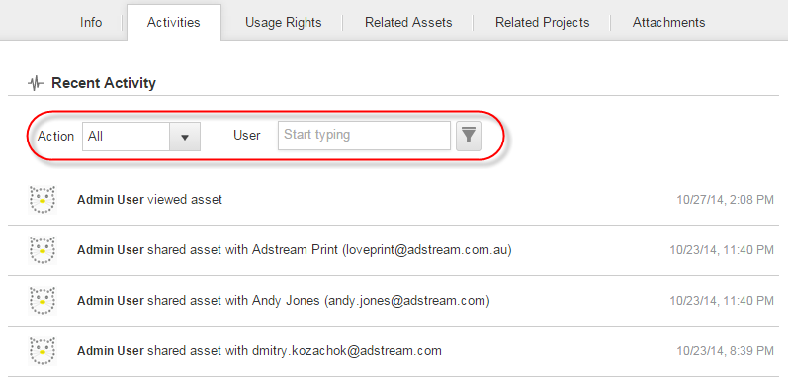

Figure 124 Asset details page > *Activities* tab > *Action* and *User* activity filters

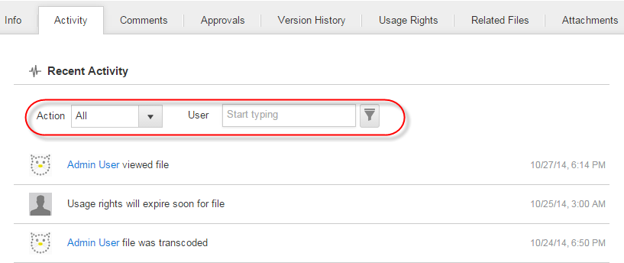

Figure 125 File details page > *Activit*y tab > *Action* and *User* activity filters

To filter list of activity records by an activity type it is necessary to select appropriate activity title from the *Action* dropdown list on the appropriate tab/widget and click the  control to apply the filter. *All* is default value for the dropdown list (see Figure 126).

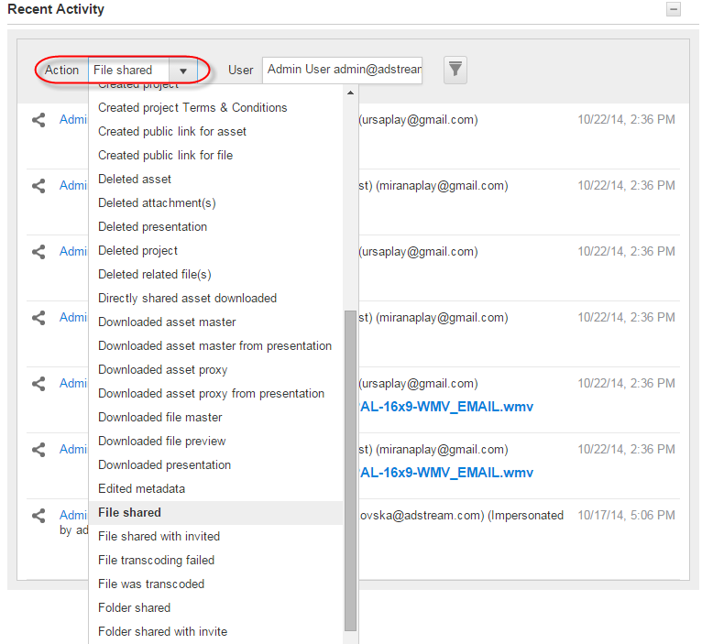

Figure 126 Dashboard > *Recent Activity* widget > Filtering list of activities by activity type

To filter list of activity records by an activity user it is necessary to start typing username or email in the *User* field, then select appropriate user from the pop-up under the field, and click the  control to apply the filter (see Figure 127).

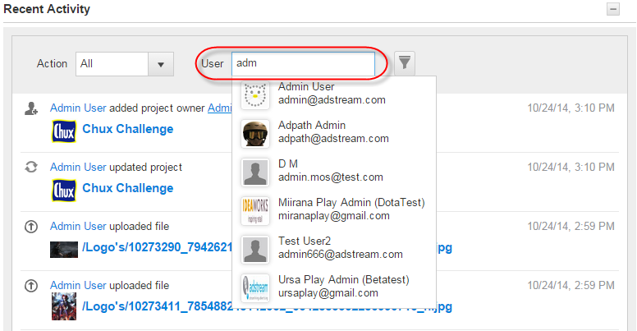

Figure 127 Dashboard > *Recent Activity* widget > Filtering list of activities by activity user

User can apply any one of the filters, as well as both of them simultaneously.

*Action* and *User* activity filters resize their length according to the length of the selected values while filtering activity records by activity types and actors. Also, they preserve the values selected by current user while they navigate through the *Adbank 5*. This behaviour persists after log out, as well.

**Note**: Value for the *User* field can be selected from the Address Book of current user, as well as from the list of all Business Unit users.

#### Filtering list of Projects/Work Requests/Templates/files/Assets by columns

Users have possibility to filter lists of files, Assets, Projects, Work Requests, Project Templates and Work Request Templates by the metadata of *Catalogue Structure* or *Dropdown* types which are displayed as columns in List view.

To do this it is necessary to:

1. Click  new control on appropriate tab (e.g. *Library* tab) to enable the ability to filter by column. Then, click the same control in respective column to open filtering settings (see Figure 128).

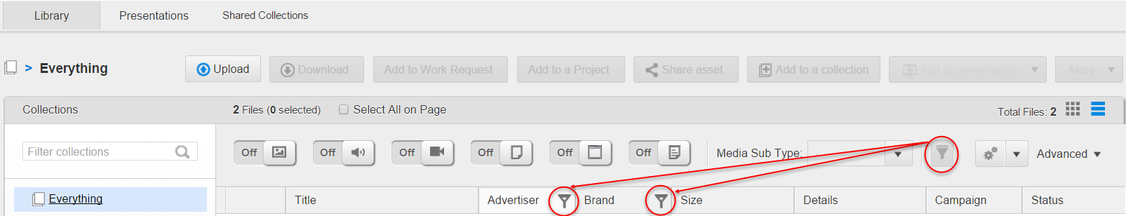

Figure 128 *Library* tab > Filtering Assets in List view by columns

1. Select appropriate metadata value from the first dropdown list and sorting order for it (if necessary), then click the *Submit* button in the pop-up window (see Figure 129).

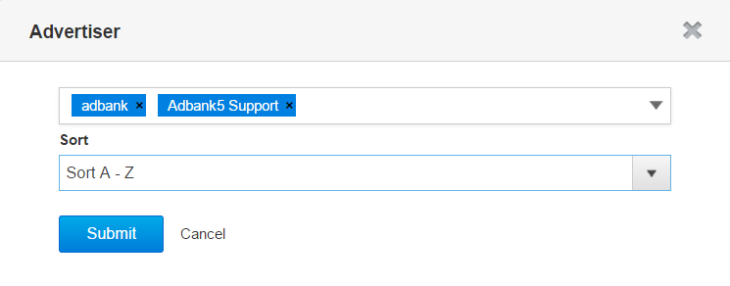

Figure 129 Filtering by column

Filtering can be applied by several columns at once. In this case, it will takes into account all applied filters.

Implementation details (or, the lack of such): <https://jira.adstream.com/browse/NGN-13507>

**Note**: Users cannot filter by columns if Project metadata filters are enabled for lists of Projects and Work Requests. So, to allow users to filter by columns on the *Projects* and *Work Requests* tabs Global Admin should untick the *Enable Project Filters* checkbox in the Window for editing Business Unit details.

After relogin the *Adbank 5*, all column filters enabled for files, Assets, Projects, Work Requests, Project Templates and Work Request Templates in List view are reset. Although, after current page refresh these filters are kept in the position specified by a user.

#### Filtering files and Assets by Media types and Media sub-types

Users have possibility to filter Project files and Library Assets by Media types and Media sub-types. Herewith, while filtering files/Assets can be displayed either in Grid or in List view on the Project details page > *Files* tab or *Library* tab.

To filter files/Assets by one or several Media types a user should enable or disable appropriate Media type filters (represented as ON/OFF triggers) on the Project details page > *Files* tab or *Library* tab. For more details about Media type filters please refer to the Table 5.

Additionally, if only one Media type filter is enabled, users can filter files/Assets by Media sub-types specific for selected Media type. To do this they should select appropriate value from the Media sub-type dropdown list (see Figure 130). For more details about Media sub-type filters please refer to the page 627.

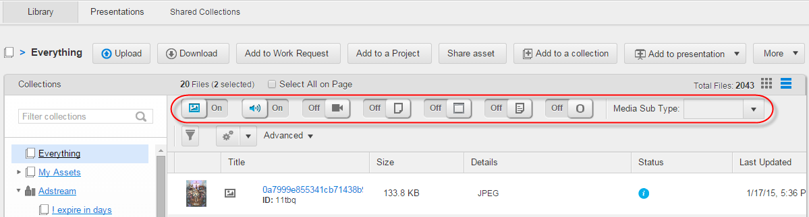

Figure 130 *Library* tab > Media type filters (triggers) and *Media Sub-Type* dropdown list

### Switching data views

#### Switching between views for Projects and Library

When a user is on the Project details page > *Files* tab, they have possibility to switch between *Tile*, *List* and *Finder-style* views to view and operate the files. *Finder-style* view can be disabled for a Business Unit; in this case, switching is possible only between *Tile* and *List* views.

When a user is on the *Library* tab, they have possibility to switch between *Tile* and *List* views to view and operate the Assets. *Finder-style* view is not available for Library.

To switch to *List* view it is necessary to click the  control. To switch to *Tile* view it is necessary to click the  control. To switch to *Finder-style* view it is necessary to click the  control (see Figure 131).

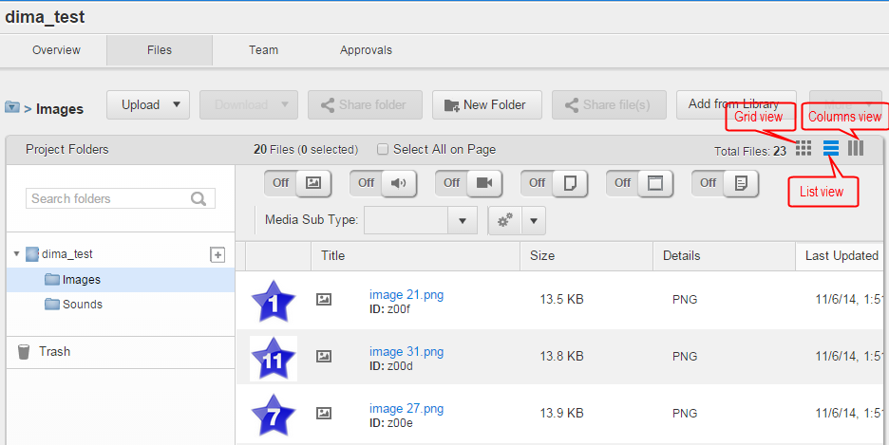

Figure 131 Project details page > *Files* tab > Controls to switch between *Tile*, *List* and *Finder-style* views

The last selected view, as well as sorting order in this view, are kept in the position set by a user during navigation through the *Adbank 5*, even after re-login. Also, the last selected view remains activated across all Projects on the *Projects* tab, until a user switches it to the opposite one.

So, when a user switches to the *Finder-style* or *Tile* view in some Project, system remembers user's last selection and shows next opened Project in this view. Also, switching between these views within current Project keeps the content of last opened folder.

***Finder-style* view**

Implementation details:

<https://jira.adstream.com/browse/NGN-11497>

https://jira.adstream.com/browse/NGN-11483

When a Project is in *Finder-style* view, a user can see all its folders and files as separate columns, herewith, parent folders are always to the left from the child ones, and the rightmost column in this view can be used for file preview.

*Finder-style* view is a way to not only see what folders a user has within their Project, but also what files are within each Project without having to open each folder up. It's also a nice way to reduce the need to scroll when they have a lot of folders to scan through.

If Global Admin enabled the use of *Finder-style* view for Business Unit users, they can navigate within Project folders from left to right by drilling down through folders tree until target folder and file(s) are found. Opening folder content in the right column keeps all content in the left columns, so the user can see the full path to target folder/file. Clicking the file title opens file preview in the rightmost column with basic metadata as they are displayed in the Project details page > *Overview/Files* tab (see Figure 132).

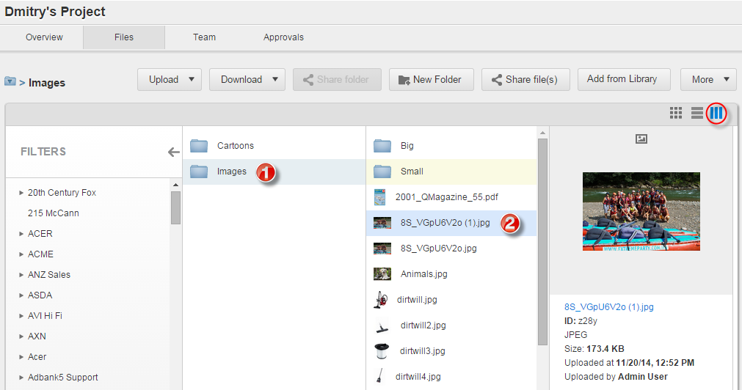

Figure 132 Project details page > *Files* tab > *Finder-style* view

Clicking the file title on the file preview opens the File details page. Clicking the back browser arrow returns the user to the same *Finder-style* view that they have left.

*Project Filters* panel can be enabled to the left when a Project is in *Finder-style* view. The panel allows users to quick switch to the list of Projects on the *Projects* tab while they are on the Project details page.

While a user navigates through Projects folders using *Finder-style* view, they can resize panels with folders by drag and drop their borders.

Users with appropriate permissions have possibility to perform actions related with single and multiple folders/files if current Project is in *Finder-style* view. This is possible via the action-related buttons which enabled for Project users on the Project details page > *Files* tab.

To perform actions related with multiple Project folders/files a user should highlight them by clicking necessary folders/files and holding the *Ctrl* button pressed (see Figure 133).

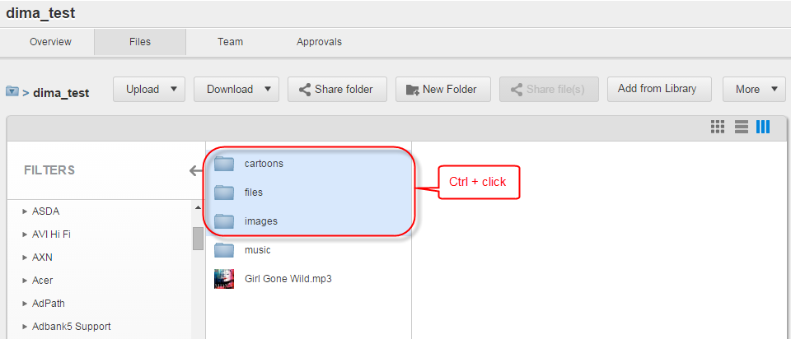

Figure 133 Project details page (in *Finder-style* view) > Highlighting multiple folders

**Note**: Folder-specific or file-specific action buttons for Projects in the *Finder-style* view are enabled only if at least one folder/file is highlighted on the Project details page > *Files* tab.

#### Switching between previews of Files/Assets

Users have possibility to navigate between files/Assets by clicking *Previous/Next*arrow buttons (**<** and **>**) which are displayed on the File/Asset details page (see Figure 134).

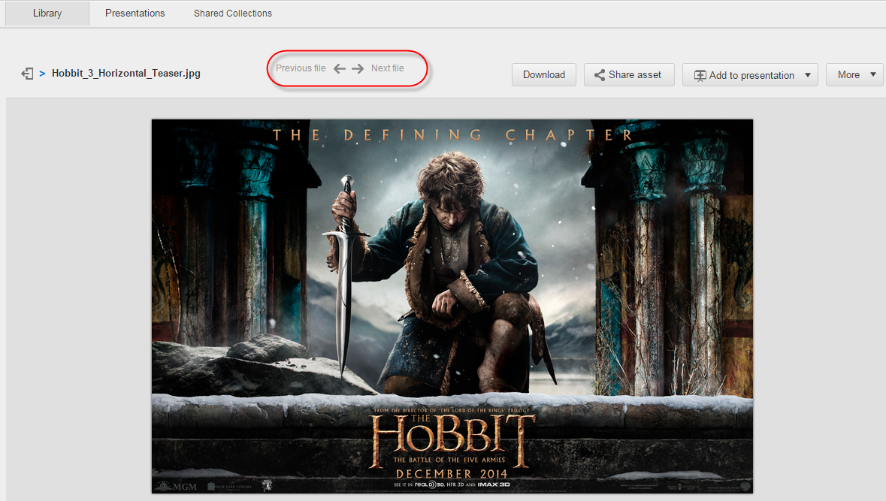

Figure 134 File details page > Controls to navigatebetween previews of Files/Assets

Context of File/Asset preserves its position in search results and allows a user to go to next search result according to user's selected sorting. For example, if a user has searched several Assets and then they opened one of them, the navigation is possible between only found Assets.

**Note**: *Back to Collection* button () on the Asset details page is used to bring users back to the *Library* tab or related Search Results page depending on what has been previously opened. Search results are kept on the Search Results page for Assets while a user navigates between the Asset details page and Search Results page for Assets.

### Customizing metadata visibility in List and Tile views

#### Hiding/displaying metadata for list of Projects, Work Requests and Templates

Users have possibility to display or hide Project-specific metadata on the *Projects, Work Requests*, *Project Templates* and *Work Requests* *Templates* tabs, i.e. select custom metadata (from *Common* and *Project* schemas) to be displayed as columns for the lists of Projects, Work Requests and their Templates.

Metadata displaying or hiding is achieved by ticking appropriate checkboxes under the ** control on current tab. To display the default metadata set as columns it is necessary to click the *Restore to Default* link under this control. All metadata in the columns can be sorted by ascending or descending (see Figure 135).

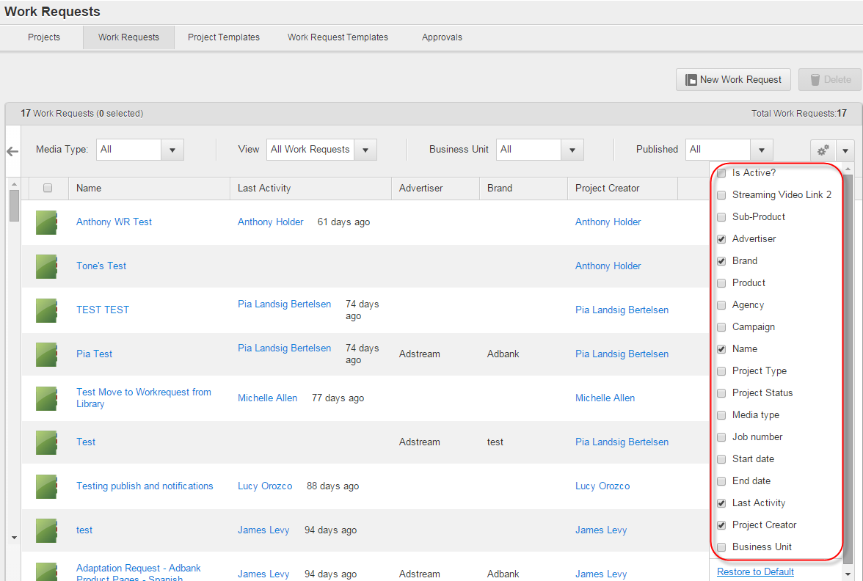

Figure 135 *Work Requests* tab > Hiding/displaying metadata as columns

**Note**: Selection is kept in the position set by a user during navigation through the *Adbank 5*, even after re-authorization. On the initial system login, users will see the default columns on currently opened tab.

#### Hiding/displaying media-specific metadata for files/Assets in List view

If Business Unit Admin has configured visibility of custom media-specific metadata for files/Assets in Tile view (on the Admin area > *View* tab), users of this the Business Unit have possibility to select the metadata to be displayed as columns when the files/Assets are in List view.

To display media-specific custom metadata as columns for files/Assets in List view it is necessary to tick appropriate checkboxes under the  columns selector on the Project details page > *Files* tab or the *Library* tab. All available for displaying media-specific metadata are grouped per appropriate Media Type, i.e. *Audio, Video*, etc. Common metadata are displayed under the *Common* group.

To display the default metadata set (as columns) on selected tab it is necessary to click the *Restore to Default* link under this control. All metadata in the columns can be sorted by ascending or descending (see Figure 136 and Figure 137).

Implementation details: <https://jira.adstream.com/browse/NGN-11813>

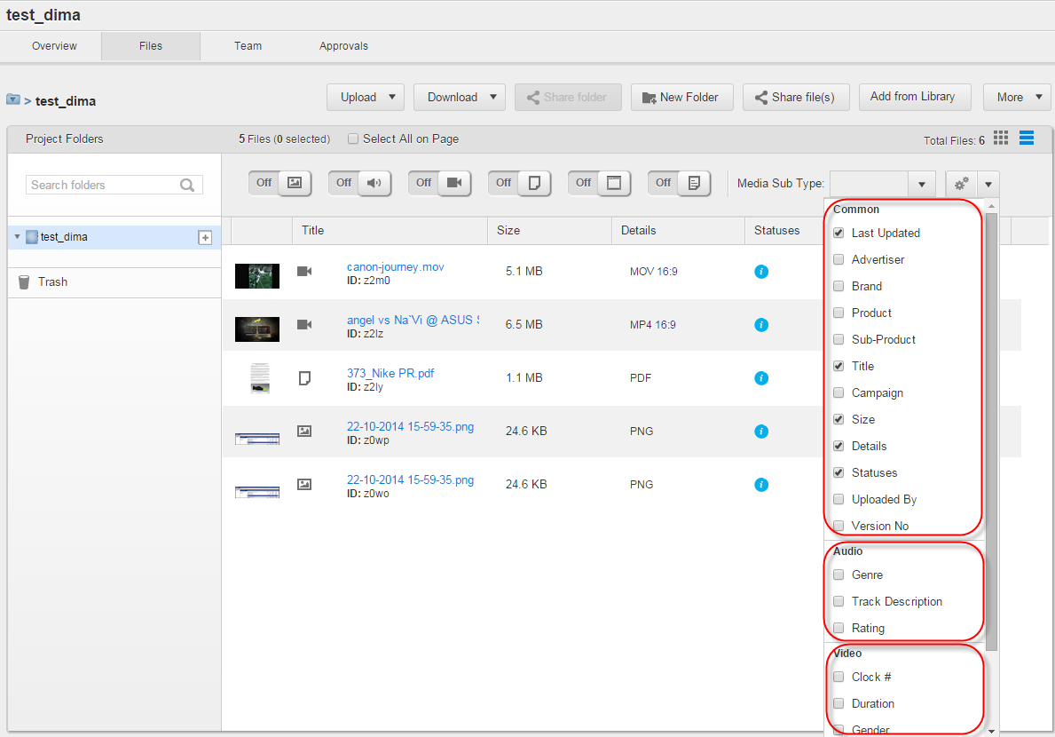

Figure 136 Project details page > *Files* tab > Customizing media-specific metadata for files in List view

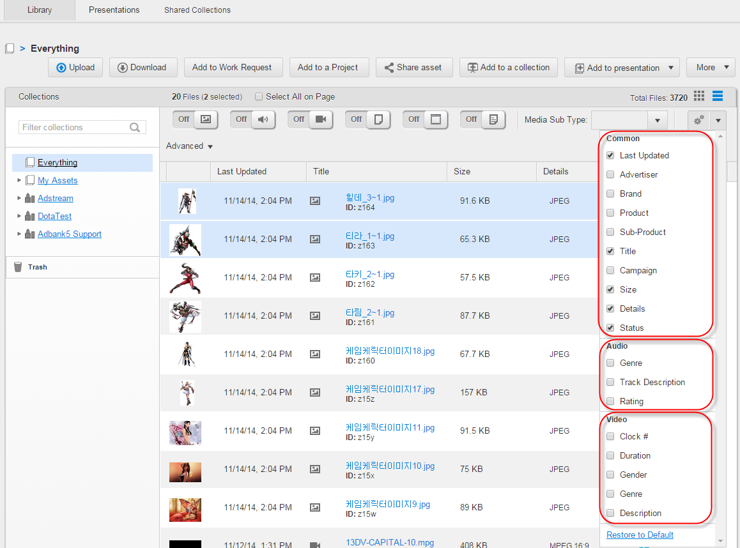

Figure 137 *Library* tab > Customizing media-specific metadata for Assets in List view

### Sorting folders/files/Assets

Users have possibility to sort Project folders and files, and Library Assets displayed in Grid view. To do this they should select appropriate sorting option from the *Sort by* dropdown list on the Project details page > *Files* tab or *Library* tab. These options are:

* *Title (A to Z / Z to A).*
* *Size (Ascending / Descending).*
* *Most Recently Uploaded First / Most Recently Modified First*.
* *Most Recently Uploaded Last / Most Recently Modified Last* (see Figure 138).

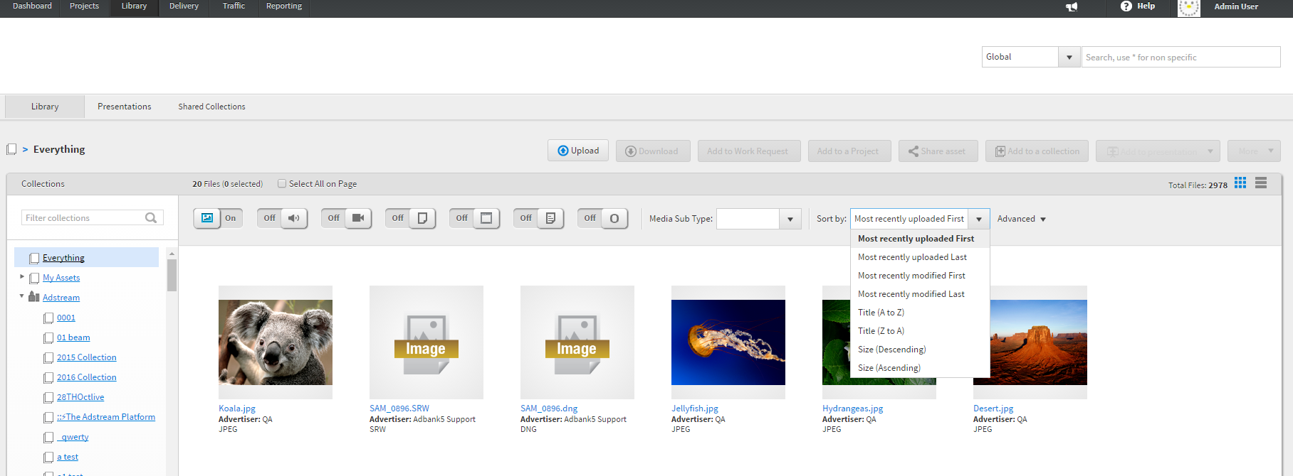

Figure 138 Project details page > *Files* tab > *Sort by* dropdown list

# PROJECTS AREA

## Projects/Work Requests

Users with the *project.create* permission can create Projects, while users endued with the *adkit.create* permission can create Work Requests.

Each Project/Work Request has at least one Project Owner (by default, this would be Project Creator). Business Unit Admin and Project/Work Request Owners can add separate users to the Project/Work Request Team, as well as users within Public Project Team Templates or Groups.

Also, Work Requests can be based on separate Asset or group of Assets taken from the Library. Work Requests have different metadata from the regular Projects, but their functionality is the same. Work Requests is listed on the *Projects* tab among regular Projects.

**Note**: *project.create* and *adkit.create* permissions belong to the Global roles group and allow to create projects / work requests within this BU. These permissions are a good example of why we need the concept of a Global role separated from Project roles. You can create a project in a BU. You cannot create a project in a project.

### Creating Projects/Work Requests

#### Creating Projects/Work Requests from scratch

To create a new Project/Work Request from scratch it is necessary to click the *New Project*/*New* *Work Request* button on the *Projects*/*Work Requests* tab (see Figure 22). Then, the user should fill in metadata fields in the Window for creating Projects/Work Requests and click the *Save* button (see Figure 139).

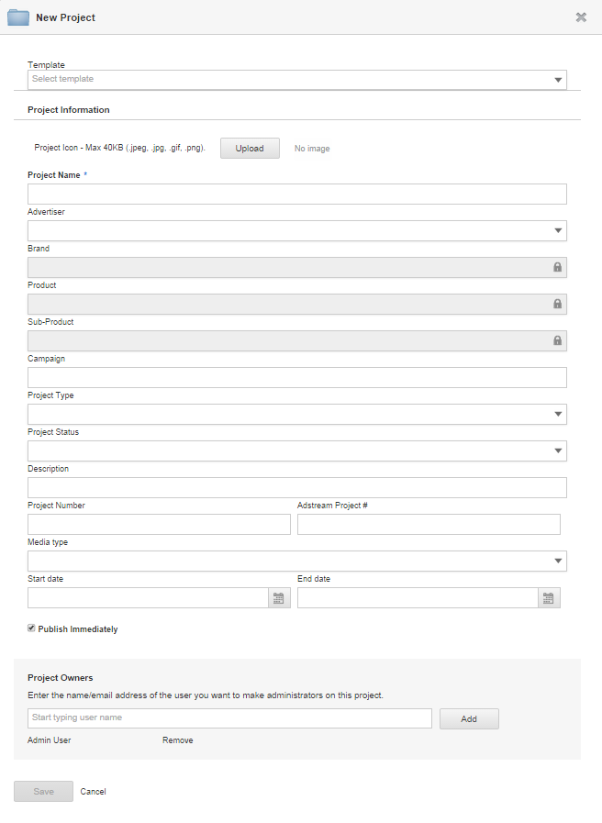

Figure 139 Window for creating Projects/Work Requests

**Note:** a list of metadata fields on the Create New Project form is completely custom per BU.

User with project.create permission in more than one BU will see additional drop down to select a BU (on top of the form). By default, user’s Primary BU will be selected. If user decides to change a BU, this will update the list of Templates available for selection, and metadata fields available on the form.

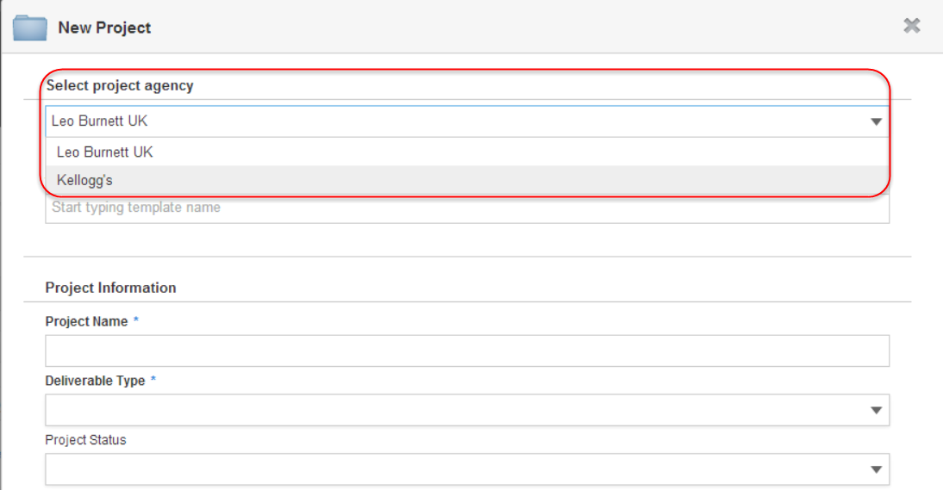

Figure 140 Window for creating Projects/Work Requests > Selecting Business Unit for Project

There is an obscure checkbox in Global Admin > BU settings, “Hide Template field on Create New Project forms”. Checking this option will hide Templates dropdown from the Create New Project form for this BU. If you happen to meet Alex Richards (who requested this change), please say hi to him from Maria, and ask what was the business value behind this feature (I honestly don’t remember, and can’t think of any).

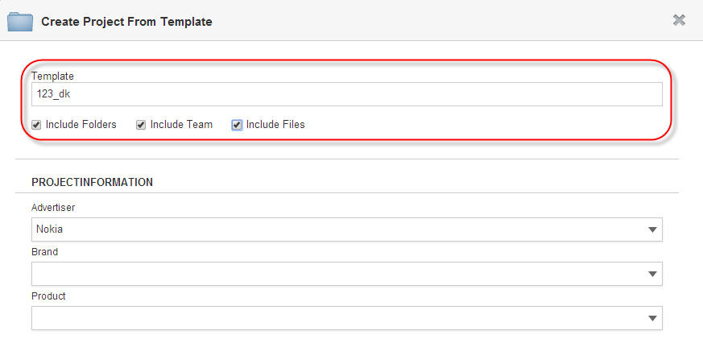

Figure 141 Window for creating Projects/Work Requests > Applying the Template and its options

While creating a Project/Work Request, a user can:

* Select a Business Unit where the project should be created (if user has permission project.create in more than one BU)
* Select a Template to use for creating a project. User can select from the list of templates that they have created, AND from the list of Public templates of selected BU, IF this user has View Public Templates option enabled in their profile in this BU. Note: list of Templates is coming from a selected BU. So if the user selects a different BU, the list of templates should be updated. It is not possible to select a Business Unit-specific Template before selecting appropriate Business Unit.
* Apply files, folders and Teams of a selected Template to the Project/Work Request by ticking the *Include Files, Include Folders, Include Team* checkboxes. They appear under the *Template* field once the Template is specified. If user checks the *Include Folders* checkbox, all folders from selected Template are replicated to the Project/Work Request. If user checks the *Include Team* checkbox, all Teams from selected Template are replicated to the Project/Work Request. If user checks the *Include Files* checkbox, all files from selected Template are replicated to the Project/Work Request (see Figure 141).
* Upload project logo. Very important feature (seriously – once it was a bit broken, we had an escalation from the major client to fix it! https://jira.adstream.com/browse/NGN-9663)
* Fill in Project metadata. Lots of Project Metadata! Project metadata comprise of Common Editable fields, Common Custom Fields, and Project-level custom fields of this selected BU (see BU Admin > Metadata for setup of all this jazz). Common level metadata will be automatically inherited to all the files uploaded into this project.
* Set “Publish Immediately” option to get this project Published / visible to all users added to the Project Team. Default behaviour of the “Publish Immediately” checkbox is defined in a BU settings. If the user wants to leave the Project/Work Request unpublished (= not visible to anyone but Project Owners), they should un-tick this option.
* Set future publish date, time and timezone (see Figure 142). Project will be published automatically on that date and time. See details in <https://jira.adstream.com/browse/NGN-17771> (I wish we had never wasted development time building this, as the client requesting this feature got lost in their own requirements and in the end stopped using it).
* Add more Project Owners to the project. In the Project Owners lookup, user can type email of any contact available in their address book (there’s a big religious war going about this major functionality; if contact is not present in user’s address book, you have to type email once in full to get it added – obviously too much of an effort for some particularly hardworking people; however, mixing Contacts and Users in this control is not a straightforward implementation and should be addressed carefully). If Contact selected for a project owner is not a registered User in the system, they will be added to a selected BU and will receive an email asking them to register before accessing a Project. After registration, Project’s BU will become their Primary. If Contact selected for Project Owner is registered User in another BU, they will be added to Project’s BU as secondary user. See <https://jira.adstream.com/browse/NGN-4968>.

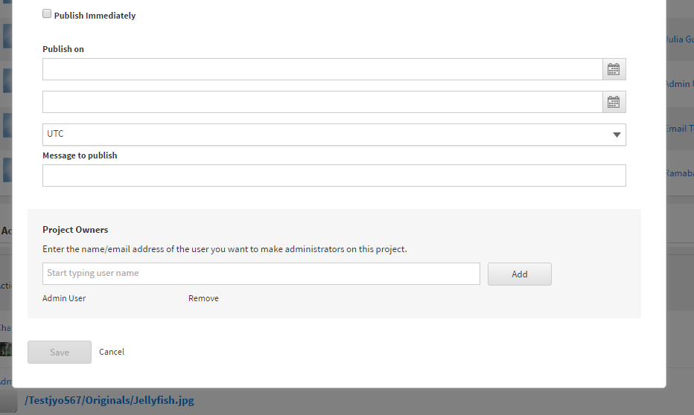

Figure 142 Future Date Publication options

#### Creating Projects/Work Requests from Templates

Projects can be created from Project Templates, while Work Requests can be created from Work Request Templates.

While creating a Project/Work Request from a Template a user can either select appropriate Template from the *Template* autocomplete field on the Window for creating Projects/Work Requests (see Figure 141), or click the *Use template* button next to appropriate Template on the *Templates* tab (see Figure 25).

Then, the user should fill in metadata fields in the Window for creating Projects/Work Requests and click the *Save* button (see Figure 139).

After a user clicked the *Use template* button, the *Template* field is automatically populated with selected Template. *Include Folders* and *Include Team* checkboxes are ticked by default on the Window for creating Projects/Work Requests.

When a Project is created from a Template with a Team, copying the Team from the Template to the Project will be finished before a user can start work with this Project.

While a Project is being created on a Template, a user can see special window with progress bar (see Figure 143). Once the process is finished, the user is taken to the Project details page > *Overview* tab.

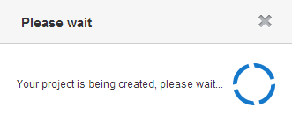

Figure 143 Window with progress bar when creating Projects from Templates

**Note:** Using Template Files is quite a rare case. On the contrary, using Template Folders and Team is the whole point of why we have Templates.

Copying Team from a Template to a Project is a heavy back-end job. It is run in asynchronous mode, so user might not see all of the Team copied at once – might take a few minutes to see all users copied into the Project Team. This behaviour is especially noticeable on the Warner Bros templates with 800+ users in the team.

#### Creating Work Requests based on Assets retrieved from Library

Users with access to Library Assets have possibility to create Work Requests based on single or multiple Assets retrieved from the *Library* tab, related Search Results page or the Asset details page.

Original implementation: <https://jira.adstream.com/browse/NGN-6712>

To create a Work Request based on Asset(s) retrieved from the *Library* tab or related Search Results page it is necessary to highlight the Asset(s) there and click the *Add to Work Request* button (see Figure 144 and Figure 145).

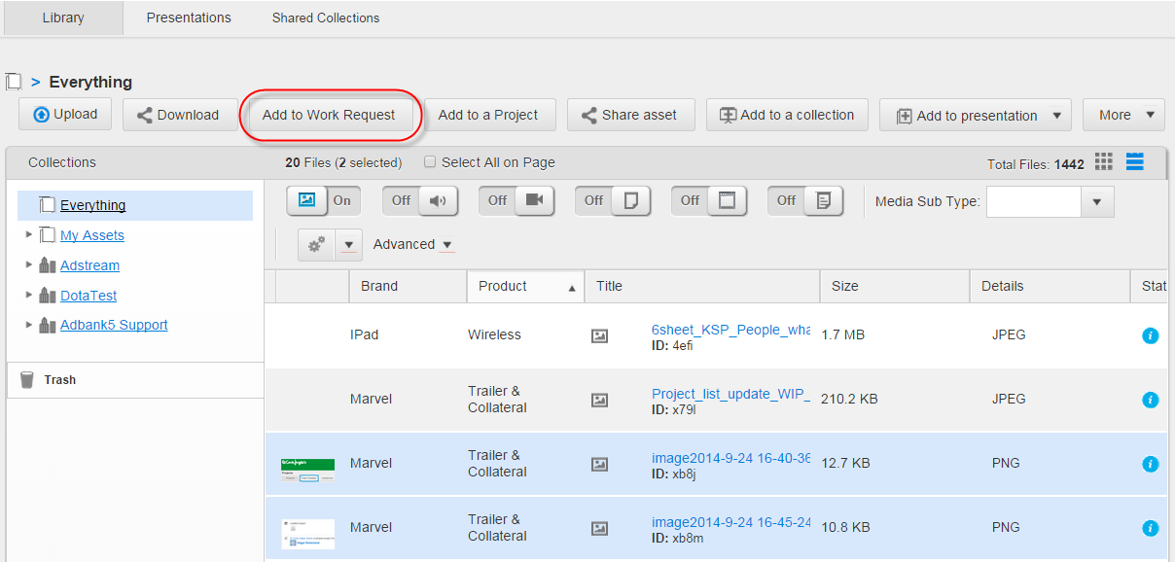

Figure 144 *Library* tab > *Add to Work Request* button

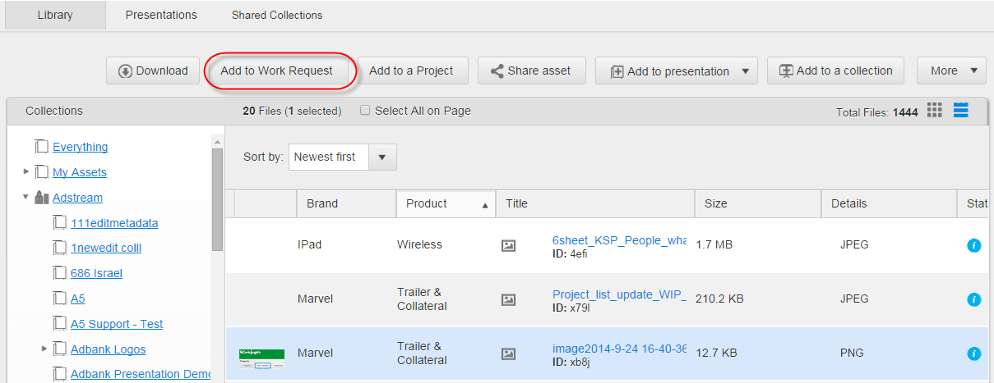

Figure 145 Search Results page (for Assets) > *Add to Work Request* button

To create a Work Request based on an Asset retrieved from the Asset details page it is necessary to click the *More* > *Add to Work Request* button there (see Figure 146).

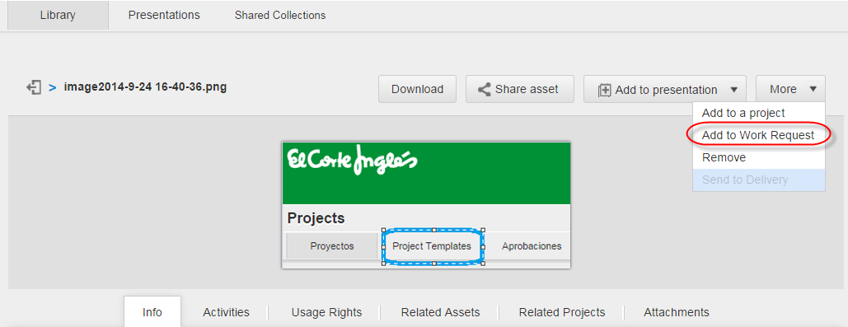

Figure 146 Asset details page > *More 🡪 Add to Work Request* button

Once the *Add to Work Request* button is clicked on the *Library* tab, related Search Results page or the Asset details page, the *Create New Work Request* pop-up window appears (see Figure 147).

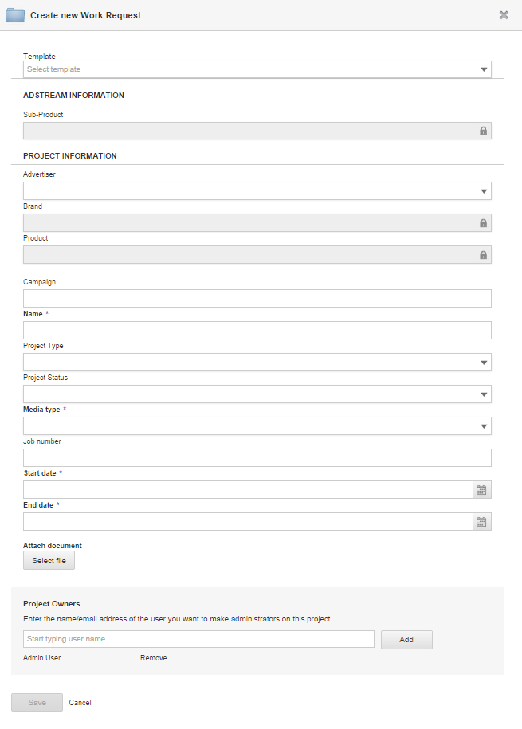

Figure 147 *Create new Work Request* window

There, it is necessary to:

1. Fill in, at least, mandatory metadata fields, e.g. *Name, Media Type,* etc.
   * iple drawings. Drawings can be coloured free-hand lines, rectangles or ovals made via the , ,  drawing tools correspondingly and the  colour picker. For each drawing a user must add and save a comment via the *Notes* text box. Another user who has access to annotate the same file can view the drawings of the user who created the annotation. Herewith, when user is drawing, and then changes a colour, all previously made drawings are recoloured. Once the drawing is saved, changing drawing colour is impossible. To delete all drawings within an annotation it is necessary to click the  tool (see Figure 228).

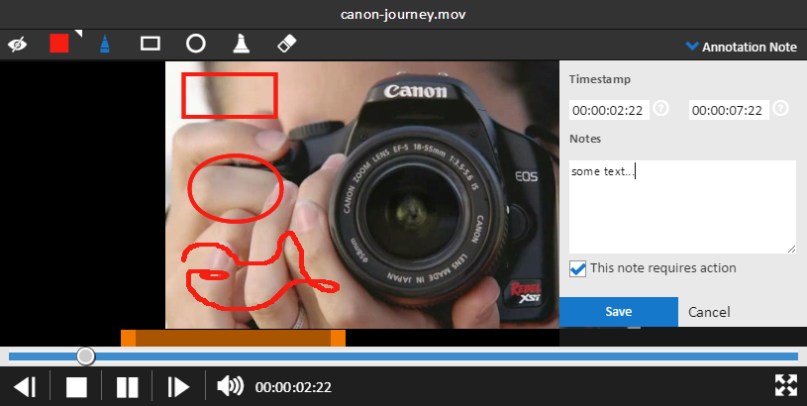

Figure 228 Annotation tool > Annotating Video files

* Compare annotations for two file revisions by clicking the  control (enabled if a file has at least one revision). The current file revision is displayed in the left pane, it can be annotated. Panes in the split screen view have independent zooming and rotation, so each revision can be manipulated without affecting the view in the other pane. If the file was versioned more than once, user can expand the dropdown list  in the right pane to select an older file revision for comparing. Values in the drop-down represent version numbers. To complete comparing the  control should be clicked. It closes the right pane with the old file version (see Figure 229).

Figure 229 Annotation tool > Comparing annotations for two file revisions

* Edit (via the  tool) and delete (via the  tool) comments when annotating Print/Image files. Annotation comments left by other users cannot be edited and deleted (see Figure 230).

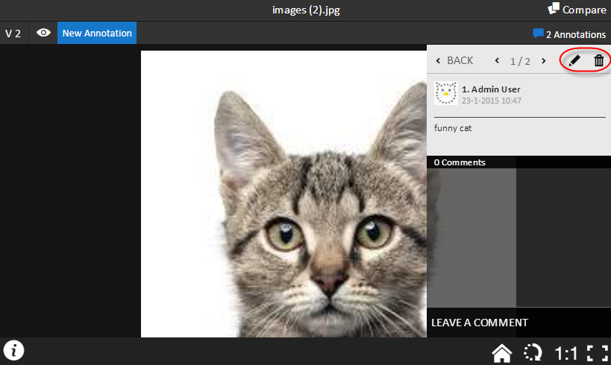

Figure 230 Annotation tool > Tools for editing and deleting comments

* Filter annotations by the users who annotated the file. To filter annotations it is necessary to click the  control at the top right corner, enter the username in the pop-up text box and then tick appropriate checkbox below it. After this, list of corresponding annotations will be revealed below. To clear the filter tool the user should click the *Close* button (see Figure 231).

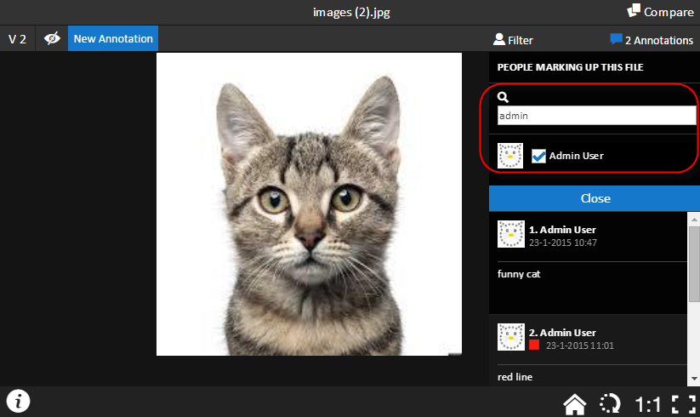

Figure 231 Annotation tool > Filtering annotations by users

* Approve or reject a file received for approval. To do this it is necessary to click either  or  control at the top left corner (see Figure 232), enter a comment in the pop-up text box and then click the *Save* button (see Figure 233). Once the file is approved/rejected, appropriate mark will be displayed instead of the controls, so the file cannot be annotated further. Also, current Approval status is displayed in the tooltip by hover over on the icon (see Figure 234 and Figure 235). Note that approval workflow behaves same as when approving from the File details page (e.g. rejected file can be approved).

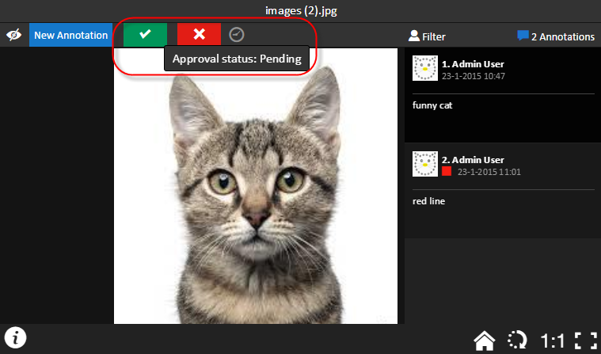

Figure 232 Annotation tool > Approving/rejecting file

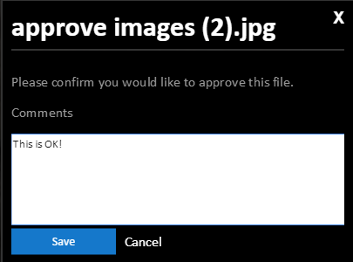 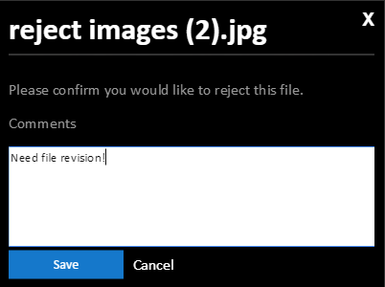

Figure 233 Annotation tool > Confirming approval/rejection

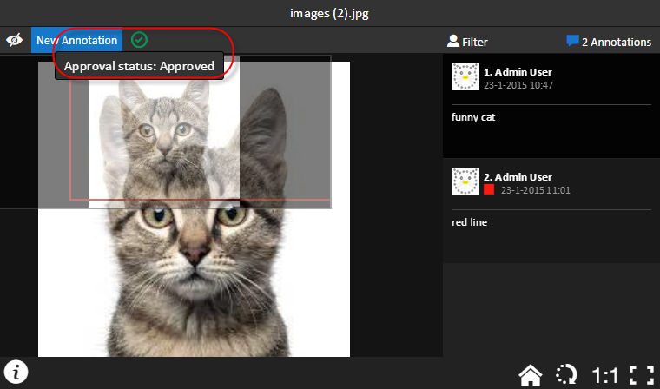

Figure 234 Annotation tool > File marked as approved

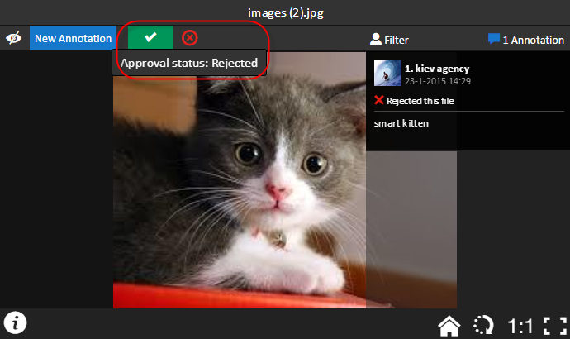

Figure 235 Annotation tool > File marked as rejected

The Annotation tool window includes controls as described in Table 21.

Table 21 Annotation tool controls

| **Field** | **Description** |
| --- | --- |
|  | (*Annotations* control) Is used to show or hide available annotations. |
|  | (Filter box) Is used to filter existing annotations by annotators via appropriate checkbox(es) and the search field. Filter box can be used if the annotations are shown.  Unticking a checkbox next to corresponding annotator will hide the annotations made by them.  *Close* button in the box is used to close the box and left the list of annotations. |
|  | (List of annotations) Is used to select (by single-click) appropriate annotation to view, edit, delete or comment it via the Annotation navigator. |
|  | (Annotation navigator) Is used to navigate between available annotations. Navigator is opened by single-click on appropriate annotation in the List of annotations. To switch between available annotations it is necessary to click the left or right arrows.  To edit or delete current annotation it is necessary to click either  or  control.  To reply to an annotation it is necessary to click the *Reply* control. Added comments are displayed below current annotation and can be deleted by click the  next to them.  To come back to the List of annotations it is necessary to click the *Back* control. |
| /  tool | Is used to hide/show drawings within active annotations. |
| button | Is used to create a new annotation. When it is clicked, all drawing tools and annotation box are enabled. |
|  | (Annotation box) Is used to:   * Add/edit notes to annotations. * Set timestamps for Video files. * Notify about need to act according to note.   The box is opened by single-click on the  button or  control in the Annotation navigator.  Annotations cannot be saved without notes. |
| , , | (Drawing tools) Are used to draw free-hand lines, rectangles and ovals within active annotation. |
|  | Is used to highlight text within active annotation. |
|  | Is used to delete all drawings within active annotation. |
|  | Is used to reload the annotation window to discard any zooming and rotation that has been applied by the user. |
|  | Is used to navigate between pages in multi-page documents (e.g. PDFs). This control is enabled only for multi-page documents. |
|  | Is used to rotate canvas of Print and Image files by 90 degrees in clockwise order*.* |
|  | Is used to return scaling to actual file preview’s size. |
|  | Is used to enable fullscreen mode for Image/Print files. |
|  | Is used to enable fullscreen mode for Video files. |
|  | Is used to view information about file preview (width, height, duration). |
|  | (Colour picker) Is used to open a palette of colours to use with the selected drawing tool (free-hand, oval, or rectangle). Once a colour is selected, it applies to all drawing tools (it’s not possible to specify a colour for each individual drawing tool). Note that colour selection does not apply to the text entered in the annotation box. |
|  | Is used to compare two file revisions with possibility to annotate the current one. The control is enabled if a file has at least one revision. |
|  | Is used to complete comparing of annotations for two file revisions. |
| , | Are used to approve or reject a file received for approval directly from the Annotation tool. |
| C:\Users\KOZACH~1\AppData\Local\Temp\SNAGHTML155d56e.PNG | Is used to switch between file revisions when comparing them. |

### Editing metadata of files

Users have possibility to edit metadata on single and multiple files within Projects area. Also, they can view activity records and receive email notifications about editing metadata of single and multiple files.

These activity records are displayed on the:

* Dashboard > *Recent Activity* widget.
* Project details page > *Overview* tab > *Project Last activities* section.
* File details page > *Activity* tab.

The activity records display details about who (username) and when (timestamp) edited the files (filenames). Herewith, in the activity records on the Dashboard and Project Overview each filename is clickable to allow the user to open the File details page for corresponding file.

After editing metadata of several files at once:

* On the Dashboard and Project Overview a user can view single corresponding activity record which contains list of edited files, while for each this file on the File details page they can view activity record which concerns to only current file.
* A user with access to them (i.e. Project Owner or the user who has access to appropriate Project folder) receives single email notification with the list of edited files and the data about files’ editor and target Project. Herewith, each filename in this list is clickable to allow the user to go to the corresponding file from the notification.

#### Editing metadata of single files

To edit metadata of a single file it is necessary to:

1. Click the *Edit* control on the File details page > *Info* tab (see Figure 201).
2. Make necessary changes in metadata fields in the *Edit file* pop-up window and click the *Save* button (see Figure 236).

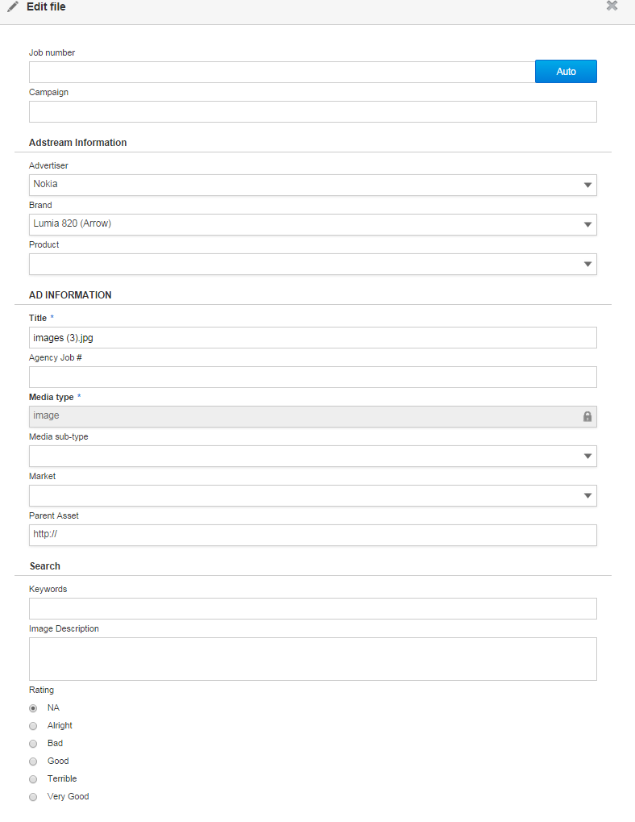

Figure 236 *Edit file* window

#### Editing metadata of multiple files in batch

To edit metadata of multiple files in batch it is necessary to:

1. Highlight necessary files on the Project details page > *Files* tab and click the *More > Edit all selected* button. Selected files can be of different media types (see Figure 237).

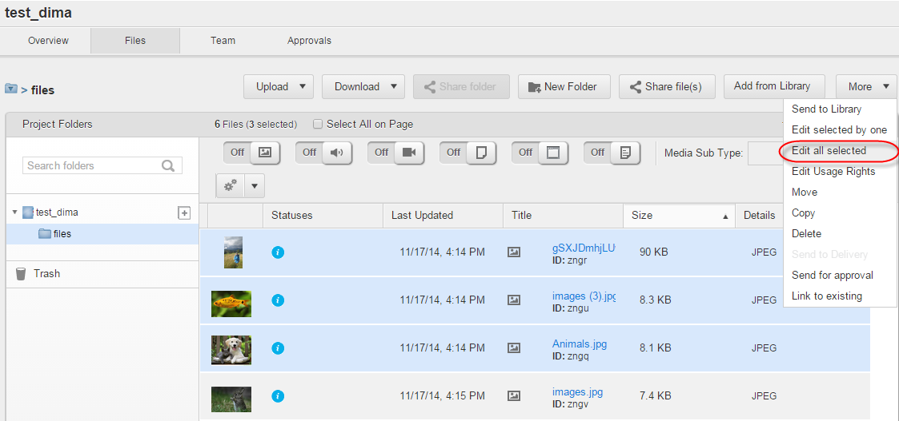

Figure 237 Project details page > *Files* tab > *More 🡪 Edit all selected* button

1. Once the button is clicked, the *Edit metadata* pop-up window will be opened. By default, the Window opens on the *Common* tab where a user should edit metadata common for the files of all selected media types (see Figure 238).

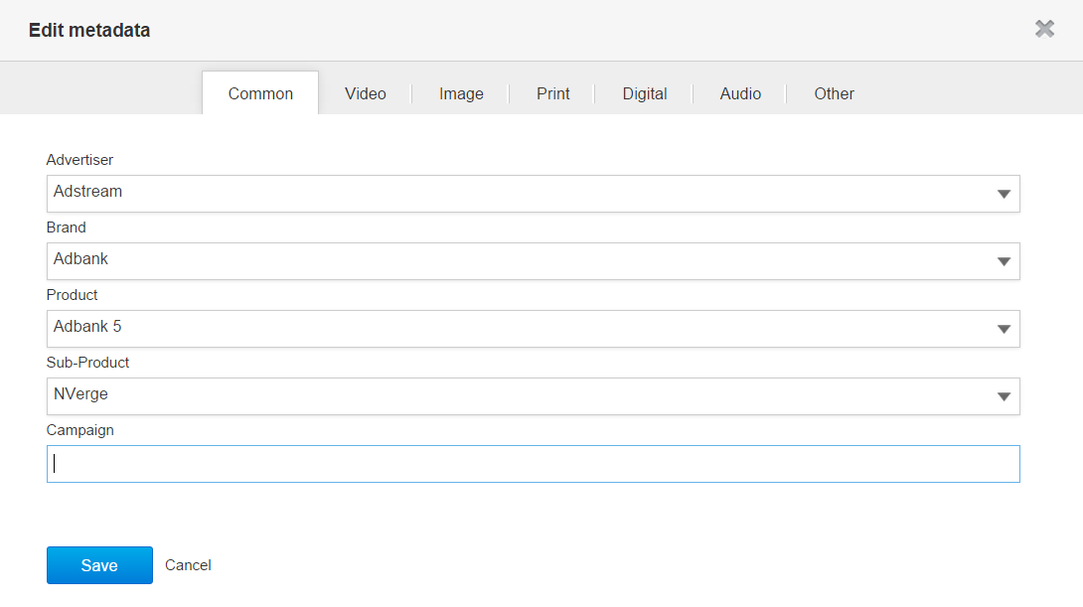

Figure 238 *Editing multiple files in batch* > *Common* tab

1. To edit custom files metadata, e.g. for Video files, it is necessary to switch to the appropriate media-specific tab, i.e. *Video* tab, and edit Video-specific metadata there. Similarly can be edited another media-specific metadata for Image, Print, Digital, Audio and Othertypes of files.
2. After necessary changes with metadata were made, the user should click the *Save* button to save them.

The *Edit metadata* window contains *Common* tab and media-specific tabs according to the types of selected files. E.g. if the user edits only Video and Audio files, the *Edit metadata* pop-up window consists of only *Common, Video* and *Audio* tabs.

**Note**: If the user does not have permission to edit some highlighted files (i.e. *element.write* permission), they will see special notification about this in the *Edit metadata* pop-up window:

*‘You do not have permission to edit metadata on <file 1, 2, 3...>. Changes will not be applied to these files’.*

#### Editing metadata of multiple files one-by-one

Users have possibility to edit metadata of multiple files within Projects one-by-one, i.e. metadata of each file can be edited individually. Herewith, editable files can be of different media types.

To edit metadata of multiple files it is necessary to highlight them on the Project details page > *Files* tab and click the *More > Edit selected one by one* button (see Figure 239).

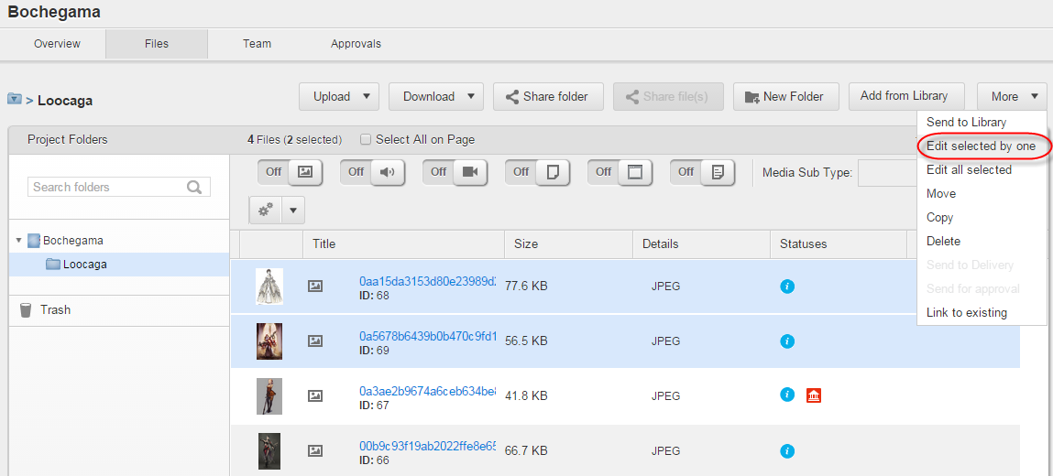

Figure 239 Project details page > *Files* tab > *More 🡪 Edit selected by one* button

Once the button is clicked, the *Edit metadata for files* pop-up window will be opened.

By default, the Window displays metadata for the first selected file. To switch to the metadata of the next one, a user should click the *Next* control. To come back to previous file’s metadata it is necessary to click the *Previous* control.

Once editing is finished, the user should click the *Save all & close* button. Herewith, there is no necessity to click this button each time before switching between files, one click is enough to save all made editing (see Figure 240).

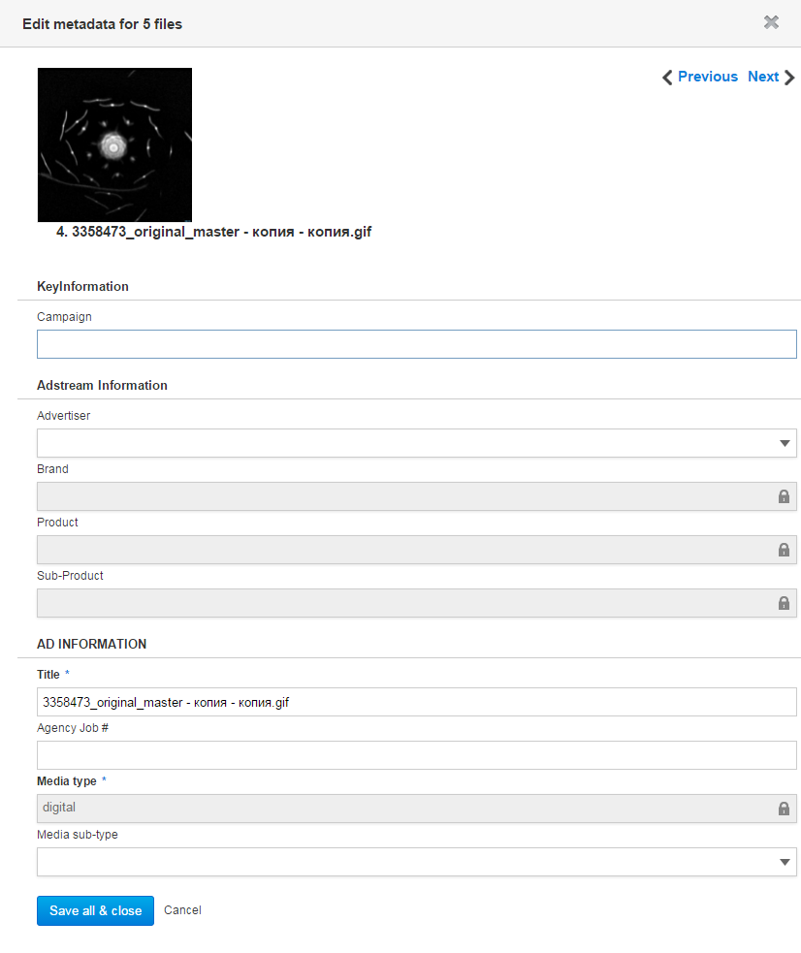

Figure 240 *Edit metadata for N files* window

While loading metadata for current file is in progress, the user can see spinning wheel in the *Edit metadata for N files* window.

If only one file is selected for editing, *Next* and *Previous* controls are disabled. *Previous* control is shaded if the first file is selected in the *Edit metadata for files* window; and the *Next* control is shaded if the last file is selected in the Window.

If the user does not have permission to edit some selected file (i.e. *element.write* permission), they will see special notification about this in the *Edit metadata* pop-up window:

*‘You do not have permission to edit metadata on <file 1, 2, 3...>. Changes will not be applied to these files’.*

### Adding/editing Usage Rights of multiple files in batch

Users endued with the *element.usage_rights.write* permission on files have possibility to add and edit Usage Rights on them in batch. Herewith, the files can be of different media types.

To edit Usage Rights of multiple files in batch it is necessary to highlight them on the Project details page > *Files* tab and click the *More > Edit Usage Rights* button there (see Figure 241).

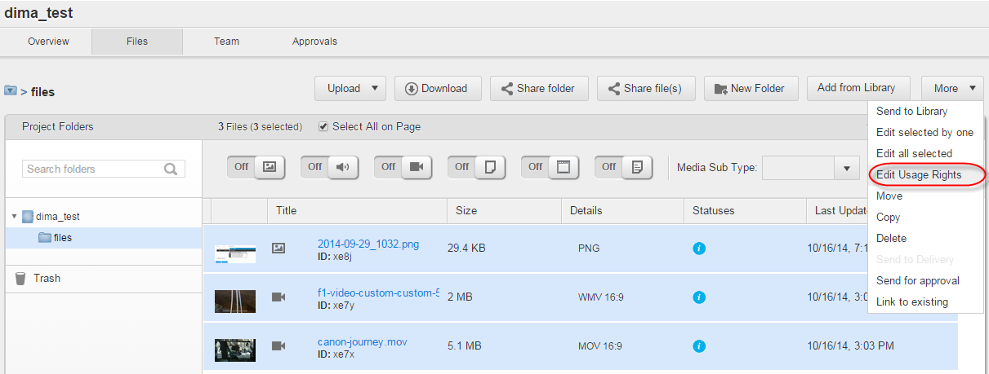

Figure 241 Project details page > *Files* tab > *More 🡪 Edit Usage Rights* button

Once the button is clicked, the *Edit Usage Rights for <Number> files* pop-up window will be opened. This window has the tabs according to the existing types of Usage Rights. By default, it opens on the *General* tab where a user can edit the *General* type of Usage Rights for selected files.

To edit any other type of Usage Rights they should switch to appropriate tab. By default, all metadata fields on the tabs are blank. Once necessary changes were made, the user should click the *Save* button in the Window. Herewith, there is no necessity to click this button each time before switching between the tabs, one click is enough to save all made changes on all tabs (see Figure 242).

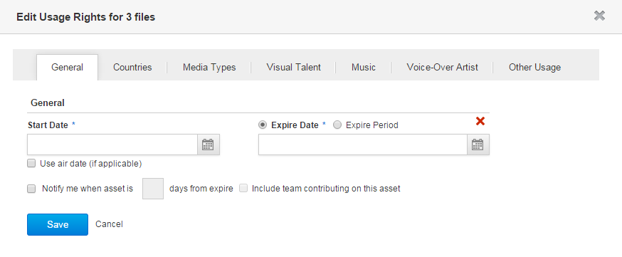

Figure 242 Editing Usage Rights on multiple files in batch > General tab

Per each selected file permissions to edit Usage Rights are checked:

* If a user has appropriate permission on at least one editable file, *Edit Usage Rights* button option is enabled for this user. When the user clicks it, they get warning which files are missing the permissions and will not be updated.
* If the user has no the permissions on any selected file, *More > Edit Usage* *Rights* button is disabled for them.

So, Usage Rights’ update is applied to all editable files where the user has appropriate permissions. Files where the user does not have the permissions, are not updated.

Activity records about editing Usage Rights are created on the File details page > *Activity* tab and on the Dashboard *> Recent Activity* widget.

While editing different Usage Rights on files in batch, metadata update occurs in such manner:

* Existing *General* Usage Rights are updated (i.e. existing metadata are rewritten by new ones). However, a user can add another *General* Usage Rights on appropriate tab on the File details page.
* Existing *Visual Talent*, *Voice-over Artists* and *Countries* Usage Rights are updated, while new *Visual Talent, Voice-over Artists* and *Countries* Usage Rights are added to the existing ones (i.e. new metadata are added to the existing ones and existing metadata are rewritten by their updates). Herewith, both old and updated metadata are displayed together on appropriate tab on the File details page.
* Existing *Other usage* and *Music* Usage Rights are remain, while new *Other usage* and *Music* Usage Rights are added to the existing ones.
* Existing *Media* *Types* Usage Rights are rewritten by new ones, while new *Media* *Types* Usage Rights are added to the existing ones. Batch adding/editing Usage Rights on multiple files of different media types is impossible. So, when a user tries to do this, *Media* *Types* tab is absent on the *Edit Usage Rights for files* window.

Note that while editing *Media Types* Usage Rights on single files, existing metadata are rewritten by new ones, and new metadata are added to the existing ones.

Also, *Visual Talent* and *Voice-over Artist* Usage Rights have the same set of metadata for each file. For both these types a user can either select predefined value from the *Artist Name* dropdown list (if a value is available) or add new value on-the-fly. After selecting a predefined value from the dropdown list, all artist-related fields will be autofilled.

*Role, More Info, Start Date* and *Expiry Date* metadata are specific per a file and thus they can be filled only manually.

**Note**: Any changes related to the *Visual Talent* and *Voice-over Artist* Usage Rights are recorded on the File details page and the Dashboard.

In case when these Usage Rights have been changed (i.e. added, edited or deleted), appropriate activity records have such format:

*‘<Username> updated usage rights on <File name> <Timestamp>’*.

Herewith, if a Talent information has been updated for these Usage Rights, appropriate activity records have such format:

*‘<Username> updated information for this talent <Talent name> <Timestamp>’*.

The last activity records are always related to the previous ones, thus they are displayed above them.

**Adding multiple *Countries* when** **adding/editing Usage Rights on files in batch**

Users endued with the *element.usage_rights.write* permission on files have possibility to add multiple *Countries* Usage Rights to them when adding/editing Usage Rights on files in batch.

To do this it is necessary to:

1. Highlight several files on the Project details page > *Files* tab and click the *Edit Usage Rights* action button.
2. Open the *Countries* tab in the window for managing Usage Rights and select appropriate values from the *Countries* dropdown list. All these countries are displayed in the dropdown list as appropriate country-related tags.
3. Assign Start Date and Expiry Date to all selected countries, set notification option (if necessary) and click the *Save* button to confirm the adding (see Figure 210).

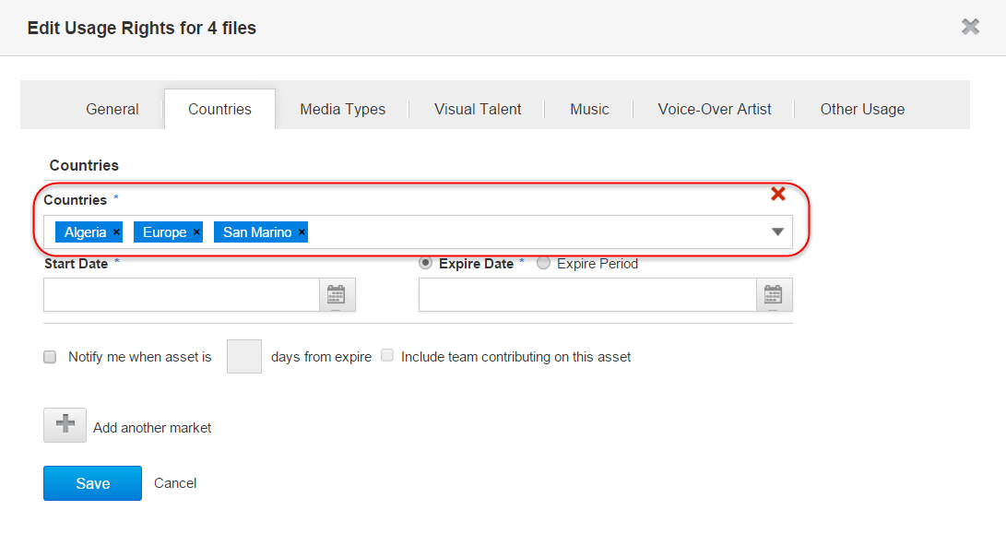

Figure 243 Window for managing *Countries* Usage Rights > Adding multiple countries on files

Each added in batch Country, as well as assigned Start Date and Expiry Date per it, can be edited individually on the File details page > *Usage Rights* tab.

**Note**: Users receive email notifications after editing Usage Rights of single and multiple files. After editing Usage Rights of several files at once, a user receives single email notification with the list of files where Usage Rights were edited.

### Copying/moving files to Projects

Users, endued with the *element.create* permission on Projects/Work Requests, can copy files there.

Users, endued with the *element.create* permission on target Projects/Work Requests, and at the same time, with the *element.delete* permission on source Projects/Work Requests, can move files from source Projects/Work Requests to the target ones.

Files can be copied and moved to Projects/Work Requests created under current Business Unit, as well as to Projects/Work Requests created under another Business Units (provided that these files were shared with current Business Unit).

To copy/move a file to a Project it is necessary to:

1. Select target file on the Project/Work Request details page > *Files* tab, or on the File details page and click the *More* > *Copy*/*Move* button there (see Figure 33 and Figure 201).

In case of copying/moving several files at once, it is suitable to highlight them on the *Files* tab and then click the *More > Copy*/*Move* button. Note that the button is enabled if at least one file is highlighted there.

1. In the pop-up Window for copying/moving folders:
   1. Click the target folder in the current Project/Work Request and click the *Copy/Move* button, or
   2. Click the *Want to copy/move files to another project?* link if necessary to copy/move the file to another Project/Work Request which was created under current Business Unit or a Business Unit from where it was shared. Note that the Window for copying files is similar to the Window for moving files (see Figure 244).

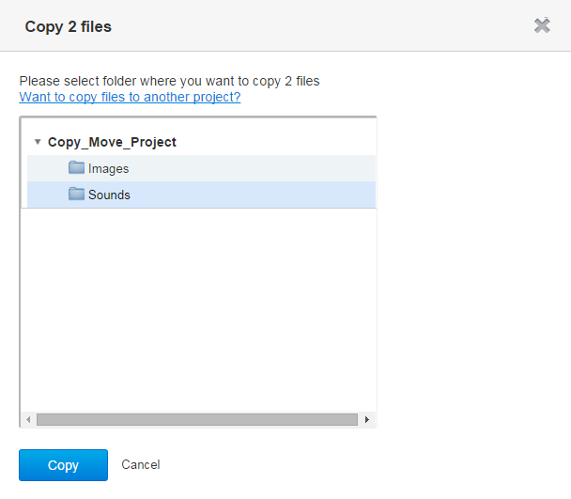

Figure 244 Window for copying files > Selecting target folder within current Project

1. If the *Want to copy/move files to another project?* link is clicked, the Window for copying/moving files will be refreshed, so that the user can enter the title of target Project/Work Request at the search field to find it, then click appropriate folder in the folder tree of found Project/Work Request and click the *Copy/Move* button. It is possible to copy/move the file to the root folder of target Project/Work Request, as well (see Figure 245).

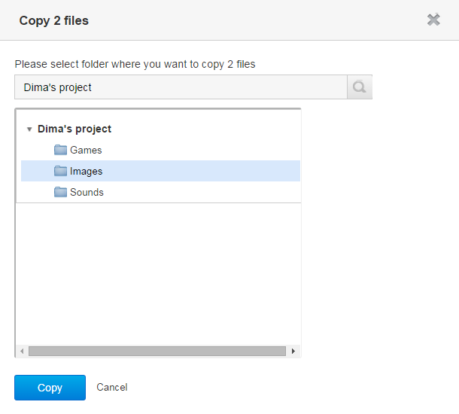

Figure 245 Window for copying files > Selecting target folder within another Project/Work Request

While copying/moving process is in progress, the user can view the pop-up window with progress bar and notification:

*‘Your files are being copied/moved, please wait…’*

Once a file was copied/moved, target Project/Work Request is opened on the Project/Work Request details page > *Files* tab where this file appears under the selected parent folder in the folder tree (or under the Project root folder).

Also, users have possibility to move single/multiple files from one folder to another one by drag-and-drop them either to target folder’s title in the folder tree or to target folder’s thumbnail next.

Before the drag-and-drop, multiple files should be highlighted by single-click.

**Note**: In case of copying/moving a file to a Project/Work Request which was shared from another Business Unit, this file will be automatically recreated in the destination Project/Work Request according to its metadata schema (file’s metadata will be populated according to the metadata mapping rules defined for this Business Unit).

In case of copying/moving a file to another Project/Work Request from current Business Unit, a user will be prompted to update file metadata according to the schema of destination Project/Work Request (workflow is the same as for folders copying/moving, see Figure 182).

### Copying files to the Library

Users have possibility to copy (send) to the Library single and multiple files at once. To do this it is necessary to:

1. Highlight the file(s) and click the *More* > *Send to the Library* button on the Project details page > *Files* tab or on the File details page.
2. Correct editable metadata (if necessary) and click the *Save* button on the *New Assets* page (see Figure 246).

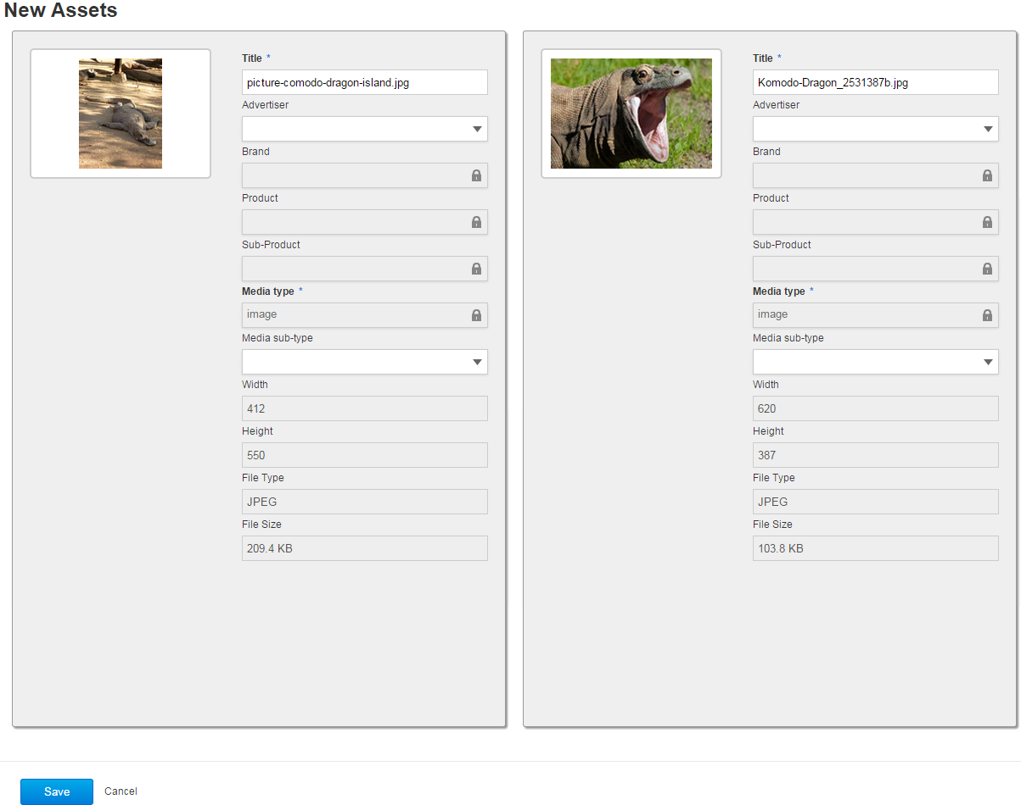

Figure 246 *New Assets* page

After a Project file was copied to the Library, it is marked as ‘Adbanked’ () in parent Project folder. Approval workflow for this file is disabled (*Approvals* tab is absent for it). Key metadata and Asset sub-type are inherited from Project file, but they are editable.

**Note:** Ifauser has access to multiple Business Units and is endued with the *element.send_to_library* permission, they can copy files from Projects to the Library of any partner Business Unit, as well as to the own Library. After copying, Project files appear on the *Library* tab under the Business Unit where the Project was created.

If copied files were created under the Project of a partner Business Unit, user of current Business Unit cannot view them in own Library.

After Project files were sent to the Library in batch, users receive single email notification about it. Herewith, corresponding activity records are displayed on the Dashboard > *Recent Activity* widget and Project details page > *Overview* tab > *Project Last activities* section.

### Deleting files

To delete a file from a Project folder it is necessary to:

1. Click the *More* > *Delete* button on the File details page or on the Project details page > *Files* tab.
2. Confirm deletion by clicking the *Delete* button in the dialog window (see Figure 247). File will be removed to the *Trash* directory.

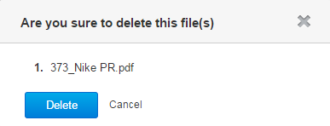

Figure 247 Deleting files

Also, single/multiple files can be removed to the *Trash* folder by drag-and-drop them to the *Trash* title in the folder tree.

**Note:** User can delete files if they has delete permission on folder or if they has uploaded this file himself, until share date expires.

### Restoring files

To restore a deleted file from *Trash* directory it is necessary to:

1. Go to the Project details page > *Files* tab (see Figure 33).
2. Click the *Trash* directory, select deleted file and click the *Restore* button (see Figure 248).

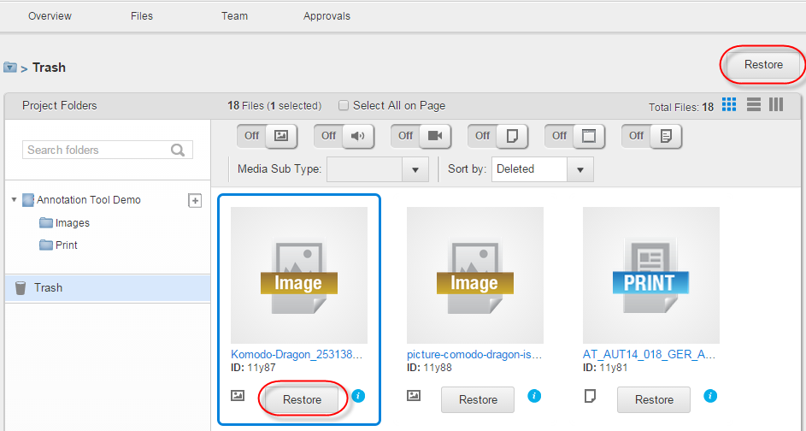

Figure 248 Project details page > *Files* tab > *Trash* directory > *Restore* button

1. Select target folder and click the *Ok* button in the *Select folder* pop-up window (see Figure 249).

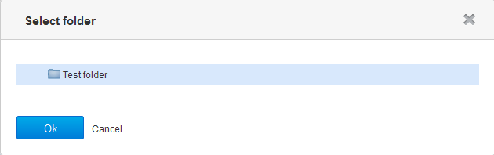

Figure 249 Restoring files

**Note**: Restored file will not be transcoded.

### Adjusting file previews

User can adjust file preview for some Digital, Print and Document files, e.g. for files: *.doc(x), .xls(x), .pdf, .ppt(x)*. To adjust file preview it is necessary to open the File details page and use special navigation tools to flip between pages, enable or disable full screen mode or scale file. First page of PDF file’s preview always fits screen on the File details page, while second page inherits scale of the first one (see Figure 250).

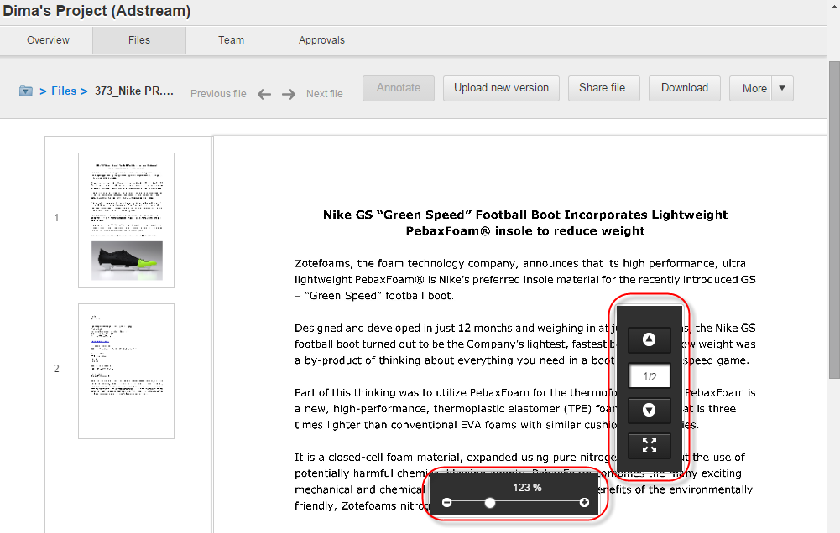

Figure 250 File details page > Tools for adjusting file’s preview

**Note**: SWF files are shown in file details as is (without transcoding). If SWF file is sequence, it will be played and looped. If SWF file is action script, it will be shown only first frame (without interactivity). Special navigation tools can be dragged and dropped if it is necessary.

### Sending files for approval

User can send separate file or group of files for approval. Herewith, it is possible to create new Approvals for the files or apply existing Approval templates for them.

To send separate file for approval, Approval/Stage Owner should click the *More > Send for Approval* button on the File details page (see Figure 251).

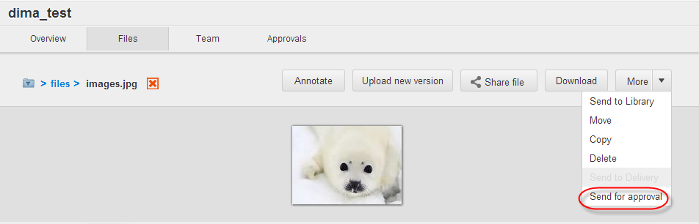

Figure 251 File details page > Sending separate file for approval

To send a group of files for approval Approval/Stage Owner should highlight them on the Project details page *>* *Files* tab and then click the *More > Send for Approval* button (see Figure 252).

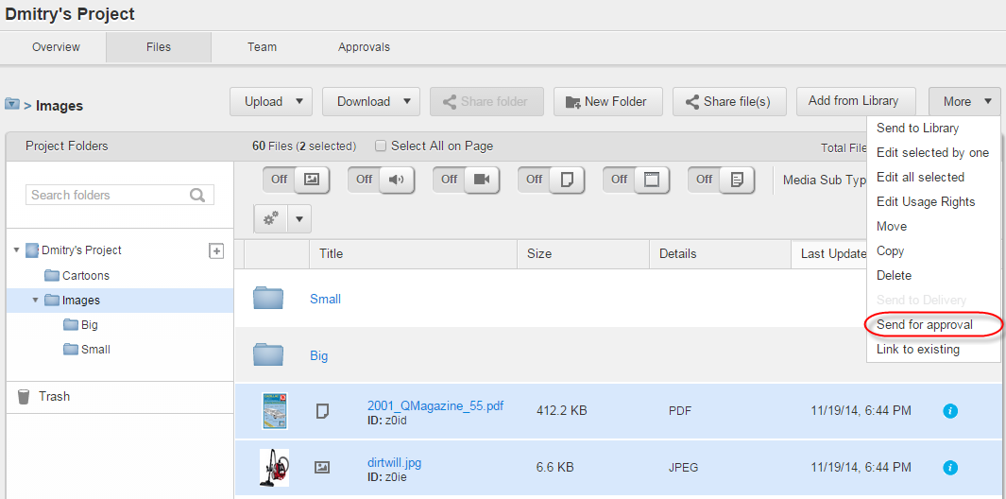

Figure 252 Project details page *> Files* tab > Sending group of files for approval

Once the *More > Send for Approval* button is clicked, the *Submit file(s) for approval* pop-up window opens (see Figure 253).

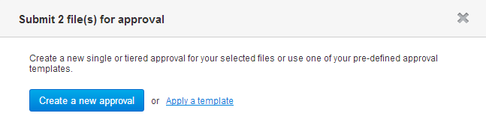

Figure 253 *Submit file(s) for approval* pop-up window

**Note**: After multiple files were sent for approval to an Approver, they receive single email notification about this.

This email contains special link by clicking which the user is automatically redirected to the first file in the batch which was submitted for approval. There, they can switch between all submitted files in the batch via arrow buttons (see Figure 254).

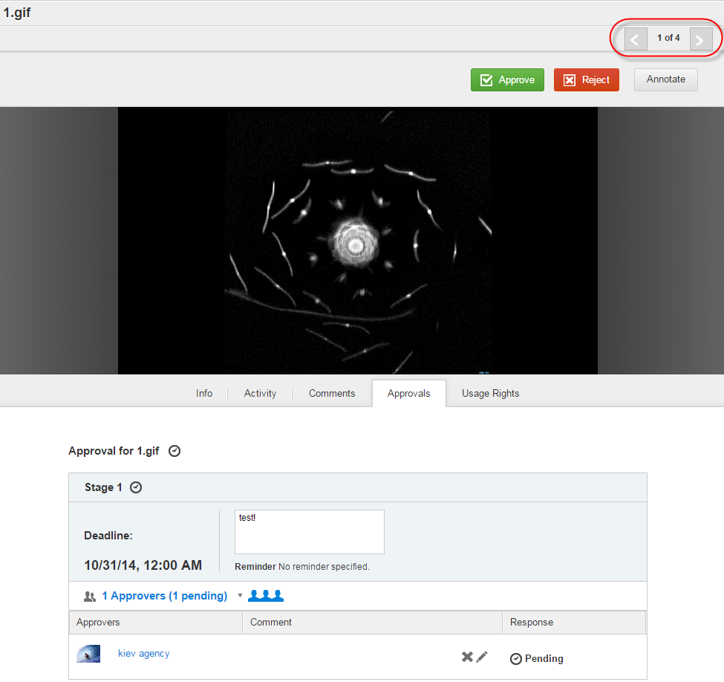

Figure 254 File details page > *Approvals* tab

#### Creating new Approvals when sending files for approval

To create a new Approval when sending a separate file or a group of files for approval it is necessary to click the *Create a new approval* button in the *Submit file(s) for approval* window (see Figure 253).

Once it is clicked, the *Add a new* Stage window appears, which is intended to create a new Approval Stage. For more details about creating Stages please refer to the page 298.

**Note**: In case of sending group of files for approval, once user creates the first Stage and starts it, separate Approvals with the same Stages are created per each file; these Approvals are totally independent from each other.

Separate email notifications are triggered per each Approval. These notifications have attributes: *From* address field, Custom URL, Locale, Branding (Logo, Background, etc.).

#### Applying Approval templates when sending files for approval

To apply an Approval template when sending separate file or group of files for approval it is necessary to click the *Apply a template* link in the *Submit file(s) for approval* window (see Figure 253).

Once it is clicked, the *Select an approval template* pop-up window appears where the user should select appropriate Approval template for file(s) (see Figure 255).

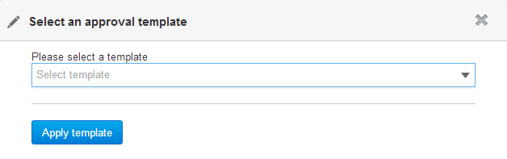

Figure 255 *Select an approval template* pop-up window

Once necessary template is selected from the dropdown list of templates, the user should click the *Apply template* button (see Figure 256).

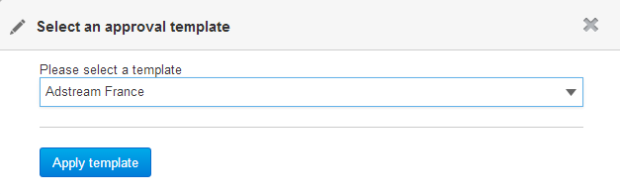

Figure 256 *Select an approval template* pop-up window > Approval template is selected

### Sharing files with users

Files can be securely and publically shared with unregistered and registered users. Sharing files within a Business Unit can be performed with any user invited to it, no matter either this user is from current Business Unit or from a partner one. So, lookup field in the Windows for sharing files can display the same list of users that is visible on the Admin area > *Users* tab of current Business Unit.

Users who have access to a Project/folder have possibility to view shared files which are in this Project/folder in the context of the Project. This means that by clicking received email’s link on shared file, such user accesses to the full file’s details (e.g. all tabs, action buttons, breadcrumbs, etc.), as if they would open the File details page from the Project folder which contains this file.

#### Sharing files securely

Single files, as well as multiple ones, can be shared securely with registered and unregistered users.

Sharing single files is possible from the File details page and from the Project details page > *Files* tab, while sharing multiple files is possible only from the Project details page > *Files* tab.

To share file(s) securely with a user it is necessary to:

1. Highlight file(s) on the Project details page > *Files* tab and click the *Share file(s)* button there (see Figure 257), or just click the *Share file* button on the File details page (see Figure 258).

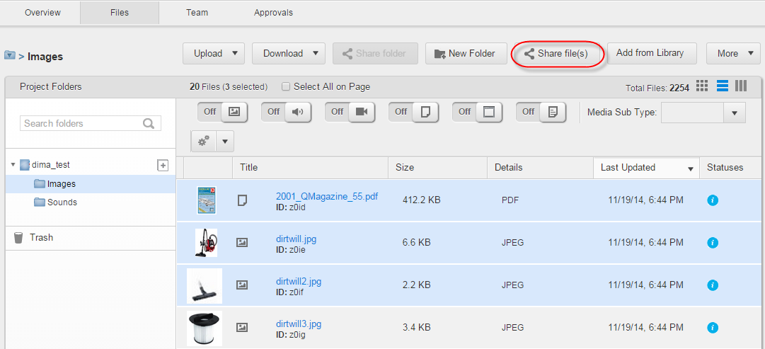

Figure 257 Project details page > *Files* tab > *Share file(s)* button

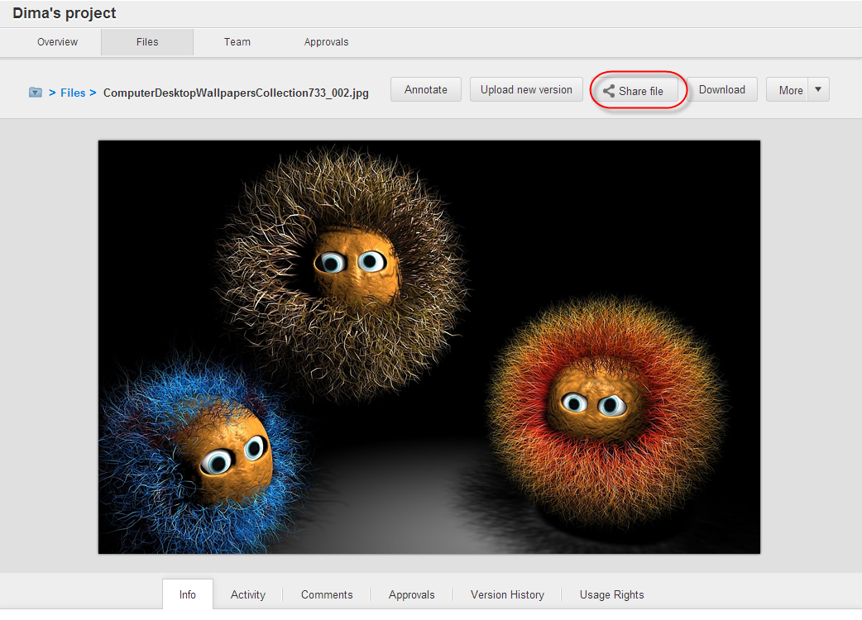

Figure 258 File details page > *Share file* button

1. In the *Share files* pop-upwindow specify:

* Email of the user(s) to whom the file(s) should be shared. In case of sharing the file with an unregistered user it is necessary to enter their email into the *Send link to* field and then click the ***create new*** pop-up link.
* Expiry date. If there is no need to set the expiry date, the *Never expires* checkbox should be ticked.
* Share comment, if necessary.
* Permissions to download file master and/or proxies by ticking appropriate checkbox(es) (see Figure 259).

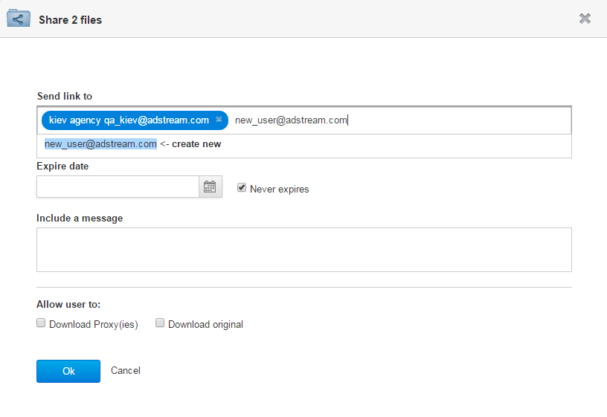

Figure 259 Sharing multiple files securely

1. In case of sharing the single file, do the step 2 on the *Share* tab which opens by default while opening the *Share files* pop-upwindow (see Figure 260).

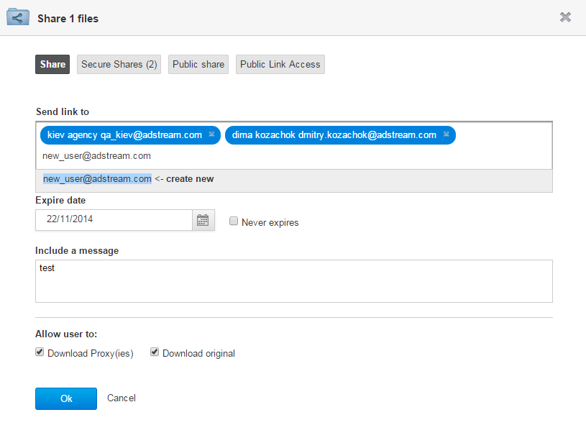

Figure 260 Sharing single files securely

1. Click the *Ok* button.

After the file(s) was/were shared, the specific email notification(s) about this will be sent to the user(s) (one notification per one shared file).

During sharing a file to an unregistered user, a user who shares the file can apply a sharing message to it. This message is saved as a comment on the Secure Share page, so unregistered user can view and reply to this comment after they opens a shared file.

File can be shared by a user if they is endued with the *file.share* permission. It is available for user roles which are included in the Project Roles group. This permission is added by default to the *Project Administrator* and *Project Contributor* roles, also it can be added to other roles via the Administration area > *Roles* tab.

Project Owner can see activity records about secure shared files on the:

* Dashboard.
* Project details page > *Overview* tab.
* File details page > *Activity* tab.

Such activity records are invisible to the users who received the shared file. They get only email notification about it.

After a registered user receives the email notification about file shared to them, they should click the link in the email to open shared file.

If registered user has already logged in the *Adbank 5*, after clicking the link they can see file metadata on the *Info* tab, herewith file’s metadata cannot be edited. Also, the user can download original and/or preview of a shared file if corresponding permissions were granted to him by the user who shared the file.

If registered user has not logged in the *Adbank 5*, after clicking the link they is taken to the Login Page where they should enter login details to view the shared file.

**Note**: This user cannot not see shared files anywhere in the *Adbank 5*, only by clicking the link in the email notification.

#### Sharing files publicly

File’s public sharing can be applied only for single files. Herewith, they can be publically shared with both registered and unregistered users via special Public link.

To share a single file publically with user(s) it is necessary to:

1. Highlight the file on the Project details page > *Files* tab and click the *Share file(s)* button there (see Figure 257), or just click the *Share file* button on the File details page (see Figure 258).
2. In the *Share files* pop-upwindow click the *Public share* tab and then click the *Activate* button to enable the Public link for the file (this link is generated automatically in the *Adbank 5* and is used to access to the shared file). If the file is shared publically for the first time (see Figure 261):
   * Public link is inactive.
   * *Never expires* checkbox is ticked.
   * Both the *Never expires* checkbox and the *Expiry date* Calendar field are shaded.

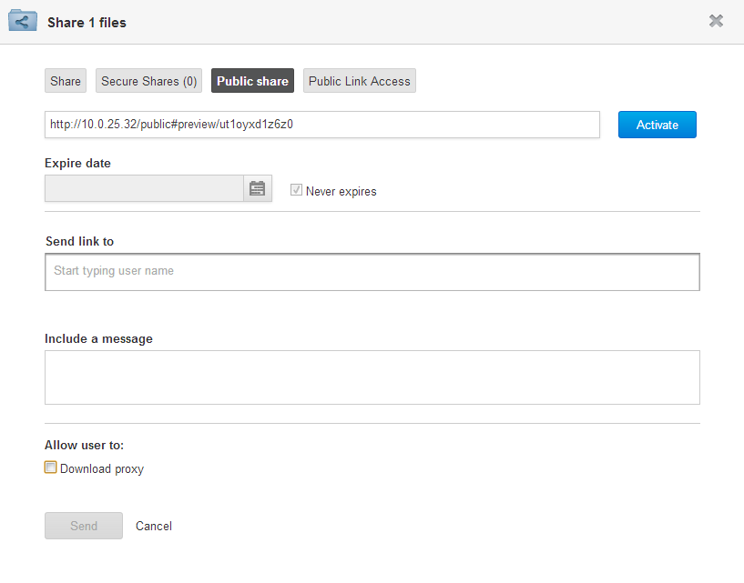

Figure 261 Sharing single files publicly > Deactivated Public link

1. Once the *Activate* button is clicked:
   * *Never expires* checkbox becomes ticked until a user either unticks it or selects an actual expiry date from the *Expiry date* Calendar field.
   * *Activate* button is changed to the *Deactivate* one
2. *(optionally)* Specify an expiry date for the file/Asset via the *Expiry date* Calendar field. Otherwise, leave the *Never expires* checkbox ticked if there is no need to select an expiry date for the file.
3. Specify recipient(s) for the file by filling in the *Send link to* field. To add the recipient’s email, start typing it and then select appropriate one from the pop-up under the field. If the file is shared to an unregistered user, enter complete email address and then click the *create new* pop-up link under the field. It can be added registered and unregistered users at the same time (see Figure 262).

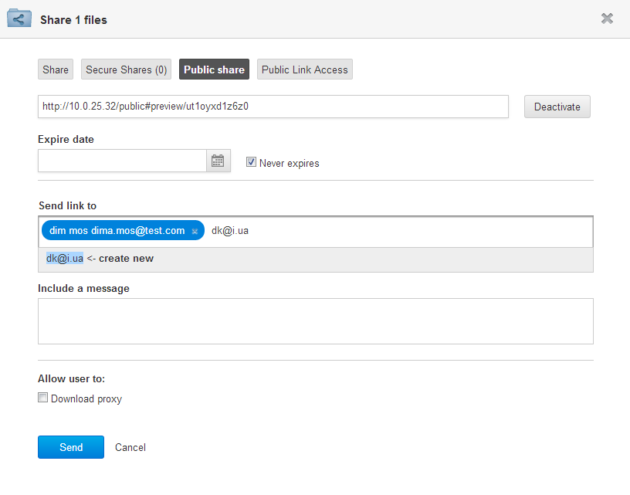

Figure 262 Sharing single files publicly > Activated Public link

1. *(optionally)* Attach a share message which the recipient(s) will receive in the email notification.
2. *(optionally)* Tick the *Download proxy* checkbox to allow the recipient(s) to download the file’s proxies from the Public Share page. In this case, at the opening the Public Share page, this user is able to download file proxy via the *Download Proxy* button (see Figure 263).
3. Click the *Send* button to send the email notification with Public link to all specified users. The Public is only visible in this email.

It is possible to activate Public link on files without sharing them to users. In this case, a user should activate Public link, as described by steps 1 – 2 on page 276, and then close the Window for sharing files/Assets by clicking the *Cancel* link or cross icon at the top-right corner.

Users to which a file was shared can access it by clicking the Public link from email notifications sent to them, without logon the *Adbank 5*.

Format of the email notification about public sharing is:

* Email Subject: *“<Username> has shared file with you”.*
* Email Body: *<Username> from <Business Unit> has shared file <File/Asset Name> with you. Please click link to view the file: <Public Link>.*

Unregistered users receive email notifications with Public link based on the locale of the Business Unit which shared a file. After clicking the Public link a user will be redirected to the Public Share page. Except the file and the branding of the Business Unit who shared it, the Public Share page can contain:

* Expiration date if it was specified during file/Asset sharing.
* *Download Proxy* button if the option to download proxy for shared file/Asset was allowed to the user during the sharing.

An example of Public Share page for a shared file, with specified expiration date and available option to download file’s proxy, is shown on Figure 263.

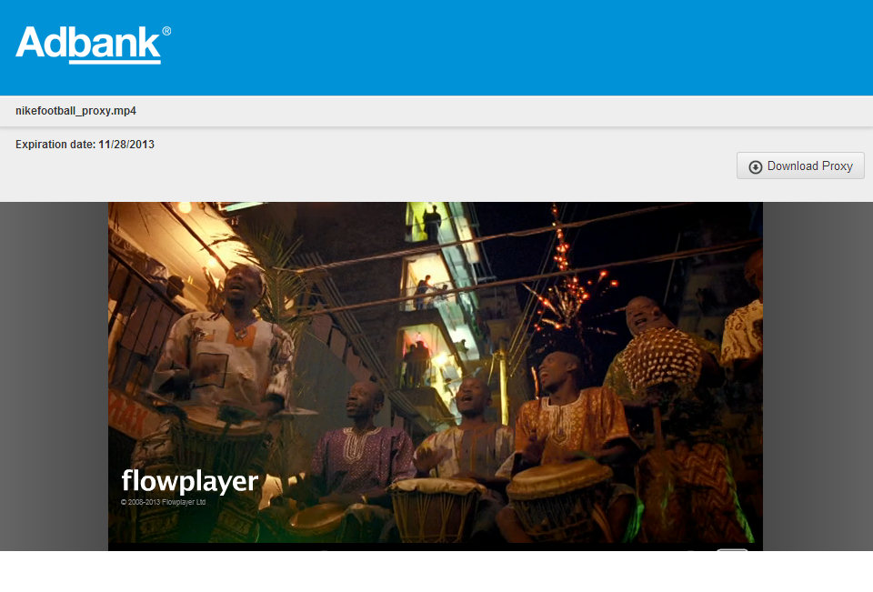

Figure 263Public Share page

Any file metadata as well as comments do not display on the Public Share page.

After a file was publically shared with users, the respective activity record is displayed on the:

* Project details page > *Overview* tab > *Project Last activities* section.
* Dashboard > *Recent Activity* widget (for files within the Projects that a user created himself and the Assets that he uploaded himself).
* File/Asset details page > *Activity* tab.

This activity record contains link to the shared file and its proxy if the option to download file’s proxy was allowed for the user.

If a user has no longer access to a shared file, they will see the polite notification:

*‘We are sorry! You do not have permission to access this area*’.

Users granted with the *element.public_share.create* permission can view theWindow for sharing/unsharing files > *Public* *share* tab. Users granted with the *asset.public_share.create* permission can view the Window for sharing/unsharing Assets > *Public* *share* tab,

By default, both these permissions are unavailable for any Project Roles, but available for Business Unit Admin.

**Note**: When a file or an Asset is shared to an unregistered user through Public link, user sees Public Share page according to their browser language settings.

### Unsharing files with users

Files which were securely and publically shared with unregistered or registered users can be unshared with them.

#### Unsharing securely shared files

To unshare a securely shared single file it is necessary to:

1. Highlight the file on the Project details page > *Files* tab and click the *Share file(s)* button there (see Figure 257), or just click the *Share file* button on the File details page (see Figure 258).
2. In the *Share files* pop-upwindow click the *Secure Shares* tab and then click the  control next to appropriate user email(s) (see Figure 264).

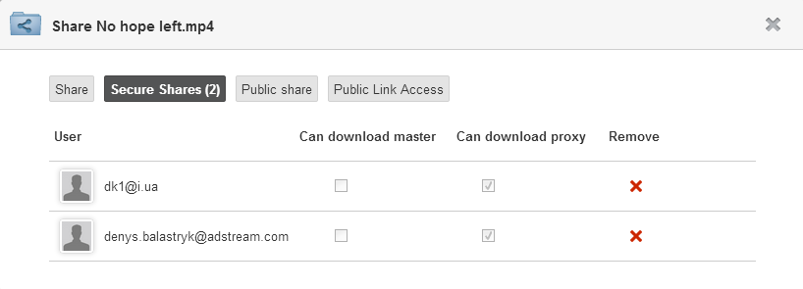

Figure 264 *Share files* pop-upwindow > Unsharing single files securely

#### Unsharing publicly shared files

To unshare a publically shared single file it is necessary to:

1. Highlight the file on the Project details page > *Files* tab and click the *Share file(s)* button there (see Figure 257), or just click the *Share file* button on the File details page (see Figure 258).
2. In the *Share files* pop-upwindow click the *Public share* tab and then click the *Deactivate* button (see Figure 262).

In this case, the Public link becomes deactivated, and *Deactivate* button is changed to the *Activate* one (see Figure 261). So, the users with whom the file was publicly shared cannot view any more it via appropriate Public link.

### Viewing users with whom files were shared

To view users with whom a file was shared it is necessary to:

1. Highlight the file on the Project details page > *Files* tab and click the *Share file(s)* button there (see Figure 257), or just click the *Share file* button on the File details page (see Figure 258).
2. In the *Share files* pop-upwindow click the:
   * *Public Link Access* tab to view the users that have public access to the file, also the date and time when this file was shared to each users (see Figure 265).
   * *Secure Shares* tab to view the users that have secure access to the file, also downloading permissions assigned to each user (see Figure 264).

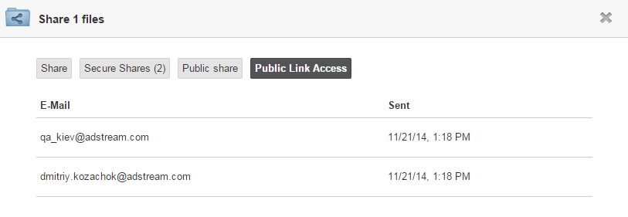

Figure 265 Window for sharing/unsharing files > Viewing users to whom files were publically shared

### Viewing/commenting securely shared files

After a file was shared with an unregistered user, it can be viewed and commented on the Secure Share page, which can be opened by clicking the special link in the email notification received by the user.

By click the access link, unregistered user is redirected to the Secure Share page for file which was shared to them. On this page, unregistered user can view file metadata, also download original and/or preview of file if corresponding permissions were granted to them by the user who shared the item.

Metadata for shared file are shown on the Secure Share page > *Info* tab. Besides the *Info* tab, the Secure Share page for shared file contains the *Comments* tab, while the Secure Share page for shared Asset does not contain such tab (see Figure 266).

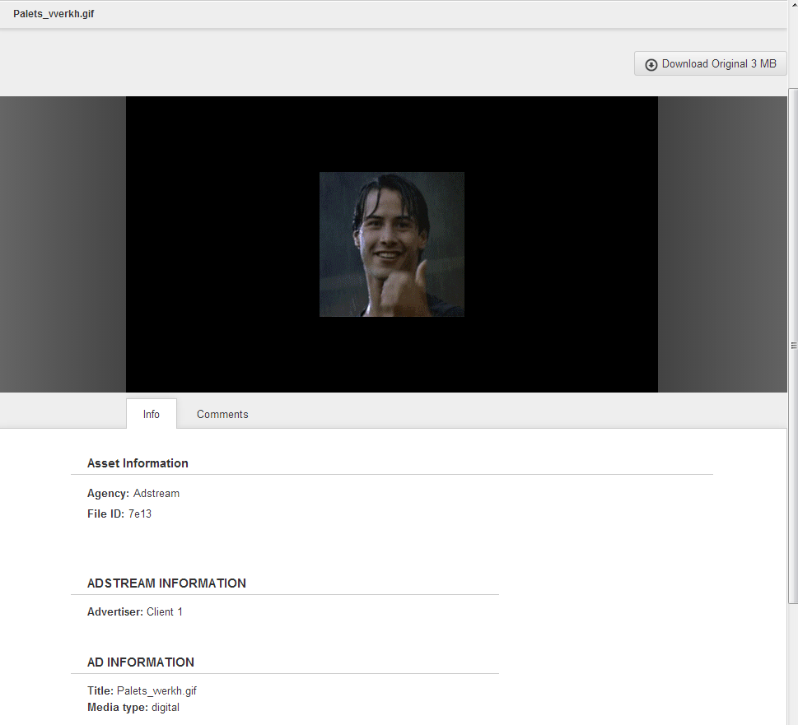

Figure 266 Secure Share page

Unregistered user can comment shared file on the Secure Share page > *Comments* tab. This tab is enabled only for shared files and disabled for shared Assets (see Figure 267).

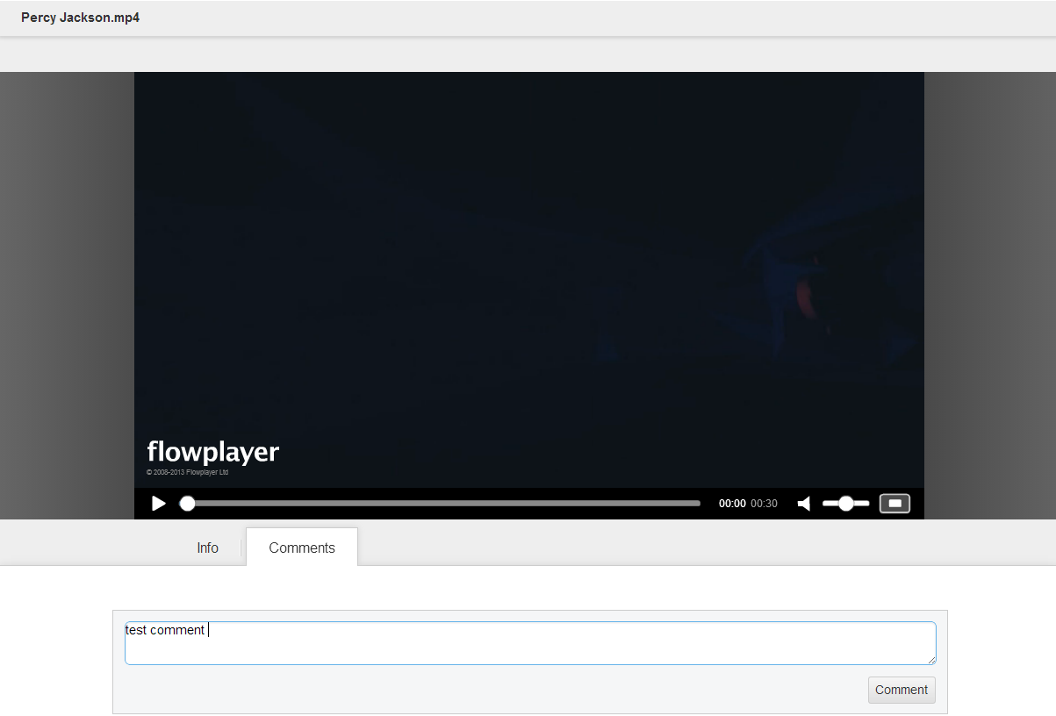

Figure 267 Secure Share page > Commenting shared file

Such comments are visible on the File details page > *Comments* tab to all users who have access to shared file.

Unregistered user can not see any other comments left on this file by other users.

**Note**: After clicking the link in the email notification unregistered user can see only the Secure Share page. When unregistered user views metadata or downloads file, this creates appropriate records in the Activity log of this file.

File which was shared with an unregistered user is always displayed on the Secure Share page with the branding of Business Unit under which this file was shared to this user.

When a Secure Share user adds a comment on a shared Project file, this generates special activity record for this file on the File details page > *Activity* tab.

Users who have a permission to view comments on shared files are notified by emails about the comments left by Secure Share users. Such notifications can be switched on or off via the *Comment written* checkbox in the Administration area > *User Settings* page >*Notification Setting* tab.

### Redefining Media Types for uploaded files

Users endued with *element.write* permission on files have possibility to redefine Media Types for them. This redefining can be applied to single and multiple files.

To redefine Media Types for files it is necessary to:

1. Open the Project details page > *Files* tab and highlight single or multiple files, or go to the File details page (in case of redefining Media Type for a particular file).
2. Click the *More > Change media type* button there (see Figure 268).

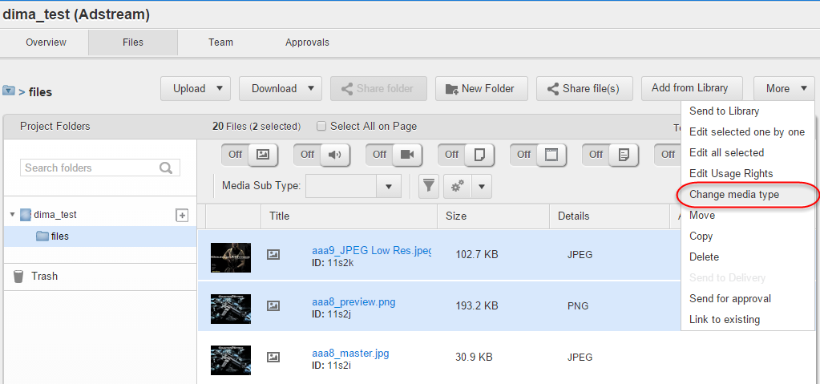

Figure 268 Project details page > *Files* tab > *More* 🡪 *Change media type* button

1. Select a new Media Type for highlighted file(s) from the *Media Type* dropdown list and click the *Save* button in the pop-up window for redefining Media Types. Media Type’s redefining updates metadata schema for a file according to the selected Media Type. So, any media-specific metadata are lost, while any common metadata are kept (see Figure 269).

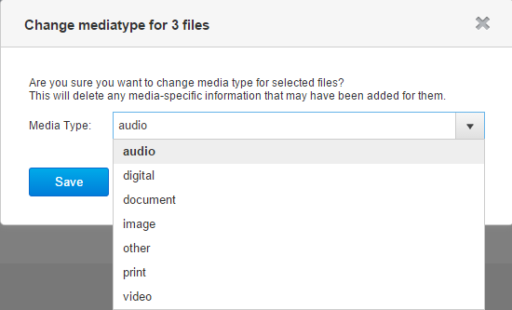

Figure 269 Window for redefining Media Types of files

While Media Types of files are being redefined, a user can see special window with progress bar (see Figure 270).

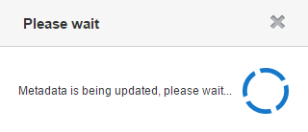

Figure 270 Redefining Media Types of files

**Note**: File with redefined Media Type can be properly filtered by Media Type filters on the Project details page > *Files* tab.

### Managing captured frames of video files

Users endued with the *element.write* permission on video files have possibility to capture, edit, download and delete frames for them.

#### Capturing frames

To capture frames from video files it is necessary to:

1. Go to the File details page and either click the *More > Capture Frame* button, or open the *Frames* tab and click the *Capture Frame* button (see Figure 271).

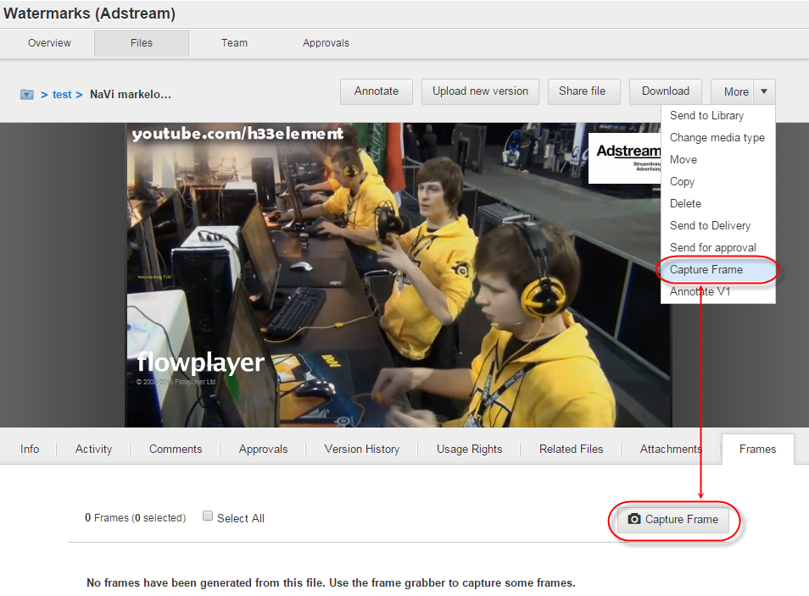

Figure 271 File details page > *Frames* tab > *More 🡪 Capture Frame* and *Capture Frame* buttons

1. Once the button is clicked, Frame Grabber tool is opened. There a user should play through the video (via the  and  controls) until the frame to capture will be found and then press the  control to capture it. For more accurate capturing the user should use  and  controls, or 🡨 and 🡪 arrow buttons on the keyboard to seek through the video frame by frame. Also, the user can view help how to grab frames by clicking the  control. In addition, the user can see the frame number of the frame currently selected in the video; it displays under the video control bar. Also, users have possibility to capture frames from video files in resolution of 300DPI. To do this they should tick the *300 DPI* checkbox before clicking the  control (see Figure 272).

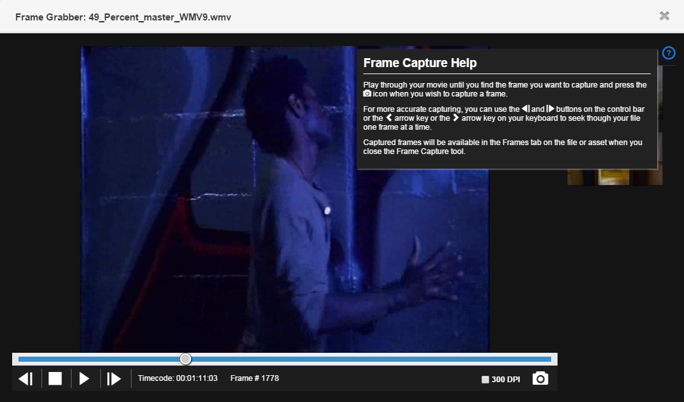

Figure 272 Frame Grabber tool

1. All captured frames are available for preview to the right on the Frame Grabber tool, and on the *Frames* tab after the tool is closed (see Figure 273).

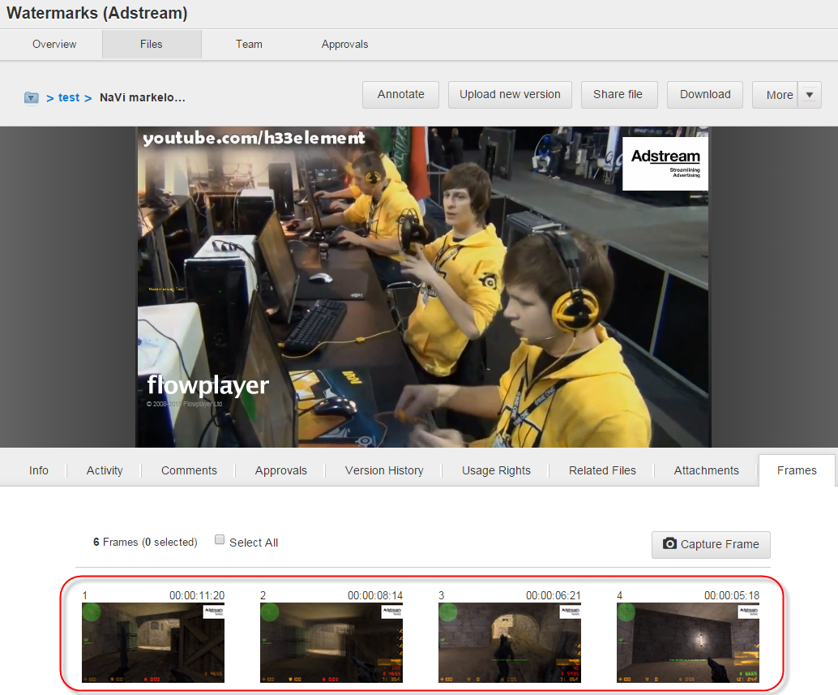

Figure 273 File details page > *Frames* tab > Captured frames

**Note**: If frames are created for a video file, and then new file revision is uploaded, all old frames are hidden, and the *Frames* tab is empty until the new ones are created again from the revision.

#### Downloading captured frames

To download a frame captured from a video file it is necessary to hover over the frame on the File details page > *Frames* tab and click the *Download Frame* option in the pop-up context frame’s menu (see Figure 274).

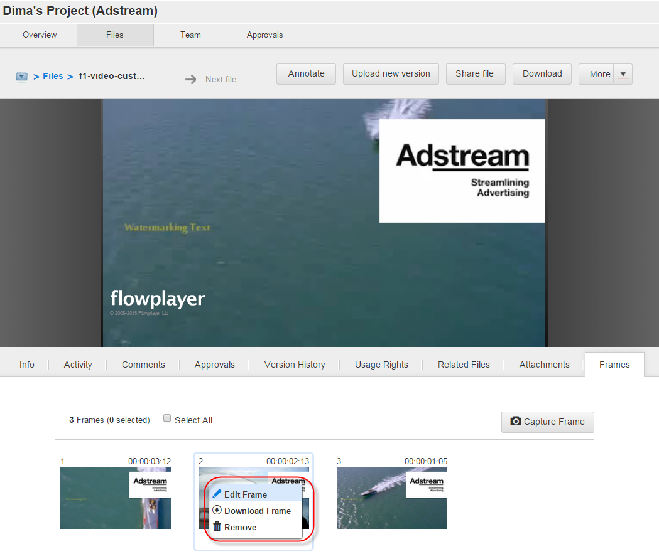

Figure 274 File details page > *Frames* tab > Context frame menu

Once the option is clicked, appropriate frame will be downloaded as *.PNG* file immediately from user’s browser.

#### Editing captured frames

To edit a frame captured from a video file it is necessary to hover over the frame on the File details page > *Frames* tab and click the *Edit Frame* option in the pop-up context frame menu (see Figure 274).

Once the option is clicked, Window for editing selected frame will be opened from where a user has possibility to:

* Add text description to the frame in the *Description* field.
* Download the frame via the Download control.

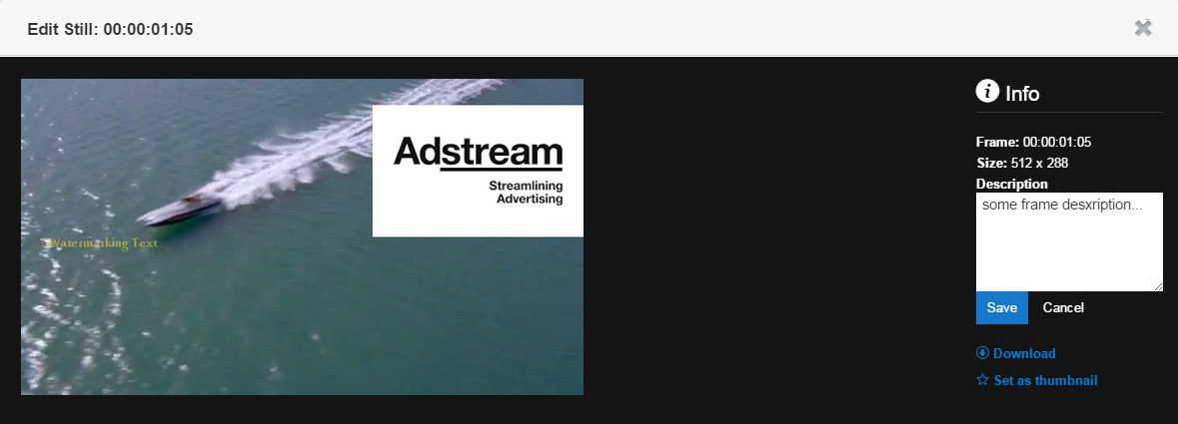

Figure 275 Editing captured frames

**Note**: Entered text description will be displayed for a user and can be edited again when they reopen the frame.

#### Deleting captured frames

To delete a single frame captured from a video file it is necessary to hover over the frame on the File details page > *Frames* tab and click the *Remove* option in the pop-up context frame menu (see Figure 274).

To delete several frames captured from a video file it is necessary to highlight them by single-click and click the *Delete Frames* button which appears on the File details page > *Frames* tab once the frames are highlighted (see Figure 276).

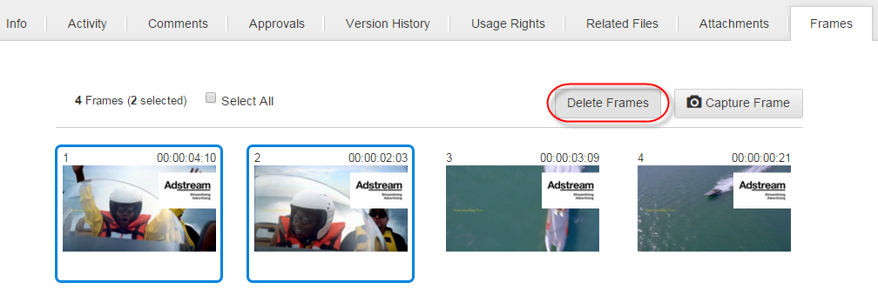

Figure 276 File details page > *Frames* tab > Deleting captured frames

To delete all frames captured from a video file it is necessary to tick the *Select All* checkbox and then click the *Delete Frames* button which appears on the File details page > *Frames* tab once the checkbox is ticked (see Figure 276).

**Note**: To deselect all highlighted frames it is necessary to untick the *Unselect All* checkbox which appears as ticked instead of the *Select All* one.

Sending files to the Delivery area

Video files from can be sent to the Delivery area. Sending in this case means creating new Orders where attached media are files retrieved from the Projects area.

To send single or multiple files to the Delivery area it is necessary to highlight them on the Project details page > *Files* tab or File details page (in case of sending a single file) and then click the *More* > *Send to Delivery* button (see Figure 33 or Figure 40).

Once the button is clicked, the Order details page opens with the retrieved media. For more details how to proceed creating the Order please refer to the page 455.

**Note**: Users do not have possibility to send to the Delivery area several files with different values of metadata providing that these metadata are marked as common for Orders (i.e. fields in which properties the *Make it common for order* checkbox is ticked). In this case, the UI pop-up warning appears:

*‘You are not able to add another commercial to this order with different metadata. Please create a separate order’.*

Also, the same logic is correct and the same message is shown to a user when they try to retrieve several files from a Project during creating an Order.

## Templates of Projects/Work Requests

Templates are inactive Projects/Work Requests which are visible only to their creators. Project Templates can be used for creating Projects, while Work Request Templates can be used for creating Work Requests.

### Creating Project/Work Request Templates from scratch

To create a Project Template it is necessary to click the *Create a new Project Template* button on the *Project* *Templates* tab (see Figure 277).

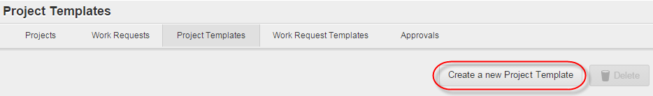

Figure 277 *Project* *Templates* tab > *Create a new Project Template* button

To create a Work Request Template it is necessary to click the *Create a new Work Request Template* button on the *Work Request* *Templates* tab (see Figure 278).

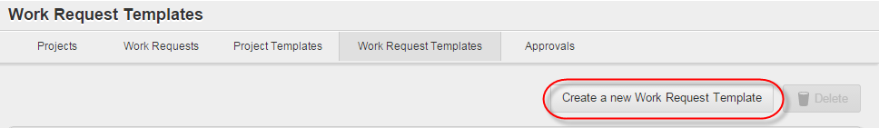

Figure 278 *Work Request Templates* tab > Create a new Work Request Template button

After appropriate button is clicked, a user should fill in metadata fields in the *New Template* window and click the *Save* button (see Figure 279).

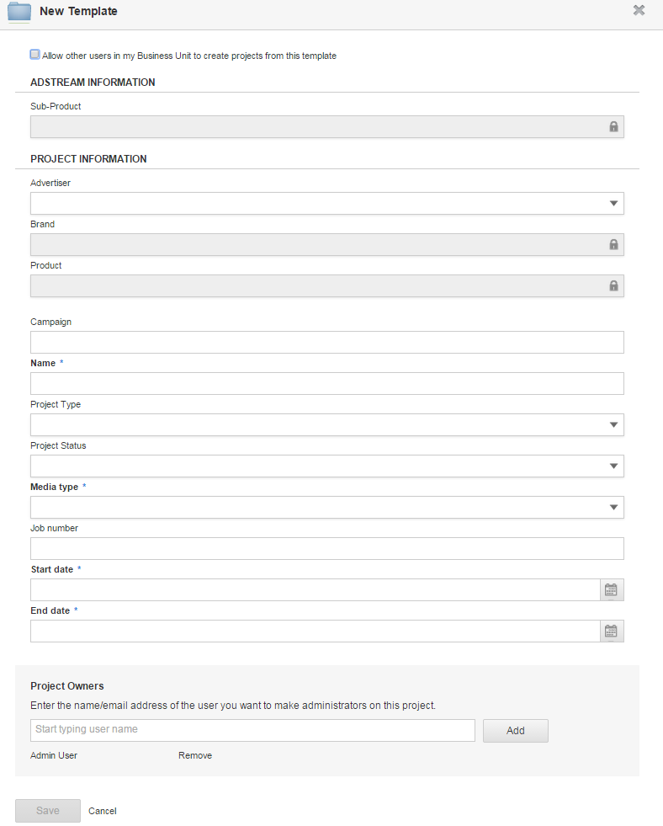

Figure 279 Window for creating Project/Work Request Templates from scratch

### Publishing Project/Work Request Templates

While creating/editing a Project Template/Work Request Template from scratch, Template Creator, Business Unit Admin and users, who were added to the Template’s Team as Template Owners, can make this Template accessible to any other users within current Business Unit (i.e. make the Templates public).

To make a Template public it is necessary to tick the *Allow other users in my Business Unit to create projects from this template* checkbox in the Window for adding/editing Templates (see Figure 279).

**Note**: Only those users who have the *View Public Templates* checkbox ticked in their user profile can have access to the public Templates.Also, these users can find corresponding public Templates on the appropriate tabs, view Templates details (folders, files and Teams) and create Projects/Work Requests based on appropriate Template types.

### Creating Templates from Projects/Work Requests

Project/Work Request Owner can create appropriate Templates based on own Projects/Work Requests.

To create a Template from a Project/Work Request it is necessary to click the *Create template from Project* link on the Projects/Work Request details page > *Overview* tab (see Figure 31).

Then, the user should fill in fields in the Window for creating Templates from Projects/Work Requests and click the *Save* button

When a user opens the Window for creating Templates from Projects/Work Requests, they can view the *Include Folders* and the *Include Team* checkboxes at the top which are ticked by default (see Figure 280).

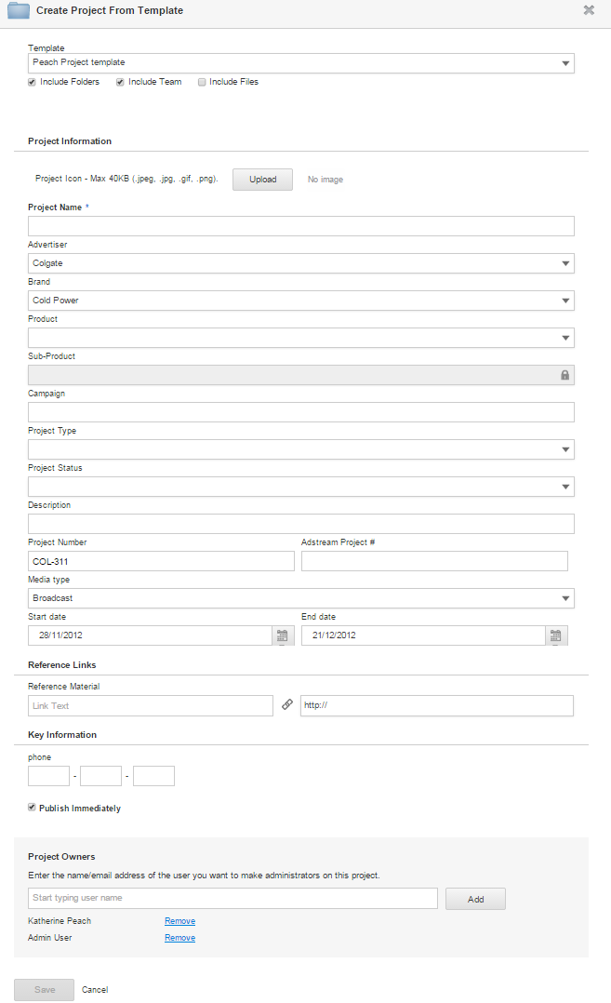

Figure 280 Window for creating Templates from Projects/Work Requests

### Deleting Project/Work Request Templates

To delete a Project/Work Request Template it is necessary to:

1. Go to the *Templates* tab.
2. Select a Template(s) for deleting and click the *Delete* button (see Figure 25).
3. Click the *Delete* button to confirm Template(s) deleting in the special window (see Figure 281).

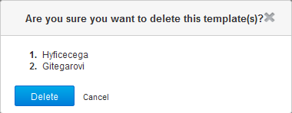

Figure 281 Deleting Project/Work Request Templates > Deleting confirmation

## Approvals

Approval workflow is based around Approval Owners that have the ability to manage Approvals on files within their Projects. The workflow corresponds such requirements:

1. Project Owners and Project Contributors are able to start Approvals and create their Stages.
2. Project Owner that created the first Approval Stage, automatically becomes Approval Owner for an Approval. Project Owner can manage all Approvals within their Projects, even those ones which were not created by them. The file owner cannot be assumed as the Approval Owner as it may be a production house that uploads it.
3. All Project Owners are Approval Owners for all Approvals within a Project, so they can override these Approvals. Subsequently, new Project Owners that are added to the Project, also become Approval Owners within it.
4. Business Unit Admin has access to all Approvals within all Projects of their Business Unit.

Ability to submit files for approval, apply Approval Templates to files, save Approvals as Approval Templates depends on the *approval*.*admin* and *approval.create* permissions. Users endued with the *approval.create* permission have possibility to see the *Approvals* tab and all related controls on the File details page, while users endued with the *approval.admin* permission have also possibility to administrate the Approvals created by other users. By default, these permissions are enabled for Project Owners and Project Contributors, but also they can be enabled/disabled for other Project roles by the Global Admin.

If a user belongs to multiple Business Units, and they start Approval on a file under a shared Project of a partner Business Unit, this user has possibility to apply only those Approval Templates to the Approval which are specific for this partner Business Unit. Herewith, Approval Templates of own Business Unit are disabled for them in this case.

Approval process can be singlestage and multistage for any Project file. In case of multistage Approval process:

* Any number of Approval Stages can be added to the same file.
* Approval Stages are hierarchical, i. e. the first Stage should be completed before the next one begins. If a file is rejected during the first Stage, the next one never begins.

Project Owner can start Approvals on files for published and unpublished Projects. When starting an Approval for unpublished Project, Project Owner should previously publish this Project, otherwise, when Project Owner tries to start Approval Stage for unpublished Project, the warning appears:

*‘This project is not published. Please publish the project to be able to start an approval.*’

If a Project has been unpublished after an Approval was started within it, users who try to access such Approvals can see the notification:

*‘You cannot access this area*.’

Users have possibility to view activity records about files submitted for approval, approved or rejected. These records are displayed on the:

* Dashboard > *Recent Activity* widget.
* Project details page > *Overview* tab > *Project Last activities* section.
* File details page > *Activity* tab.

Herewith, on the Dashboard a user can see Approvals information from the Projects where this user is creator. These activity records have such format:

*<Username> shared for approval/approved/rejected <Clickable filename> <Timestamp>.*

If an Approval has **one** Stage with **one** assigned Approver, the *Automatically close approval when all stages have been approved* checkbox is **ticked** for this Approval (in its details) and the Approver approved it, then Approval Owner receives one email notification about the Approver’s decision, Stage closing and whole Approval closing.

If an Approval has **one** Stage with **one** assigned Approver, the *Automatically close approval when all stages have been approved* checkbox is **unticked** for this Approval and the Approver approved it, then Approval Owner receives one email notification about the Approver’s decision and Stage closing.

If an Approval has **several** Stages with **several** assigned Approvers on them, the *Automatically close approval when all stages have been approved* checkbox is **ticked** for this Approval, and the last pending Approver approved it, then Approval Owner receives one email notification about the Approver’s decision, Stage closing and whole Approval closing.

If an Approval has **several** Stages with **several** assigned Approvers on them, the *Automatically close approval when all stages have been approved* checkbox is **unticked** for this Approval, and the last pending Approver approved it, then Approval Owner receives one email notification about the Approver’s decision and Stage closing.

**Automatic changing statuses of Approvals when making revision of files**

If a new revision was uploaded to a file while previous file version has an Approval in progress, this Approval automatically expires, and all users assigned to this Approval receive a warning which inform them that they have no longer access to previous file version. Therefore, if a user navigates to previous file version, they cannot submit it for Approval. In this case, the *Approvals* tab displays the message, which informs a user that they should navigate to current file version to create an Approval. So, only the latest file version can be submitted for Approval.

If a new revision is uploaded to a file after it was rejected, or rejected and closed, Approval status of the previous file version becomes *Changes Requested* on the File details page > *Version History* tab (see Figure 282).

If a new file revision is uploaded to a file after it was approved, or is awaiting approval/rejection, and option to automatically close Approvals is disabled for the file (i.e. the *Automatically close approval when all stages have been Approved* checkbox is unticked on the File details page > *Approvals* tab), Approval status of the previous file version becomes *Cancelled* on the File details page > *Version History* tab (see Figure 283).

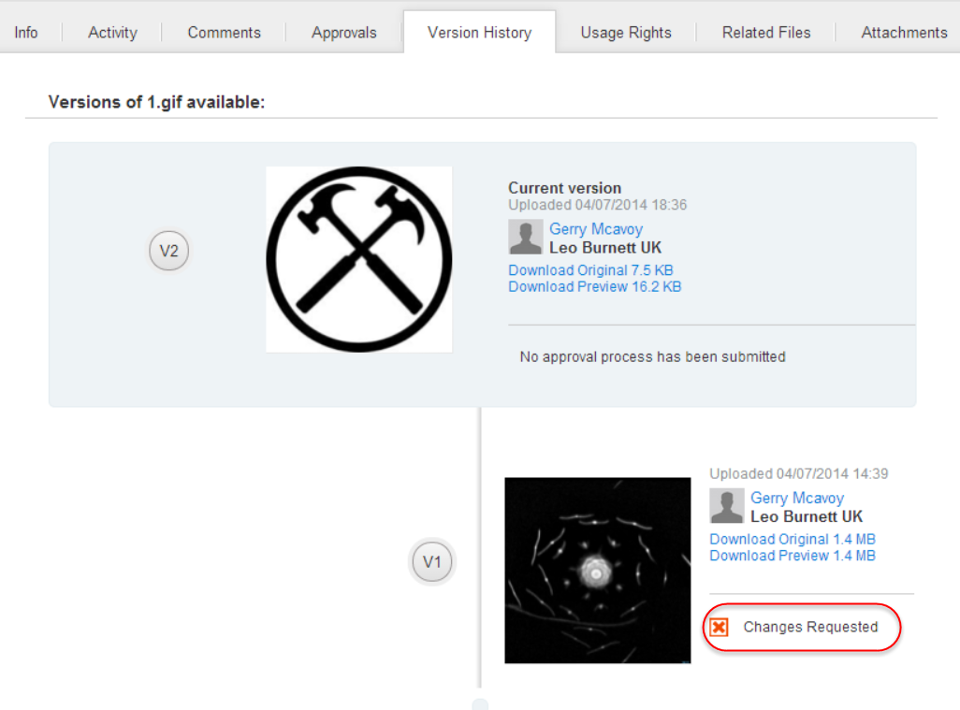

Figure 282 File details page > *Version History* tab > *Changes Requested* Approvalstatus

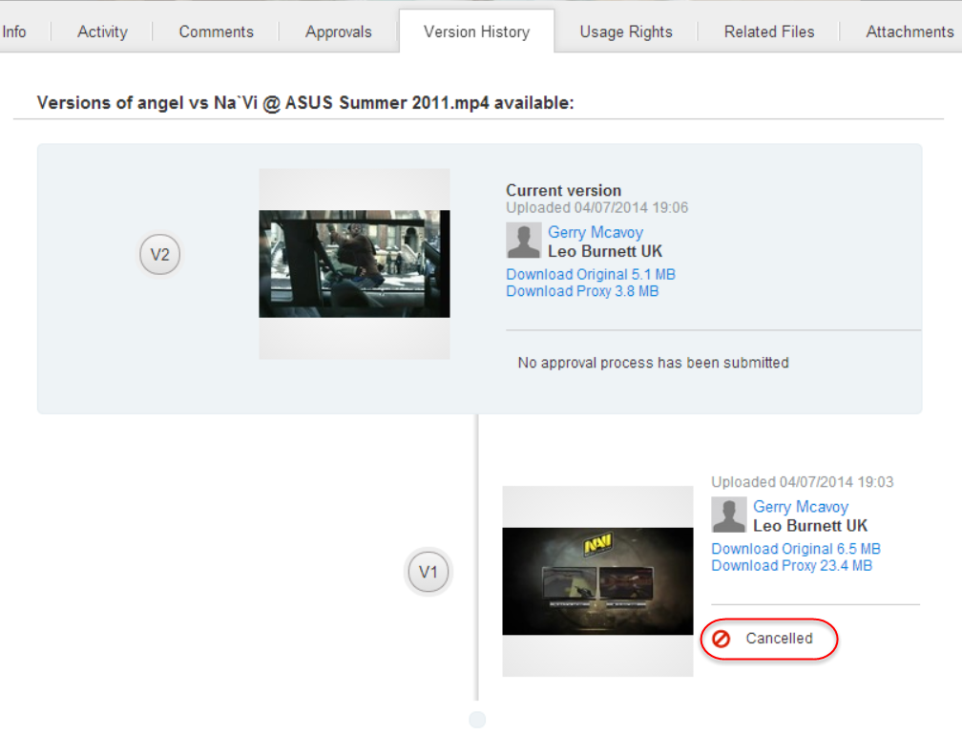

Figure 283 File details page > *Version History* tab > *Cancelled* Approvalstatus

### Adding Approval Stages

Approval Stages can be added via the File details page > *Approvals* tab. By default, before a user adds at least one Approval Stage, the *Approvals* tab is empty and displays a notification:

*‘’Start a single or tiered Approval. Add the users you require Approval from and setup reminders to keep the Stages of your Project on track.’*

To add the first Approval Stage user should click the *Submit for Approval* control (see Figure 284).

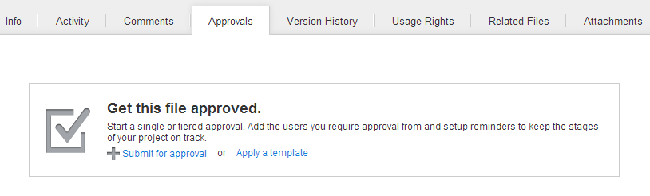

Figure 284 File details page > *Approvals* tab > No Approval Stages

To add a new Approval Stage to already existing Stages user should click the *New Stage* button which is enabled on the tab after the first Stage is created (see Figure 287).

By clicking the *Submit for Approval* control, the *Add a new Stage* window opens. By default, all fields into this window are empty, except the *Stage Name* field, which is automatically filled with the *Stage <number>* text. *<number>* is autoincremental ordinal Stage number (see Figure 285).

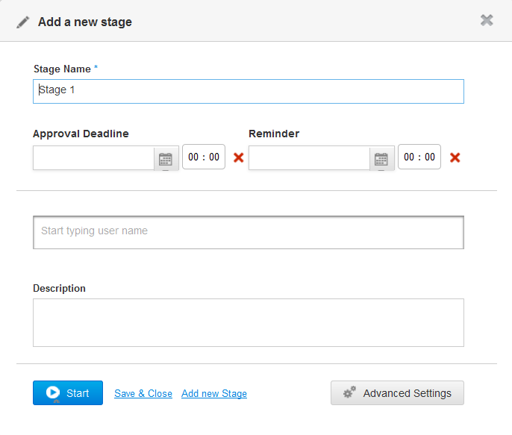

Figure 285 File details page > *Approvals* tab > Adding Approval Stage > Main settings

Fields in the *Add a new Stage* window are described in Table 22.

Table 22 File details page > *Approvals* tab > *Add a new Stage* window > Main settings

| **Field** | **Description** |
| --- | --- |
| *Stage Name\** | *(required)* Is used to edit Approval Stage title. By default, the title is *Stage 1* (*Stage 2, Stage 3*, etc.). |
| *Description* | Is used to enter comments to an Approval Stage: description or instruction related to the file. The description is displayed in the Approval Stage header. |
| *Start* button | Is used to start current Approval Stage. On clicking the button, Approval notification is sent to all Stage Approvers. The button appears only when:   * User starts the first Approval Stage.   There is no active Stage currently, e.g. all existing Stages were approved or rejected. |
|  | Is used to specify a date and time of an Approval Stage deadline. User should click the Calendar control to select the date (manual entry is impossible). Deadline time should be entered manually in current user's time zone. Entering the date in the past is impossible (past dates are disabled).  icon is used to clear selected date and time.  Once the Approval is submitted, the *Approval Deadline* value will populate the *Due Date* field in the notification shown to all Approvers. If the field is blank, defaults to the Approval submission date, so the notification to Approvers will display *Due Date* as *Now.*  Approval deadline added to email notifications converted to recipient’s time zone. Text should be added to the Approval notification email: *Approval required by: [date], [time]*. If Approval deadline is not entered, this line should be: *Approval required by: No deadline specified*. Approval deadline date and time are first enabled when the user clicks the *Start* button.  Automatic email notification is sent one hour after Approval deadline has passed, to all recipients with *Pending* Approval status in the current Stage only. Email notification text should be the same as for Approval request, but subject should be different: *Approval required - past deadline!*  Approval Owner can change deadline date until the Stage is closed. When the Stage is closed, it is no longer possible to change deadline date. |
| *Save & Close* link | Is used to create a new Approval Stage and to close the *Add a new Stage* window. On clicking the button, no Approval notification is sent to Approvers. |
|  | Is used to add or to delete Approvers to current Approval Stage. User should start typing Approver’s name or email, and then select appropriate value from the pop-up below.  Adding Approvers to a Stage automatically adds them to the Project Team of a Project where the file is. It is possible to add the same Approver to different Approval Stages. |
|  | Is used to specify a date and time when a reminder will be sent to Approvers with the *Pending* Approval status. User should click the Calendar control to select the date (manual entry is impossible). Reminder time should be entered manually in current user's time zone. Approval reminder date and time are first enabled when the user clicks the *Start* button.  icon is used to clear selected date and time.  Automatic email notification is sent to all recipients with *Pending* Approval status in the current Stage only on this date and time. If the field is blank, no reminders are sent to Approvers.  Email notification text is the same as for Approval request, but subject is different: ‘*Approval required - reminder!*’  User can add just reminder date, without Approval deadline time, just to trigger automatic reminder notification on certain date.  Approval Owner can change reminder date until the Stage is closed. When the Stage is closed, it is no longer possible to change it. |
|  |  |
| *Advanced Settings* button | Is used to open advanced settings for current Approval Stage. User can (see Figure 286):   * Select the Stage type – *Multiple Approval Stage* or *Single Approval Stage*. * Assign Stage Owners from the list of Stage Approvers.   For details about advanced settings fields and controls see Table 35. |
| *Add new Stage* link | Is used to create a new Approval Stage by opening the *Add a new Stage* window for each new Stage. It is possible to add and save blank Stages with their subsequent filling if necessary.  All Approvers added to current Stage are notified when previous active Stage is approved/rejected. |
| icon | Is used to close the *Add a new Stage* window without any made changes. |

It is possible to set advanced settings for the Approval Stage. To do this Approval Owner should click the *Advanced Settings* button on the *Add a new Stage* window (see Figure 285). Once the button is clicked, the window is refreshed (see Figure 286).

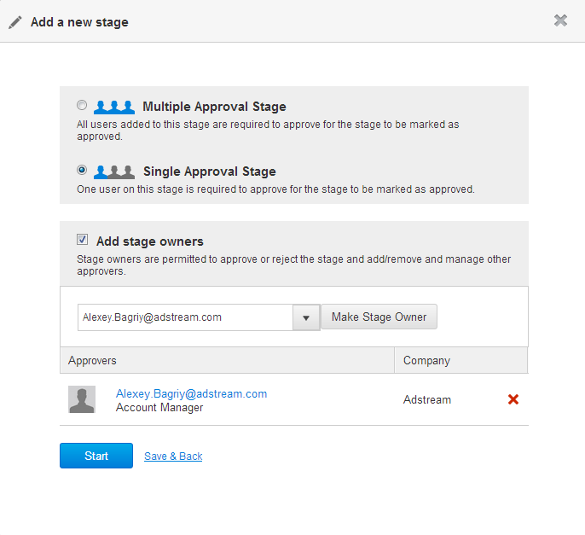

Figure 286 File details page > *Approvals* tab > Adding Approval Stage > Advanced settings

Advanced settings fields for the *Add a new Stage* window are described in the Table 35.

Table 23 File details page > *Approvals* tab > *Add a new Stage* window > Advanced settings

| Field | **Description** |
| --- | --- |
| *Multiple Approval Stage* radiobutton | Is used to set current Approval Stage as Multiple Approval one. If the radiobutton is ticked, the current Approval Stage will be completed only after all Stage Approvers approved/rejected the file. When the last Approver made a decision on Stage, the file passed to the next Approval Stage. Theoption is selected by default. |
| *Single Approval Stage* radiobutton | Is used to set current Approval Stage as Single Approval one. If the radiobutton is ticked, at least one Stage Approver on the Stage should approve it. |
| *Add Stage owners* checkbox | If the checkbox is ticked, it is possible to add Stage Owners to current Approval Stage. |
|  | Is used to make Stage Owners from the list of Stage Approvers that were assigned to current Approval Stage while Main settings were made.  Stage Owner as well as Approval Owner cannot automatically upload new version of the file (unless granted separate permission). |
|  | Is used to view and delete Stage Owners within current Approval Stage.  control is used to delete Stage Owner from the list of Stage Owners who are assigned to the Approval Stage. |
| *Save & Back* link | Is used to save all made Advanced settings and return to the Main settings for current Approval Stage. |
| *Start* button | Is used to start an Approval Stage. It is necessary to add at least one Approver to an Approval Stage before starting it, otherwise the *Save* button is disabled. |

Until the Stage is completed, it is possible to switch between the *Multiple Approval Stage* and the *Single Approval Stage* options, herewith:

* If no feedback has been given from Stage Approvers, an Approval/Stage Owner can reverse *Multiple Approval Stage* to *Single Approval Stage*, and conversely.
* If one feedback has been given from Stage Approvers, an Approval/Stage Owner can reverse *Multiple Approval Stage* to *Single Approval Stage.*
* If two feedbacks have been given from Stage Approvers, and one of them has the *Approved* responsestatus, an Approval/Stage Owner can reverse *Multiple Approval Stage* to *Single Approval Stage*, and current Stage automatically receives the *Approved* status*.*
* If two feedbacks have been given from Stage Approvers, and both of them have the *Rejected* responsestatus, an Approval/Stage Owner can reverse:
  + *Single* *Approval Stage* to *Multiple Approval Stage*, and the Stage receives to the *Rejected* status;
  + *Multiple Approval Stage* to *Single Approval Stage*,and the Stage remains in the *Open* status.

If the first Approval Stage was added but not started, i.e., the *Save & Close* link was clicked in the *Add a new Stage* window (see Figure 285), unbegun Approval is displayed on the *Approvals* tab (see Figure 287).

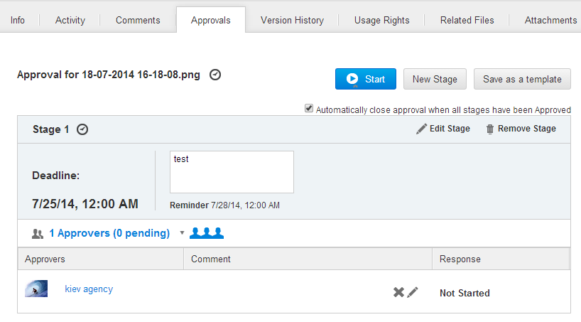

Figure 287 File details page > *Approvals* tab > First stage of unbegun Approval

If the first Approval Stage was added and started, i.e., the *Start* button was clicked in the *Add a new Stage* window (see Figure 285), begun Approval is displayed on the *Approvals* tab (see Figure 288).

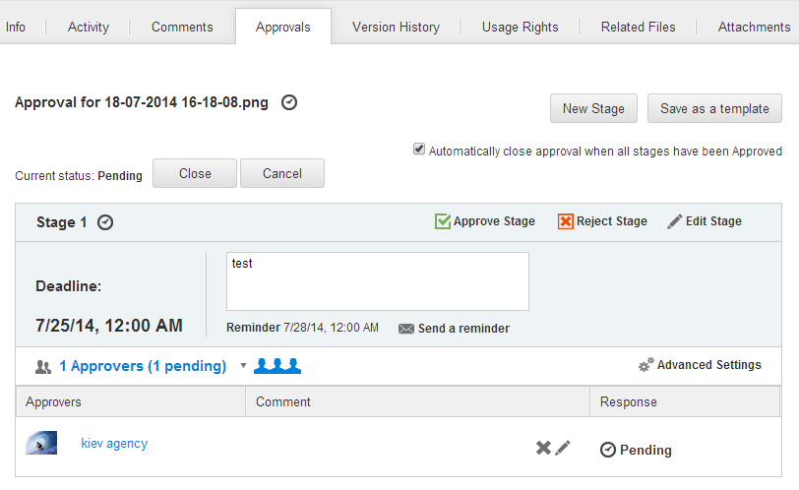

Figure 288 File details page > *Approvals* tab > First stage of started Approval

The Approval Stage details are described in Table 24.

Table 24 File details page > *Approvals* tab > Approval Stage details

| **Field** | **Description** |
| --- | --- |
| *New Stage* button | Is used to initiate adding next Approval Stage by opening the *Add a new Stage* window (see Figure 285). |
| *Save as a template* button | Is used to save an Approval in its current state as new Approval Template. |
| *Start* button (available only for an unbegun Approvals) | Is used to start an Approval if the first Approval Stage was not started while it was added to a file. |
| Approval Stage title | Is used to display Stage title. If it is not edited, Stage title consist of the word *Stage* and ordinal Stage number. |
| *Edit* *Stage* link | Is used to edit the Approval Stage details by opening the *Edit stage* window which is similar to the *Add a new Stage* window. |
| *Remove Stage* link (available only for an unbegun Approvals) | Is used to remove an Approval Stage if the whole Approval was not started for a file. |
| *Deadline* field | Is used to view date and time of an Approval Stage deadline. |
| *Reminder* field | Is used to view date and time when a reminder will be sent to Approvers about an Approval Stage with the *Pending Approval* status. |
| or | Is used to indicate the Approval Stage type: *Multiple Approval Stage* (first icon) or *Single Approval Stage* (second icon)*.* |
| List of Approvers | Is used to view all Approvers added for current Stage. They can be shown or hidden by clicking the icon. Approvers details are shown into the three columns: *Approvers, Comment* and *Response*.  *Approvers* column displays the contact name of an Approver.  *Comment* column displays an Approval / rejection comment if added by the Approver.  *Response* column displays an Approval status. Possible statuses are:   * *Pending* (displayed for all Approvers by default before the Approval is started). * *Approved*. * *Rejected.* |
| *Advanced Settings* link | Is used to manage advanced Stage settings. These settings allow user (see Figure 286):   * To edit Approval Stage type. * To assign extra Stage Approvers as Stage owners.   For details about advanced settings fields see Table 35. |

It is possible to add as many Approval Stages to a file as necessary. Approvers of the next Stage cannot see the Approval until previous Stage is approved, or force approve has been applied to a file. If previous Stage is rejected, Approvers of next Stage will not see this Approval, until the previous Stage becomes approved.

**Note**: After a Project file has been sent to the Library (file marked with  icon), the *Submit for approval* and the *Apply a template* options become disabled for it; so, a user has no ability to submit this file for approval or apply an Approval Template for it.

If a file had not been submitted for approval before it became ‘adbanked’, the notification is displayed on the File detail page > *Approvals* tab:

‘You don’t have a permission or see approval.’

If a file had been submitted for approval before it was moved to the Library (i.e. became ‘Adbanked’), a user can only view Approval details and cannot do any actions with the Approval on the File detail page > *Approvals* tab (see Figure 289).

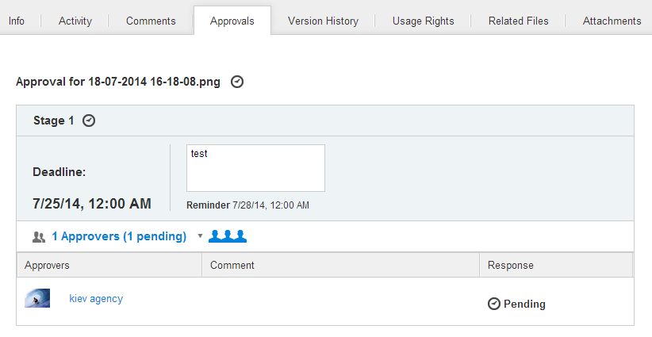

Figure 289 File detail page > *Approvals* tab > ‘Adbanked’ file with Approval Stages

### Editing Approval Stages

Clicking the *Edit Stage* control in an Approval Stage details (see Figure 288) will launch the *Edit Stage* pop-up window where Approval/Stage Owner can update main and advanced Stage settings (see Figure 290).

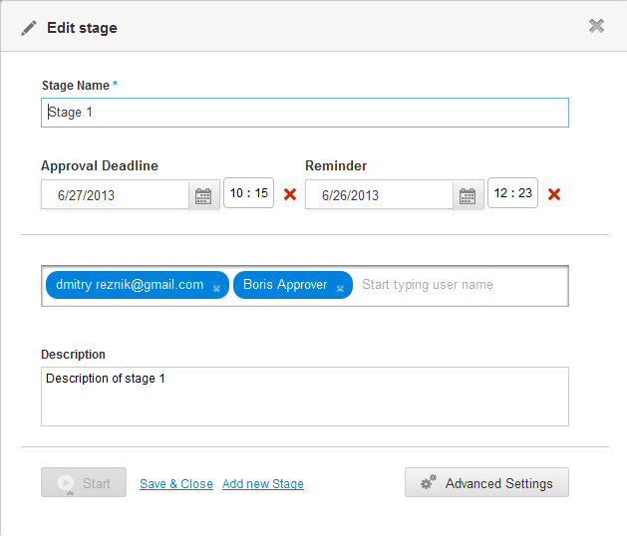

Figure 290 File details page > *Approvals* tab > Editing Approval Stage

Workflow of editing Approval Stage is similar to the workflow of adding Approval Stage. For more details about it please refer to the page 298.

#### Adding or deleting Approvers to Approval Stages

Approval Owner and Stage Owners can add or delete Approvers for active Stages.

To add Approvers to active Approval Stage it is necessary to click the *Edit Stage* control in an Approval Stage details (see Figure 288). This will launch the *Edit Stage* pop-up window where Approval/Stage Owner should start typing Approver name or email in the respective field and select appropriate value using the prompts listed into the pop-up (see Figure 291).

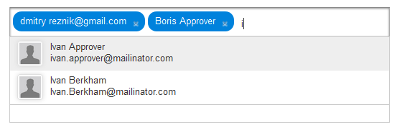

Figure 291 File details page > *Approvals* tab > Adding Approvers to a Stage

Adding users to a Stage is possible until it has been finalised. Once Approvers are added, this will trigger email and user interface notifications to them.

To delete added Approver from an Approval Stage it is necessary to mouseover on Approver entry and click the  icon next to it.

To confirm adding or deleting Approvers for a Stage, user should click the *Save & Close* button in the *Edit Stage* window (see Figure 290).

**Note**: If an Approver is added to *Stage 1*, the Approval is started, and then the Approver is removed from *Stage 1* and is added to *Stage 2*, this have to expire the Approval share visible to him, until the *Stage 1* is approved.

#### Sending reminders to Approvers

Approval/Stage Owner can send reminder about necessity to approve/reject active Stage to the Approvers on this Stage. To do this it is necessary to click the *Send a riminder* control which is placed in an Approval Stage details (see Figure 292).

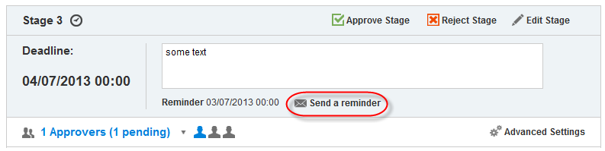

Figure 292 File details page > *Approvals* tab > Sending Stage reminder

When the button is clicked:

* Email notification is sent to all Approvers with *Pending* Approval status in the active Stage only.
* Email notification text is the same as for Approval request, but subject is different:

*‘Approval required - reminder!’*

* The UI notification appears:

*‘Reminder is sent’*

#### Editing/deleting comments on Approval Stages

If an Approver left a comment while they approved or rejected an Approval Stage, this comment will be received by the Approval/Stage Owner in appropriate email notification.

Approval/Stage Owner can edit and delete Approvers’ comments on Approval Stages.

To edit Approver’s comment Approval/Stage Owner should click the  icon next to it, type a new comment and click the *Ok* button to confirm the action (see Figure 293).

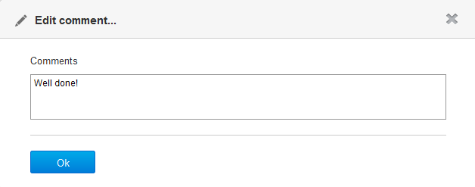

Figure 293 File details page > *Approvals* tab > Editing Approver’s comment

After that moderated comment appears instead of the original one. It is marked as *moderated* (see Figure 294).

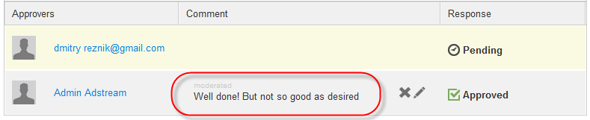

Figure 294 File details page > *Approvals* tab > Moderated Approver’s comment

To delete some Approver’s comment Approval/Stage Owner should click the  icon next to it and then click the *Yes* button in the respective pop-up to confirm the action (see Figure 295).

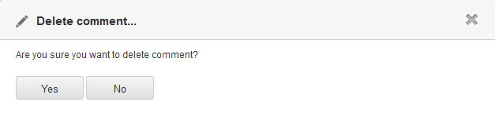

Figure 295 File details page > *Approvals* tab > Deleting Approver’s comment

After that, this comment will be deleted from the list of Approvers (see Figure 296).

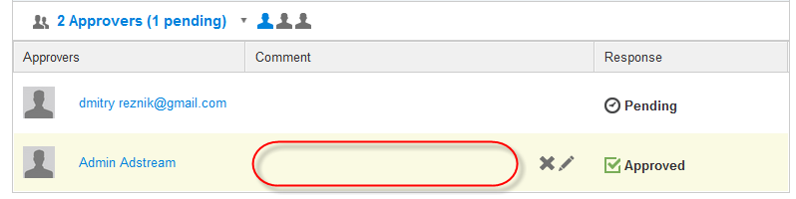

Figure 296 File details page > *Approvals* tab > Deleted Approver’s comment

### Removing Approval Stages

Approval Owner can remove Approval Stages before the Approval is started. This can be done by clicking the *Remove Stage* control in an Approval Stage details on the File details page > *Approvals* tab (see Figure 287).

Once the control is clicked, the *Removing* pop-up window appears where it is necessary to click the *Yes* button (see Figure 297).

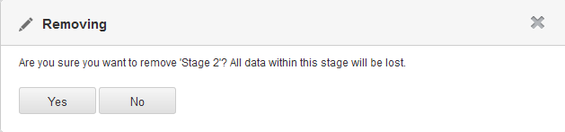

Figure 297 File details page > Approvals management > Removing Approval Stage

### Starting Approvals

Approval Owner can start an Approval after at least one Approval Stage is added. To do this they should click the *Start* button on the:

* *Add a new Stage* window, while adding the first Approval Stage (see Figure 285).
* File details page > *Approvals* tab if an Approval created but not started (see Figure 287).
* *Approvals* tab > *Not Started* sub-tab. Note that the sub-tab allows starting approval process for a batch of files at once (see Figure 298).

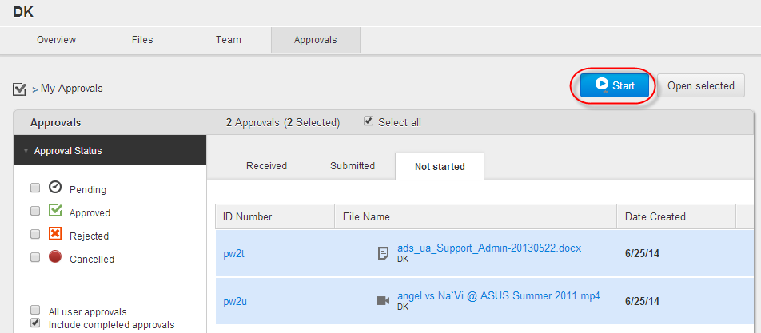

Figure 298 *Approvals* tab> *Not Started* tab > *Start* button

By clicking the buttonall Approvers who are added to the current active Stage will receive an email notifications. Approvers of the next Stage cannot receive email notifications until current Stage is approved (or force approve has been applied to it). If previous Stage is rejected, Approvers of the next Stage will not receive any notifications.

Once an Approval is started, it becomes possible to approve/reject its first Stage via special controls. For example, it is impossible to approve/reject *Stage 2* until *Stage 1* is approved or rejected (see Figure 299).

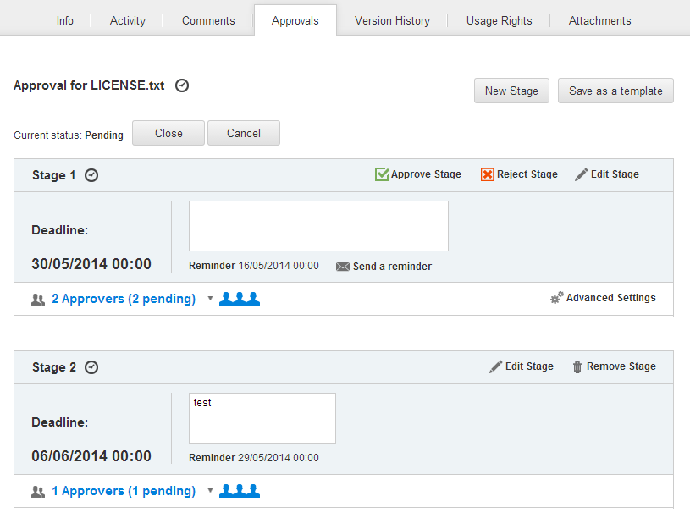

Figure 299 File details page > *Approvals* tab > Started Approval with several Stages

At any time after starting an Approval, Approval Owner can:

* Add a new Stage.
* Add users to a Stage until it has been finalised.
* Remove users from a Stage, so removed users will no longer see the Approval.
* Remove a Stage, so users of this Stage will no longer see the Approval.

### Approving or rejecting files

It is possible to approve or reject single file or group of files in batch.

#### Approving or rejecting single files

Once an active Stage of an Approval is started, each Approver who is assigned to it receives the email notification about this. After click special link to this Stage in the email and log in the system, they is taken directly to the Stage details. Approver can enter a comment and then either approve or reject the Stage. After that, they receives the message:

*‘Thank you! Your decision has been recorded. You can change your decision until the approval stage is closed’*

**Note**: If the Approver is not invited to the next Approval revision, they can see only the old revision of the file, but cannot access the new one until it has been shared with him.

Approvers of any Approval Stage can see only Approvers of the same Stage, and their feedbacks. They cannot see Approvers of the other Stages. Only Approval Owner can see the whole Approval Stages, so they can approve or reject a file or any of its Stages if necessary. Stage Owner can approve or reject only Approval Stages to which they were assigned by Approval Owner.

Once the Approver approved current Approval Stage, Approval Owner and Stage Owners are notified about this by email, and the Approvers of the next Stage are invited to make a decision on the file by email.

Whereas, if the Approver rejected current Approval Stage, Approval Owner and Stage Owners are notified about this by email, and the Approvers of the next Stage will not be invited to make a decision on the file until the rejected Stage is approved.

**Note**: Approved Stage can be rejected as well as rejected Stage can be approved by the same Approver if this Stage is unlocked and the whole Approval is not closed at that point in time. Approval Stage is locked in such cases:

* File has only one Approver regardless of which option (the *Multiple Approval Stage* or the *Single Approval Stage* one) was set for active Approval Stage, and this Approver has already approved/rejected the file.
* File has more than one Approver, one of them has already approved/rejected the file, and the *Single Approval Stage* option was set for active Approval Stage.

To open File details page > *Approvals* tab for approving or rejecting a file, Approver should click the filename link of an Approval on the:

* *Approvals* tab > *Received* tab (see Figure 27).
* Dashboard *> Received* tab (see Figure 11).

Once the link is clicked, Approver can:

* View the Stage details and annotate it via the *Annotate* button, if necessary.
* Approve active Approval Stage via the  button and reject it via the button (see Figure 300).

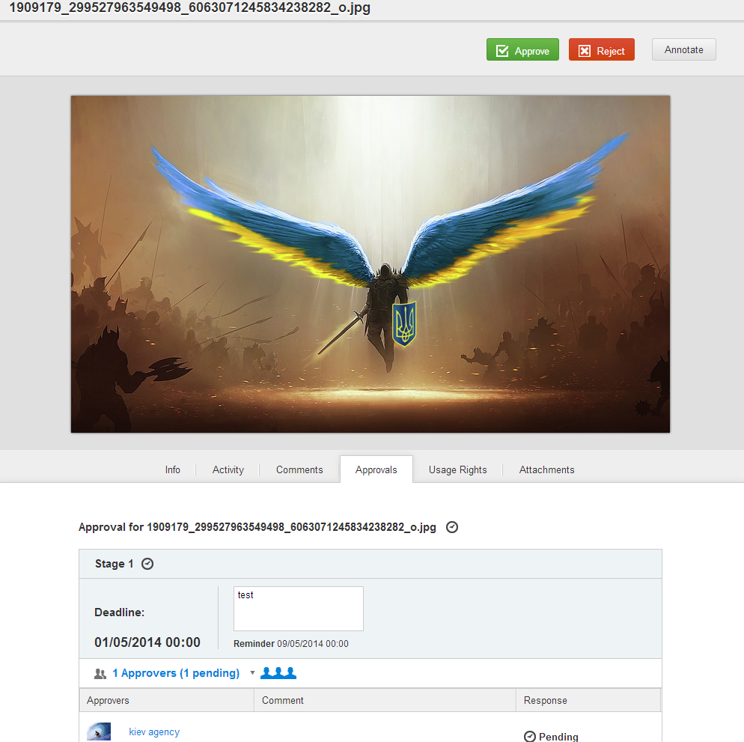

Figure 300 File details page > *Approvals* tab > Approver’s view

Approval/Stage Owners can approve active Approval Stage via the  button and reject it via the button on the File details page > *Approvals* tab (see Figure 301).

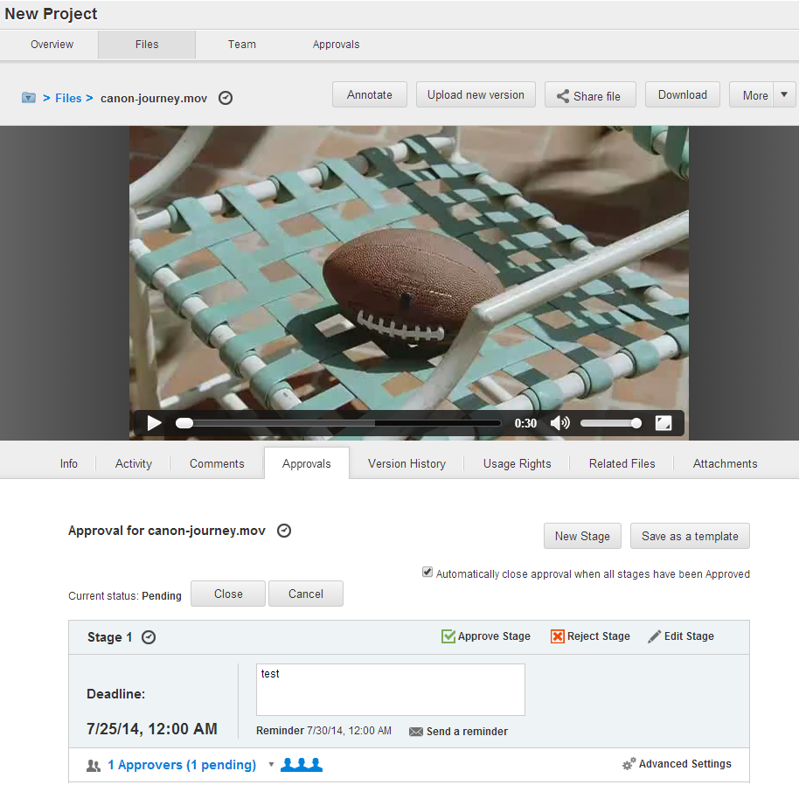

Figure 301 File details page > *Approvals* tab > Approval Owner and Stage Owners’ view

Approving a Stage by Approval/Stage Owners opens the confirmation window where it is necessary to click the *Approve* button to confirm. Stage approvement will trigger notification to Approvers of the next Stage; this action cannot be reverted (see Figure 302).

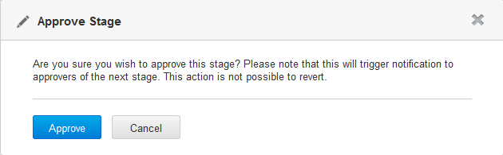

Figure 302 File details page > *Approvals* tab > Approving a Stage

Rejecting a Stage by Approval/Stage Owners opens the confirmation window where it is necessary to click the *Reject* button to confirm. Stage rejection will trigger notification to Approvers of the next Stage; this action also cannot be reverted (see Figure 303).

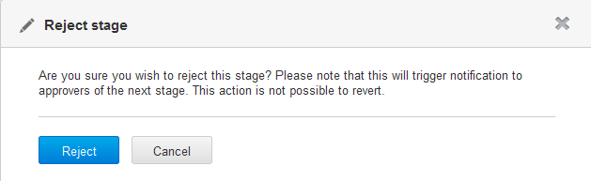

Figure 303 File details page > *Approvals* tab > Rejecting a Stage

Approving and rejecting a Stage by Approver opens the confirmation window where they can enter a comment to the decision. Approver who left a comment can edit or delete it until the Stage is closed. This comment is visible together with Approval status on the *Approvals* tab, but is not visible on the Dashboard (see Figure 304).

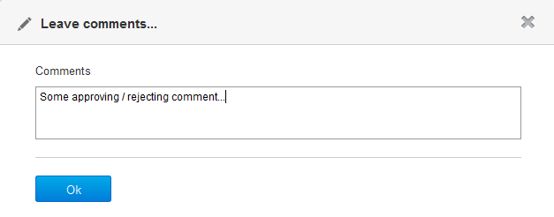

Figure 304 File details page > *Approvals* tab > Adding a comment to a Stage

If current Stage is approved or rejected:

1. Stage/Approval Owner are notified about this. Comment added by Approver during approving/rejecting the Stage is displayed by default in expanded mode in the Stage details for Approval Owner/Stage Owners.
2. Its status is changed from the *Pending* to the *Approved*/*Rejected*, and  (*Approved*) or  (*Rejected*) icon appears next to the Stage(s) and the Approval title. Status change is visible to all Approvers assigned to the Stage (see Figure 305).

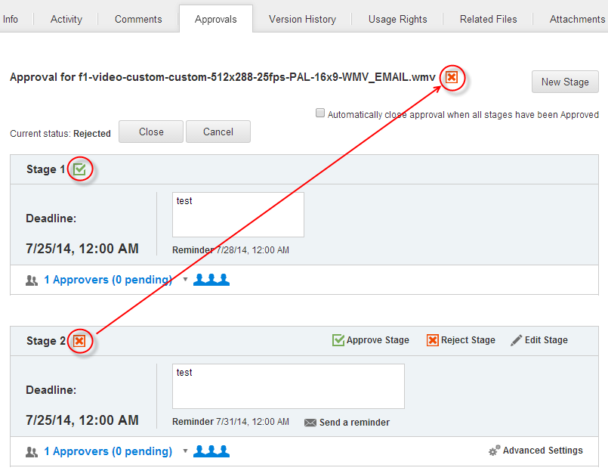

Figure 305 File details page > *Approvals* tab > Added Approver’s comment

Approval/Stage Owner cannot reject approved Stage (there is no action buttons next to it), but they can approve rejected Stage via the  button.

Once an Approver approved a file by clicking the *Approve* button on the File details page > *Approvals* tab, this button becomes hidden, while the *Reject* button remains visible there (see Figure 306).

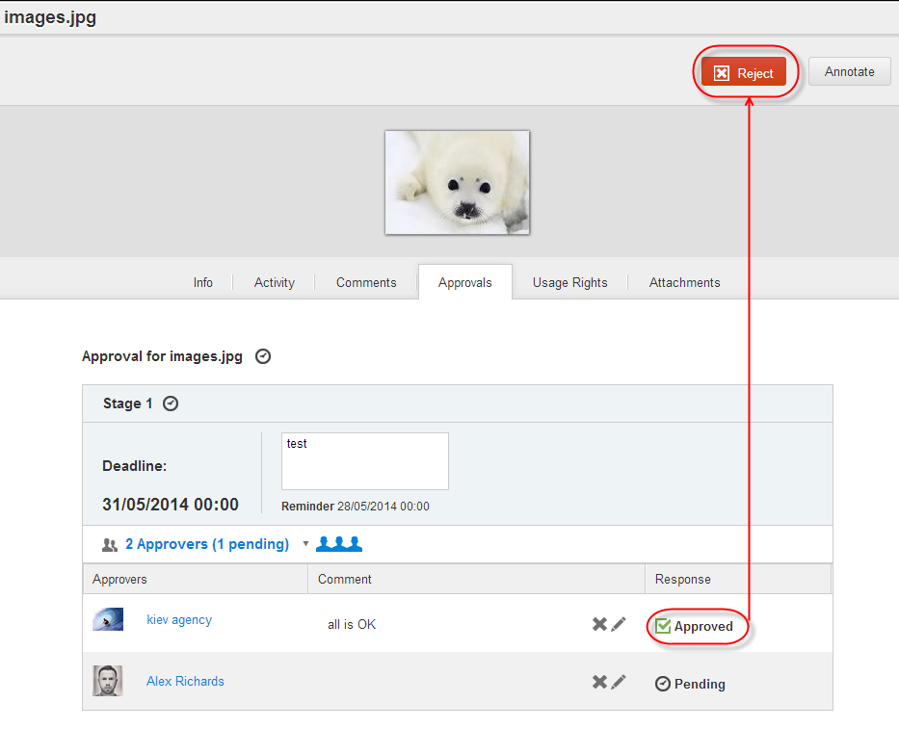

Figure 306 File details page > *Approvals* tab > Approved Stage can be rejected

Rejecting current Approval Stage by any Approver automatically changes the whole Approval Status from *Pending* to *Rejected* (marked with  next to the filename), whether the Approver rejects single Approval Stage or several ones simultaneously. However, thisstatus can be reverted from *Rejected* to *Approved* by clicking the *Reject* button. In this case, this button is hidden, while the *Approve* button is visible (see Figure 307).

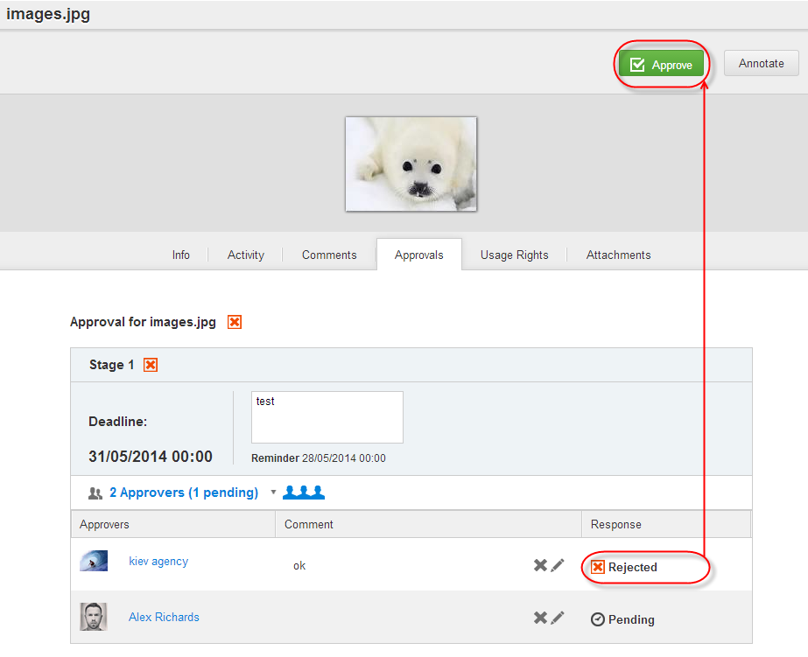

Figure 307 File details page > *Approvals* tab > Rejected Stage can be approved

**Note**: Once the file was approved or rejected, the Approver will see the pop-up notification in their user interface:

*‘Thank you! Your decision has been recorded. You can change your decision until the approval stage is closed’*

If new Approval Stage is added to the file after previous one was approved or rejected, the new Stage starts automatically, so the  and the buttons become available for this Stage. All Approvers for this Stage receive respective email notifications.

Once a file has been approved or rejected, a user can view its current Approval status icons (i.e. status of the latest Approval Stage), without obligatory page refresh, on the:

* File details page, next to the breadcrumbs (see Figure 308).

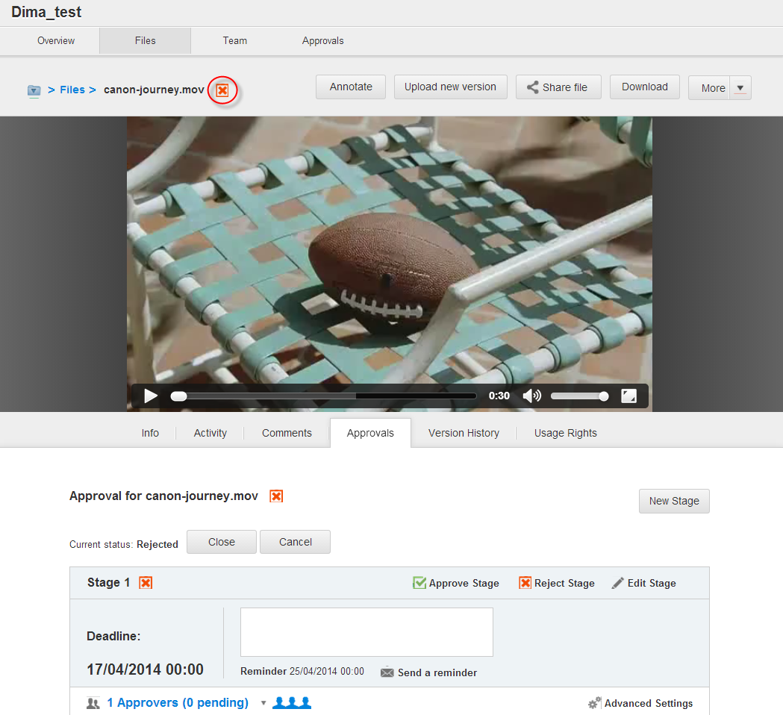

Figure 308 File details page > Approval status for a file

* Project details page > *Files* tab, within file thumbnails. User can also view pop-up tooltip about current status by hover a cursor over the icon (see Figure 309).

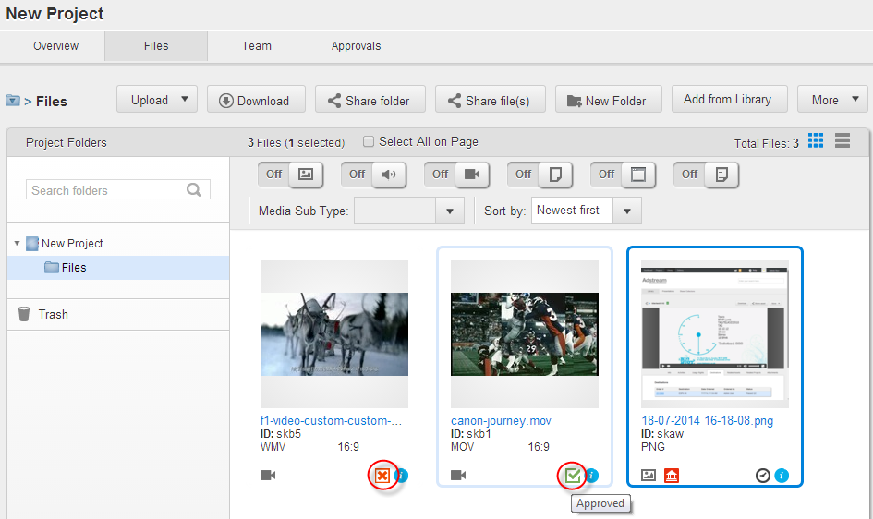

Figure 309 Project details page > *Files* tab > Statuses of Approvals on files

* Project details page > *Overview* tab, within file thumbnails (see Figure 310).

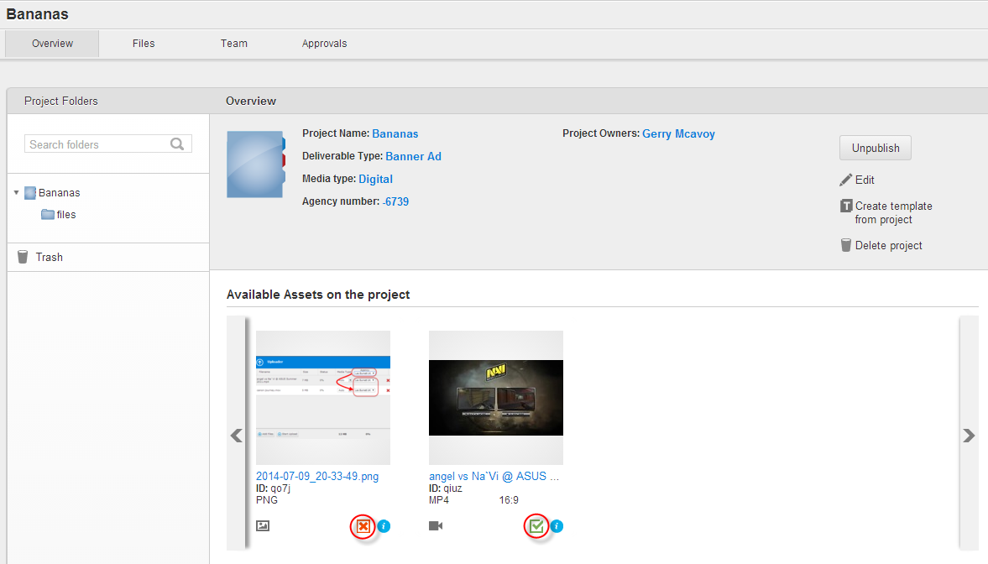

Figure 310 Project details page > *Overview* tab > Statuses of Approvals on files

During approving/rejecting a file Approver that does not have any other Project role can view only the File details page for this file without relation to the Project where this file is. In this case, the Approver cannot view the:

* Project details on the *Projects* tab where this file is.
* Breadcrumbs on the File details page (see Figure 311).

During approving/rejecting a file Approver that does not have any other Project role can view only the File details page for this file without relation to the Project where this file is. In this case, the Approver cannot view the:

* Project details on the *Projects* tab where this file is.
* Breadcrumbs on the File details page (see Figure 311).

During approving/rejecting a file Approver that does not have any other Project role can view only the File details page for this file without relation to the Project where this file is. In this case, the Approver cannot view the:

* Project details on the *Projects* tab where this file is.
* Breadcrumbs on the File details page (see Figure 311).

During approving/rejecting a file Approver that does not have any other Project role can view only the File details page for this file without relation to the Project where this file is. In this case, the Approver cannot view the:

* Project details on the *Projects* tab where this file is.
* Breadcrumbs on the File details page (see Figure 311).

During approving/rejecting a file Approver that does not have any other Project role can view only the File details page for this file without relation to the Project where this file is. In this case, the Approver cannot view the:

* Project details on the *Projects* tab where this file is.
* Breadcrumbs on the File details page (see Figure 311).

During approving/rejecting a file Approver that does not have any other Project role can view only the File details page for this file without relation to the Project where this file is. In this case, the Approver cannot view the:

* Project details on the *Projects* tab where this file is.
* Breadcrumbs on the File details page (see Figure 311).

During approving/rejecting a file Approver that does not have any other Project role can view only the File details page for this file without relation to the Project where this file is. In this case, the Approver cannot view the:

* Project details on the *Projects* tab where this file is.
* Breadcrumbs on the File details page (see Figure 311).

During approving/rejecting a file Approver that does not have any other Project role can view only the File details page for this file without relation to the Project where this file is. In this case, the Approver cannot view the:

* Project details on the *Projects* tab where this file is.
* Breadcrumbs on the File details page (see Figure 311).

During approving/rejecting a file Approver that does not have any other Project role can view only the File details page for this file without relation to the Project where this file is. In this case, the Approver cannot view the:

* Project details on the *Projects* tab where this file is.
* Breadcrumbs on the File details page (see Figure 311).

During approving/rejecting a file Approver that does not have any other Project role can view only the File details page for this file without relation to the Project where this file is. In this case, the Approver cannot view the:

* Project details on the *Projects* tab where this file is.
* Breadcrumbs on the File details page (see Figure 311).

During approving/rejecting a file Approver that does not have any other Project role can view only the File details page for this file without relation to the Project where this file is. In this case, the Approver cannot view the:

* Project details on the *Projects* tab where this file is.
* Breadcrumbs on the File details page (see Figure 311).

During approving/rejecting a file Approver that does not have any other Project role can view only the File details page for this file without relation to the Project where this file is. In this case, the Approver cannot view the:

* Project details on the *Projects* tab where this file is.
* Breadcrumbs on the File details page (see Figure 311).

During approving/rejecting a file Approver that does not have any other Project role can view only the File details page for this file without relation to the Project where this file is. In this case, the Approver cannot view the:

* Project details on the *Projects* tab where this file is.
* Breadcrumbs on the File details page (see Figure 311).

During approving/rejecting a file Approver that does not have any other Project role can view only the File details page for this file without relation to the Project where this file is. In this case, the Approver cannot view the:

* Project details on the *Projects* tab where this file is.
* Breadcrumbs on the File details page (see Figure 311).

During approving/rejecting a file Approver that does not have any other Project role can view only the File details page for this file without relation to the Project where this file is. In this case, the Approver cannot view the:

* Project details on the *Projects* tab where this file is.
* Breadcrumbs on the File details page (see Figure 311).

During approving/rejecting a file Approver that does not have any other Project role can view only the File details page for this file without relation to the Project where this file is. In this case, the Approver cannot view the:

* Project details on the *Projects* tab where this file is.
* Breadcrumbs on the File details page (see Figure 311).

During approving/rejecting a file Approver that does not have any other Project role can view only the File details page for this file without relation to the Project where this file is. In this case, the Approver cannot view the:

* Project details on the *Projects* tab where this file is.
* Breadcrumbs on the File details page (see Figure 311).

During approving/rejecting a file Approver that does not have any other Project role can view only the File details page for this file without relation to the Project where this file is. In this case, the Approver cannot view the:

* Project details on the *Projects* tab where this file is.
* Breadcrumbs on the File details page (see Figure 311).

During approving/rejecting a file Approver that does not have any other Project role can view only the File details page for this file without relation to the Project where this file is. In this case, the Approver cannot view the:

* Project details on the *Projects* tab where this file is.
* Breadcrumbs on the File details page (see Figure 311).

During approving/rejecting a file Approver that does not have any other Project role can view only the File details page for this file without relation to the Project where this file is. In this case, the Approver cannot view the:

* Project details on the *Projects* tab where this file is.
* Breadcrumbs on the File details page (see Figure 311).

During approving/rejecting a file Approver that does not have any other Project role can view only the File details page for this file without relation to the Project where this file is. In this case, the Approver cannot view the:

* Project details on the *Projects* tab where this file is.
* Breadcrumbs on the File details page (see Figure 311).

During approving/rejecting a file Approver that does not have any other Project role can view only the File details page for this file without relation to the Project where this file is. In this case, the Approver cannot view the:

* Project details on the *Projects* tab where this file is.
* Breadcrumbs on the File details page (see Figure 311).

During approving/rejecting a file Approver that does not have any other Project role can view only the File details page for this file without relation to the Project where this file is. In this case, the Approver cannot view the:

* Project details on the *Projects* tab where this file is.
* Breadcrumbs on the File details page (see Figure 311).

During approving/rejecting a file Approver that does not have any other Project role can view only the File details page for this file without relation to the Project where this file is. In this case, the Approver cannot view the:

* Project details on the *Projects* tab where this file is.
* Breadcrumbs on the File details page (see Figure 311).

During approving/rejecting a file Approver that does not have any other Project role can view only the File details page for this file without relation to the Project where this file is. In this case, the Approver cannot view the:

* Project details on the *Projects* tab where this file is.
* Breadcrumbs on the File details page (see Figure 311).

During approving/rejecting a file Approver that does not have any other Project role can view only the File details page for this file without relation to the Project where this file is. In this case, the Approver cannot view the:

* Project details on the *Projects* tab where this file is.
* Breadcrumbs on the File details page (see Figure 311).

During approving/rejecting a file Approver that does not have any other Project role can view only the File details page for this file without relation to the Project where this file is. In this case, the Approver cannot view the:

* Project details on the *Projects* tab where this file is.
* Breadcrumbs on the File details page (see Figure 311).

During approving/rejecting a file Approver that does not have any other Project role can view only the File details page for this file without relation to the Project where this file is. In this case, the Approver cannot view the:

* Project details on the *Projects* tab where this file is.
* Breadcrumbs on the File details page (see Figure 311).

During approving/rejecting a file Approver that does not have any other Project role can view only the File details page for this file without relation to the Project where this file is. In this case, the Approver cannot view the:

* Project details on the *Projects* tab where this file is.
* Breadcrumbs on the File details page (see Figure 311).

During approving/rejecting a file Approver that does not have any other Project role can view only the File details page for this file without relation to the Project where this file is. In this case, the Approver cannot view the:

* Project details on the *Projects* tab where this file is.
* Breadcrumbs on the File details page (see Figure 311).

During approving/rejecting a file Approver that does not have any other Project role can view only the File details page for this file without relation to the Project where this file is. In this case, the Approver cannot view the:

* Project details on the *Projects* tab where this file is.
* Breadcrumbs on the File details page (see Figure 311).

During approving/rejecting a file Approver that does not have any other Project role can view only the File details page for this file without relation to the Project where this file is. In this case, the Approver cannot view the:

* Project details on the *Projects* tab where this file is.
* Breadcrumbs on the File details page (see Figure 311).

During approving/rejecting a file Approver that does not have any other Project role can view only the File details page for this file without relation to the Project where this file is. In this case, the Approver cannot view the:

* Project details on the *Projects* tab where this file is.
* Breadcrumbs on the File details page (see Figure 311).

During approving/rejecting a file Approver that does not have any other Project role can view only the File details page for this file without relation to the Project where this file is. In this case, the Approver cannot view the:

* Project details on the *Projects* tab where this file is.
* Breadcrumbs on the File details page (see Figure 311).

During approving/rejecting a file Approver that does not have any other Project role can view only the File details page for this file without relation to the Project where this file is. In this case, the Approver cannot view the:

* Project details on the *Projects* tab where this file is.
* Breadcrumbs on the File details page (see Figure 311).

During approving/rejecting a file Approver that does not have any other Project role can view only the File details page for this file without relation to the Project where this file is. In this case, the Approver cannot view the:

* Project details on the *Projects* tab where this file is.
* Breadcrumbs on the File details page (see Figure 311).

During approving/rejecting a file Approver that does not have any other Project role can view only the File details page for this file without relation to the Project where this file is. In this case, the Approver cannot view the:

* Project details on the *Projects* tab where this file is.
* Breadcrumbs on the File details page (see Figure 311).

During approving/rejecting a file Approver that does not have any other Project role can view only the File details page for this file without relation to the Project where this file is. In this case, the Approver cannot view the:

* Project details on the *Projects* tab where this file is.
* Breadcrumbs on the File details page (see Figure 311).

During approving/rejecting a file Approver that does not have any other Project role can view only the File details page for this file without relation to the Project where this file is. In this case, the Approver cannot view the:

* Project details on the *Projects* tab where this file is.
* Breadcrumbs on the File details page (see Figure 311).

During approving/rejecting a file Approver that does not have any other Project role can view only the File details page for this file without relation to the Project where this file is. In this case, the Approver cannot view the:

* Project details on the *Projects* tab where this file is.
* Breadcrumbs on the File details page (see Figure 311).

During approving/rejecting a file Approver that does not have any other Project role can view only the File details page for this file without relation to the Project where this file is. In this case, the Approver cannot view the:

* Project details on the *Projects* tab where this file is.
* Breadcrumbs on the File details page (see Figure 311).
* 











Figure 294 File details page > *Approvals* tab > Moderated Approver’s comment

To delete some Approver’s comment Approval/Stage Owner should click the  icon next to it and then click the *Yes* button in the respective pop-up to confirm the action (see Figure 295).



Figure 295 File details page > *Approvals* tab > Deleting Approver’s comment

After that, this comment will be deleted from the list of Approvers (see Figure 296).



Figure 294 File details page > *Approvals* tab > Moderated Approver’s comment

To delete some Approver’s comment Approval/Stage Owner should click the  icon next to it and then click the *Yes* button in the respective pop-up to confirm the action (see Figure 295).



Figure 295 File details page > *Approvals* tab > Deleting Approver’s comment

After that, this comment will be deleted from the list of Approvers (see Figure 296).



Figure 294 File details page > *Approvals* tab > Moderated Approver’s comment

To delete some Approver’s comment Approval/Stage Owner should click the  icon next to it and then click the *Yes* button in the respective pop-up to confirm the action (see Figure 295).



Figure 295 File details page > *Approvals* tab > Deleting Approver’s comment

After that, this comment will be deleted from the list of Approvers (see Figure 296).



Figure 294 File details page > *Approvals* tab > Moderated Approver’s comment

To delete some Approver’s comment Approval/Stage Owner should click the  icon next to it and then click the *Yes* button in the respective pop-up to confirm the action (see Figure 295).



Figure 295 File details page > *Approvals* tab > Deleting Approver’s comment

After that, this comment will be deleted from the list of Approvers (see Figure 296).



Figure 294 File details page > *Approvals* tab > Moderated Approver’s comment

To delete some Approver’s comment Approval/Stage Owner should click the  icon next to it and then click the *Yes* button in the respective pop-up to confirm the action (see Figure 295).



Figure 295 File details page > *Approvals* tab > Deleting Approver’s comment

After that, this comment will be deleted from the list of Approvers (see Figure 296).



Figure 294 File details page > *Approvals* tab > Moderated Approver’s comment

To delete some Approver’s comment Approval/Stage Owner should click the  icon next to it and then click the *Yes* button in the respective pop-up to confirm the action (see Figure 295).



Figure 295 File details page > *Approvals* tab > Deleting Approver’s comment

After that, this comment will be deleted from the list of Approvers (see Figure 296).



Figure 294 File details page > *Approvals* tab > Moderated Approver’s comment

To delete some Approver’s comment Approval/Stage Owner should click the  icon next to it and then click the *Yes* button in the respective pop-up to confirm the action (see Figure 295).



Figure 295 File details page > *Approvals* tab > Deleting Approver’s comment

After that, this comment will be deleted from the list of Approvers (see Figure 296).



Figure 294 File details page > *Approvals* tab > Moderated Approver’s comment

To delete some Approver’s comment Approval/Stage Owner should click the  icon next to it and then click the *Yes* button in the respective pop-up to confirm the action (see Figure 295).



Figure 295 File details page > *Approvals* tab > Deleting Approver’s comment

After that, this comment will be deleted from the list of Approvers (see Figure 296).



Figure 294 File details page > *Approvals* tab > Moderated Approver’s comment

To delete some Approver’s comment Approval/Stage Owner should click the  icon next to it and then click the *Yes* button in the respective pop-up to confirm the action (see Figure 295).



Figure 295 File details page > *Approvals* tab > Deleting Approver’s comment

After that, this comment will be deleted from the list of Approvers (see Figure 296).



Figure 294 File details page > *Approvals* tab > Moderated Approver’s comment

To delete some Approver’s comment Approval/Stage Owner should click the  icon next to it and then click the *Yes* button in the respective pop-up to confirm the action (see Figure 295).



Figure 295 File details page > *Approvals* tab > Deleting Approver’s comment

After that, this comment will be deleted from the list of Approvers (see Figure 296).



Figure 294 File details page > *Approvals* tab > Moderated Approver’s comment

To delete some Approver’s comment Approval/Stage Owner should click the  icon next to it and then click the *Yes* button in the respective pop-up to confirm the action (see Figure 295).



Figure 295 File details page > *Approvals* tab > Deleting Approver’s comment

After that, this comment will be deleted from the list of Approvers (see Figure 296).



Figure 294 File details page > *Approvals* tab > Moderated Approver’s comment

To delete some Approver’s comment Approval/Stage Owner should click the  icon next to it and then click the *Yes* button in the respective pop-up to confirm the action (see Figure 295).



Figure 295 File details page > *Approvals* tab > Deleting Approver’s comment

After that, this comment will be deleted from the list of Approvers (see Figure 296).



Figure 294 File details page > *Approvals* tab > Moderated Approver’s comment

To delete some Approver’s comment Approval/Stage Owner should click the  icon next to it and then click the *Yes* button in the respective pop-up to confirm the action (see Figure 295).



Figure 295 File details page > *Approvals* tab > Deleting Approver’s comment

After that, this comment will be deleted from the list of Approvers (see Figure 296).



Figure 294 File details page > *Approvals* tab > Moderated Approver’s comment

To delete some Approver’s comment Approval/Stage Owner should click the  icon next to it and then click the *Yes* button in the respective pop-up to confirm the action (see Figure 295).



Figure 295 File details page > *Approvals* tab > Deleting Approver’s comment

After that, this comment will be deleted from the list of Approvers (see Figure 296).



Figure 294 File details page > *Approvals* tab > Moderated Approver’s comment

To delete some Approver’s comment Approval/Stage Owner should click the  icon next to it and then click the *Yes* button in the respective pop-up to confirm the action (see Figure 295).



Figure 295 File details page > *Approvals* tab > Deleting Approver’s comment

After that, this comment will be deleted from the list of Approvers (see Figure 296).



Figure 294 File details page > *Approvals* tab > Moderated Approver’s comment

To delete some Approver’s comment Approval/Stage Owner should click the  icon next to it and then click the *Yes* button in the respective pop-up to confirm the action (see Figure 295).



Figure 295 File details page > *Approvals* tab > Deleting Approver’s comment

After that, this comment will be deleted from the list of Approvers (see Figure 296).

**H264**

Standard: 1024x576@25fps

Encoding System: PAL

Frame Rate: 25

Aspect Ratio: 16x9

hRes: 1024

vRes: 576

Bit Rate: 1400

Extension: mp4

***

**Flash**

A Flash v8 .flv video file that can be used on web sites. This uses the ON2 VP6 CODEC (your web guys will know what this is).

Standard: 400x224@25fps

Encoding System: PAL Frame Rate: 25

Aspect Ratio: 16x9

hRes: 400

vRes: 224

Bit Rate: 450

Extension: flv

***

**Quicktime H264**

A small size but good quality .mov file that will play back on any Mac or PC with Quicktime v7 or newer installed. Small enough to email.

Standard: 432x240@25fps

Encoding System: PAL

Frame Rate: 25

Aspect Ratio: 16x9

hRes: 432

vRes: 240

Bit Rate: 1000

Extension: mov

***

**iPhone 3Gs / 3G / 3rd gen iTouch**

A good quality H.264 file that will play back on older iPhone 3Gs, 3G and 3rd generation iTouch mobile devices. This file should also play on some Android, Windows Mobile and Blackberry mobile devices.

Standard: 480x270@25fps

Encoding System: PAL

Frame Rate: 25

AspectRatio: 16x9

hRes: 480

vRes: 270

Bit Rate: 1200

Extension: mp4

***

**MPEG-1 Email**

A low-resolution file that will play back on any Mac or PC. Small enough to be sent via email.

Standard: 512x288@25fps

Encoding System: PAL

Frame Rate: 25

Aspect Ratio: 16x9

hRes: 512

vRes: 288

Bit Rate: 600

Extension: mpg

***

**WM9**

A small size but good quality file that will play back on the vast majority of PC's. Mac users will need to install the free 'Flip4Mac' software to play it. Small enough to email.

Standard: 512x288@25fps

Encoding System: PAL

Frame Rate: 25

Aspect Ratio: 16x9

hRes: 512

vRes: 288

Bit Rate: 600

Extension: wmv

***

**MPEG-1 – High**

A good quality file that will play back on any Mac or PC. Great for embedding video into Powerpoint presentations.

Standard: 640x360@25fps

Encoding System: PAL

Frame Rate: 25

Aspect Ratio: 16x9

hRes: 640

vRes: 360

Bit Rate: 1200

Extension: mpg

***

**WM9 – High**

A high quality file that will play back on the vast majority of PC's. Mac users will need to install the free 'Flip4Mac' software to play it. Great for client reviews and high quality creative presentations.

Standard: 640x360@25fps

Encoding System: PAL

Frame Rate: 25

Aspect Ratio: 16x9

hRes: 640

vRes: 360

Bit Rate: 1200

Extension: wmv

***

**YouTube**

A video file ready to be uploaded to YouTube, compatible with the 16x9 YouTube 360p standard.

Standard: 640x360P@25fps

Encoding System: PAL

Frame Rate: 25

Aspect Ratio: 16x9

hRes: 640

vRes: 360

Bit Rate: 2000

Extension: mp4

***

**Quicktime H.264 – High**

A very high quality .mov file that will play back on any Mac or PC with Quicktime v7 or newer installed. Great for client reviews and high quality creative presentations.

Standard: 720x400@25fps

Encoding System: PAL

FrameRate: 25

Aspect Ratio: 16x9

hRes: 720

vRes: 400

Bit Rate: 8000

Extension: mov

***

**DV25**

A file format compatible with all major Mac & PC video editing software. Commonly used for non-broadcast or offline editing work in software such as Apple Final Cut Pro, AVID Media Composer or Adobe Premiere. This will be a big file-size.

Standard: 720x576@25fps

Encoding System: PAL

Frame Rate: 25

Aspect Ratio: 16x9

hRes: 720

vRes: 576

Bit Rate: 8000

Extension: mov

***

**MPEG-2 4:2:0 DVD**

A DVD quality file often used for high quality presentation use, awards submissions and DVD authoring software. You may require additional software to be installed on your Mac or PC to play this file.

Standard: 720x576@25fps

Encoding System: PAL

Frame Rate: 25

Aspect Ratio: 16x9

hRes: 720

vRes: 576

Bit Rate: 6000

Extension: mpg

***

**MPEG-2 4:2:0 DVD 12 Mbit**

A DVD quality file often used for high quality presentation use, awards submissions and DVD authoring software. You may require additional software to be installed on your Mac or PC to play this file.

Standard: 720x576@25fps

Encoding System: PAL

Frame Rate: 25

Aspect Ratio: 16x9

hRes: 720

vRes: 576

Bit Rate: 12000

Extension: mpg

***

**PhotoJPEG**

A high quality .mov file that can be used by Quicktime compatible video editing software such as Final Cut Pro. The video is interlaced and for editing use only. This will be a big file-size.

Standard: 720x576@25fps

Encoding System: PAL

Frame Rate: 25

Aspect Ratio: 16x9

hRes: 720

vRes: 576

Bit Rate: 8000

Extension: mov

***

**MPEG-2 4:2:2 Broadcast**

This is the format the TV broadcasters require. It is used for broadcast delivery only and not suitable for any kind of editing or post-production work. Not viewable on the progressive monitors. This will be a big file-size.

Standard: 720x608@25fps

Encoding System: PAL

Frame Rate: 25

Aspect Ratio: 16x9

hRes: 720

vRes: 608

Bit Rate: 25000

Extension: mpg

***

**Xvid Large Presentation**

An AVI playable on many media player devices

Standard: 800x600@25fps

Encoding System: PAL

Frame Rate: 25

Aspect Ratio: 16x9

hRes: 800

vRes: 600

Bit Rate: 1200

Extension: avi

***

**iPhone 4 / iPad / 4th gen iTouch**

A high quality H.264 file that will play back on newer iPhone 4G, iPad and 4th generation iTouch mobile devices. This file should also play on some newer Android, Windows Mobile and Blackberry mobile devices.

Standard: 960x540@25fps

Encoding System: PAL

Frame Rate: 25

Aspect Ratio: 16x9

hRes: 960

vRes: 540

Bit Rate: 2000

Extension: mp4

**H264**

Standard: 1024x576@25fps

Encoding System: PAL

Frame Rate: 25

Aspect Ratio: 16x9

hRes: 1024

vRes: 576

Bit Rate: 1400

Extension: mp4

***

**Flash**

A Flash v8 .flv video file that can be used on web sites. This uses the ON2 VP6 CODEC (your web guys will know what this is).

Standard: 400x224@25fps

Encoding System: PAL Frame Rate: 25

Aspect Ratio: 16x9

hRes: 400

vRes: 224

Bit Rate: 450

Extension: flv

***

**Quicktime H264**

A small size but good quality .mov file that will play back on any Mac or PC with Quicktime v7 or newer installed. Small enough to email.

Standard: 432x240@25fps

Encoding System: PAL

Frame Rate: 25

Aspect Ratio: 16x9

hRes: 432

vRes: 240

Bit Rate: 1000

Extension: mov

***

**iPhone 3Gs / 3G / 3rd gen iTouch**

A good quality H.264 file that will play back on older iPhone 3Gs, 3G and 3rd generation iTouch mobile devices. This file should also play on some Android, Windows Mobile and Blackberry mobile devices.

Standard: 480x270@25fps

Encoding System: PAL

Frame Rate: 25

AspectRatio: 16x9

hRes: 480

vRes: 270

Bit Rate: 1200

Extension: mp4

***

**MPEG-1 Email**

A low-resolution file that will play back on any Mac or PC. Small enough to be sent via email.

Standard: 512x288@25fps

Encoding System: PAL

Frame Rate: 25

Aspect Ratio: 16x9

hRes: 512

vRes: 288

Bit Rate: 600

Extension: mpg

***

**WM9**

A small size but good quality file that will play back on the vast majority of PC's. Mac users will need to install the free 'Flip4Mac' software to play it. Small enough to email.

Standard: 512x288@25fps

Encoding System: PAL

Frame Rate: 25

Aspect Ratio: 16x9

hRes: 512

vRes: 288

Bit Rate: 600

Extension: wmv

***

**MPEG-1 – High**

A good quality file that will play back on any Mac or PC. Great for embedding video into Powerpoint presentations.

Standard: 640x360@25fps

Encoding System: PAL

Frame Rate: 25

Aspect Ratio: 16x9

hRes: 640

vRes: 360

Bit Rate: 1200

Extension: mpg

***

**WM9 – High**

A high quality file that will play back on the vast majority of PC's. Mac users will need to install the free 'Flip4Mac' software to play it. Great for client reviews and high quality creative presentations.

Standard: 640x360@25fps

Encoding System: PAL

Frame Rate: 25

Aspect Ratio: 16x9

hRes: 640

vRes: 360

Bit Rate: 1200

Extension: wmv

***

**YouTube**

A video file ready to be uploaded to YouTube, compatible with the 16x9 YouTube 360p standard.

Standard: 640x360P@25fps

Encoding System: PAL

Frame Rate: 25

Aspect Ratio: 16x9

hRes: 640

vRes: 360

Bit Rate: 2000

Extension: mp4

***

**Quicktime H.264 – High**

A very high quality .mov file that will play back on any Mac or PC with Quicktime v7 or newer installed. Great for client reviews and high quality creative presentations.

Standard: 720x400@25fps

Encoding System: PAL

FrameRate: 25

Aspect Ratio: 16x9

hRes: 720

vRes: 400

Bit Rate: 8000

Extension: mov

***

**DV25**

A file format compatible with all major Mac & PC video editing software. Commonly used for non-broadcast or offline editing work in software such as Apple Final Cut Pro, AVID Media Composer or Adobe Premiere. This will be a big file-size.

Standard: 720x576@25fps

Encoding System: PAL

Frame Rate: 25

Aspect Ratio: 16x9

hRes: 720

vRes: 576

Bit Rate: 8000

Extension: mov

***

**MPEG-2 4:2:0 DVD**

A DVD quality file often used for high quality presentation use, awards submissions and DVD authoring software. You may require additional software to be installed on your Mac or PC to play this file.

Standard: 720x576@25fps

Encoding System: PAL

Frame Rate: 25

Aspect Ratio: 16x9

hRes: 720

vRes: 576

Bit Rate: 6000

Extension: mpg

***

**MPEG-2 4:2:0 DVD 12 Mbit**

A DVD quality file often used for high quality presentation use, awards submissions and DVD authoring software. You may require additional software to be installed on your Mac or PC to play this file.

Standard: 720x576@25fps

Encoding System: PAL

Frame Rate: 25

Aspect Ratio: 16x9

hRes: 720

vRes: 576

Bit Rate: 12000

Extension: mpg

***

**PhotoJPEG**

A high quality .mov file that can be used by Quicktime compatible video editing software such as Final Cut Pro. The video is interlaced and for editing use only. This will be a big file-size.

Standard: 720x576@25fps

Encoding System: PAL

Frame Rate: 25

Aspect Ratio: 16x9

hRes: 720

vRes: 576

Bit Rate: 8000

Extension: mov

***

**MPEG-2 4:2:2 Broadcast**

This is the format the TV broadcasters require. It is used for broadcast delivery only and not suitable for any kind of editing or post-production work. Not viewable on the progressive monitors. This will be a big file-size.

Standard: 720x608@25fps

Encoding System: PAL

Frame Rate: 25

Aspect Ratio: 16x9

hRes: 720

vRes: 608

Bit Rate: 25000

Extension: mpg

***

**Xvid Large Presentation**

An AVI playable on many media player devices

Standard: 800x600@25fps

Encoding System: PAL

Frame Rate: 25

Aspect Ratio: 16x9

hRes: 800

vRes: 600

Bit Rate: 1200

Extension: avi

***

**iPhone 4 / iPad / 4th gen iTouch**

A high quality H.264 file that will play back on newer iPhone 4G, iPad and 4th generation iTouch mobile devices. This file should also play on some newer Android, Windows Mobile and Blackberry mobile devices.

Standard: 960x540@25fps

Encoding System: PAL

Frame Rate: 25

Aspect Ratio: 16x9

hRes: 960

vRes: 540

Bit Rate: 2000

Extension: mp4

**H264**

Standard: 1024x576@25fps

Encoding System: PAL

Frame Rate: 25

Aspect Ratio: 16x9

hRes: 1024

vRes: 576

Bit Rate: 1400

Extension: mp4

***

**Flash**

A Flash v8 .flv video file that can be used on web sites. This uses the ON2 VP6 CODEC (your web guys will know what this is).

Standard: 400x224@25fps

Encoding System: PAL Frame Rate: 25

Aspect Ratio: 16x9

hRes: 400

vRes: 224

Bit Rate: 450

Extension: flv

***

**Quicktime H264**

A small size but good quality .mov file that will play back on any Mac or PC with Quicktime v7 or newer installed. Small enough to email.

Standard: 432x240@25fps

Encoding System: PAL

Frame Rate: 25

Aspect Ratio: 16x9

hRes: 432

vRes: 240

Bit Rate: 1000

Extension: mov

***

**iPhone 3Gs / 3G / 3rd gen iTouch**

A good quality H.264 file that will play back on older iPhone 3Gs, 3G and 3rd generation iTouch mobile devices. This file should also play on some Android, Windows Mobile and Blackberry mobile devices.

Standard: 480x270@25fps

Encoding System: PAL

Frame Rate: 25

AspectRatio: 16x9

hRes: 480

vRes: 270

Bit Rate: 1200

Extension: mp4

***

**MPEG-1 Email**

A low-resolution file that will play back on any Mac or PC. Small enough to be sent via email.

Standard: 512x288@25fps

Encoding System: PAL

Frame Rate: 25

Aspect Ratio: 16x9

hRes: 512

vRes: 288

Bit Rate: 600

Extension: mpg

***

**WM9**

A small size but good quality file that will play back on the vast majority of PC's. Mac users will need to install the free 'Flip4Mac' software to play it. Small enough to email.

Standard: 512x288@25fps

Encoding System: PAL

Frame Rate: 25

Aspect Ratio: 16x9

hRes: 512

vRes: 288

Bit Rate: 600

Extension: wmv

***

**MPEG-1 – High**

A good quality file that will play back on any Mac or PC. Great for embedding video into Powerpoint presentations.

Standard: 640x360@25fps

Encoding System: PAL

Frame Rate: 25

Aspect Ratio: 16x9

hRes: 640

vRes: 360

Bit Rate: 1200

Extension: mpg

***

**WM9 – High**

A high quality file that will play back on the vast majority of PC's. Mac users will need to install the free 'Flip4Mac' software to play it. Great for client reviews and high quality creative presentations.

Standard: 640x360@25fps

Encoding System: PAL

Frame Rate: 25

Aspect Ratio: 16x9

hRes: 640

vRes: 360

Bit Rate: 1200

Extension: wmv

***

**YouTube**

A video file ready to be uploaded to YouTube, compatible with the 16x9 YouTube 360p standard.

Standard: 640x360P@25fps

Encoding System: PAL

Frame Rate: 25

Aspect Ratio: 16x9

hRes: 640

vRes: 360

Bit Rate: 2000

Extension: mp4

***

**Quicktime H.264 – High**

A very high quality .mov file that will play back on any Mac or PC with Quicktime v7 or newer installed. Great for client reviews and high quality creative presentations.

Standard: 720x400@25fps

Encoding System: PAL

FrameRate: 25

Aspect Ratio: 16x9

hRes: 720

vRes: 400

Bit Rate: 8000

Extension: mov

***

**DV25**

A file format compatible with all major Mac & PC video editing software. Commonly used for non-broadcast or offline editing work in software such as Apple Final Cut Pro, AVID Media Composer or Adobe Premiere. This will be a big file-size.

Standard: 720x576@25fps

Encoding System: PAL

Frame Rate: 25

Aspect Ratio: 16x9

hRes: 720

vRes: 576

Bit Rate: 8000

Extension: mov

***

**MPEG-2 4:2:0 DVD**

A DVD quality file often used for high quality presentation use, awards submissions and DVD authoring software. You may require additional software to be installed on your Mac or PC to play this file.

Standard: 720x576@25fps

Encoding System: PAL

Frame Rate: 25

Aspect Ratio: 16x9

hRes: 720

vRes: 576

Bit Rate: 6000

Extension: mpg

***

**MPEG-2 4:2:0 DVD 12 Mbit**

A DVD quality file often used for high quality presentation use, awards submissions and DVD authoring software. You may require additional software to be installed on your Mac or PC to play this file.

Standard: 720x576@25fps

Encoding System: PAL

Frame Rate: 25

Aspect Ratio: 16x9

hRes: 720

vRes: 576

Bit Rate: 12000

Extension: mpg

***

**PhotoJPEG**

A high quality .mov file that can be used by Quicktime compatible video editing software such as Final Cut Pro. The video is interlaced and for editing use only. This will be a big file-size.

Standard: 720x576@25fps

Encoding System: PAL

Frame Rate: 25

Aspect Ratio: 16x9

hRes: 720

vRes: 576

Bit Rate: 8000

Extension: mov

***

**MPEG-2 4:2:2 Broadcast**

This is the format the TV broadcasters require. It is used for broadcast delivery only and not suitable for any kind of editing or post-production work. Not viewable on the progressive monitors. This will be a big file-size.

Standard: 720x608@25fps

Encoding System: PAL

Frame Rate: 25

Aspect Ratio: 16x9

hRes: 720

vRes: 608

Bit Rate: 25000

Extension: mpg

***

**Xvid Large Presentation**

An AVI playable on many media player devices

Standard: 800x600@25fps

Encoding System: PAL

Frame Rate: 25

Aspect Ratio: 16x9

hRes: 800

vRes: 600

Bit Rate: 1200

Extension: avi

***

**iPhone 4 / iPad / 4th gen iTouch**

A high quality H.264 file that will play back on newer iPhone 4G, iPad and 4th generation iTouch mobile devices. This file should also play on some newer Android, Windows Mobile and Blackberry mobile devices.

Standard: 960x540@25fps

Encoding System: PAL

Frame Rate: 25

Aspect Ratio: 16x9

hRes: 960

vRes: 540

Bit Rate: 2000

Extension: mp4

**H264**

Standard: 1024x576@25fps

Encoding System: PAL

Frame Rate: 25

Aspect Ratio: 16x9

hRes: 1024

vRes: 576

Bit Rate: 1400

Extension: mp4

***

**Flash**

A Flash v8 .flv video file that can be used on web sites. This uses the ON2 VP6 CODEC (your web guys will know what this is).

Standard: 400x224@25fps

Encoding System: PAL Frame Rate: 25

Aspect Ratio: 16x9

hRes: 400

vRes: 224

Bit Rate: 450

Extension: flv

***

**Quicktime H264**

A small size but good quality .mov file that will play back on any Mac or PC with Quicktime v7 or newer installed. Small enough to email.

Standard: 432x240@25fps

Encoding System: PAL

Frame Rate: 25

Aspect Ratio: 16x9

hRes: 432

vRes: 240

Bit Rate: 1000

Extension: mov

***

**iPhone 3Gs / 3G / 3rd gen iTouch**

A good quality H.264 file that will play back on older iPhone 3Gs, 3G and 3rd generation iTouch mobile devices. This file should also play on some Android, Windows Mobile and Blackberry mobile devices.

Standard: 480x270@25fps

Encoding System: PAL

Frame Rate: 25

AspectRatio: 16x9

hRes: 480

vRes: 270

Bit Rate: 1200

Extension: mp4

***

**MPEG-1 Email**

A low-resolution file that will play back on any Mac or PC. Small enough to be sent via email.

Standard: 512x288@25fps

Encoding System: PAL

Frame Rate: 25

Aspect Ratio: 16x9

hRes: 512

vRes: 288

Bit Rate: 600

Extension: mpg

***

**WM9**

A small size but good quality file that will play back on the vast majority of PC's. Mac users will need to install the free 'Flip4Mac' software to play it. Small enough to email.

Standard: 512x288@25fps

Encoding System: PAL

Frame Rate: 25

Aspect Ratio: 16x9

hRes: 512

vRes: 288

Bit Rate: 600

Extension: wmv

***

**MPEG-1 – High**

A good quality file that will play back on any Mac or PC. Great for embedding video into Powerpoint presentations.

Standard: 640x360@25fps

Encoding System: PAL

Frame Rate: 25

Aspect Ratio: 16x9

hRes: 640

vRes: 360

Bit Rate: 1200

Extension: mpg

***

**WM9 – High**

A high quality file that will play back on the vast majority of PC's. Mac users will need to install the free 'Flip4Mac' software to play it. Great for client reviews and high quality creative presentations.

Standard: 640x360@25fps

Encoding System: PAL

Frame Rate: 25

Aspect Ratio: 16x9

hRes: 640

vRes: 360

Bit Rate: 1200

Extension: wmv

***

**YouTube**

A video file ready to be uploaded to YouTube, compatible with the 16x9 YouTube 360p standard.

Standard: 640x360P@25fps

Encoding System: PAL

Frame Rate: 25

Aspect Ratio: 16x9

hRes: 640

vRes: 360

Bit Rate: 2000

Extension: mp4

***

**Quicktime H.264 – High**

A very high quality .mov file that will play back on any Mac or PC with Quicktime v7 or newer installed. Great for client reviews and high quality creative presentations.

Standard: 720x400@25fps

Encoding System: PAL

FrameRate: 25

Aspect Ratio: 16x9

hRes: 720

vRes: 400

Bit Rate: 8000

Extension: mov

***

**DV25**

A file format compatible with all major Mac & PC video editing software. Commonly used for non-broadcast or offline editing work in software such as Apple Final Cut Pro, AVID Media Composer or Adobe Premiere. This will be a big file-size.

Standard: 720x576@25fps

Encoding System: PAL

Frame Rate: 25

Aspect Ratio: 16x9

hRes: 720

vRes: 576

Bit Rate: 8000

Extension: mov

***

**MPEG-2 4:2:0 DVD**

A DVD quality file often used for high quality presentation use, awards submissions and DVD authoring software. You may require additional software to be installed on your Mac or PC to play this file.

Standard: 720x576@25fps

Encoding System: PAL

Frame Rate: 25

Aspect Ratio: 16x9

hRes: 720

vRes: 576

Bit Rate: 6000

Extension: mpg

***

**MPEG-2 4:2:0 DVD 12 Mbit**

A DVD quality file often used for high quality presentation use, awards submissions and DVD authoring software. You may require additional software to be installed on your Mac or PC to play this file.

Standard: 720x576@25fps

Encoding System: PAL

Frame Rate: 25

Aspect Ratio: 16x9

hRes: 720

vRes: 576

Bit Rate: 12000

Extension: mpg

***

**PhotoJPEG**

A high quality .mov file that can be used by Quicktime compatible video editing software such as Final Cut Pro. The video is interlaced and for editing use only. This will be a big file-size.

Standard: 720x576@25fps

Encoding System: PAL

Frame Rate: 25

Aspect Ratio: 16x9

hRes: 720

vRes: 576

Bit Rate: 8000

Extension: mov

***

**MPEG-2 4:2:2 Broadcast**

This is the format the TV broadcasters require. It is used for broadcast delivery only and not suitable for any kind of editing or post-production work. Not viewable on the progressive monitors. This will be a big file-size.

Standard: 720x608@25fps

Encoding System: PAL

Frame Rate: 25

Aspect Ratio: 16x9

hRes: 720

vRes: 608

Bit Rate: 25000

Extension: mpg

***

**Xvid Large Presentation**

An AVI playable on many media player devices

Standard: 800x600@25fps

Encoding System: PAL

Frame Rate: 25

Aspect Ratio: 16x9

hRes: 800

vRes: 600

Bit Rate: 1200

Extension: avi

***

**iPhone 4 / iPad / 4th gen iTouch**

A high quality H.264 file that will play back on newer iPhone 4G, iPad and 4th generation iTouch mobile devices. This file should also play on some newer Android, Windows Mobile and Blackberry mobile devices.

Standard: 960x540@25fps

Encoding System: PAL

Frame Rate: 25

Aspect Ratio: 16x9

hRes: 960

vRes: 540

Bit Rate: 2000

Extension: mp4

**H264**

Standard: 1024x576@25fps

Encoding System: PAL

Frame Rate: 25

Aspect Ratio: 16x9

hRes: 1024

vRes: 576

Bit Rate: 1400

Extension: mp4

***

**Flash**

A Flash v8 .flv video file that can be used on web sites. This uses the ON2 VP6 CODEC (your web guys will know what this is).

Standard: 400x224@25fps

Encoding System: PAL Frame Rate: 25

Aspect Ratio: 16x9

hRes: 400

vRes: 224

Bit Rate: 450

Extension: flv

***

**Quicktime H264**

A small size but good quality .mov file that will play back on any Mac or PC with Quicktime v7 or newer installed. Small enough to email.

Standard: 432x240@25fps

Encoding System: PAL

Frame Rate: 25

Aspect Ratio: 16x9

hRes: 432

vRes: 240

Bit Rate: 1000

Extension: mov

***

**iPhone 3Gs / 3G / 3rd gen iTouch**

A good quality H.264 file that will play back on older iPhone 3Gs, 3G and 3rd generation iTouch mobile devices. This file should also play on some Android, Windows Mobile and Blackberry mobile devices.

Standard: 480x270@25fps

Encoding System: PAL

Frame Rate: 25

AspectRatio: 16x9

hRes: 480

vRes: 270

Bit Rate: 1200

Extension: mp4

***

**MPEG-1 Email**

A low-resolution file that will play back on any Mac or PC. Small enough to be sent via email.

Standard: 512x288@25fps

Encoding System: PAL

Frame Rate: 25

Aspect Ratio: 16x9

hRes: 512

vRes: 288

Bit Rate: 600

Extension: mpg

***

**WM9**

A small size but good quality file that will play back on the vast majority of PC's. Mac users will need to install the free 'Flip4Mac' software to play it. Small enough to email.

Standard: 512x288@25fps

Encoding System: PAL

Frame Rate: 25

Aspect Ratio: 16x9

hRes: 512

vRes: 288

Bit Rate: 600

Extension: wmv

***

**MPEG-1 – High**

A good quality file that will play back on any Mac or PC. Great for embedding video into Powerpoint presentations.

Standard: 640x360@25fps

Encoding System: PAL

Frame Rate: 25

Aspect Ratio: 16x9

hRes: 640

vRes: 360

Bit Rate: 1200

Extension: mpg

***

**WM9 – High**

A high quality file that will play back on the vast majority of PC's. Mac users will need to install the free 'Flip4Mac' software to play it. Great for client reviews and high quality creative presentations.

Standard: 640x360@25fps

Encoding System: PAL

Frame Rate: 25

Aspect Ratio: 16x9

hRes: 640

vRes: 360

Bit Rate: 1200

Extension: wmv

***

**YouTube**

A video file ready to be uploaded to YouTube, compatible with the 16x9 YouTube 360p standard.

Standard: 640x360P@25fps

Encoding System: PAL

Frame Rate: 25

Aspect Ratio: 16x9

hRes: 640

vRes: 360

Bit Rate: 2000

Extension: mp4

***

**Quicktime H.264 – High**

A very high quality .mov file that will play back on any Mac or PC with Quicktime v7 or newer installed. Great for client reviews and high quality creative presentations.

Standard: 720x400@25fps

Encoding System: PAL

FrameRate: 25

Aspect Ratio: 16x9

hRes: 720

vRes: 400

Bit Rate: 8000

Extension: mov

***

**DV25**

A file format compatible with all major Mac & PC video editing software. Commonly used for non-broadcast or offline editing work in software such as Apple Final Cut Pro, AVID Media Composer or Adobe Premiere. This will be a big file-size.

Standard: 720x576@25fps

Encoding System: PAL

Frame Rate: 25

Aspect Ratio: 16x9

hRes: 720

vRes: 576

Bit Rate: 8000

Extension: mov

***

**MPEG-2 4:2:0 DVD**

A DVD quality file often used for high quality presentation use, awards submissions and DVD authoring software. You may require additional software to be installed on your Mac or PC to play this file.

Standard: 720x576@25fps

Encoding System: PAL

Frame Rate: 25

Aspect Ratio: 16x9

hRes: 720

vRes: 576

Bit Rate: 6000

Extension: mpg

***

**MPEG-2 4:2:0 DVD 12 Mbit**

A DVD quality file often used for high quality presentation use, awards submissions and DVD authoring software. You may require additional software to be installed on your Mac or PC to play this file.

Standard: 720x576@25fps

Encoding System: PAL

Frame Rate: 25

Aspect Ratio: 16x9

hRes: 720

vRes: 576

Bit Rate: 12000

Extension: mpg

***

**PhotoJPEG**

A high quality .mov file that can be used by Quicktime compatible video editing software such as Final Cut Pro. The video is interlaced and for editing use only. This will be a big file-size.

Standard: 720x576@25fps

Encoding System: PAL

Frame Rate: 25

Aspect Ratio: 16x9

hRes: 720

vRes: 576

Bit Rate: 8000

Extension: mov

***

**MPEG-2 4:2:2 Broadcast**

This is the format the TV broadcasters require. It is used for broadcast delivery only and not suitable for any kind of editing or post-production work. Not viewable on the progressive monitors. This will be a big file-size.

Standard: 720x608@25fps

Encoding System: PAL

Frame Rate: 25

Aspect Ratio: 16x9

hRes: 720

vRes: 608

Bit Rate: 25000

Extension: mpg

***

**Xvid Large Presentation**

An AVI playable on many media player devices

Standard: 800x600@25fps

Encoding System: PAL

Frame Rate: 25

Aspect Ratio: 16x9

hRes: 800

vRes: 600

Bit Rate: 1200

Extension: avi

***

**iPhone 4 / iPad / 4th gen iTouch**

A high quality H.264 file that will play back on newer iPhone 4G, iPad and 4th generation iTouch mobile devices. This file should also play on some newer Android, Windows Mobile and Blackberry mobile devices.

Standard: 960x540@25fps

Encoding System: PAL

Frame Rate: 25

Aspect Ratio: 16x9

hRes: 960

vRes: 540

Bit Rate: 2000

Extension: mp4

**H264**

Standard: 1024x576@25fps

Encoding System: PAL

Frame Rate: 25

Aspect Ratio: 16x9

hRes: 1024

vRes: 576

Bit Rate: 1400

Extension: mp4

***

**Flash**

A Flash v8 .flv video file that can be used on web sites. This uses the ON2 VP6 CODEC (your web guys will know what this is).

Standard: 400x224@25fps

Encoding System: PAL Frame Rate: 25

Aspect Ratio: 16x9

hRes: 400

vRes: 224

Bit Rate: 450

Extension: flv

***

**Quicktime H264**

A small size but good quality .mov file that will play back on any Mac or PC with Quicktime v7 or newer installed. Small enough to email.

Standard: 432x240@25fps

Encoding System: PAL

Frame Rate: 25

Aspect Ratio: 16x9

hRes: 432

vRes: 240

Bit Rate: 1000

Extension: mov

***

**iPhone 3Gs / 3G / 3rd gen iTouch**

A good quality H.264 file that will play back on older iPhone 3Gs, 3G and 3rd generation iTouch mobile devices. This file should also play on some Android, Windows Mobile and Blackberry mobile devices.

Standard: 480x270@25fps

Encoding System: PAL

Frame Rate: 25

AspectRatio: 16x9

hRes: 480

vRes: 270

Bit Rate: 1200

Extension: mp4

***

**MPEG-1 Email**

A low-resolution file that will play back on any Mac or PC. Small enough to be sent via email.

Standard: 512x288@25fps

Encoding System: PAL

Frame Rate: 25

Aspect Ratio: 16x9

hRes: 512

vRes: 288

Bit Rate: 600

Extension: mpg

***

**WM9**

A small size but good quality file that will play back on the vast majority of PC's. Mac users will need to install the free 'Flip4Mac' software to play it. Small enough to email.

Standard: 512x288@25fps

Encoding System: PAL

Frame Rate: 25

Aspect Ratio: 16x9

hRes: 512

vRes: 288

Bit Rate: 600

Extension: wmv

***

**MPEG-1 – High**

A good quality file that will play back on any Mac or PC. Great for embedding video into Powerpoint presentations.

Standard: 640x360@25fps

Encoding System: PAL

Frame Rate: 25

Aspect Ratio: 16x9

hRes: 640

vRes: 360

Bit Rate: 1200

Extension: mpg

***

**WM9 – High**

A high quality file that will play back on the vast majority of PC's. Mac users will need to install the free 'Flip4Mac' software to play it. Great for client reviews and high quality creative presentations.

Standard: 640x360@25fps

Encoding System: PAL

Frame Rate: 25

Aspect Ratio: 16x9

hRes: 640

vRes: 360

Bit Rate: 1200

Extension: wmv

***

**YouTube**

A video file ready to be uploaded to YouTube, compatible with the 16x9 YouTube 360p standard.

Standard: 640x360P@25fps

Encoding System: PAL

Frame Rate: 25

Aspect Ratio: 16x9

hRes: 640

vRes: 360

Bit Rate: 2000

Extension: mp4

***

**Quicktime H.264 – High**

A very high quality .mov file that will play back on any Mac or PC with Quicktime v7 or newer installed. Great for client reviews and high quality creative presentations.

Standard: 720x400@25fps

Encoding System: PAL

FrameRate: 25

Aspect Ratio: 16x9

hRes: 720

vRes: 400

Bit Rate: 8000

Extension: mov

***

**DV25**

A file format compatible with all major Mac & PC video editing software. Commonly used for non-broadcast or offline editing work in software such as Apple Final Cut Pro, AVID Media Composer or Adobe Premiere. This will be a big file-size.

Standard: 720x576@25fps

Encoding System: PAL

Frame Rate: 25

Aspect Ratio: 16x9

hRes: 720

vRes: 576

Bit Rate: 8000

Extension: mov

***

**MPEG-2 4:2:0 DVD**

A DVD quality file often used for high quality presentation use, awards submissions and DVD authoring software. You may require additional software to be installed on your Mac or PC to play this file.

Standard: 720x576@25fps

Encoding System: PAL

Frame Rate: 25

Aspect Ratio: 16x9

hRes: 720

vRes: 576

Bit Rate: 6000

Extension: mpg

***

**MPEG-2 4:2:0 DVD 12 Mbit**

A DVD quality file often used for high quality presentation use, awards submissions and DVD authoring software. You may require additional software to be installed on your Mac or PC to play this file.

Standard: 720x576@25fps

Encoding System: PAL

Frame Rate: 25

Aspect Ratio: 16x9

hRes: 720

vRes: 576

Bit Rate: 12000

Extension: mpg

***

**PhotoJPEG**

A high quality .mov file that can be used by Quicktime compatible video editing software such as Final Cut Pro. The video is interlaced and for editing use only. This will be a big file-size.

Standard: 720x576@25fps

Encoding System: PAL

Frame Rate: 25

Aspect Ratio: 16x9

hRes: 720

vRes: 576

Bit Rate: 8000

Extension: mov

***

**MPEG-2 4:2:2 Broadcast**

This is the format the TV broadcasters require. It is used for broadcast delivery only and not suitable for any kind of editing or post-production work. Not viewable on the progressive monitors. This will be a big file-size.

Standard: 720x608@25fps

Encoding System: PAL

Frame Rate: 25

Aspect Ratio: 16x9

hRes: 720

vRes: 608

Bit Rate: 25000

Extension: mpg

***

**Xvid Large Presentation**

An AVI playable on many media player devices

Standard: 800x600@25fps

Encoding System: PAL

Frame Rate: 25

Aspect Ratio: 16x9

hRes: 800

vRes: 600

Bit Rate: 1200

Extension: avi

***

**iPhone 4 / iPad / 4th gen iTouch**

A high quality H.264 file that will play back on newer iPhone 4G, iPad and 4th generation iTouch mobile devices. This file should also play on some newer Android, Windows Mobile and Blackberry mobile devices.

Standard: 960x540@25fps

Encoding System: PAL

Frame Rate: 25

Aspect Ratio: 16x9

hRes: 960

vRes: 540

Bit Rate: 2000

Extension: mp4

**H264**

Standard: 1024x576@25fps

Encoding System: PAL

Frame Rate: 25

Aspect Ratio: 16x9

hRes: 1024

vRes: 576

Bit Rate: 1400

Extension: mp4

***

**Flash**

A Flash v8 .flv video file that can be used on web sites. This uses the ON2 VP6 CODEC (your web guys will know what this is).

Standard: 400x224@25fps

Encoding System: PAL Frame Rate: 25

Aspect Ratio: 16x9

hRes: 400

vRes: 224

Bit Rate: 450

Extension: flv

***

**Quicktime H264**

A small size but good quality .mov file that will play back on any Mac or PC with Quicktime v7 or newer installed. Small enough to email.

Standard: 432x240@25fps

Encoding System: PAL

Frame Rate: 25

Aspect Ratio: 16x9

hRes: 432

vRes: 240

Bit Rate: 1000

Extension: mov

***

**iPhone 3Gs / 3G / 3rd gen iTouch**

A good quality H.264 file that will play back on older iPhone 3Gs, 3G and 3rd generation iTouch mobile devices. This file should also play on some Android, Windows Mobile and Blackberry mobile devices.

Standard: 480x270@25fps

Encoding System: PAL

Frame Rate: 25

AspectRatio: 16x9

hRes: 480

vRes: 270

Bit Rate: 1200

Extension: mp4

***

**MPEG-1 Email**

A low-resolution file that will play back on any Mac or PC. Small enough to be sent via email.

Standard: 512x288@25fps

Encoding System: PAL

Frame Rate: 25

Aspect Ratio: 16x9

hRes: 512

vRes: 288

Bit Rate: 600

Extension: mpg

***

**WM9**

A small size but good quality file that will play back on the vast majority of PC's. Mac users will need to install the free 'Flip4Mac' software to play it. Small enough to email.

Standard: 512x288@25fps

Encoding System: PAL

Frame Rate: 25

Aspect Ratio: 16x9

hRes: 512

vRes: 288

Bit Rate: 600

Extension: wmv

***

**MPEG-1 – High**

A good quality file that will play back on any Mac or PC. Great for embedding video into Powerpoint presentations.

Standard: 640x360@25fps

Encoding System: PAL

Frame Rate: 25

Aspect Ratio: 16x9

hRes: 640

vRes: 360

Bit Rate: 1200

Extension: mpg

***

**WM9 – High**

A high quality file that will play back on the vast majority of PC's. Mac users will need to install the free 'Flip4Mac' software to play it. Great for client reviews and high quality creative presentations.

Standard: 640x360@25fps

Encoding System: PAL

Frame Rate: 25

Aspect Ratio: 16x9

hRes: 640

vRes: 360

Bit Rate: 1200

Extension: wmv

***

**YouTube**

A video file ready to be uploaded to YouTube, compatible with the 16x9 YouTube 360p standard.

Standard: 640x360P@25fps

Encoding System: PAL

Frame Rate: 25

Aspect Ratio: 16x9

hRes: 640

vRes: 360

Bit Rate: 2000

Extension: mp4

***

**Quicktime H.264 – High**

A very high quality .mov file that will play back on any Mac or PC with Quicktime v7 or newer installed. Great for client reviews and high quality creative presentations.

Standard: 720x400@25fps

Encoding System: PAL

FrameRate: 25

Aspect Ratio: 16x9

hRes: 720

vRes: 400

Bit Rate: 8000

Extension: mov

***

**DV25**

A file format compatible with all major Mac & PC video editing software. Commonly used for non-broadcast or offline editing work in software such as Apple Final Cut Pro, AVID Media Composer or Adobe Premiere. This will be a big file-size.

Standard: 720x576@25fps

Encoding System: PAL

Frame Rate: 25

Aspect Ratio: 16x9

hRes: 720

vRes: 576

Bit Rate: 8000

Extension: mov

***

**MPEG-2 4:2:0 DVD**

A DVD quality file often used for high quality presentation use, awards submissions and DVD authoring software. You may require additional software to be installed on your Mac or PC to play this file.

Standard: 720x576@25fps

Encoding System: PAL

Frame Rate: 25

Aspect Ratio: 16x9

hRes: 720

vRes: 576

Bit Rate: 6000

Extension: mpg

***

**MPEG-2 4:2:0 DVD 12 Mbit**

A DVD quality file often used for high quality presentation use, awards submissions and DVD authoring software. You may require additional software to be installed on your Mac or PC to play this file.

Standard: 720x576@25fps

Encoding System: PAL

Frame Rate: 25

Aspect Ratio: 16x9

hRes: 720

vRes: 576

Bit Rate: 12000

Extension: mpg

***

**PhotoJPEG**

A high quality .mov file that can be used by Quicktime compatible video editing software such as Final Cut Pro. The video is interlaced and for editing use only. This will be a big file-size.

Standard: 720x576@25fps

Encoding System: PAL

Frame Rate: 25

Aspect Ratio: 16x9

hRes: 720

vRes: 576

Bit Rate: 8000

Extension: mov

***

**MPEG-2 4:2:2 Broadcast**

This is the format the TV broadcasters require. It is used for broadcast delivery only and not suitable for any kind of editing or post-production work. Not viewable on the progressive monitors. This will be a big file-size.

Standard: 720x608@25fps

Encoding System: PAL

Frame Rate: 25

Aspect Ratio: 16x9

hRes: 720

vRes: 608

Bit Rate: 25000

Extension: mpg

***

**Xvid Large Presentation**

An AVI playable on many media player devices

Standard: 800x600@25fps

Encoding System: PAL

Frame Rate: 25

Aspect Ratio: 16x9

hRes: 800

vRes: 600

Bit Rate: 1200

Extension: avi

***

**iPhone 4 / iPad / 4th gen iTouch**

A high quality H.264 file that will play back on newer iPhone 4G, iPad and 4th generation iTouch mobile devices. This file should also play on some newer Android, Windows Mobile and Blackberry mobile devices.

Standard: 960x540@25fps

Encoding System: PAL

Frame Rate: 25

Aspect Ratio: 16x9

hRes: 960

vRes: 540

Bit Rate: 2000

Extension: mp4

**H264**

Standard: 1024x576@25fps

Encoding System: PAL

Frame Rate: 25

Aspect Ratio: 16x9

hRes: 1024

vRes: 576

Bit Rate: 1400

Extension: mp4

***

**Flash**

A Flash v8 .flv video file that can be used on web sites. This uses the ON2 VP6 CODEC (your web guys will know what this is).

Standard: 400x224@25fps

Encoding System: PAL Frame Rate: 25

Aspect Ratio: 16x9

hRes: 400

vRes: 224

Bit Rate: 450

Extension: flv

***

**Quicktime H264**

A small size but good quality .mov file that will play back on any Mac or PC with Quicktime v7 or newer installed. Small enough to email.

Standard: 432x240@25fps

Encoding System: PAL

Frame Rate: 25

Aspect Ratio: 16x9

hRes: 432

vRes: 240

Bit Rate: 1000

Extension: mov

***

**iPhone 3Gs / 3G / 3rd gen iTouch**

A good quality H.264 file that will play back on older iPhone 3Gs, 3G and 3rd generation iTouch mobile devices. This file should also play on some Android, Windows Mobile and Blackberry mobile devices.

Standard: 480x270@25fps

Encoding System: PAL

Frame Rate: 25

AspectRatio: 16x9

hRes: 480

vRes: 270

Bit Rate: 1200

Extension: mp4

***

**MPEG-1 Email**

A low-resolution file that will play back on any Mac or PC. Small enough to be sent via email.

Standard: 512x288@25fps

Encoding System: PAL

Frame Rate: 25

Aspect Ratio: 16x9

hRes: 512

vRes: 288

Bit Rate: 600

Extension: mpg

***

**WM9**

A small size but good quality file that will play back on the vast majority of PC's. Mac users will need to install the free 'Flip4Mac' software to play it. Small enough to email.

Standard: 512x288@25fps

Encoding System: PAL

Frame Rate: 25

Aspect Ratio: 16x9

hRes: 512

vRes: 288

Bit Rate: 600

Extension: wmv

***

**MPEG-1 – High**

A good quality file that will play back on any Mac or PC. Great for embedding video into Powerpoint presentations.

Standard: 640x360@25fps

Encoding System: PAL

Frame Rate: 25

Aspect Ratio: 16x9

hRes: 640

vRes: 360

Bit Rate: 1200

Extension: mpg

***

**WM9 – High**

A high quality file that will play back on the vast majority of PC's. Mac users will need to install the free 'Flip4Mac' software to play it. Great for client reviews and high quality creative presentations.

Standard: 640x360@25fps

Encoding System: PAL

Frame Rate: 25

Aspect Ratio: 16x9

hRes: 640

vRes: 360

Bit Rate: 1200

Extension: wmv

***

**YouTube**

A video file ready to be uploaded to YouTube, compatible with the 16x9 YouTube 360p standard.

Standard: 640x360P@25fps

Encoding System: PAL

Frame Rate: 25

Aspect Ratio: 16x9

hRes: 640

vRes: 360

Bit Rate: 2000

Extension: mp4

***

**Quicktime H.264 – High**

A very high quality .mov file that will play back on any Mac or PC with Quicktime v7 or newer installed. Great for client reviews and high quality creative presentations.

Standard: 720x400@25fps

Encoding System: PAL

FrameRate: 25

Aspect Ratio: 16x9

hRes: 720

vRes: 400

Bit Rate: 8000

Extension: mov

***

**DV25**

A file format compatible with all major Mac & PC video editing software. Commonly used for non-broadcast or offline editing work in software such as Apple Final Cut Pro, AVID Media Composer or Adobe Premiere. This will be a big file-size.

Standard: 720x576@25fps

Encoding System: PAL

Frame Rate: 25

Aspect Ratio: 16x9

hRes: 720

vRes: 576

Bit Rate: 8000

Extension: mov

***

**MPEG-2 4:2:0 DVD**

A DVD quality file often used for high quality presentation use, awards submissions and DVD authoring software. You may require additional software to be installed on your Mac or PC to play this file.

Standard: 720x576@25fps

Encoding System: PAL

Frame Rate: 25

Aspect Ratio: 16x9

hRes: 720

vRes: 576

Bit Rate: 6000

Extension: mpg

***

**MPEG-2 4:2:0 DVD 12 Mbit**

A DVD quality file often used for high quality presentation use, awards submissions and DVD authoring software. You may require additional software to be installed on your Mac or PC to play this file.

Standard: 720x576@25fps

Encoding System: PAL

Frame Rate: 25

Aspect Ratio: 16x9

hRes: 720

vRes: 576

Bit Rate: 12000

Extension: mpg

***

**PhotoJPEG**

A high quality .mov file that can be used by Quicktime compatible video editing software such as Final Cut Pro. The video is interlaced and for editing use only. This will be a big file-size.

Standard: 720x576@25fps

Encoding System: PAL

Frame Rate: 25

Aspect Ratio: 16x9

hRes: 720

vRes: 576

Bit Rate: 8000

Extension: mov

***

**MPEG-2 4:2:2 Broadcast**

This is the format the TV broadcasters require. It is used for broadcast delivery only and not suitable for any kind of editing or post-production work. Not viewable on the progressive monitors. This will be a big file-size.

Standard: 720x608@25fps

Encoding System: PAL

Frame Rate: 25

Aspect Ratio: 16x9

hRes: 720

vRes: 608

Bit Rate: 25000

Extension: mpg

***

**Xvid Large Presentation**

An AVI playable on many media player devices

Standard: 800x600@25fps

Encoding System: PAL

Frame Rate: 25

Aspect Ratio: 16x9

hRes: 800

vRes: 600

Bit Rate: 1200

Extension: avi

***

**iPhone 4 / iPad / 4th gen iTouch**

A high quality H.264 file that will play back on newer iPhone 4G, iPad and 4th generation iTouch mobile devices. This file should also play on some newer Android, Windows Mobile and Blackberry mobile devices.

Standard: 960x540@25fps

Encoding System: PAL

Frame Rate: 25

Aspect Ratio: 16x9

hRes: 960

vRes: 540

Bit Rate: 2000

Extension: mp4

**H264**

Standard: 1024x576@25fps

Encoding System: PAL

Frame Rate: 25

Aspect Ratio: 16x9

hRes: 1024

vRes: 576

Bit Rate: 1400

Extension: mp4

***

**Flash**

A Flash v8 .flv video file that can be used on web sites. This uses the ON2 VP6 CODEC (your web guys will know what this is).

Standard: 400x224@25fps

Encoding System: PAL Frame Rate: 25

Aspect Ratio: 16x9

hRes: 400

vRes: 224

Bit Rate: 450

Extension: flv

***

**Quicktime H264**

A small size but good quality .mov file that will play back on any Mac or PC with Quicktime v7 or newer installed. Small enough to email.

Standard: 432x240@25fps

Encoding System: PAL

Frame Rate: 25

Aspect Ratio: 16x9

hRes: 432

vRes: 240

Bit Rate: 1000

Extension: mov

***

**iPhone 3Gs / 3G / 3rd gen iTouch**

A good quality H.264 file that will play back on older iPhone 3Gs, 3G and 3rd generation iTouch mobile devices. This file should also play on some Android, Windows Mobile and Blackberry mobile devices.

Standard: 480x270@25fps

Encoding System: PAL

Frame Rate: 25

AspectRatio: 16x9

hRes: 480

vRes: 270

Bit Rate: 1200

Extension: mp4

***

**MPEG-1 Email**

A low-resolution file that will play back on any Mac or PC. Small enough to be sent via email.

Standard: 512x288@25fps

Encoding System: PAL

Frame Rate: 25

Aspect Ratio: 16x9

hRes: 512

vRes: 288

Bit Rate: 600

Extension: mpg

***

**WM9**

A small size but good quality file that will play back on the vast majority of PC's. Mac users will need to install the free 'Flip4Mac' software to play it. Small enough to email.

Standard: 512x288@25fps

Encoding System: PAL

Frame Rate: 25

Aspect Ratio: 16x9

hRes: 512

vRes: 288

Bit Rate: 600

Extension: wmv

***

**MPEG-1 – High**

A good quality file that will play back on any Mac or PC. Great for embedding video into Powerpoint presentations.

Standard: 640x360@25fps

Encoding System: PAL

Frame Rate: 25

Aspect Ratio: 16x9

hRes: 640

vRes: 360

Bit Rate: 1200

Extension: mpg

***

**WM9 – High**

A high quality file that will play back on the vast majority of PC's. Mac users will need to install the free 'Flip4Mac' software to play it. Great for client reviews and high quality creative presentations.

Standard: 640x360@25fps

Encoding System: PAL

Frame Rate: 25

Aspect Ratio: 16x9

hRes: 640

vRes: 360

Bit Rate: 1200

Extension: wmv

***

**YouTube**

A video file ready to be uploaded to YouTube, compatible with the 16x9 YouTube 360p standard.

Standard: 640x360P@25fps

Encoding System: PAL

Frame Rate: 25

Aspect Ratio: 16x9

hRes: 640

vRes: 360

Bit Rate: 2000

Extension: mp4

***

**Quicktime H.264 – High**

A very high quality .mov file that will play back on any Mac or PC with Quicktime v7 or newer installed. Great for client reviews and high quality creative presentations.

Standard: 720x400@25fps

Encoding System: PAL

FrameRate: 25

Aspect Ratio: 16x9

hRes: 720

vRes: 400

Bit Rate: 8000

Extension: mov

***

**DV25**

A file format compatible with all major Mac & PC video editing software. Commonly used for non-broadcast or offline editing work in software such as Apple Final Cut Pro, AVID Media Composer or Adobe Premiere. This will be a big file-size.

Standard: 720x576@25fps

Encoding System: PAL

Frame Rate: 25

Aspect Ratio: 16x9

hRes: 720

vRes: 576

Bit Rate: 8000

Extension: mov

***

**MPEG-2 4:2:0 DVD**

A DVD quality file often used for high quality presentation use, awards submissions and DVD authoring software. You may require additional software to be installed on your Mac or PC to play this file.

Standard: 720x576@25fps

Encoding System: PAL

Frame Rate: 25

Aspect Ratio: 16x9

hRes: 720

vRes: 576

Bit Rate: 6000

Extension: mpg

***

**MPEG-2 4:2:0 DVD 12 Mbit**

A DVD quality file often used for high quality presentation use, awards submissions and DVD authoring software. You may require additional software to be installed on your Mac or PC to play this file.

Standard: 720x576@25fps

Encoding System: PAL

Frame Rate: 25

Aspect Ratio: 16x9

hRes: 720

vRes: 576

Bit Rate: 12000

Extension: mpg

***

**PhotoJPEG**

A high quality .mov file that can be used by Quicktime compatible video editing software such as Final Cut Pro. The video is interlaced and for editing use only. This will be a big file-size.

Standard: 720x576@25fps

Encoding System: PAL

Frame Rate: 25

Aspect Ratio: 16x9

hRes: 720

vRes: 576

Bit Rate: 8000

Extension: mov

***

**MPEG-2 4:2:2 Broadcast**

This is the format the TV broadcasters require. It is used for broadcast delivery only and not suitable for any kind of editing or post-production work. Not viewable on the progressive monitors. This will be a big file-size.

Standard: 720x608@25fps

Encoding System: PAL

Frame Rate: 25

Aspect Ratio: 16x9

hRes: 720

vRes: 608

Bit Rate: 25000

Extension: mpg

***

**Xvid Large Presentation**

An AVI playable on many media player devices

Standard: 800x600@25fps

Encoding System: PAL

Frame Rate: 25

Aspect Ratio: 16x9

hRes: 800

vRes: 600

Bit Rate: 1200

Extension: avi

***

**iPhone 4 / iPad / 4th gen iTouch**

A high quality H.264 file that will play back on newer iPhone 4G, iPad and 4th generation iTouch mobile devices. This file should also play on some newer Android, Windows Mobile and Blackberry mobile devices.

Standard: 960x540@25fps

Encoding System: PAL

Frame Rate: 25

Aspect Ratio: 16x9

hRes: 960

vRes: 540

Bit Rate: 2000

Extension: mp4

**H264**

Standard: 1024x576@25fps

Encoding System: PAL

Frame Rate: 25

Aspect Ratio: 16x9

hRes: 1024

vRes: 576

Bit Rate: 1400

Extension: mp4

***

**Flash**

A Flash v8 .flv video file that can be used on web sites. This uses the ON2 VP6 CODEC (your web guys will know what this is).

Standard: 400x224@25fps

Encoding System: PAL Frame Rate: 25

Aspect Ratio: 16x9

hRes: 400

vRes: 224

Bit Rate: 450

Extension: flv

***

**Quicktime H264**

A small size but good quality .mov file that will play back on any Mac or PC with Quicktime v7 or newer installed. Small enough to email.

Standard: 432x240@25fps

Encoding System: PAL

Frame Rate: 25

Aspect Ratio: 16x9

hRes: 432

vRes: 240

Bit Rate: 1000

Extension: mov

***

**iPhone 3Gs / 3G / 3rd gen iTouch**

A good quality H.264 file that will play back on older iPhone 3Gs, 3G and 3rd generation iTouch mobile devices. This file should also play on some Android, Windows Mobile and Blackberry mobile devices.

Standard: 480x270@25fps

Encoding System: PAL

Frame Rate: 25

AspectRatio: 16x9

hRes: 480

vRes: 270

Bit Rate: 1200

Extension: mp4

***

**MPEG-1 Email**

A low-resolution file that will play back on any Mac or PC. Small enough to be sent via email.

Standard: 512x288@25fps

Encoding System: PAL

Frame Rate: 25

Aspect Ratio: 16x9

hRes: 512

vRes: 288

Bit Rate: 600

Extension: mpg

***

**WM9**

A small size but good quality file that will play back on the vast majority of PC's. Mac users will need to install the free 'Flip4Mac' software to play it. Small enough to email.

Standard: 512x288@25fps

Encoding System: PAL

Frame Rate: 25

Aspect Ratio: 16x9

hRes: 512

vRes: 288

Bit Rate: 600

Extension: wmv

***

**MPEG-1 – High**

A good quality file that will play back on any Mac or PC. Great for embedding video into Powerpoint presentations.

Standard: 640x360@25fps

Encoding System: PAL

Frame Rate: 25

Aspect Ratio: 16x9

hRes: 640

vRes: 360

Bit Rate: 1200

Extension: mpg

***

**WM9 – High**

A high quality file that will play back on the vast majority of PC's. Mac users will need to install the free 'Flip4Mac' software to play it. Great for client reviews and high quality creative presentations.

Standard: 640x360@25fps

Encoding System: PAL

Frame Rate: 25

Aspect Ratio: 16x9

hRes: 640

vRes: 360

Bit Rate: 1200

Extension: wmv

***

**YouTube**

A video file ready to be uploaded to YouTube, compatible with the 16x9 YouTube 360p standard.

Standard: 640x360P@25fps

Encoding System: PAL

Frame Rate: 25

Aspect Ratio: 16x9

hRes: 640

vRes: 360

Bit Rate: 2000

Extension: mp4

***

**Quicktime H.264 – High**

A very high quality .mov file that will play back on any Mac or PC with Quicktime v7 or newer installed. Great for client reviews and high quality creative presentations.

Standard: 720x400@25fps

Encoding System: PAL

FrameRate: 25

Aspect Ratio: 16x9

hRes: 720

vRes: 400

Bit Rate: 8000

Extension: mov

***

**DV25**

A file format compatible with all major Mac & PC video editing software. Commonly used for non-broadcast or offline editing work in software such as Apple Final Cut Pro, AVID Media Composer or Adobe Premiere. This will be a big file-size.

Standard: 720x576@25fps

Encoding System: PAL

Frame Rate: 25

Aspect Ratio: 16x9

hRes: 720

vRes: 576

Bit Rate: 8000

Extension: mov

***

**MPEG-2 4:2:0 DVD**

A DVD quality file often used for high quality presentation use, awards submissions and DVD authoring software. You may require additional software to be installed on your Mac or PC to play this file.

Standard: 720x576@25fps

Encoding System: PAL

Frame Rate: 25

Aspect Ratio: 16x9

hRes: 720

vRes: 576

Bit Rate: 6000

Extension: mpg

***

**MPEG-2 4:2:0 DVD 12 Mbit**

A DVD quality file often used for high quality presentation use, awards submissions and DVD authoring software. You may require additional software to be installed on your Mac or PC to play this file.

Standard: 720x576@25fps

Encoding System: PAL

Frame Rate: 25

Aspect Ratio: 16x9

hRes: 720

vRes: 576

Bit Rate: 12000

Extension: mpg

***

**PhotoJPEG**

A high quality .mov file that can be used by Quicktime compatible video editing software such as Final Cut Pro. The video is interlaced and for editing use only. This will be a big file-size.

Standard: 720x576@25fps

Encoding System: PAL

Frame Rate: 25

Aspect Ratio: 16x9

hRes: 720

vRes: 576

Bit Rate: 8000

Extension: mov

***

**MPEG-2 4:2:2 Broadcast**

This is the format the TV broadcasters require. It is used for broadcast delivery only and not suitable for any kind of editing or post-production work. Not viewable on the progressive monitors. This will be a big file-size.

Standard: 720x608@25fps

Encoding System: PAL

Frame Rate: 25

Aspect Ratio: 16x9

hRes: 720

vRes: 608

Bit Rate: 25000

Extension: mpg

***

**Xvid Large Presentation**

An AVI playable on many media player devices

Standard: 800x600@25fps

Encoding System: PAL

Frame Rate: 25

Aspect Ratio: 16x9

hRes: 800

vRes: 600

Bit Rate: 1200

Extension: avi

***

**iPhone 4 / iPad / 4th gen iTouch**

A high quality H.264 file that will play back on newer iPhone 4G, iPad and 4th generation iTouch mobile devices. This file should also play on some newer Android, Windows Mobile and Blackberry mobile devices.

Standard: 960x540@25fps

Encoding System: PAL

Frame Rate: 25

Aspect Ratio: 16x9

hRes: 960

vRes: 540

Bit Rate: 2000

Extension: mp4

**H264**

Standard: 1024x576@25fps

Encoding System: PAL

Frame Rate: 25

Aspect Ratio: 16x9

hRes: 1024

vRes: 576

Bit Rate: 1400

Extension: mp4

***

**Flash**

A Flash v8 .flv video file that can be used on web sites. This uses the ON2 VP6 CODEC (your web guys will know what this is).

Standard: 400x224@25fps

Encoding System: PAL Frame Rate: 25

Aspect Ratio: 16x9

hRes: 400

vRes: 224

Bit Rate: 450

Extension: flv

***

**Quicktime H264**

A small size but good quality .mov file that will play back on any Mac or PC with Quicktime v7 or newer installed. Small enough to email.

Standard: 432x240@25fps

Encoding System: PAL

Frame Rate: 25

Aspect Ratio: 16x9

hRes: 432

vRes: 240

Bit Rate: 1000

Extension: mov

***

**iPhone 3Gs / 3G / 3rd gen iTouch**

A good quality H.264 file that will play back on older iPhone 3Gs, 3G and 3rd generation iTouch mobile devices. This file should also play on some Android, Windows Mobile and Blackberry mobile devices.

Standard: 480x270@25fps

Encoding System: PAL

Frame Rate: 25

AspectRatio: 16x9

hRes: 480

vRes: 270

Bit Rate: 1200

Extension: mp4

***

**MPEG-1 Email**

A low-resolution file that will play back on any Mac or PC. Small enough to be sent via email.

Standard: 512x288@25fps

Encoding System: PAL

Frame Rate: 25

Aspect Ratio: 16x9

hRes: 512

vRes: 288

Bit Rate: 600

Extension: mpg

***

**WM9**

A small size but good quality file that will play back on the vast majority of PC's. Mac users will need to install the free 'Flip4Mac' software to play it. Small enough to email.

Standard: 512x288@25fps

Encoding System: PAL

Frame Rate: 25

Aspect Ratio: 16x9

hRes: 512

vRes: 288

Bit Rate: 600

Extension: wmv

***

**MPEG-1 – High**

A good quality file that will play back on any Mac or PC. Great for embedding video into Powerpoint presentations.

Standard: 640x360@25fps

Encoding System: PAL

Frame Rate: 25

Aspect Ratio: 16x9

hRes: 640

vRes: 360

Bit Rate: 1200

Extension: mpg

***

**WM9 – High**

A high quality file that will play back on the vast majority of PC's. Mac users will need to install the free 'Flip4Mac' software to play it. Great for client reviews and high quality creative presentations.

Standard: 640x360@25fps

Encoding System: PAL

Frame Rate: 25

Aspect Ratio: 16x9

hRes: 640

vRes: 360

Bit Rate: 1200

Extension: wmv

***

**YouTube**

A video file ready to be uploaded to YouTube, compatible with the 16x9 YouTube 360p standard.

Standard: 640x360P@25fps

Encoding System: PAL

Frame Rate: 25

Aspect Ratio: 16x9

hRes: 640

vRes: 360

Bit Rate: 2000

Extension: mp4

***

**Quicktime H.264 – High**

A very high quality .mov file that will play back on any Mac or PC with Quicktime v7 or newer installed. Great for client reviews and high quality creative presentations.

Standard: 720x400@25fps

Encoding System: PAL

FrameRate: 25

Aspect Ratio: 16x9

hRes: 720

vRes: 400

Bit Rate: 8000

Extension: mov

***

**DV25**

A file format compatible with all major Mac & PC video editing software. Commonly used for non-broadcast or offline editing work in software such as Apple Final Cut Pro, AVID Media Composer or Adobe Premiere. This will be a big file-size.

Standard: 720x576@25fps

Encoding System: PAL

Frame Rate: 25

Aspect Ratio: 16x9

hRes: 720

vRes: 576

Bit Rate: 8000

Extension: mov

***

**MPEG-2 4:2:0 DVD**

A DVD quality file often used for high quality presentation use, awards submissions and DVD authoring software. You may require additional software to be installed on your Mac or PC to play this file.

Standard: 720x576@25fps

Encoding System: PAL

Frame Rate: 25

Aspect Ratio: 16x9

hRes: 720

vRes: 576

Bit Rate: 6000

Extension: mpg

***

**MPEG-2 4:2:0 DVD 12 Mbit**

A DVD quality file often used for high quality presentation use, awards submissions and DVD authoring software. You may require additional software to be installed on your Mac or PC to play this file.

Standard: 720x576@25fps

Encoding System: PAL

Frame Rate: 25

Aspect Ratio: 16x9

hRes: 720

vRes: 576

Bit Rate: 12000

Extension: mpg

***

**PhotoJPEG**

A high quality .mov file that can be used by Quicktime compatible video editing software such as Final Cut Pro. The video is interlaced and for editing use only. This will be a big file-size.

Standard: 720x576@25fps

Encoding System: PAL

Frame Rate: 25

Aspect Ratio: 16x9

hRes: 720

vRes: 576

Bit Rate: 8000

Extension: mov

***

**MPEG-2 4:2:2 Broadcast**

This is the format the TV broadcasters require. It is used for broadcast delivery only and not suitable for any kind of editing or post-production work. Not viewable on the progressive monitors. This will be a big file-size.

Standard: 720x608@25fps

Encoding System: PAL

Frame Rate: 25

Aspect Ratio: 16x9

hRes: 720

vRes: 608

Bit Rate: 25000

Extension: mpg

***

**Xvid Large Presentation**

An AVI playable on many media player devices

Standard: 800x600@25fps

Encoding System: PAL

Frame Rate: 25

Aspect Ratio: 16x9

hRes: 800

vRes: 600

Bit Rate: 1200

Extension: avi

***

**iPhone 4 / iPad / 4th gen iTouch**

A high quality H.264 file that will play back on newer iPhone 4G, iPad and 4th generation iTouch mobile devices. This file should also play on some newer Android, Windows Mobile and Blackberry mobile devices.

Standard: 960x540@25fps

Encoding System: PAL

Frame Rate: 25

Aspect Ratio: 16x9

hRes: 960

vRes: 540

Bit Rate: 2000

Extension: mp4

**H264**

Standard: 1024x576@25fps

Encoding System: PAL

Frame Rate: 25

Aspect Ratio: 16x9

hRes: 1024

vRes: 576

Bit Rate: 1400

Extension: mp4

***

**Flash**

A Flash v8 .flv video file that can be used on web sites. This uses the ON2 VP6 CODEC (your web guys will know what this is).

Standard: 400x224@25fps

Encoding System: PAL Frame Rate: 25

Aspect Ratio: 16x9

hRes: 400

vRes: 224

Bit Rate: 450

Extension: flv

***

**Quicktime H264**

A small size but good quality .mov file that will play back on any Mac or PC with Quicktime v7 or newer installed. Small enough to email.

Standard: 432x240@25fps

Encoding System: PAL

Frame Rate: 25

Aspect Ratio: 16x9

hRes: 432

vRes: 240

Bit Rate: 1000

Extension: mov

***

**iPhone 3Gs / 3G / 3rd gen iTouch**

A good quality H.264 file that will play back on older iPhone 3Gs, 3G and 3rd generation iTouch mobile devices. This file should also play on some Android, Windows Mobile and Blackberry mobile devices.

Standard: 480x270@25fps

Encoding System: PAL

Frame Rate: 25

AspectRatio: 16x9

hRes: 480

vRes: 270

Bit Rate: 1200

Extension: mp4

***

**MPEG-1 Email**

A low-resolution file that will play back on any Mac or PC. Small enough to be sent via email.

Standard: 512x288@25fps

Encoding System: PAL

Frame Rate: 25

Aspect Ratio: 16x9

hRes: 512

vRes: 288

Bit Rate: 600

Extension: mpg

***

**WM9**

A small size but good quality file that will play back on the vast majority of PC's. Mac users will need to install the free 'Flip4Mac' software to play it. Small enough to email.

Standard: 512x288@25fps

Encoding System: PAL

Frame Rate: 25

Aspect Ratio: 16x9

hRes: 512

vRes: 288

Bit Rate: 600

Extension: wmv

***

**MPEG-1 – High**

A good quality file that will play back on any Mac or PC. Great for embedding video into Powerpoint presentations.

Standard: 640x360@25fps

Encoding System: PAL

Frame Rate: 25

Aspect Ratio: 16x9

hRes: 640

vRes: 360

Bit Rate: 1200

Extension: mpg

***

**WM9 – High**

A high quality file that will play back on the vast majority of PC's. Mac users will need to install the free 'Flip4Mac' software to play it. Great for client reviews and high quality creative presentations.

Standard: 640x360@25fps

Encoding System: PAL

Frame Rate: 25

Aspect Ratio: 16x9

hRes: 640

vRes: 360

Bit Rate: 1200

Extension: wmv

***

**YouTube**

A video file ready to be uploaded to YouTube, compatible with the 16x9 YouTube 360p standard.

Standard: 640x360P@25fps

Encoding System: PAL

Frame Rate: 25

Aspect Ratio: 16x9

hRes: 640

vRes: 360

Bit Rate: 2000

Extension: mp4

***

**Quicktime H.264 – High**

A very high quality .mov file that will play back on any Mac or PC with Quicktime v7 or newer installed. Great for client reviews and high quality creative presentations.

Standard: 720x400@25fps

Encoding System: PAL

FrameRate: 25

Aspect Ratio: 16x9

hRes: 720

vRes: 400

Bit Rate: 8000

Extension: mov

***

**DV25**

A file format compatible with all major Mac & PC video editing software. Commonly used for non-broadcast or offline editing work in software such as Apple Final Cut Pro, AVID Media Composer or Adobe Premiere. This will be a big file-size.

Standard: 720x576@25fps

Encoding System: PAL

Frame Rate: 25

Aspect Ratio: 16x9

hRes: 720

vRes: 576

Bit Rate: 8000

Extension: mov

***

**MPEG-2 4:2:0 DVD**

A DVD quality file often used for high quality presentation use, awards submissions and DVD authoring software. You may require additional software to be installed on your Mac or PC to play this file.

Standard: 720x576@25fps

Encoding System: PAL

Frame Rate: 25

Aspect Ratio: 16x9

hRes: 720

vRes: 576

Bit Rate: 6000

Extension: mpg

***

**MPEG-2 4:2:0 DVD 12 Mbit**

A DVD quality file often used for high quality presentation use, awards submissions and DVD authoring software. You may require additional software to be installed on your Mac or PC to play this file.

Standard: 720x576@25fps

Encoding System: PAL

Frame Rate: 25

Aspect Ratio: 16x9

hRes: 720

vRes: 576

Bit Rate: 12000

Extension: mpg

***

**PhotoJPEG**

A high quality .mov file that can be used by Quicktime compatible video editing software such as Final Cut Pro. The video is interlaced and for editing use only. This will be a big file-size.

Standard: 720x576@25fps

Encoding System: PAL

Frame Rate: 25

Aspect Ratio: 16x9

hRes: 720

vRes: 576

Bit Rate: 8000

Extension: mov

***

**MPEG-2 4:2:2 Broadcast**

This is the format the TV broadcasters require. It is used for broadcast delivery only and not suitable for any kind of editing or post-production work. Not viewable on the progressive monitors. This will be a big file-size.

Standard: 720x608@25fps

Encoding System: PAL

Frame Rate: 25

Aspect Ratio: 16x9

hRes: 720

vRes: 608

Bit Rate: 25000

Extension: mpg

***

**Xvid Large Presentation**

An AVI playable on many media player devices

Standard: 800x600@25fps

Encoding System: PAL

Frame Rate: 25

Aspect Ratio: 16x9

hRes: 800

vRes: 600

Bit Rate: 1200

Extension: avi

***

**iPhone 4 / iPad / 4th gen iTouch**

A high quality H.264 file that will play back on newer iPhone 4G, iPad and 4th generation iTouch mobile devices. This file should also play on some newer Android, Windows Mobile and Blackberry mobile devices.

Standard: 960x540@25fps

Encoding System: PAL

Frame Rate: 25

Aspect Ratio: 16x9

hRes: 960

vRes: 540

Bit Rate: 2000

Extension: mp4

**H264**

Standard: 1024x576@25fps

Encoding System: PAL

Frame Rate: 25

Aspect Ratio: 16x9

hRes: 1024

vRes: 576

Bit Rate: 1400

Extension: mp4

***

**Flash**

A Flash v8 .flv video file that can be used on web sites. This uses the ON2 VP6 CODEC (your web guys will know what this is).

Standard: 400x224@25fps

Encoding System: PAL Frame Rate: 25

Aspect Ratio: 16x9

hRes: 400

vRes: 224

Bit Rate: 450

Extension: flv

***

**Quicktime H264**

A small size but good quality .mov file that will play back on any Mac or PC with Quicktime v7 or newer installed. Small enough to email.

Standard: 432x240@25fps

Encoding System: PAL

Frame Rate: 25

Aspect Ratio: 16x9

hRes: 432

vRes: 240

Bit Rate: 1000

Extension: mov

***

**iPhone 3Gs / 3G / 3rd gen iTouch**

A good quality H.264 file that will play back on older iPhone 3Gs, 3G and 3rd generation iTouch mobile devices. This file should also play on some Android, Windows Mobile and Blackberry mobile devices.

Standard: 480x270@25fps

Encoding System: PAL

Frame Rate: 25

AspectRatio: 16x9

hRes: 480

vRes: 270

Bit Rate: 1200

Extension: mp4

***

**MPEG-1 Email**

A low-resolution file that will play back on any Mac or PC. Small enough to be sent via email.

Standard: 512x288@25fps

Encoding System: PAL

Frame Rate: 25

Aspect Ratio: 16x9

hRes: 512

vRes: 288

Bit Rate: 600

Extension: mpg

***

**WM9**

A small size but good quality file that will play back on the vast majority of PC's. Mac users will need to install the free 'Flip4Mac' software to play it. Small enough to email.

Standard: 512x288@25fps

Encoding System: PAL

Frame Rate: 25

Aspect Ratio: 16x9

hRes: 512

vRes: 288

Bit Rate: 600

Extension: wmv

***

**MPEG-1 – High**

A good quality file that will play back on any Mac or PC. Great for embedding video into Powerpoint presentations.

Standard: 640x360@25fps

Encoding System: PAL

Frame Rate: 25

Aspect Ratio: 16x9

hRes: 640

vRes: 360

Bit Rate: 1200

Extension: mpg

***

**WM9 – High**

A high quality file that will play back on the vast majority of PC's. Mac users will need to install the free 'Flip4Mac' software to play it. Great for client reviews and high quality creative presentations.

Standard: 640x360@25fps

Encoding System: PAL

Frame Rate: 25

Aspect Ratio: 16x9

hRes: 640

vRes: 360

Bit Rate: 1200

Extension: wmv

***

**YouTube**

A video file ready to be uploaded to YouTube, compatible with the 16x9 YouTube 360p standard.

Standard: 640x360P@25fps

Encoding System: PAL

Frame Rate: 25

Aspect Ratio: 16x9

hRes: 640

vRes: 360

Bit Rate: 2000

Extension: mp4

***

**Quicktime H.264 – High**

A very high quality .mov file that will play back on any Mac or PC with Quicktime v7 or newer installed. Great for client reviews and high quality creative presentations.

Standard: 720x400@25fps

Encoding System: PAL

FrameRate: 25

Aspect Ratio: 16x9

hRes: 720

vRes: 400

Bit Rate: 8000

Extension: mov

***

**DV25**

A file format compatible with all major Mac & PC video editing software. Commonly used for non-broadcast or offline editing work in software such as Apple Final Cut Pro, AVID Media Composer or Adobe Premiere. This will be a big file-size.

Standard: 720x576@25fps

Encoding System: PAL

Frame Rate: 25

Aspect Ratio: 16x9

hRes: 720

vRes: 576

Bit Rate: 8000

Extension: mov

***

**MPEG-2 4:2:0 DVD**

A DVD quality file often used for high quality presentation use, awards submissions and DVD authoring software. You may require additional software to be installed on your Mac or PC to play this file.

Standard: 720x576@25fps

Encoding System: PAL

Frame Rate: 25

Aspect Ratio: 16x9

hRes: 720

vRes: 576

Bit Rate: 6000

Extension: mpg

***

**MPEG-2 4:2:0 DVD 12 Mbit**

A DVD quality file often used for high quality presentation use, awards submissions and DVD authoring software. You may require additional software to be installed on your Mac or PC to play this file.

Standard: 720x576@25fps

Encoding System: PAL

Frame Rate: 25

Aspect Ratio: 16x9

hRes: 720

vRes: 576

Bit Rate: 12000

Extension: mpg

***

**PhotoJPEG**

A high quality .mov file that can be used by Quicktime compatible video editing software such as Final Cut Pro. The video is interlaced and for editing use only. This will be a big file-size.

Standard: 720x576@25fps

Encoding System: PAL

Frame Rate: 25

Aspect Ratio: 16x9

hRes: 720

vRes: 576

Bit Rate: 8000

Extension: mov

***

**MPEG-2 4:2:2 Broadcast**

This is the format the TV broadcasters require. It is used for broadcast delivery only and not suitable for any kind of editing or post-production work. Not viewable on the progressive monitors. This will be a big file-size.

Standard: 720x608@25fps

Encoding System: PAL

Frame Rate: 25

Aspect Ratio: 16x9

hRes: 720

vRes: 608

Bit Rate: 25000

Extension: mpg

***

**Xvid Large Presentation**

An AVI playable on many media player devices

Standard: 800x600@25fps

Encoding System: PAL

Frame Rate: 25

Aspect Ratio: 16x9

hRes: 800

vRes: 600

Bit Rate: 1200

Extension: avi

***

**iPhone 4 / iPad / 4th gen iTouch**

A high quality H.264 file that will play back on newer iPhone 4G, iPad and 4th generation iTouch mobile devices. This file should also play on some newer Android, Windows Mobile and Blackberry mobile devices.

Standard: 960x540@25fps

Encoding System: PAL

Frame Rate: 25

Aspect Ratio: 16x9

hRes: 960

vRes: 540

Bit Rate: 2000

Extension: mp4